Online Resource 4

Funnel Plot and Eggers Test Indicating Publication Bias for Control Groups

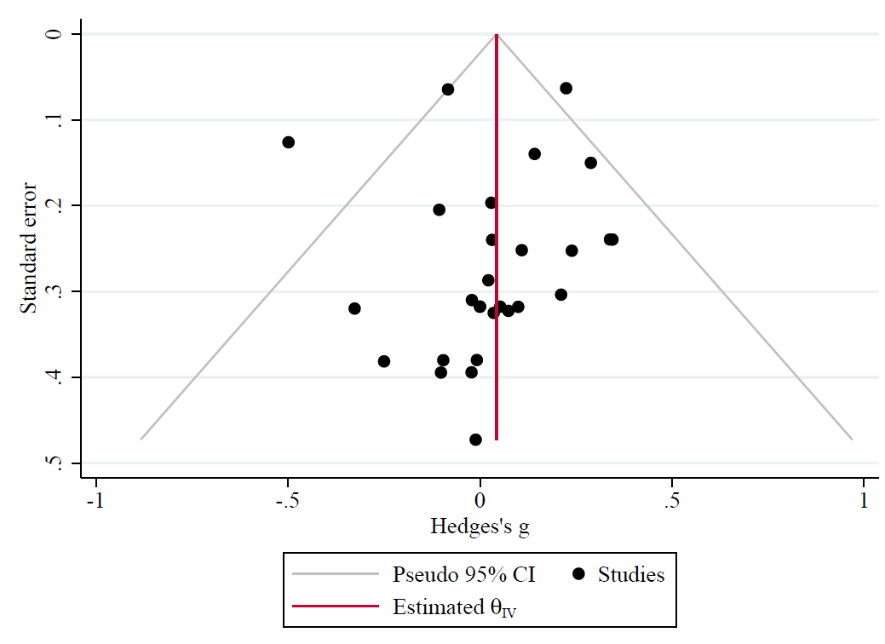

Funnel Plot and Eggers Test Indicating Publication Bias for Experimental Groups
