Perceived Mother and Father Parenting and Adolescent Social Anxiety Symptoms: A Meta-Analysis

Supplementary Material
S1: Abstract Screening Protocol
This is a quick screening process that should take no more than 2-3 minutes each. When in doubt, include it, and CH will decide if it qualifies during a more extensive review.
Screening Steps
- Review the title.
  - This is unlikely to contain enough information to exclude a study but may be sufficient for including studies (e.g., father and mother contributions to social anxiety)
- Review the abstract.
  - Reference both mothers and fathers (even “parents”)
  - References some child social or temperamental outcome
  - Contains participants between 10 – 19 years old
  - Must be a primary study, not a review.
  - Not an intervention, program, or experimental design
  - Not a study of divorce, abandonment, death, adoptive/foster families, or abuse/maltreatment
  - Must be in English
- Optional: glance over the methods/measures section.
  - Participants’ age/parent inclusion
  - Child social measure

S2: Study Coding Protocol
Note: (F = Fathers, M = Mothers), “-899” = missing/needs to be addressed
Study Characteristics
- ID: The study ID assigned by its inclusion in the meta-analysis (see Eligibility spreadsheet).
- Authors: List as in in-text citation format
- Year: Year of publication
- Outlet: Name of journal or publishing organization
- Pub_Type: Description of the publication type.
  - Published – This is any published work in a peer-reviewed journal
  - Dissertation - (published only by the dissertation organization like ProQuest or the university)
  - Unpublished (any other grey literature including non-peer-reviewed works)
- Sam_Type: Sample type (Clinical vs nonclinical)
- Design:
  - Cross-Sectional – single time point, current parenting
  - Longitudinal – any multi-wave data collection of current parenting
  - Retrospective- any study where reporters were recalling their parenting from a previous timepoint.
- Siblings: Does this study control analytically or report the number of siblings typically found in the sample of families?
  - This is not just reported, but also used in a broader analysis.
- N: Total sample size
  - Report how many males and females if they also provide correlations for males and females separately
- Sampling Method: List how participants were recruited
  - This is a general note to be qualitatively.
Study Demographics
- Avg_Age: Average age of the youth participants in the sample
  - If longitudinal: If data are available to weight each wave’s contribution to the estimated mean age, then create a weighted mean age average (Direct questions to CH).
    - If insufficient data is available to create a weighted average, then create a simple average using the mean or estimated sample age at each timepoint.
- Country: List the country the study was completed in
- %_male: Percent of male participants in the sample (decimal format)
  - If the report offers full sample effect sizes and effect sizes for boys and girls separately, then list the full sample male percentage.
- Sex_Split: Are effect sizes available for males and females separately?
Study Measures
- Soc_Con: This is the social anxiety construct (social anxiety, shyness, behavioral inhibition, etc.)
  - Sometimes, a study will measure two conceptually equal aspects of social anxiety (e.g., social avoidance and social distress). In this case, you will record the measurement details for each variable and report the effect sizes for each variable in the following section. Ultimately, these values will be averaged after they are corrected for artifacts.
- Soc_Scale: This is the survey or measure of the SA construct
- Soc_Alpha: This is the Cronbach’s alpha for the SA measure.
  - If Alpha is not available, enter “-899”
- Par_Con: This is the parenting construct that was measured (acceptance, warmth, rejection, hostility, etc.)
  - Place the actual measured construct here, not its overall construct grouping.
- Par_Scale: This is the survey or measure of the parenting construct
- Par_Alpha: This is the Cronbach’s alpha for the parenting measure.
  - Par_M_Alpha: Alpha for the mothers parenting
  - Par_M_Alpha: Alpha for the fathers parenting
  - If Alpha is not available, enter “-899”
- Reporter_Par: Who is reporting on the parenting? Child, self-, partner, etc.
  - When multiple reporters are available, we use the child report of parenting. However, if child report is not available then another can be used. If more than one (non-child) reports are there, then record both. They will ultimately be averaged.
- DataFrame: Which construct does report fit under?
  - Acceptance – Anything in the acceptance to rejection dimension
  - Control - Anything in the overcontrolling to autonomy supporting dimension
  - Multi – Any time a study has effect sizes from more than one of these categories
Study Effect Sizes
- Construct: What parenting or psychopathology measure are you reporting on?
  - List each construct once for the entire sample
  - If the study reports on males/females separately, add a separate line for each construct for males and females (example below)
Acceptance (Full)
Acceptance (Males)
Acceptance (Females)
- Wave: If the study is longitudinal, indicate which wave you are reporting on. Most instances will be 1 (cross-sectional)
- F_YSA: This is the correlation between the father’s parenting/psychopathology and youth social anxiety
- M_YSA: This is the correlation between the mother’s parenting/psychopathology and youth social anxiety
- F_M (SAME): This is the correlation between the mothers parenting/psychopathology and the fathers parenting/psychopathology
Qualitative Coding
- DAD_Qual: Does the report’s full analysis find unique Father effects predicting youth social anxiety above that of mother’s contributions?
  - Report if they do NOT test parenting together.
  - This still counts if both mothers and fathers are significant. It indicates a unique father contribution.
- MOM_Qual: Does the report’s full analysis find unique mother effects predicting youth social anxiety above that of father’s contributions?
  - Report if they do NOT test parenting together.
  - This still counts if both mothers and fathers are significant. It indicates a unique father contribution.
- Gender_Qual: Does the report’s full analysis find unique effects of parenting on social anxiety to be significantly different for boys and girls?
  - Report if they do NOT test child gender differences.

S3 Assessing Subconstructs of Parental Warmth and Control
Using a random-effects meta-analysis for fathers, mothers, and the interparental covariance effect sizes, parenting dimensions subconstructs were tested as categorical moderators. Significant moderation would indicate that a specific parenting construct is differentially associated with social anxiety symptoms or influences the extent of shared variance in parental behaviors (i.e., interparental covariance)
The parental warmth dimension was split into three constructs, warmth, relationship quality, and acceptance. The warmth construct included affection, care, reverse-scored shame, reverse-scored disrespect, nurturance, reverse-scored parent-adolescent hostility, and warmth measures. The parent-child relationship quality construct was comprised of communication, connection to parents, parent-child trust, relationship quality, social support, support, and trust measures. Finally, the acceptance construct included acceptance and reverse-scored rejection measures. The warmth moderation analysis was nonsignificant for fathers, mothers, and the interparental covariance analyses.
Two different construct groupings were testing within the parental control dimension. First, psychological control was contrasted against overcontrol. The parental overcontrol construct included reverse-scored autonomy support, reverse-scored independence, control, overcontrol, intrusiveness, strictness/imposition and overprotection. Psychological control was comprised only of effect sizes extracted from studies explicitly measuring psychological control. Moderating by overcontrol and psychological control categories yielded a nonsignificant interaction in the fathers, mothers, and the interparental covariance analyses. For the second moderation, autonomy support was contrasted against the remaining control measures. The autonomy support construct was represented by reverse-scored items that included autonomy support and independence, while control was comprised of control, overcontrol, intrusiveness, strictness/imposition, overprotection, and psychological control. Moderating by autonomy support and control categories also yielded a nonsignificant interaction for the fathers, mothers, and interparental covariance analyses.
These findings indicate that neither the heterogeneity in warmth nor control effect sizes is explained by these subconstruct groupings, supporting their inclusion within a broad warmth and control dimensions.

S4 Heterogeneity Estimates Among Effect Sizes
In the first stage of the MASEM, correlation matrices of study effect sizes are pooled, and heterogeneity is evaluated for each model path. Findings reveal significant heterogeneity in effect sizes across all paths in both the warmth and control MASEMs. Consequently, a random-effects model is more appropriate for the data than a fixed-effects MASEM.

S5 Random Forrest Plots for Parental Warmth Effect Sizes
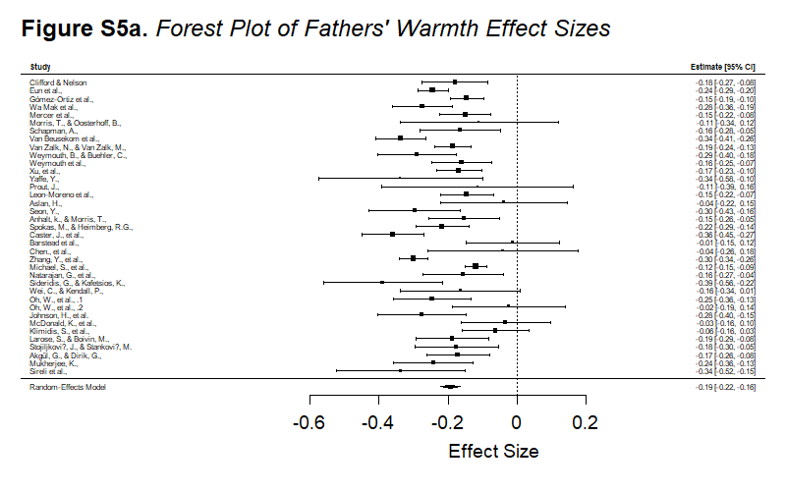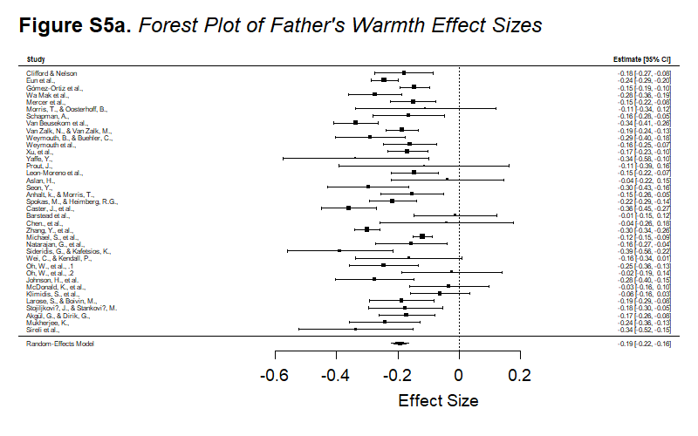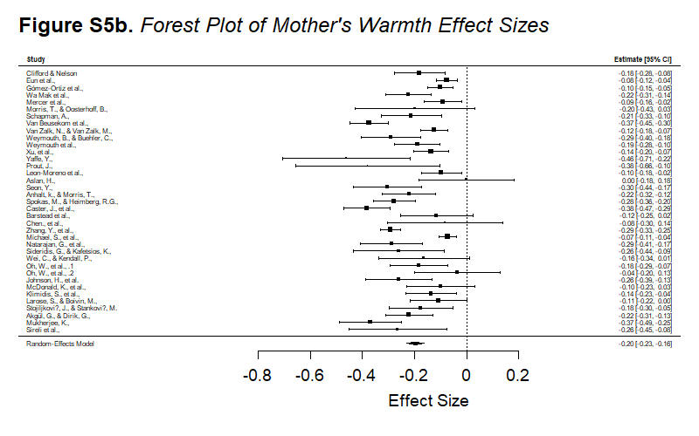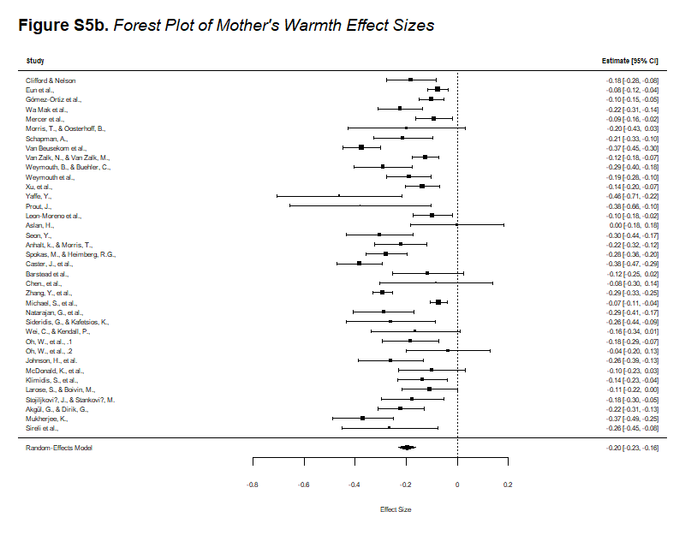
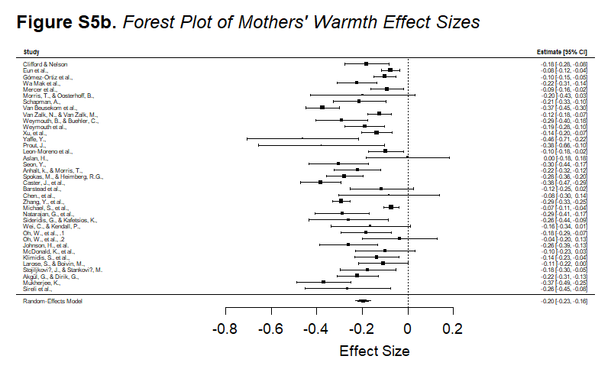

S6 Random Forrest Plots for Parental Control Effect Sizes
