Supplementary Materials for Effects of Resilience Interventions for Adolescents and Young Adults:
A Systematic Review and Network Meta-analysis

Methods 1. PRISMA checklist 2
Methods 2. Assessment of heterogeneity and inconsistency for the main outcome 3
Methods 3. Evaluating the Confidence in NMA: CINeMA 3
Network summary of within-study bias 4
Evaluation summary of the confidence in evidence 4
Table 1. Description of resilience interventions in selected studies 6
Table 2. Definition of resilience interventions 8
Table 3. Transitivity assumption assessments 8
Table 4. Meta-regression 9
Figure 1. Risk of Bias using Cochrane's RoB 2.0 tool 10
Figure 2. Assessment Publication bias 11
Figure 3. Subgroup network meta-analysis by population 12
a) at risk 12
b) non-at-risk 12
c) adolescents 12
d) young adults 13
Figure 4. Sensitivity analysis 14
Only low risk of bias 14
Only studies using immediate post assessment 14

Methods 1. PRISMA checklist
Section and Topic | Item # | Checklist item | Pages where item is reported
TITLE
Title | 1 | Identify the report as a systematic review. | 1
ABSTRACT
Abstract | 2 | See the PRISMA 2020 for Abstracts checklist. | 1
INTRODUCTION
Rationale | 3 | Describe the rationale for the review in the context of existing knowledge. | 1-2
Objectives | 4 | Provide an explicit statement of the objective(s) or question(s) the review addresses. | 1-2
METHODS
Eligibility criteria | 5 | Specify the inclusion and exclusion criteria for the review and how studies were grouped for the syntheses. | 3
Information sources | 6 | Specify all databases, registers, websites, organisations, reference lists and other sources searched or consulted to identify studies. Specify the date when each source was last searched or consulted. | 3
Search strategy | 7 | Present the full search strategies for all databases, registers and websites, including any filters and limits used. | 3
Selection process | 8 | Specify the methods used to decide whether a study met the inclusion criteria of the review, including how many reviewers screened each record and each report retrieved, whether they worked independently, and if applicable, details of automation tools used in the process. | 3
Data collection process | 9 | Specify the methods used to collect data from reports, including how many reviewers collected data from each report, whether they worked independently, any processes for obtaining or confirming data from study investigators, and if applicable, details of automation tools used in the process. | 3
Data items | 10a | List and define all outcomes for which data were sought. Specify whether all results that were compatible with each outcome domain in each study were sought (e.g. for all measures, time points, analyses), and if not, the methods used to decide which results to collect. | 4
Data items | 10b | List and define all other variables for which data were sought (e.g. participant and intervention characteristics, funding sources). Describe any assumptions made about any missing or unclear information. | 4
Study risk of bias assessment | 11 | Specify the methods used to assess risk of bias in the included studies, including details of the tool(s) used, how many reviewers assessed each study and whether they worked independently, and if applicable, details of automation tools used in the process. | 3
Effect measures | 12 | Specify for each outcome the effect measure(s) (e.g. risk ratio, mean difference) used in the synthesis or presentation of results. | 4
Synthesis methods | 13a | Describe the processes used to decide which studies were eligible for each synthesis (e.g. tabulating the study intervention characteristics and comparing against the planned groups for each synthesis (item #5)). | 3
Synthesis methods | 13b | Describe any methods required to prepare the data for presentation or synthesis, such as handling of missing summary statistics, or data conversions. | 4
Synthesis methods | 13c | Describe any methods used to tabulate or visually display results of individual studies and syntheses. | 4
Synthesis methods | 13d | Describe any methods used to synthesize results and provide a rationale for the choice(s). If meta-analysis was performed, describe the model(s), method(s) to identify the presence and extent of statistical heterogeneity, and software package(s) used. | 4
Synthesis methods | 13e | Describe any methods used to explore possible causes of heterogeneity among study results (e.g. subgroup analysis, meta-regression). | 4
Synthesis methods | 13f | Describe any sensitivity analyses conducted to assess robustness of the synthesized results. | 4
Reporting bias assessment | 14 | Describe any methods used to assess risk of bias due to missing results in a synthesis (arising from reporting biases). | 3
Certainty assessment | 15 | Describe any methods used to assess certainty (or confidence) in the body of evidence for an outcome. | 3, Supplementary materials p3-4
RESULTS
Study selection | 16a | Describe the results of the search and selection process, from the number of records identified in the search to the number of studies included in the review, ideally using a flow diagram. | 4
Study selection | 16b | Cite studies that might appear to meet the inclusion criteria, but which were excluded, and explain why they were excluded. | 4
Study characteristics | 17 | Cite each included study and present its characteristics. | 4, Table 1
Risk of bias in studies | 18 | Present assessments of risk of bias for each included study. | 4
Results of individual studies | 19 | For all outcomes, present, for each study: (a) summary statistics for each group (where appropriate) and (b) an effect estimate and its precision (e.g. confidence/credible interval), ideally using structured tables or plots. | 4-5, Figure 2-3, Supplementary materials p12-14
Results of syntheses | 20a | For each synthesis, briefly summarise the characteristics and risk of bias among contributing studies. | 4, Supplementary materials p11
Results of syntheses | 20b | Present results of all statistical syntheses conducted. If meta-analysis was done, present for each the summary estimate and its precision (e.g. confidence/credible interval) and measures of statistical heterogeneity. If comparing groups, describe the direction of the effect. | 4-5, Figure 2-3,
Results of syntheses | 20c | Present results of all investigations of possible causes of heterogeneity among study results. | Supplementary materials p3
Results of syntheses | 20d | Present results of all sensitivity analyses conducted to assess the robustness of the synthesized results. | 6, Supplementary materials p14
Reporting biases | 21 | Present assessments of risk of bias due to missing results (arising from reporting biases) for each synthesis assessed. | Supplementary materials p12
Certainty of evidence | 22 | Present assessments of certainty (or confidence) in the body of evidence for each outcome assessed. | Supplementary materials p3-4
DISCUSSION
Discussion | 23a | Provide a general interpretation of the results in the context of other evidence. | 6-7
Discussion | 23b | Discuss any limitations of the evidence included in the review. | 8
Discussion | 23c | Discuss any limitations of the review processes used. | 8
Discussion | 23d | Discuss implications of the results for practice, policy, and future research. | 8
OTHER INFORMATION
Registration and protocol | 24a | Provide registration information for the review, including register name and registration number, or state that the review was not registered. | 3
Registration and protocol | 24b | Indicate where the review protocol can be accessed, or state that a protocol was not prepared. | 3
Registration and protocol | 24c | Describe and explain any amendments to information provided at registration or in the protocol. | 3
Support | 25 | Describe sources of financial or non-financial support for the review, and the role of the funders or sponsors in the review. | 8
Competing interests | 26 | Declare any competing interests of review authors. | 8
Availability of data, code and other materials | 27 | Report which of the following are publicly available and where they can be found: template data collection forms; data extracted from included studies; data used for all analyses; analytic code; any other materials used in the review. | 8

Methods 2. Assessment of heterogeneity and inconsistency for the main outcome
The heterogeneity of the network meta-analysis was estimated as 𝜏² = 0.22. The global test for inconsistency, based on the design-by-treatment method, yielded a Q value of 10.7 with 9 degrees of freedom and a p-value of 0.2967. The local inconsistency approach, using the node-splitting model, provided the following result:
Random effects model:

comparison k prop nma direct indir. Diff z p-value
Mindfulness:Physical activity 0 0 -0.3755 . -0.3755 . . .
Mindfulness:Psychoeducation 1 0.21 0.1351 0.9483 -0.0767 1.0250 1.50 0.1348
Mindfulness:Psychological placebo 3 0.56 0.4482 0.1986 0.7694 -0.5708 -1.40 0.1603
Mindfulness:Psychotherapy 0 0 -0.2775 . -0.2775 . . .
Mindfulness:Skill training 0 0 0.0536 . 0.0536 . . .
Mindfulness:Treatment as usual 9 0.84 0.4823 0.4773 0.5081 -0.0309 -0.08 0.9398
Physical activity:Psychoeducation 0 0 0.5106 . 0.5106 . . .
Physical activity:Psychological placebo 0 0 0.8237 . 0.8237 . . .
Physical activity:Psychotherapy 0 0 0.0980 . 0.0980 . . .
Physical activity:Skill training 0 0 0.4291 . 0.4291 . . .
Physical activity:Treatment as usual 3 1.00 0.8578 0.8578 . . . .
Psychoeducation:Psychological placebo 1 0.37 0.3131 0.3660 0.2821 0.0839 0.14 0.8861
Psychoeducation:Psychotherapy 0 0 -0.4126 . -0.4126 . . .
Psychoeducation:Skill training 0 0 -0.0815 . -0.0815 . . .
Psychoeducation:Treatment as usual 2 0.58 0.3472 0.5722 0.0337 0.5385 1.02 0.3071
Psychological placebo:Psychotherapy 2 0.37 -0.7257 -0.8706 -0.6420 -0.2285 -0.49 0.6254
Psychological placebo:Skill training 1 0.21 -0.3946 -0.6862 -0.3174 -0.3688 -0.70 0.4809
Psychological placebo:Treatment as usual 2 0.28 0.0341 0.1614 -0.0166 0.1780 0.41 0.6783
Psychotherapy:Skill training 1 0.12 0.3311 0.5773 0.2970 0.2803 0.49 0.6236
Psychotherapy:Treatment as usual 9 0.82 0.7599 0.6713 1.1593 -0.4880 -1.19 0.2357
Skill training:Treatment as usual 18 0.91 0.4287 0.4220 0.5002 -0.0782 -0.20 0.8452

Methods 3. Evaluating the Confidence in NMA: CINeMA
CINeMA is a web-based application developed to facilitate the evaluation of confidence in the findings of a network meta-analysis, which evaluates six key domains: within-study bias, reporting bias, indirectness, imprecision, heterogeneity, and incoherence.
- Within-study bias: Assessed using Cochrane's RoB 2.0 tool. Selected rule: Average RoB
- Reporting bias: We referred to the following article:
Noetel, M., Sanders, T., Gallardo-Gómez, D., Taylor, P., Del Pozo Cruz, B., van den Hoek, D., Smith, J. J., Mahoney, J., Spathis, J., Moresi, M., Pagano, R., Pagano, L., Vasconcellos, R., Arnott, H., Varley, B., Parker, P., Biddle, S., & Lonsdale, C. (2024). Effect of exercise for depression: systematic review and network meta-analysis of randomised controlled trials. BMJ (Clinical research ed.), 384, e075847. https://doi.org/10.1136/bmj-2023-075847. A multilevel Egger’s regression test was conducted for comparisons involving more than 10 studies. For comparisons involving fewer than 10 studies, these were classified as showing “some concerns.”
- Indirectness: Studies were assumed be indirect if they focused on one sex only (>90% male or female). Selected rule: Average RoB
- Imprecision: To determine clinical relevance, we applied a threshold of Hedges' g = 0.2, defining a zone of equivalence. Differences within the range of −0.2 to 0.2 were considered not clinically meaningful.
- Heterogeneity: A threshold of Hedges' g = 0.2 was also used to identify a zone of equivalence for heterogeneity, with differences within −0.2 to 0.2 regarded as not clinically significant.
- Incoherence: Incoherence was evaluated using the design-by-treatment interaction test and the SIDE approach. The same threshold of Hedges' g = 0.2 was applied to assess clinical significance.

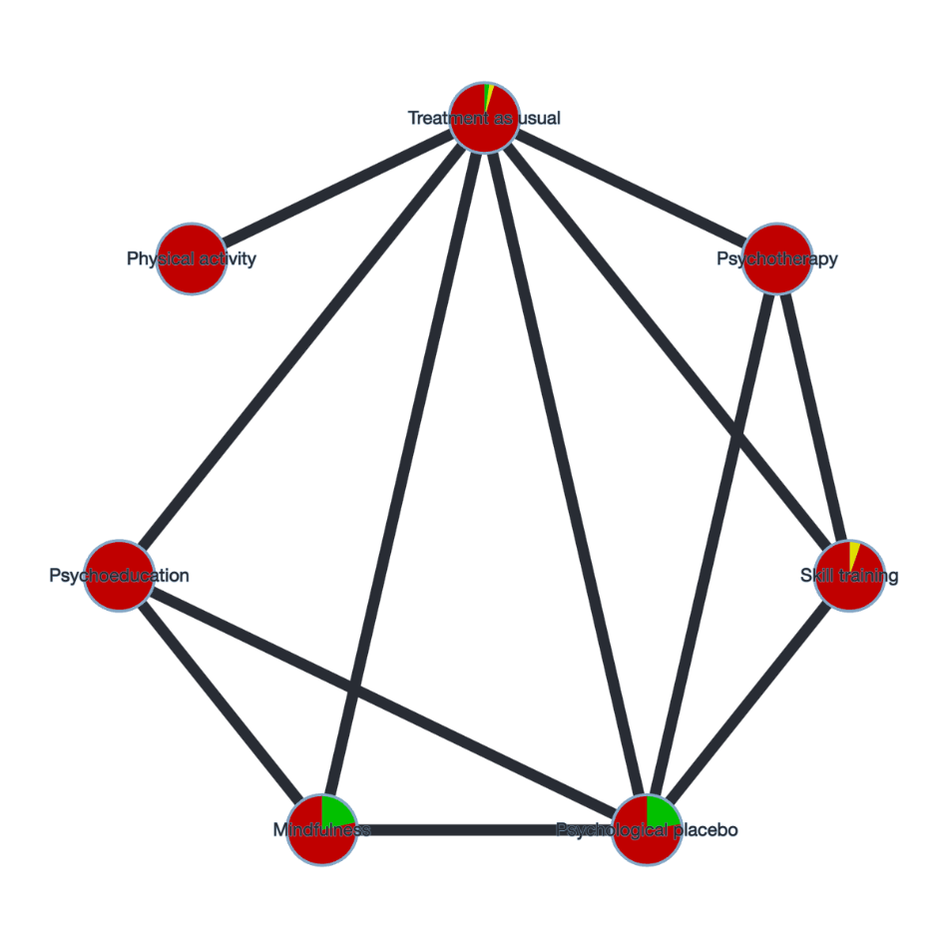
Network summary of within-study bias
- Green: Low risk of bias comparisons
- Yellow: Some concerns comparisons
- Red: High risk of bias comparisons

Evaluation summary of the confidence in evidence
Comparison | Number of studies | Within-study bias | Reporting bias | Indirectness | Imprecision | Heterogeneity | Incoherence | Confidence rating | Reason(s) for downgrading
Mindfulness:Psychoeducation | 1 | Major concerns | Some concerns | No concerns | Major concerns | No concerns | Some concerns | Very low | ["Within-study bias","Imprecision"]
Mindfulness:Psychological placebo | 3 | Some concerns | Some concerns | No concerns | No concerns | Major concerns | No concerns | Low | ["Reporting bias","Heterogeneity"]
Mindfulness:Treatment as usual | 9 | Major concerns | Some concerns | No concerns | No concerns | Major concerns | No concerns | Low | ["Within-study bias",","Heterogeneity"]
Physical activity:Treatment as usual | 3 | Major concerns | Some concerns | No concerns | No concerns | Some concerns | No concerns | Low | ["Within-study bias","Heterogeneity"]
Psychoeducation:Psychological placebo | 1 | Major concerns | Some concerns | No concerns | Some concerns | Some concerns | No concerns | Low | ["Within-study bias","Imprecision"]
Psychoeducation:Treatment as usual | 2 | Major concerns | Some concerns | No concerns | Some concerns | Some concerns | No concerns | Low | ["Within-study bias","Reporting bias"]
Psychological placebo:Psychotherapy | 2 | Major concerns | Some concerns | No concerns | No concerns | Some concerns | No concerns | Low | ["Within-study bias","Reporting bias"]
Psychological placebo:Skill training | 1 | Major concerns | Some concerns | No concerns | No concerns | Major concerns | No concerns | Very low | ["Within-study bias","Reporting bias","Heterogeneity"]
Psychological placebo:Treatment as usual | 2 | Major concerns | Some concerns | No concerns | Major concerns | No concerns | No concerns | Very low | ["Within-study bias","Reporting bias","Imprecision"]
Psychotherapy:Skill training | 1 | Major concerns | Some concerns | No concerns | Some concerns | Some concerns | No concerns | Low | ["Within-study bias","Reporting bias"]
Psychotherapy:Treatment as usual | 9 | Major concerns | Some concerns | No concerns | No concerns | Some concerns | No concerns | Low | ["Within-study bias","Reporting bias"]
Skill training:Treatment as usual | 18 | Major concerns | Low | No concerns | No concerns | Major concerns | No concerns | Low | ["Within-study bias",  " Heterogeneity "]
Mindfulness:Physical activity | 0 | Major concerns | Some concerns | No concerns | Some concerns | Some concerns | No concerns | Low | ["Within-study bias","Reporting bias"]
Mindfulness:Psychotherapy | 0 | Major concerns | Some concerns | No concerns | Some concerns | Some concerns | No concerns | Low | ["Within-study bias","Reporting bias"]
Mindfulness:Skill training | 0 | Major concerns | Some concerns | No concerns | Major concerns | No concerns | No concerns | Very low | ["Within-study bias","Imprecision"]
Physical activity:Psychoeducation | 0 | Major concerns | Some concerns | No concerns | Some concerns | Some concerns | No concerns | Low | ["Within-study bias","Reporting bias"]
Physical activity:Psychological placebo | 0 | Major concerns | Some concerns | No concerns | No concerns | Major concerns | No concerns | Very low | ["Within-study bias","Heterogeneity"]
Physical activity:Psychotherapy | 0 | Major concerns | Some concerns | No concerns | Major concerns | No concerns | No concerns | Very low | ["Within-study bias","Imprecision"]
Physical activity:Skill training | 0 | Major concerns | Some concerns | No concerns | Some concerns | Some concerns | No concerns | Low | ["Within-study bias","Reporting bias"]
Psychoeducation:Psychotherapy | 0 | Major concerns | Some concerns | No concerns | Some concerns | Some concerns | No concerns | Low | ["Within-study bias","Reporting bias"]
Psychoeducation:Skill training | 0 | Major concerns | Some concerns | No concerns | Major concerns | No concerns | No concerns | Very low | ["Within-study bias","Imprecision"]

Table 1. Description of resilience interventions in selected studies
Author(s),Year | Name of intervention | Mode | Controls | Frequency/Duration of Per Session/Duration of intervention | Follow up
Amin et al., 2020 | Students Exposed to Trauma Program | Face-to-face/Group | No treatment | once a week/45 min/10 weeks | /
Bischops et al., 2024 | REThink app and coaching program | Face to face or online/Individual or group | REThink app only | once a week/60-90min/7 weeks | 2 months
Cerit & Simsek, 2021 | Social skill training program | Face-to-face/Group | No treatment | once a week/40 min/7 weeks | 1 month
Chen et al., 2014 | Cognitive behavioural therapy | Face-to-face/Group | 1.No treatment  2.Social support | once a week/ 60min /6 weeks | 3 months
Cheng et al., 2024 | Multicomponent positive psychology program | Online/Individual | Waitlist | once a week/self-paced /4 weeks | /
Chung et al., 2021 | Adventure‐based training | Face to face/Group | Placebo control | 2‐day/1‐night | 6 months
DeTore et al., 2023 | Resilience training | Face to face/Group | Waitlist | once a week/90min/4 weeks | 12 months
Erogul et al., 2014 | Abridged mindfulness- based stress reduction | Face-to-face/Group | No treatment | once a week/75mins/8 weeks | 6 months
Felver et al., 2019 | School-based mindfulness intervention | Face-to-face/Group | Psychoeducation | once a week/48min /6 weeks | /
Flett et al., 2019 | Mobile mindfulness meditation | Online/individual | Placebo control | per day/10 to 45 min/ 10 days | 30-day
Flett et al., 2020 | App-based mindfulness meditation | Online/individual | Waitlist | per day /10-20minute/1 semester | 1 academic year
Gerson et al., 2013 | Program for accelerated thriving and health | Face-to-face/Group | Waitlist | once a week/60-90min /3 weeks | /
Greco et al., 2019 | Shotokan karate intervention | Face-to-face/Group | Waitlist | once a week/ 60min/12 weeks | /
Green et al., 2021 | SPARK pre‐teen mentoring curriculum | Face-to-face/Group | No treatment | once a week/ 50min /12-13 weeks | /
Guo et al., 2023 | Mindfulness group intervention | Face-to-face/Group | Waitlist | non-consecutive three times a week/ 35min /6 weeks | /
Hatamizadeh et al., 2020 | Resilience intervention | Face-to-face/Group | No treatment | twice a week/ 75min/6 weeks | 2 months
Houston et al., 2017 | Resilience and coping intervention | Face-to-face/Group | No treatment | once a week/ 45min /3 weeks | /
Hyun et al., 2010 | Cognitive behavioral therapy | Face-to-face/Group | No treatment | once a week/ 50min /10 weeks | /
Johnstone et al., 2020 | Universal school-based prevention programs | Face-to-face/Group | Treatment as usual | once a week/ 50min /8weeks | 6 months
Kadian et al., 2022 | Brief resilience interventions | Face-to-face/Group | Placebo control | every other week/30min/4 weeks | /
Khalsa et al., 2012 | Yoga | Face-to-face/Group | No treatment | 2 times or 3 times per week/ 30-40min /11 weeks | /
Khodakarami et al., 2023 | Cognitive-behavioral counseling | Face-to-face/Group | No treatment | once a week/ 60 min /8 weeks | /
Kuhlthau et al., 2023 | Resilience intervention | Online/group | Waitlist | once a week/ NA /8 weeks | /
Lanz, 2020 | Resilience intervention | Face-to-face/Group | No treatment | NA/60 minutes/5 weeks | /
Li et al., 2017 | Resilience intervention | Face-to-face/Group | No treatment | once a week/ 120 min/10 weeks | 6 months/12 months
Li et al., 2021 | Model-based group counseling | Face-to-face/Group | No treatment | once a week/ 60-90min/8 weeks | 3 months
Liang et al., 2018 | Psychological intervention | Face-to-face/Group | No treatment | once a week/90 min/8 weeks | /
Mejia-Downs, 2020 | Resilience curriculum | Face-to-face/Group | Waitlist | once a week/120min/4 weeks | /
Moir et al., 2016 | Peer-Support and Mindfulness Program | Face-to-face/Group | Treatment as usual | NA/120 minutes/over 6 months | /
Moore et al., 2021 | Martial arts training | Face-to-face/Group | Waitlist | once a week/60min /10 weeks | 12 weeks
Moran et al., 2024 | Building Resilience for Healthy Kids | Face-to-face/Individual | No treatment | once a week/60min /6 weeks | /
Niu et al., 2021 | Resilience intervention | Face-to-face/Group | No treatment | twice a week/90min/4.5 weeks | /
O'Connor et al., 2022 | Universal process-based CBT intervention | Face-to-face/Group | Waitlist | once a week/40 min /6 weeks | 6 weeks
Peter et al., 2022 | Mindfulness-based cognitive therapy | Face-to-face/Group | Waitlist | once a week/ 90 min /12 weeks | 3 months
Rich et al., 2022 | Resilience Builder Program | Face-to-face/Group | Waitlist | once a week/ 50 min /12 weeks | /
Roghanchi et al., 2013 | REBT interventions and art therapy | Face-to-face/Group | No treatment | once a week/120 min /10 weeks | /
Rosenberg et al., 2018 | Promoting resilience in stress management (PRISM) intervention | Face-to-face/Individual | Treatment as usual | every other week/30-50 min/8 weeks | /
Rosenberg et al., 2024 | Promoting resilience in stress management (PRISM) intervention | Face to face or Online/Individual | Treatment as usual | every other week/30-50 min/8 weeks | 6 months
Steinhardt & Dolbier, 2008 | Transforming lives through resilience education | Face to face/Group | Waitlist | once a week /120 minutes /4 weeks | /
Şenocak & Demirkıran, 2023 | Problem-solving skills development training | Face to face/Group | Waitlist | once a week /55min-150min minutes /7 weeks | 1 month
Tang et al.,2022 | Peer education training course | Face-to-face/Group | No treatment | NA/ 60min/1 academic year | /
Volanen et al., 2020 | Mindfulness-based intervention | Face-to-face/Group | 1.Treatment as usual  2. Placebo control | once a week/ 45 minute/6 weeks | 26 weeks
Yeun & Woo et al., 2018 | Interpersonal relationship improvement program | Face-to-face/Group | Treatment as usual | once a week/ 60 minute/6 weeks | /
Yi-Frazier et al., 2024 | Promoting resilience in stress management (PRISM) intervention | Face to face or online/individual | Treatment as usual | every other week/ 30-90min/8 weeks | 12 months
Zhang et al., 2022 | Mindfulness-based emotion management Intervention | Face-to-face/Group | Waitlist | once a week/ 65min/4 weeks | 6 months
Zhang et al., 2021 | Psychological counseling | Face-to-face/Group | Treatment as usual | once a week/ 60min /8 weeks | /

Table 2. Definition of resilience interventions
Psychotherapy | Psychotherapy involves structured, well-validated techniques that are commonly used to help individuals manage overall psychological well-being. It includes widely used forms of talk therapy, such as Cognitive Behavioral Therapy (CBT) and Behavioral Activation (BA).
Skill training | Skill training is a structured intervention aimed at developing specific abilities to improve resilience, such as problem-solving skills, social skills, stress management, and emotion management.
Mindfulness | Mindfulness focuses on cultivating non-judgmental awareness of the present moment, helping individuals observe their thoughts, emotions, and bodily sensations without immediate reaction. Core practices include:  Mindful Breathing: Concentrating attention on the breath to anchor awareness in the present moment, reducing stress and enhancing concentration.  Body Scanning: Systematically bringing awareness to different parts of the body to increase bodily awareness and identify areas of tension.  Observing Thoughts and Emotions: Practicing non-judgmental observation of thoughts and emotions to develop a habit of awareness without automatic reactivity.
Physical activity | Physical activity refers to a structured set of exercises developed based on established theories and prior research. This specific activity is designed not only for physical exertion but primarily aims to enhance resilience.
Psychoeducation | Psychoeducation is an intervention in which participants are provided with psychological knowledge, such as the concepts of illness, stress, mood, and resilience.
Psychological placebo | Psychological placebo refers to an intervention that triggers positive psychological responses purely through the power of suggestion or belief, without any inherent therapeutic effect in the intervention itself. In this study, it includes relaxation, social support, an organizational application, and a pamphlet.
Treatment as usual | Treatment as usual refers to providing participants with their usual standard care without any experimental intervention. Wait-list control is included, where participants do not immediately receive the experimental treatment.

Table 3. Transitivity assumption assessments
To assess the transitivity across intervention types, we performed the Kruskal-Wallis rank sum test to examine potential effect modifiers (sample size, age, and female proportion). The results showed no significant differences between the intervention types, which supports the transitivity assumption.
Group comparisons for transisivity assessment

Variable | p value
Sample size | 0.812
Age | 0.592
Female proportion | 0.715

Table 4. Meta-regression

Skill training (n=18)
Covariate | β | SE | 95% Lower | 95% Upper | Z | p value
Individualism | -0.02 | 0.01 | -0.03 | -0.00 | -2.16 | .03*
Age | 0.01 | 0.03 | -0.05 | 0.07 | 0.33 | .74
Gender | -0.00 | 0.01 | -0.02 | 0.01 | -0.20 | .84
Publication year | -0.00 | 0.03 | -0.07 | 0.06 | -0.02 | .99
Duration of intervention | 0.03 | 0.04 | -0.05 | 0.11 | 0.72 | .47
Duration of session | 0.01 | 0.00 | 0.00 | 0.02 | 2.67 | <.01**
Sample size | 0.00 | 0.00 | -0.00 | 0.00 | 1.23 | 0.22

Mindfulness(n=9)
Covariate | β | SE | 95% Lower | 95% Upper | Z | p value
Individualism | -0.03 | 0.01 | -0.04 | -0.01 | -3.90 | <.0001***
Age | -0.04 | 0.05 | -0.14 | 0.07 | -0.67 | .50
Gender | -0.00 | 0.02 | -0.03 | 0.04 | 0.10 | .92
Publication year | 0.08 | 0.06 | -0.04 | 0.21 | 1.36 | .17
Duration of intervention | 0.04 | 0.08 | -0.13 | 0.18 | 0.34 | .74
Duration of session | 0.00 | 0.01 | -0.01 | 0.02 | 0.42 | .67
Sample size | -0.00 | 0.00 | -0.00 | 0.00 | -1.32 | .19

Physical activity(n=3)
Covariate | β | SE | 95% Lower | 95% Upper | Z | p value
Individualism | 0.01 | 0.01 | -0.00 | 0.02 | 1.28 | .20
Age | -0.11 | 0.09 | -0.29 | 0.08 | -1.15 | .25
Gender | -0.02 | 0.05 | -0.11 | 0.07 | -0.39 | .69
Publication year | 0.05 | 0.03 | -0.00 | 0.11 | 1.85 | .06
Duration of intervention | 0.08 | 0.04 | 0.00 | 0.15 | 2.07 | .04*
Duration of session | 0.02 | 0.01 | 0.00 | 0.04 | 1.98 | .04*
Sample size | 0.00 | 0.00 | -0.01 | 0.01 | 0.05 | .10

Psychotherapy(n=9)
Covariate | β | SE | 95% Lower | 95% Upper | Z | p value
Individualism | -0.03 | 0.01 | -0.05 | -0.01 | -2.64 | <.01**
Age | 0.03 | 0.08 | -0.13 | 0.19 | 0.40 | .70
Gender | -0.01 | 0.01 | -0.03 | 0.02 | -0.40 | .69
Publication year | -0.03 | 0.07 | -0.16 | 0.11 | -0.36 | .72
Duration of intervention | 0.17 | 0.12 | -0.06 | 0.40 | 1.43 | .15
Duration of session | 0.02 | 0.01 | 0.00 | 0.04 | 2.07 | .04*
Sample size | -0.00 | 0.00 | -0.01 | 0.00 | -1.39 | .16

Figure 1. Risk of Bias using Cochrane's RoB 2.0 tool
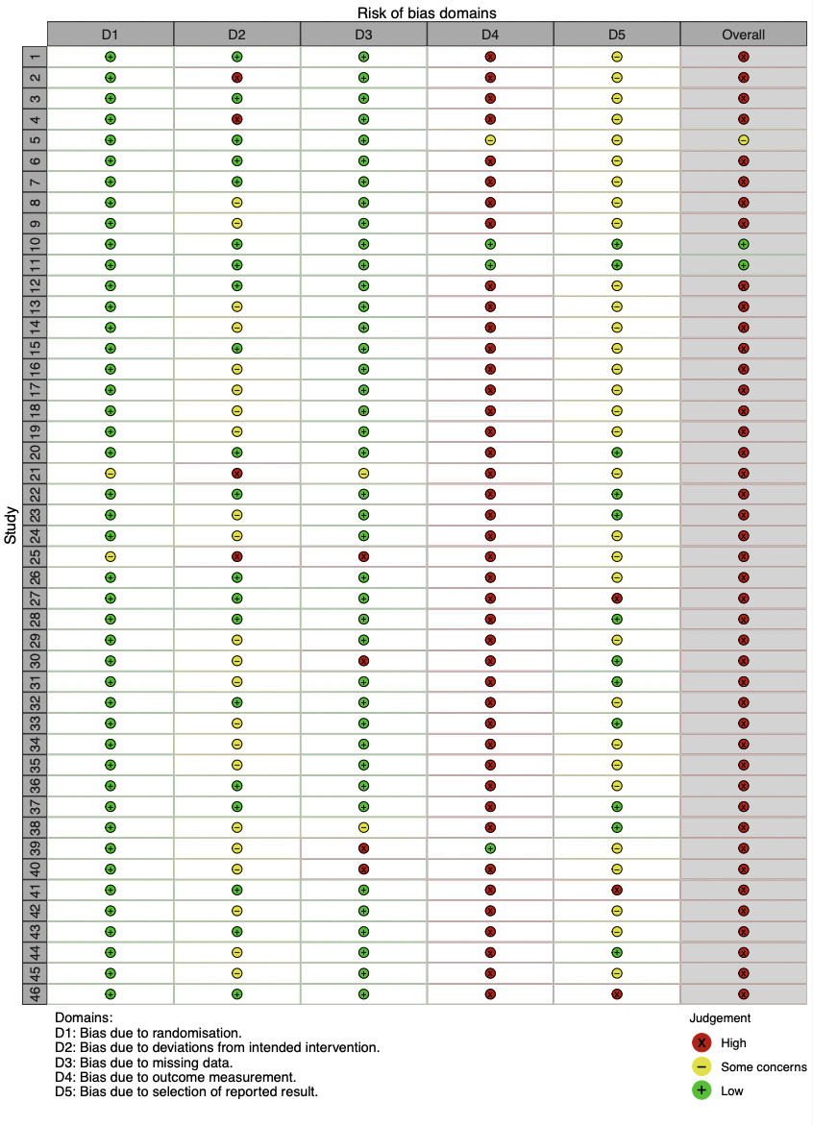
Traffic-light plot

Summary plot

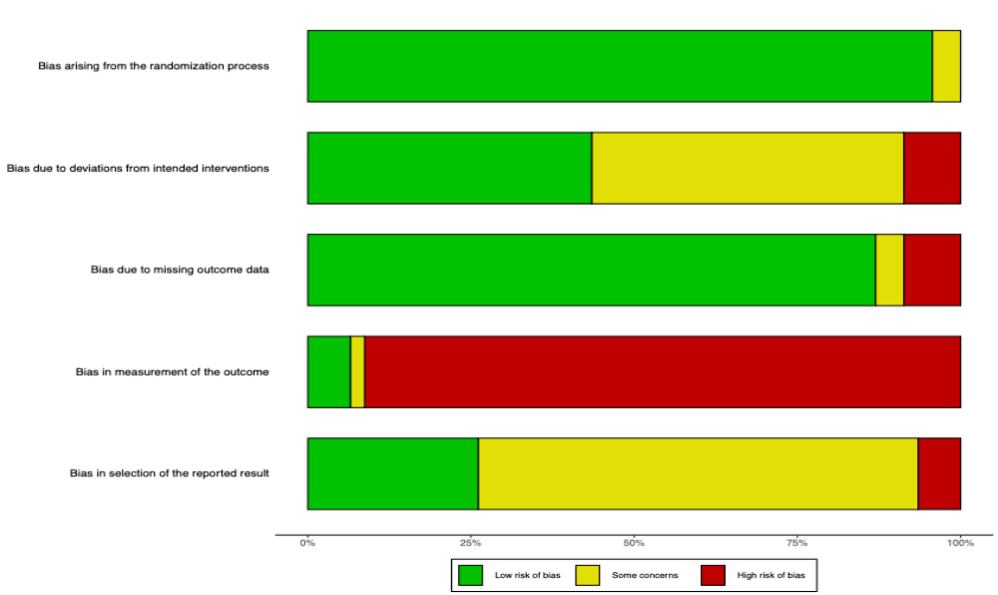

Figure 2. Assessment Publication bias
Linear regression test of funnel plot asymmetry
Test result: t = -2.13, df = 50, p-value = 0.0380
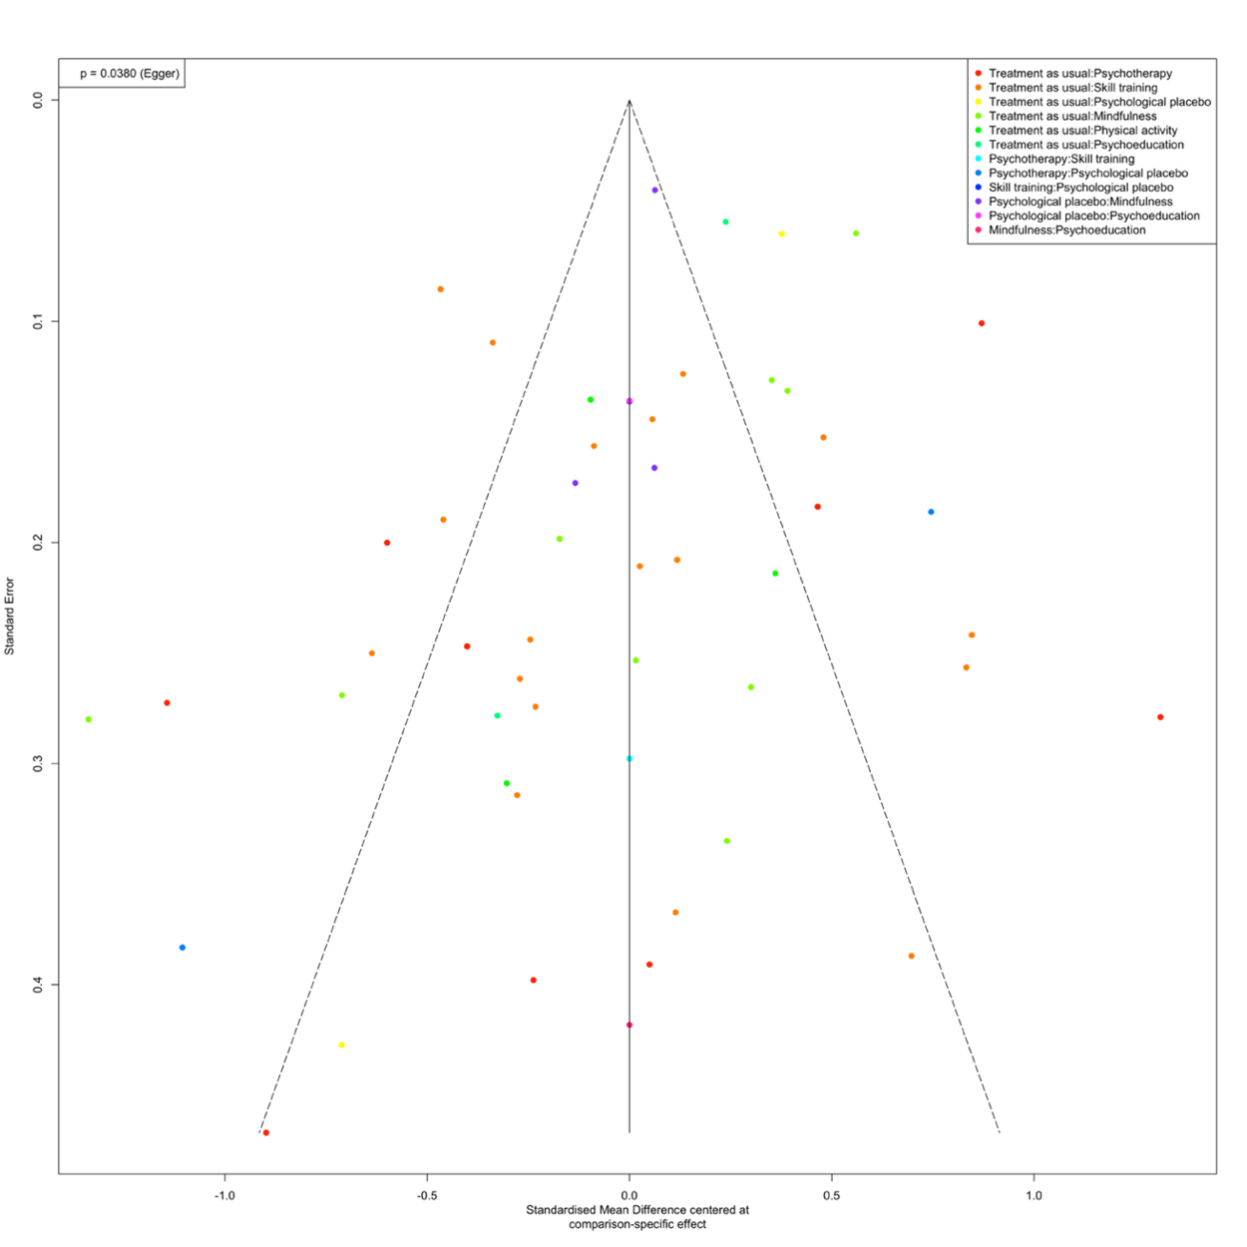
Bias estimate: -1.3540 (SE = 0.6352)

Figure 3. Subgroup network meta-analysis by population

at risk
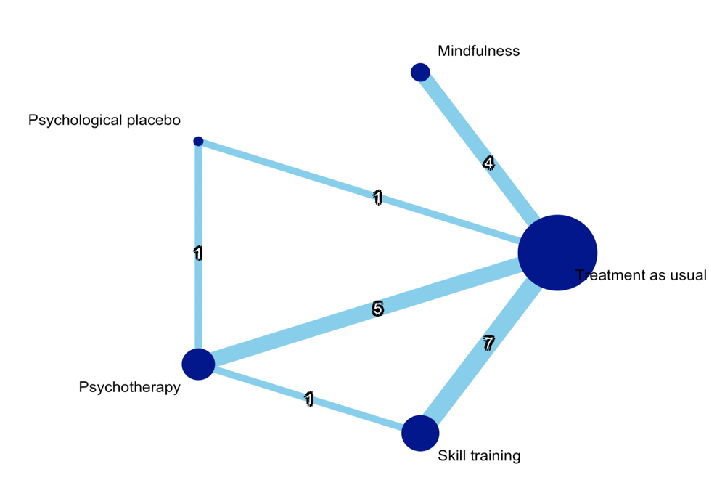
Network plot:
League table:
Mindfulness | . | . | . | 0.649 [ 0.222; 1.076]
-0.532 [-1.560; 0.495] | Psychological placebo | 0.235 [-0.780; 1.249] | . | 0.873 [-0.208; 1.953]
-0.536 [-1.099; 0.028] | -0.003 [-0.929; 0.922] | Psychotherapy | 0.577 [-0.321; 1.475] | 1.189 [ 0.789; 1.589]
0.064 [-0.448; 0.577] | 0.597 [-0.372; 1.566] | 0.600 [ 0.165; 1.035] | Skill training | 0.583 [ 0.286; 0.879]
0.649 [ 0.222; 1.076] | 1.182 [ 0.247; 2.117] | 1.185 [ 0.817; 1.553] | 0.585 [ 0.301; 0.869] | Treatment as usual

- non-at-risk:
Network plot:
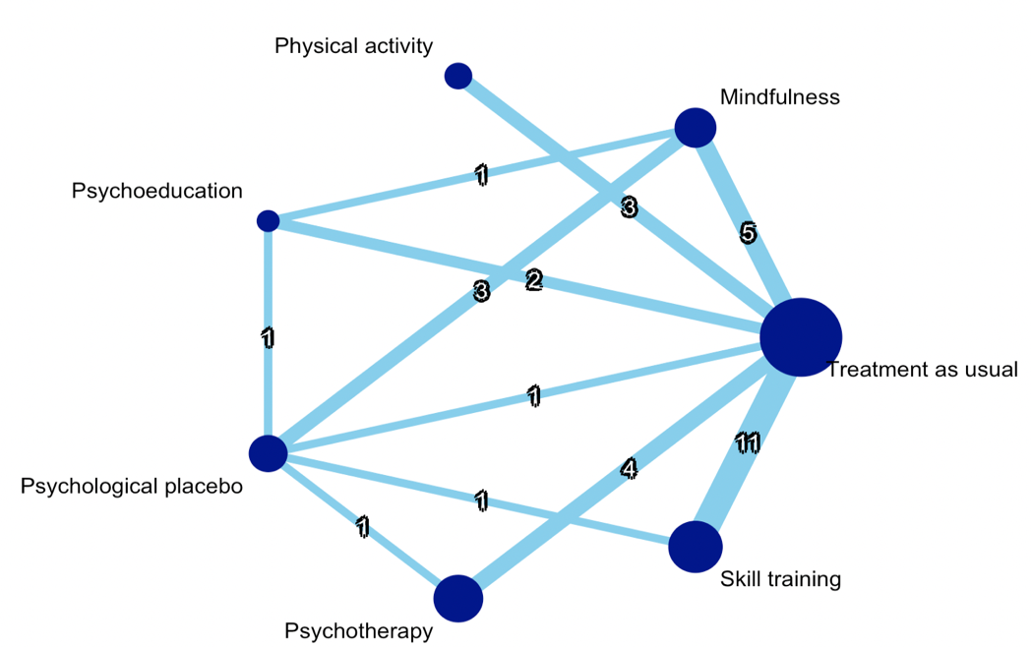
League table:
Mindfulness | . | 0.948 [-0.179; 2.075] | 0.198 [-0.275; 0.671] | . | . | 0.348 [-0.032; 0.728]
-0.566 [-1.177; 0.045] | Physical activity | . | . | . | . | 0.856 [ 0.344; 1.367]
0.051 [-0.463; 0.564] | 0.617 [-0.077; 1.310] | Psychoeducation | 0.366 [-0.452; 1.184] | . | . | 0.563 [-0.040; 1.165]
0.540 [ 0.157; 0.924] | 1.106 [ 0.468; 1.744] | 0.489 [-0.021; 1.000] | Psychological placebo | -1.616 [-2.472; -0.761] | -0.686 [-1.505; 0.132] | -0.215 [-0.998; 0.567]
-0.072 [-0.580; 0.436] | 0.494 [-0.164; 1.151] | -0.123 [-0.728; 0.483] | -0.612 [-1.113; -0.111] | Psychotherapy | . | 0.073 [-0.385; 0.532]
-0.037 [-0.449; 0.374] | 0.529 [-0.046; 1.103] | -0.088 [-0.614; 0.438] | -0.578 [-1.007; -0.148] | 0.035 [-0.447; 0.517] | Skill training | 0.315 [ 0.043; 0.587]
0.290 [-0.045; 0.625] | 0.856 [ 0.344; 1.367] | 0.239 [-0.229; 0.707] | -0.250 [-0.631; 0.131] | 0.362 [-0.051; 0.775] | 0.327 [ 0.067; 0.588] | Treatment as usual

- adolescents
Network plot:
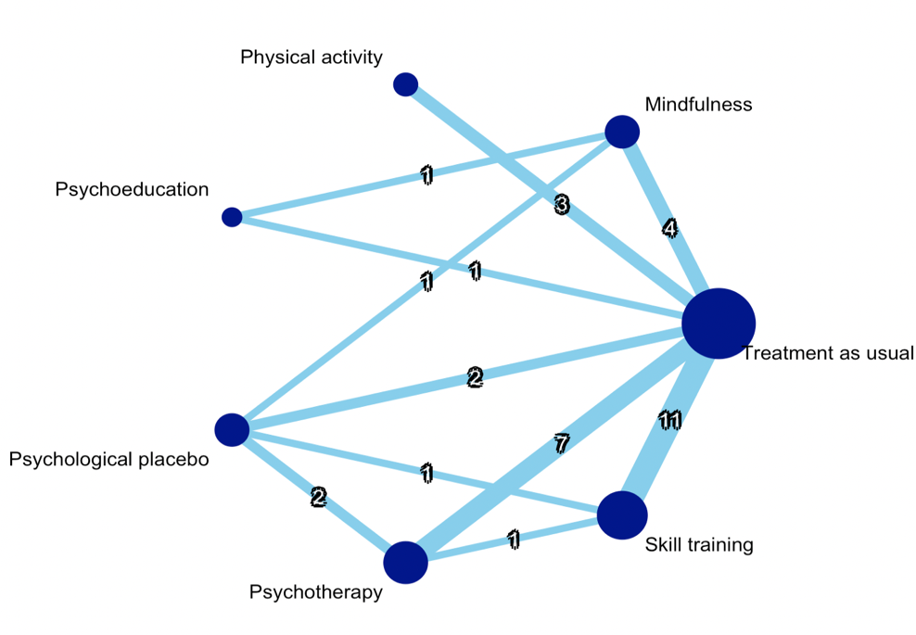
League table:
Mindfulness | . | 0.948 [-0.338; 2.234] | 0.136 [-0.858; 1.130] | . | . | 0.317 [-0.168; 0.802]
-0.474 [-1.247; 0.299] | Physical activity | . | . | . | . | 0.860 [ 0.234; 1.485]
0.388 [-0.449; 1.225] | 0.862 [-0.158; 1.882] | Psychoeducation | . | . | . | 0.334 [-0.662; 1.331]
0.439 [-0.202; 1.079] | 0.913 [ 0.093; 1.732] | 0.051 [-0.899; 1.000] | Psychological placebo | -0.841 [-1.645; -0.036] | -0.686 [-1.712; 0.340] | 0.189 [-0.602; 0.980]
-0.372 [-0.953; 0.209] | 0.102 [-0.631; 0.835] | -0.760 [-1.649; 0.129] | -0.811 [-1.376; -0.246] | Psychotherapy | 0.577 [-0.573; 1.727] | 0.671 [ 0.246; 1.097]
-0.050 [-0.594; 0.494] | 0.424 [-0.275; 1.123] | -0.438 [-1.301; 0.425] | -0.489 [-1.055; 0.077] | 0.322 [-0.140; 0.784] | Skill training | 0.436 [ 0.101; 0.771]
0.385 [-0.069; 0.840] | 0.860 [ 0.234; 1.485] | -0.002 [-0.808; 0.803] | -0.053 [-0.583; 0.476] | 0.758 [ 0.375; 1.140] | 0.436 [ 0.123; 0.748] | Treatment as usual

young adults
Network plot:
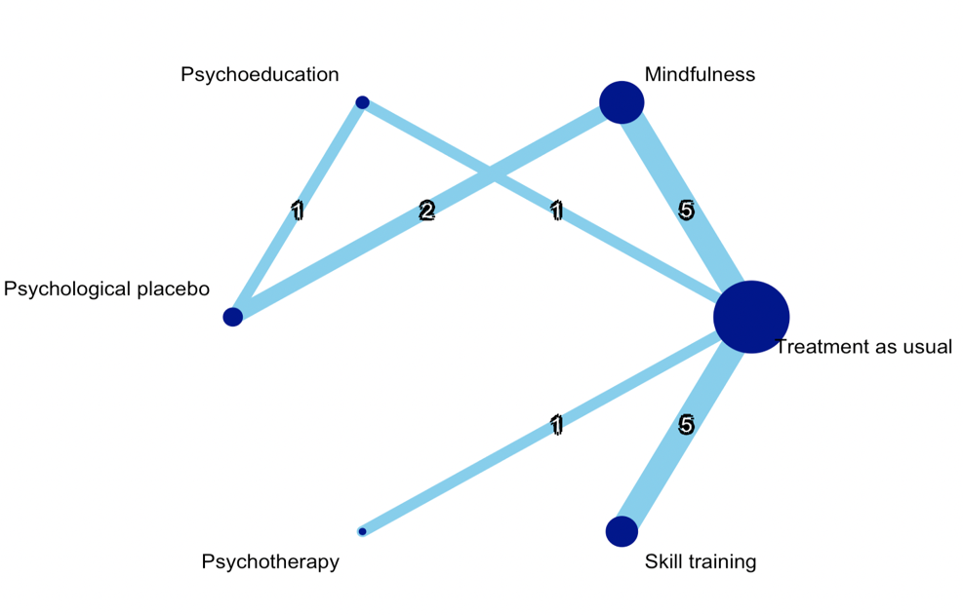
League table:
Mindfulness | . | 0.234 [-0.384; 0.852] | . | . | 0.519 [ 0.116; 0.922]
-0.255 [-1.000; 0.490] | Psychoeducation | 0.366 [-0.485; 1.217] | . | . | 0.898 [-0.077; 1.873]
0.192 [-0.371; 0.754] | 0.447 [-0.252; 1.145] | Psychological placebo | . | . | .
-1.032 [-2.313; 0.249] | -0.777 [-2.203; 0.649] | -1.224 [-2.603; 0.155] | Psychotherapy | . | 1.569 [ 0.349; 2.790]
-0.007 [-0.603; 0.589] | 0.248 [-0.616; 1.113] | -0.198 [-0.983; 0.586] | 1.026 [-0.276; 2.328] | Skill training | 0.544 [ 0.091; 0.996]
0.537 [ 0.149; 0.925] | 0.792 [ 0.055; 1.529] | 0.345 [-0.296; 0.986] | 1.569 [ 0.349; 2.790] | 0.544 [ 0.091; 0.996] | Treatment as usual

Figure 4. Sensitivity analysis

Only low risk of bias
Network plot and forest plot：
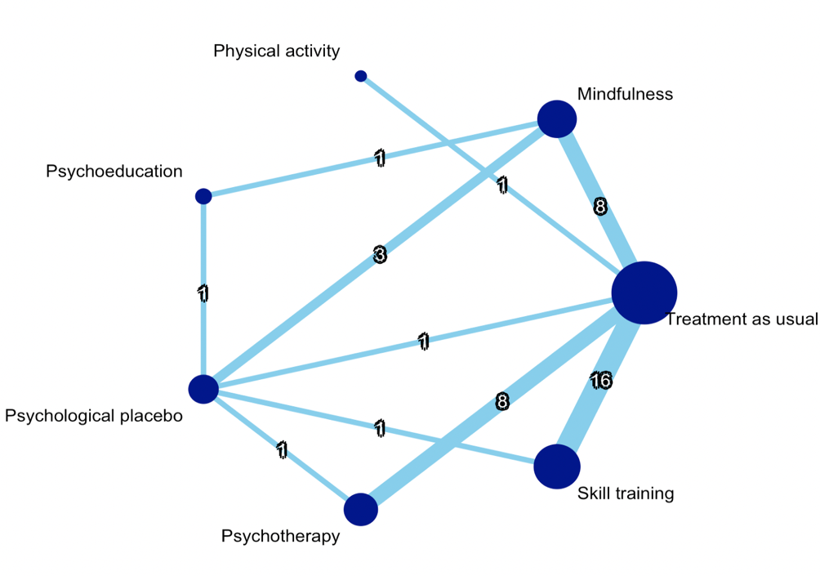 | 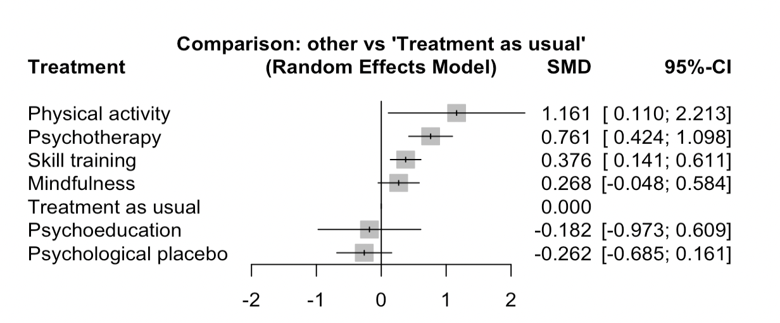

League table
Mindfulness | . | 0.948 [-0.240; 2.136] | 0.199 [-0.322; 0.719] | . | . | 0.330 [-0.008; 0.667]
-0.893 [-1.991; 0.205] | Physical activity | . | . | . | . | 1.161 [ 0.110; 2.213]
0.450 [-0.313; 1.214] | 1.343 [ 0.027; 2.659] | Psychoeducation | 0.366 [-0.534; 1.266] | . | . | .
0.530 [ 0.120; 0.941] | 1.423 [ 0.290; 2.556] | 0.080 [-0.653; 0.813] | Psychological placebo | -1.616 [-2.550; -0.682] | -0.686 [-1.586; 0.214] | -0.215 [-1.083; 0.653]
-0.493 [-0.939; -0.046] | 0.400 [-0.704; 1.504] | -0.943 [-1.783; -0.103] | -1.023 [-1.520; -0.526] | Psychotherapy | . | 0.675 [ 0.319; 1.030]
-0.108 [-0.492; 0.277] | 0.785 [-0.292; 1.863] | -0.558 [-1.372; 0.256] | -0.638 [-1.096; -0.180] | 0.385 [-0.022; 0.792] | Skill training | 0.372 [ 0.131; 0.614]

Only studies using immediate post assessment
Network plot and forest plot：
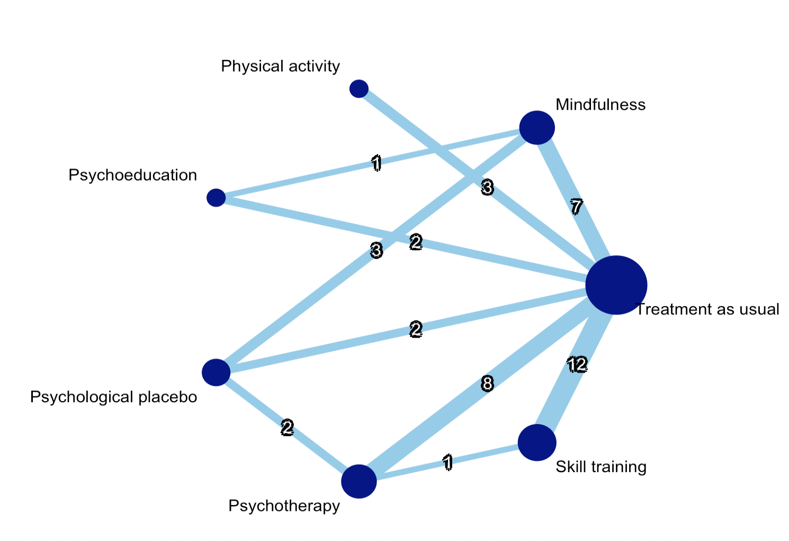 | 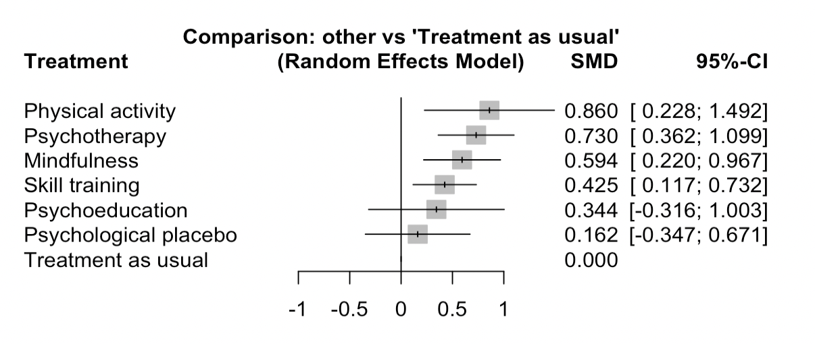

League table
Mindfulness | . | 0.948 [-0.347; 2.243] | 0.199 [-0.400; 0.799] | . | . | 0.579 [ 0.167; 0.990]
-0.266 [-1.001; 0.468] | Physical activity | . | . | . | . | 0.860 [ 0.228; 1.492]
0.250 [-0.460; 0.960] | 0.516 [-0.397; 1.430] | Psychoeducation | . | . | . | 0.582 [-0.174; 1.337]
0.432 [-0.067; 0.931] | 0.698 [-0.113; 1.510] | 0.182 [-0.628; 0.992] | Psychological placebo | -0.838 [-1.650; -0.025] | . | 0.192 [-0.607; 0.991]
-0.137 [-0.637; 0.363] | 0.130 [-0.602; 0.861] | -0.387 [-1.138; 0.365] | -0.569 [-1.123; -0.014] | Psychotherapy | 0.577 [-0.583; 1.738] | 0.598 [ 0.189; 1.007]
0.169 [-0.313; 0.651] | 0.435 [-0.267; 1.138] | -0.081 [-0.808; 0.647] | -0.263 [-0.853; 0.327] | 0.306 [-0.154; 0.766] | Skill training | 0.445 [ 0.127; 0.763]
0.594 [ 0.220; 0.967] | 0.860 [ 0.228; 1.492] | 0.344 [-0.316; 1.003] | 0.162 [-0.347; 0.671] | 0.730 [ 0.362; 1.099] | 0.425 [ 0.117; 0.732] | Treatment as usual

