Supplementary figures of link-node map of the case study
Fig. S1 Link-node map of Wang Hip BBN indicating probabilities of outcomes when no evidence is set.
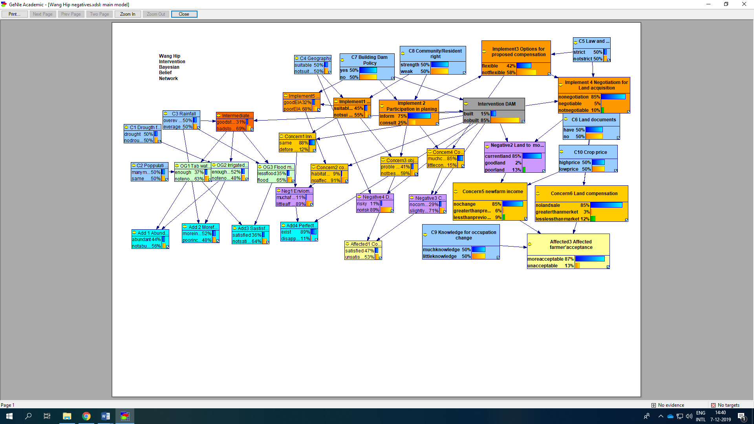
Fig. S2 Link-node map of Klong Klai BBN indicating probabilities of outcomes when no evidence is set.

