Spatial estimation of groundwater quality index, hydrogeochemical investigation and health impacts of shallow groundwater in Kabul city, Afghanistan

Sustainable Water Resources Management

^{1*}Mohammad Daud Hamidi, ²Stephen Kissane, ³Anna A. Bogush, ⁴Abdul Qayeum Karim, ⁵Janay Sagintayev, ³Sam Towers, ¹Chris H.C Greenwell
¹Department of Earth Sciences, Durham University, Durham, United Kingdom
²Landell Mills, Trowbridge, United Kingdom
³Centre for Agroecology, Water and Resilience (CAWR), Coventry University, Coventry, United Kingdom
⁴Civil Engineering Department, Kabul University, Kabul, Afghanistan.
⁵School of Engineering and Digital Sciences, Nazarbayev University, Nur-Sultan, Kazakhstan

*Corresponding author. E-mail: mohammad.d.hamidi@durham.ac.uk

Supplementary Material

Fig. A1 Precipitation projection (World Bank 2021).
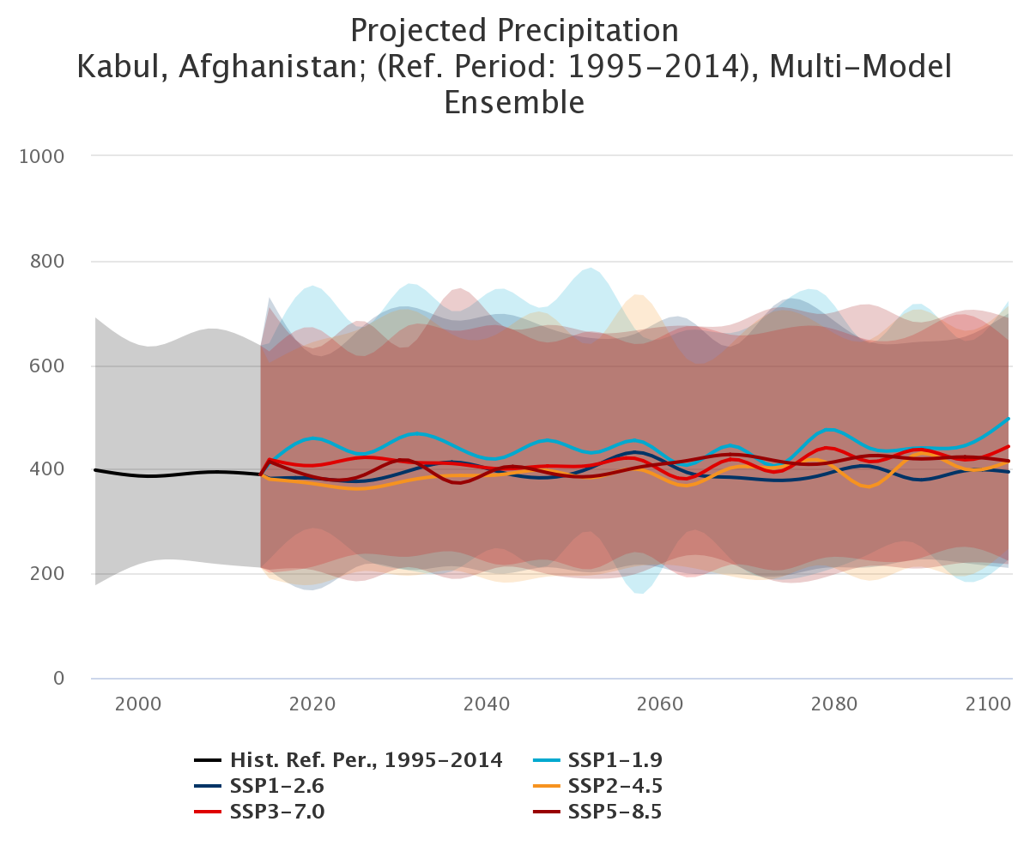

Fig. A2 Measured Nitrate level in the groundwater of Kabul city in 2007
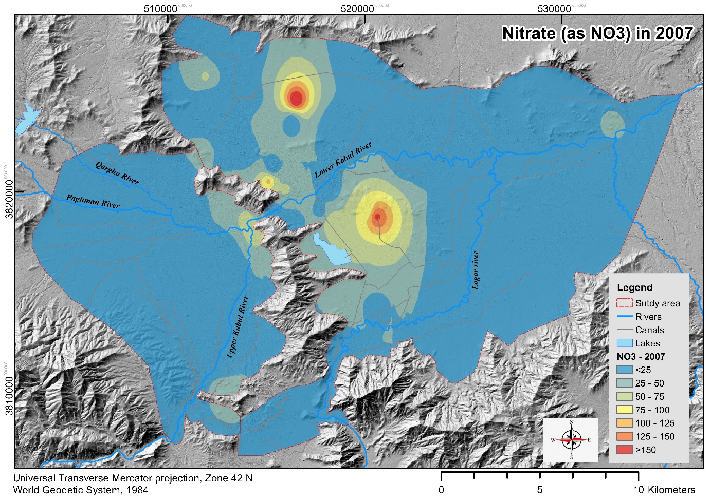

Fig. A3 Measured Nitrate level in the groundwater of Kabul city in 2020
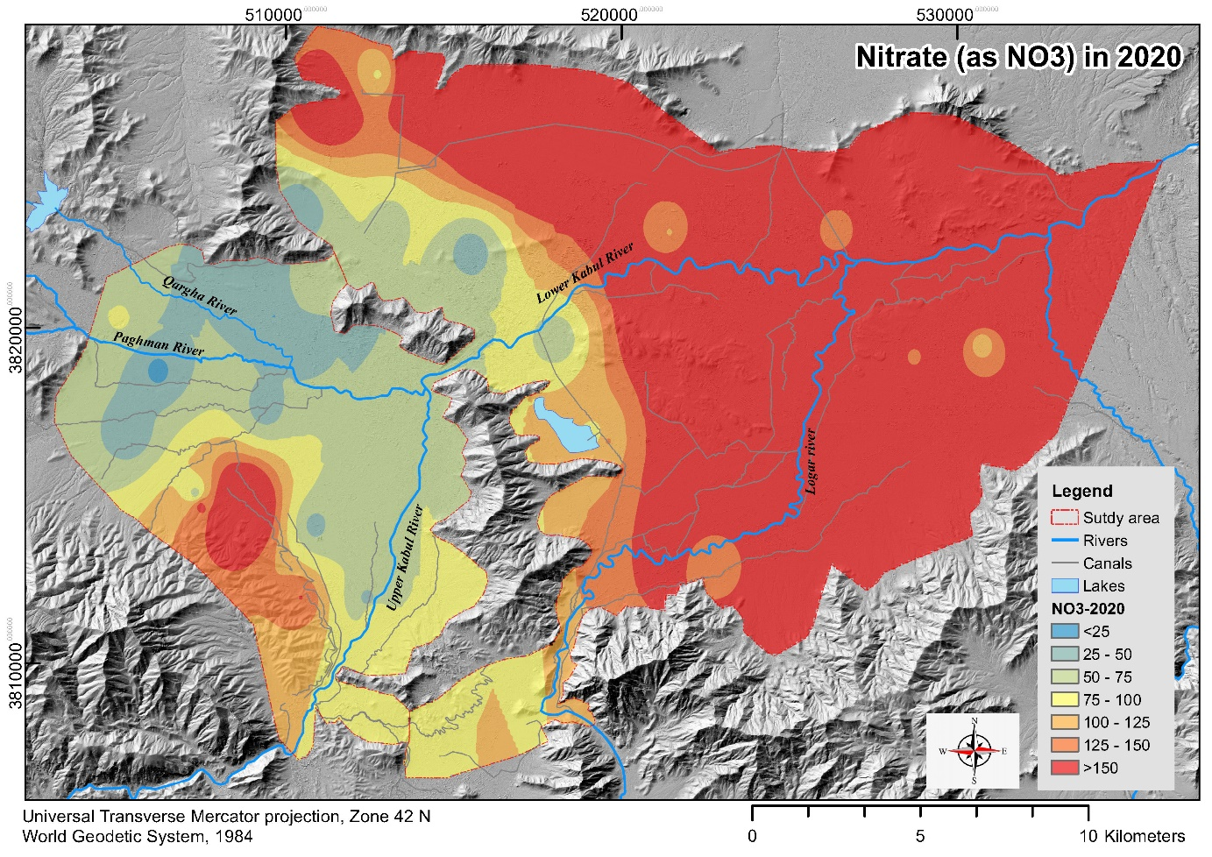

Fig. A4 Average E. coli prevalence in groundwater in 2007, from (Mack et al. 2010)

