Supplementary Information (SI)
Flood Frequency and Amplitude Analysis Under Changing Climate Scenarios in the Mono River Basin, West Africa

Djanna Koubodana Houteta^{1,2*}; Moustapha Tall³; Rodric M. Nonki⁴; Nilanchal Patel⁵; Mouhamadou B. Sylla⁶; Koffi Djaman⁷; Kossi Atchonouglo²; and Bruce Hewitson¹
¹Climate System Analysis Group, Department of Environmental and Geographical Science, University of Cape Town, Cape Town, South Africa;
²Faculty of Sciences, University of Lomé, 01P.O. Box 1515 Lomé, Togo;
³African Population and Health Research Center - West Africa Regional Office, Dakar, Senegal;
⁴Laboratory for Environmental and Atmospheric Physics (LEMAP), Department of Physics, Faculty of Sciences, University of Yaoundé 1, P.O. Box 812, Yaoundé, Cameroon;
⁵Department of Remote Sensing, Birla Institute of Technology Mesra, Ranchi - 835215, Jharkhand India
⁶ African Institute for Mathematical Sciences, Research and Innovation Centre (AIMS-RIC), Kigali, Rwanda
⁷Department of Plant and Environmental Sciences, Agricultural Science Center at Farmington, New Mexico State University, Farmington, NM, USA
* Correspondence author DKH: djanna.koubodanahouteta@uct.ac.za; koubo2014@gmail.com
ORCID: 0000-0001-9922-6496

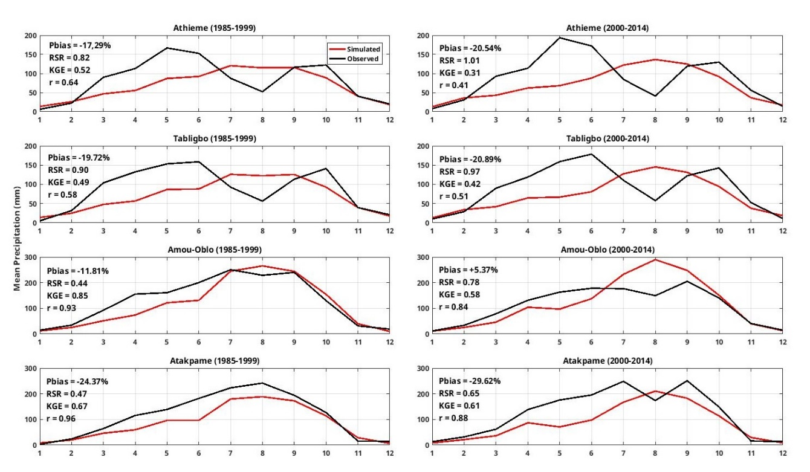
Figure SI1. Monthly mean ensemble CMIP6 model cross-validation with monthly mean observation using different statistics metrics

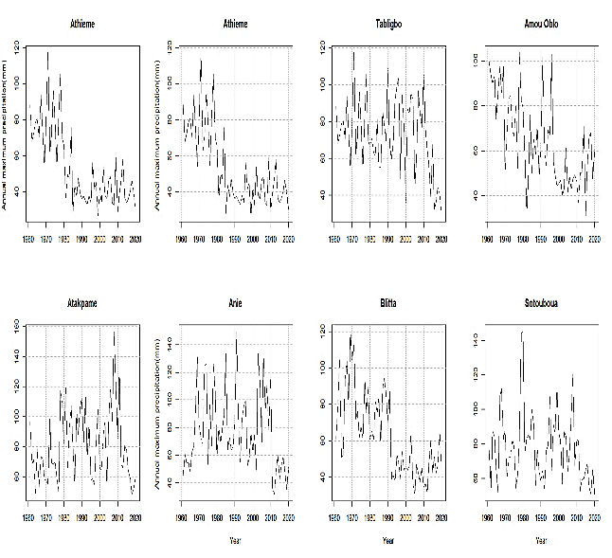 | 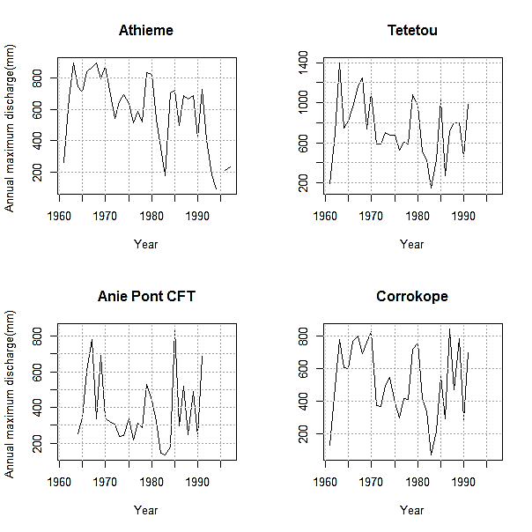

Figure SI2. Annual maximum precipitation (right) and Annual maximum discharge(left) time series

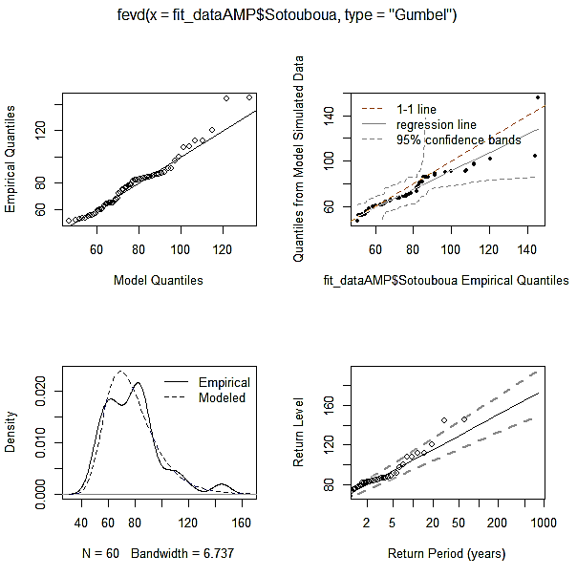 | 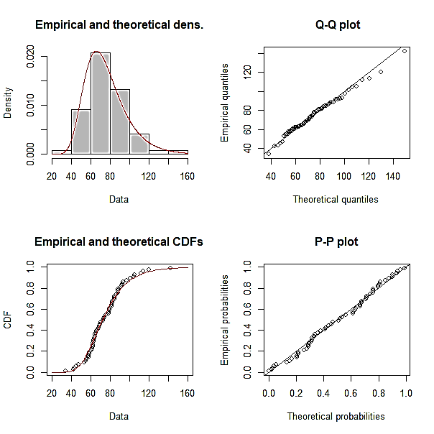

Figure SI3. Gumbel models QQ and PP plots(right) and estimated precipitation values (left)at Sokode
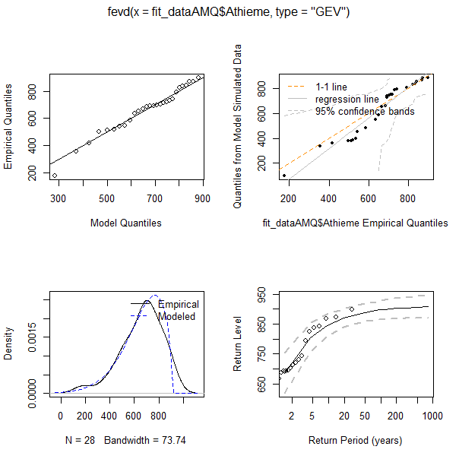 | 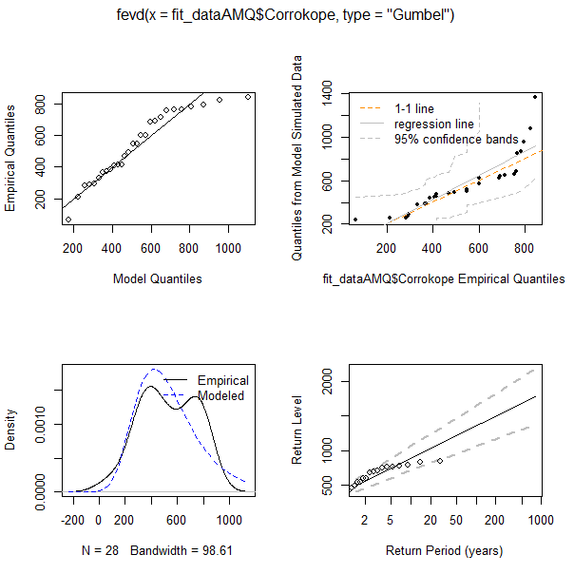
Figure SI4. Gumbel models estimated discharge values at Corrokope (right) and Athieme (left)

