Supplementary Information for Article: Reducing Breakdown Pressure and Recording Dynamic Fracture Growth Applying Cyclical Hydraulic Pressure Pulses in Bench Scale Analogue Shale (PMMA) Samples.

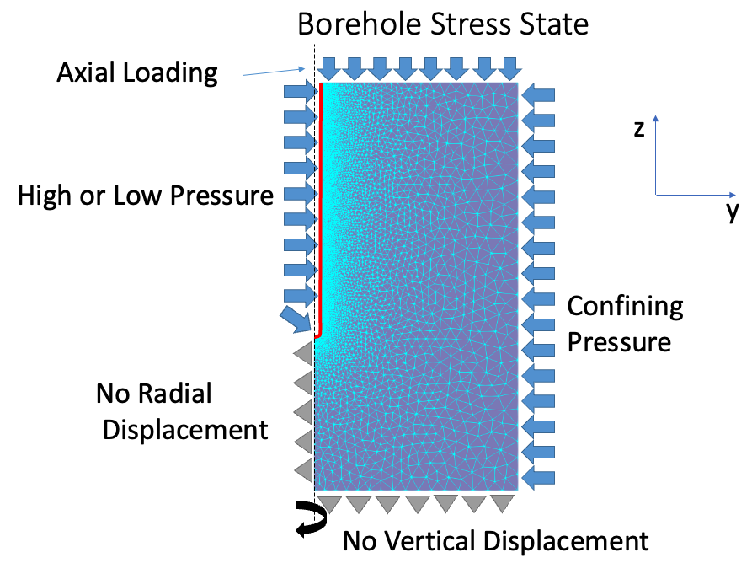
Figure 1: 2D axisymmetric mesh used to simulate the stress field inside the sample using OpenGeoSys software. The mesh is 200 mm high and 100 mm wide.
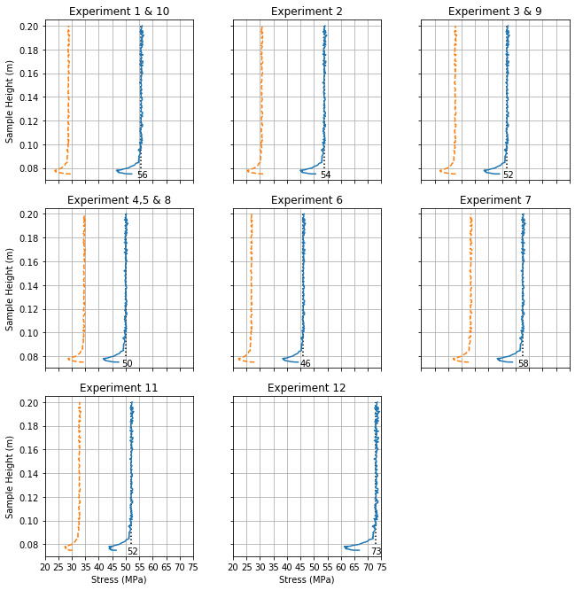
Figure 2: Unconfined un-heated simulations using OpenGeoSys. The results indicate the differential stress inside the borehole. The blue lines indicate the differential stress (σ1- σ3) at the borehole during the high-pressure part of the cycle. The orange dotted lines indicate the differential stress during the low-pressure part of the cycle. The median value of the maximum pressure rounded to the closest MPa is indicated as labelled vertical dotted line. Experiment 12 refers to experiment 0 in the paper and is a monotonic test, hence the minimum differential at the start of the experiment is not of interest for the purpose of determining fracture stress conditions.

