Supplementary Materials
Figure S1. Experiment design of visual fluid flow in the fractures during rock failure.
Figure S2. Increasing AE count, multilevel loading, and D_{f} of the flow geometry during rock failure.
Figure S3. Imaging data processing of fluid flow in the fractures during rock failure.
Figure S4. Black pixel mark, label, and count in CSOS-01 image as an example using MATLAB.
Figure S5. Mean square flow of fluid in the fractures during rock failure.
Figure S6. Relationships between D_{f} and multilevel peak loads (σ_{n}) during coal and rock failure under ML.
Figure S7. Fractional relationship between D_{f} /σ_{n} and σ_{n} of coal and rock specimens.
Table S1. Multilevel loading values of coal and rock specimens.
Movie S1 to S16. CSOS-01.avi, et al. can be found in the Supplementary files 2 to 17.
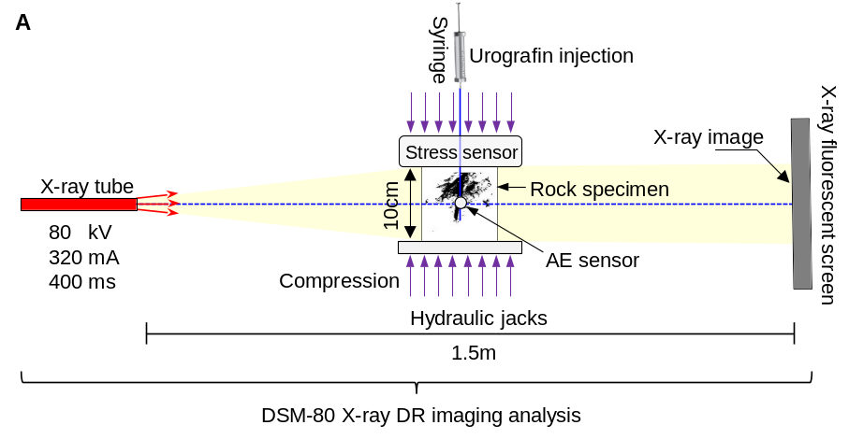
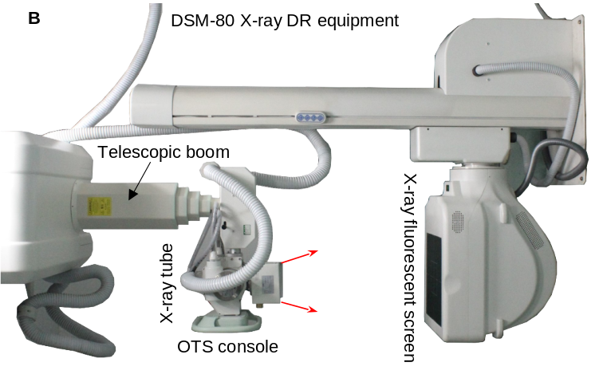
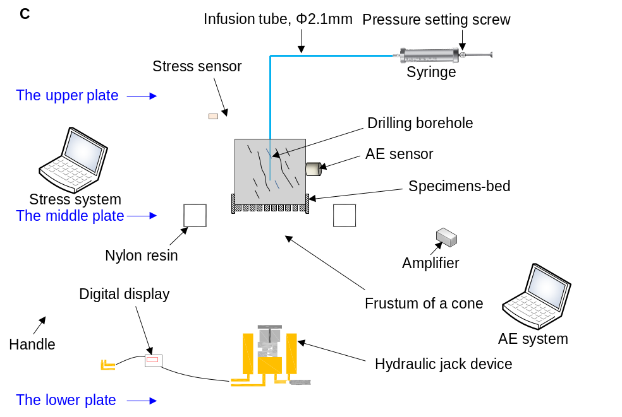
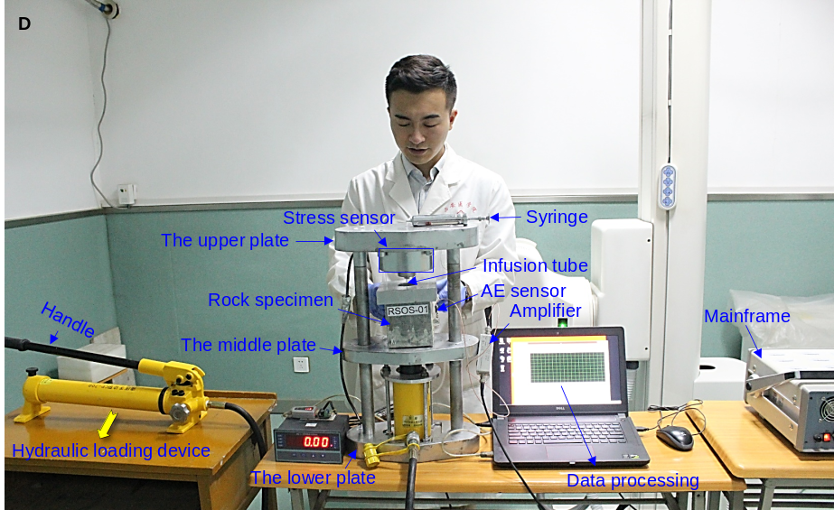
Figure S1. Experiment design of visual fluid flow in the fractures during rock failure. (A) The X-ray path and rock specimen lie in the horizontal plane. (B) The digital radiography (DR) equipment parameters of voltage, electric current, and loading time were set as 80 kV, 320 mA, and 400 ms, respectively. The distance between the X-ray tube and fluorescent screen was 1.5 m. (C) Uniaxial compression machine (UDCM) developed by independent design, which matches the X-ray DR system and AE testing system of rock failure. Design of rock uniaxial compression device with ML. A contrast agent was injected into the pre-borehole of each rock specimen under compression induced by hydraulic jacks. (D) The uniaxial compression machine (UDCM) matched the X-ray DR system and AE testing system.
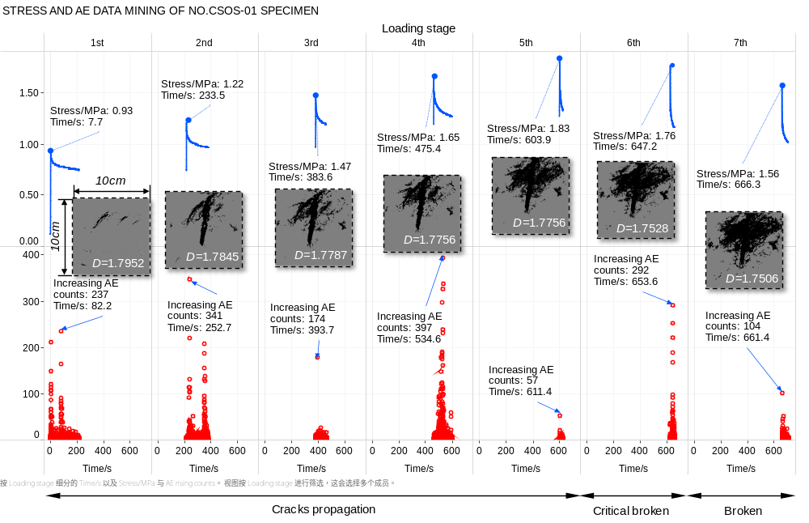
Figure S2. Increasing AE count, compression loading, and D_{f} of the flow geometry during rock failure.
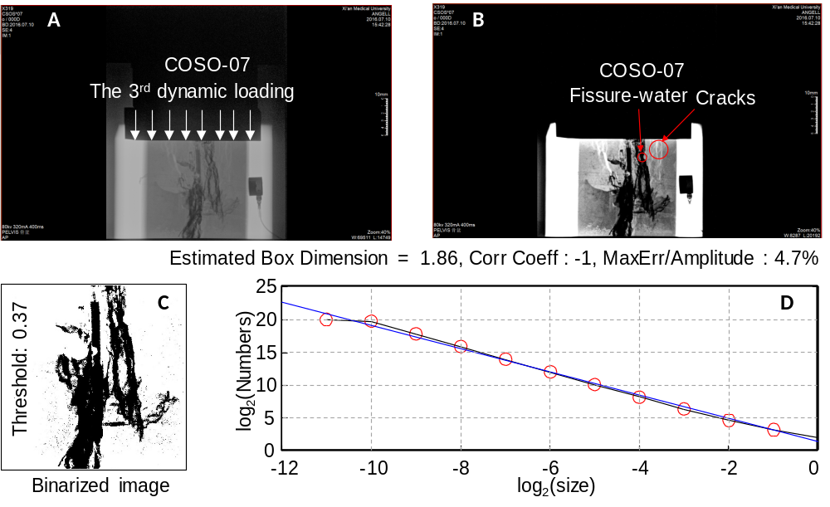
Figure S3. Imaging data processing of fluid flow during rock failure. (A) Original image in DR post-processing system. (B) Enhanced image in DR post-processing system. (C) Binary image with MATLAB processing. (D) log₂(N)-log₂(size) curves of box dimensions obtained by analysing binary images of the fluid flow.
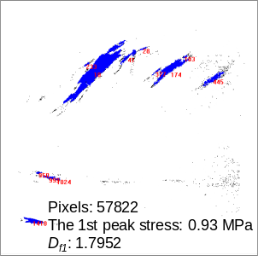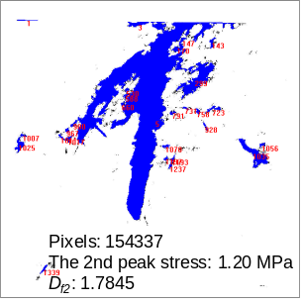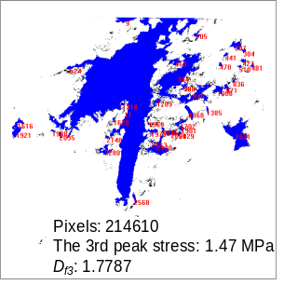
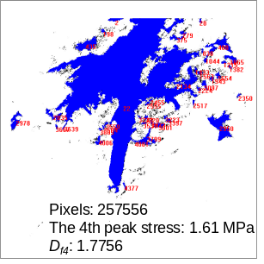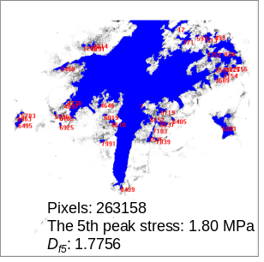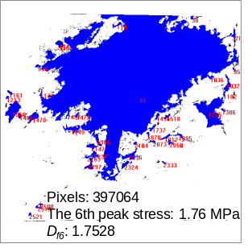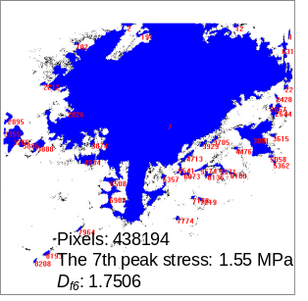
Figure S4. Black pixel mark, label, and count in CSOS-01 image as an example using MATLAB
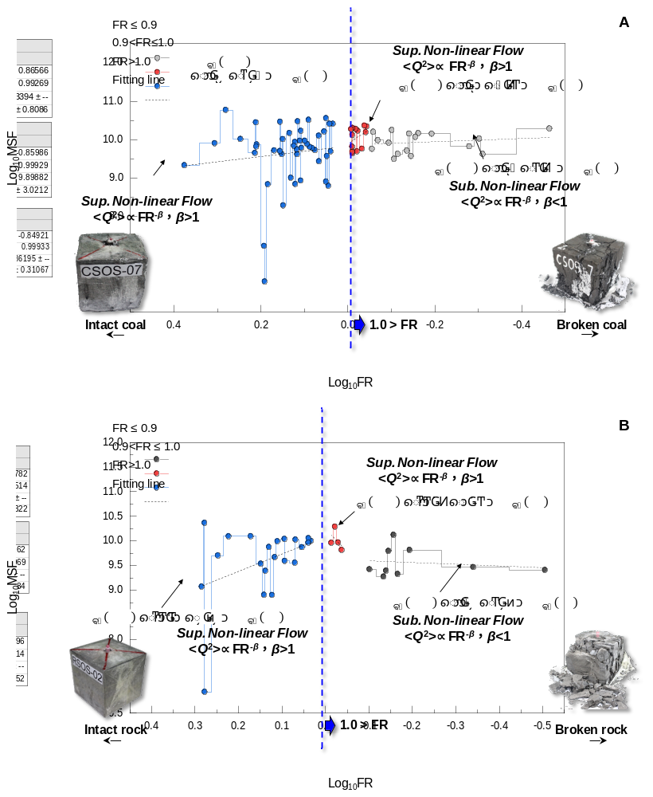
Figure S5. Mean square flow of fluid in the fractures during rock failure. (A) Coal failure. (B) Rock failure.
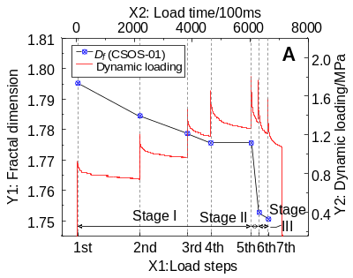 | 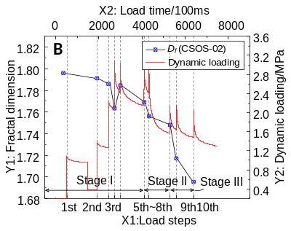 | 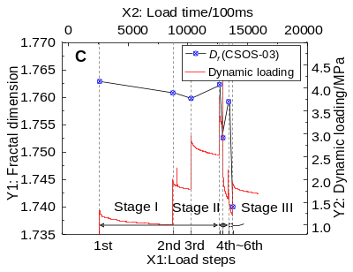
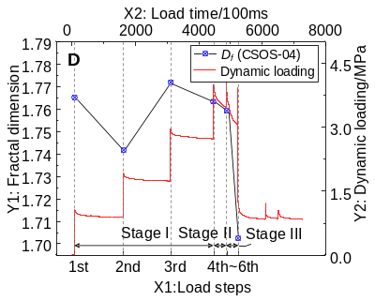 | 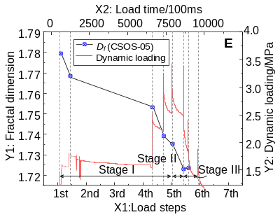 | 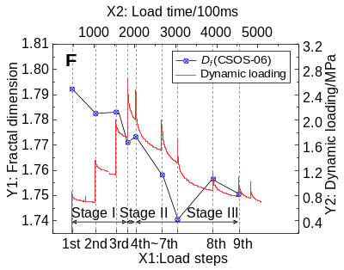
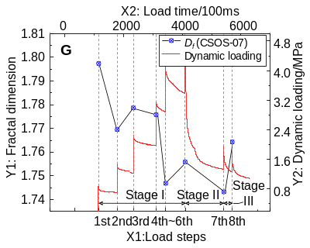 | 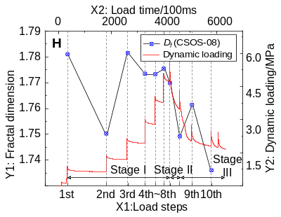 | 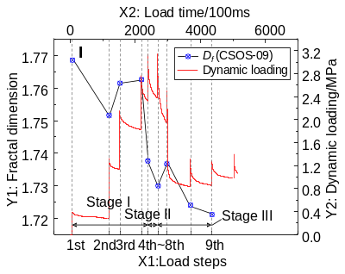
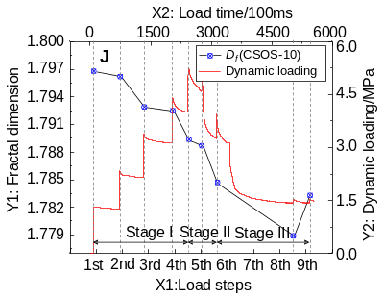 | 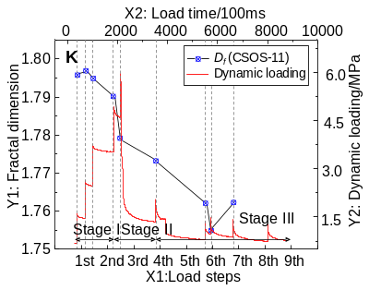 | 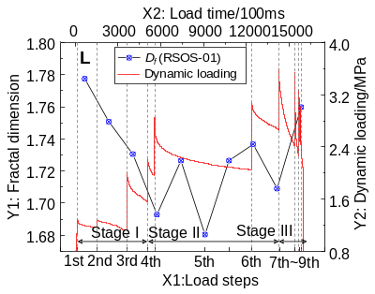
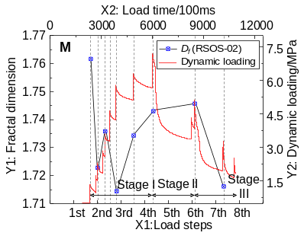 | 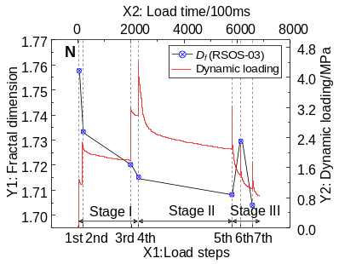 | 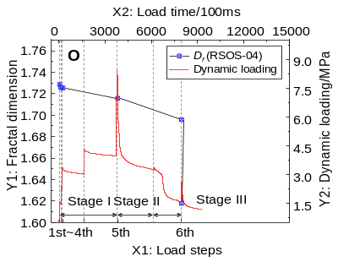
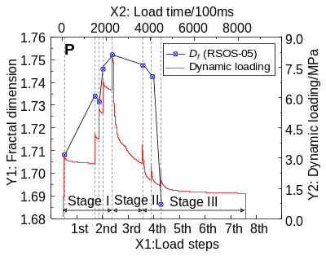 | Figure S6. Relationships between D_{f} and peak loads (σ_{n}) during coal and rock failure under ML. (A-K) CSOS-01 to CSOS-11. (L-P) RSOS-01 to RSOS-05.

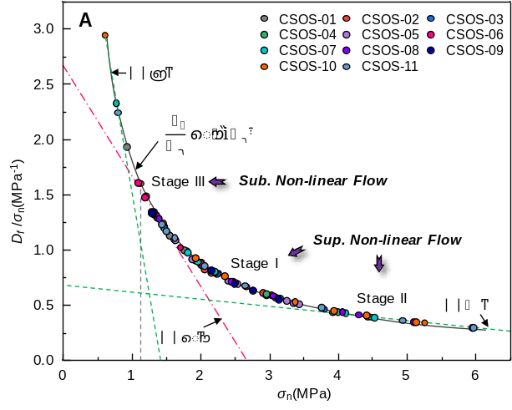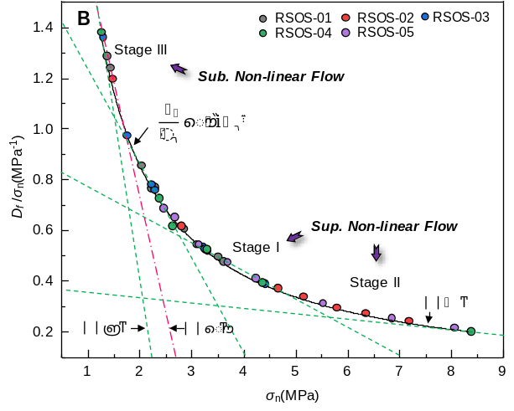
Figure S7. Fractional relationship between D_{f} /σ_{n} and σ_{n} of coal and rock specimens. (A) Coal specimens. (B) Rock specimens.

Table S1. Each compression loading values of coal and rock specimens.
Numbers | The value of each compression loading/MPa
Numbers | 1st | 2nd | 3rd | 4th | 5th | 6th | 7th | 8th | 9th | 10th
RSOS-01 | 1.43 | 1.36 | 2.02 | 2.21 | 2.85 | 3.08 | 3.61 | 3.50 | 3.27 | 2.28
RSOS-02 | 1.47 | 2.79 | 4.66 | 5.79 | 6.34 | 7.18 | 5.14 | 3.29 | N/A | N/A
RSOS-03 | 1.29 | 2.28 | 3.21 | 4.41 | 3.24 | 2.21 | 1.75 | N/A | N/A | N/A
RSOS-04 | 1.25 | 2.37 | 3.28 | 4.35 | 8.38 | 2.62 | N/A | N/A | N/A | N/A
RSOS-05 | 3.13 | 4.22 | 5.52 | 6.85 | 8.05 | 3.68 | 2.67 | 2.45 | N/A | N/A
CSOS-01 | 0.93 | 1.20 | 1.47 | 1.61 | 1.80 | 1.76 | 1.55 | N/A | N/A | N/A
CSOS-02 | 1.12 | 1.39 | 2.26 | 3.08 | 3.03 | 2.91 | 3.12 | 2.15 | 2.16 | 2.05
CSOS-03 | 2.01 | 2.24 | 2.96 | 3.80 | 4.43 | 2.21 | 2.01 | N/A | N/A | N/A
CSOS-04 | 1.37 | 1.93 | 2.95 | 3.99 | 4.48 | 3.92 | N/A | N/A | N/A | N/A
CSOS-05 | 1.63 | 2.54 | 3.25 | 3.43 | 3.35 | 2.40 | 1.88 | N/A | N/A | N/A
CSOS-06 | 0.77 | 1.36 | 2.01 | 2.66 | 2.47 | 1.99 | 1.70 | 1.19 | 1.09 | N/A
CSOS-07 | 0.77 | 1.47 | 2.20 | 3.15 | 4.11 | 4.53 | 1.96 | 1.81 | N/A | N/A
CSOS-08 | 1.39 | 2.16 | 3.05 | 4.06 | 5.10 | 5.95 | 4.3 | 2.76 | 2.50 | 2.44
CSOS-09 | 1.32 | 2.15 | 2.76 | 3.13 | 3.14 | 2.49 | 1.31 | 1.28 | 1.29 | N/A
CSOS-10 | 0.61 | 1.45 | 2.35 | 3.37 | 4.41 | 5.25 | 5.13 | 3.94 | 1.93 | N/A
CSOS-11 | 0.80 | 1.62 | 2.65 | 3.76 | 4.93 | 5.96 | 2.05 | 1.50 | 1.43 | N/A

