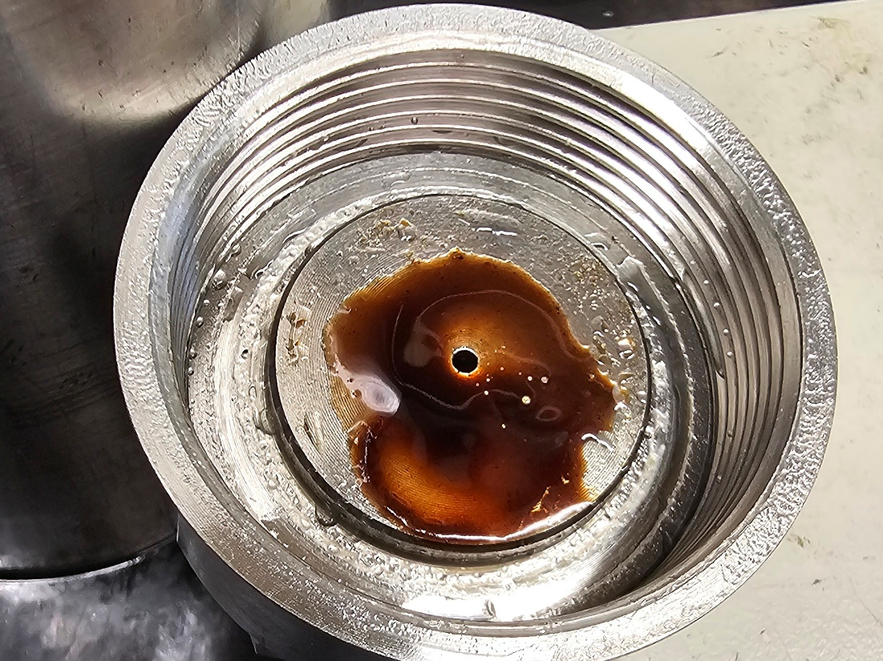
Figure S1. Hydrocarbon in the cap of the downstream separator after experiment Ent3-3 was completed.
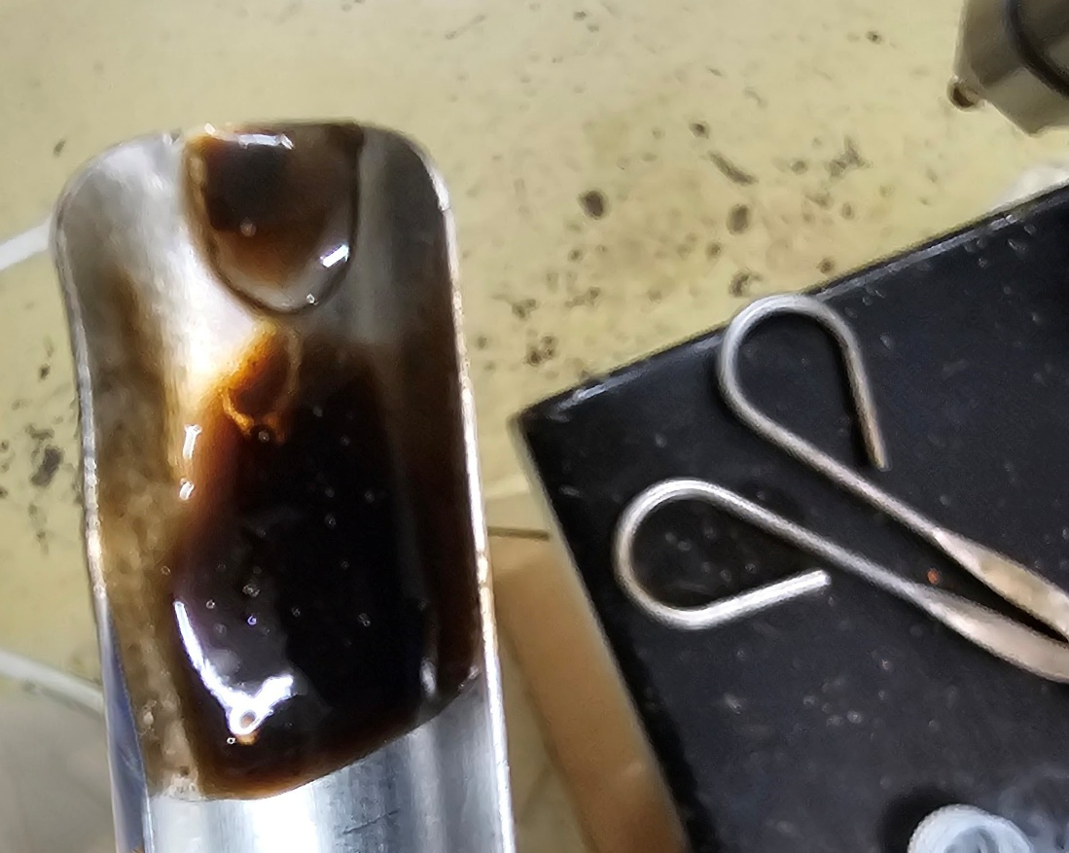
Figure S2. Hydrocarbon collected from the system after experiment Ent3-3 was completed.
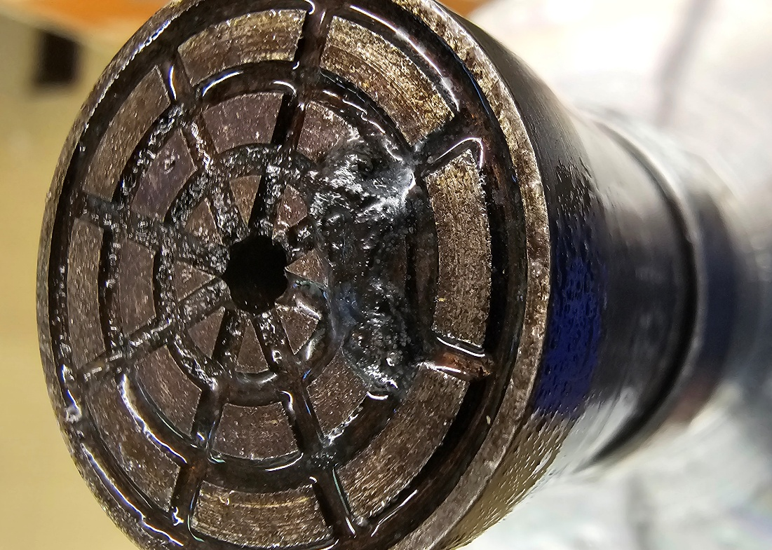
Figure S3. Hydrocarbon on the downstream flow piece of the triaxial pressure vessel after experiment Ent3-3 was completed.

