Introduction of the lowest printable (channel) characteristic length (LPCL) as a geometrical metric for the SLA 3D printing of embedded negative micro-structures
Dagoberto Torres-Alvarezª, Beatriz Bosques-Palomoª, Alejandra Martínez-Dibildoxª, Andrea Marcos-Abdalaª, Ricardo Jiménez-Nuñézª, José Rubén Morones-Ramírez^{b}, Mohammad Mahdi Aeinehvandª, Alan Aguirre-Sotoª*
- School of Engineering and Sciences, Tecnologico de Monterrey, Monterrey, N.L., 64849, México
- Facultad de Ciencias Químicas, Universidad Autónoma de Nuevo León, San Nicolás de los Garza, N.L., 66455, México
- Centro de Investigación en Biotecnología y Nanotecnología, Facultad de Ciencias Químicas, Universidad Autónoma de Nuevo León, Parque de Investigación e Innovación Tecnológica, Apodaca, N.L., 66628, México
*Corresponding author: alan.aguirre@tec.mx

Supplemental Information
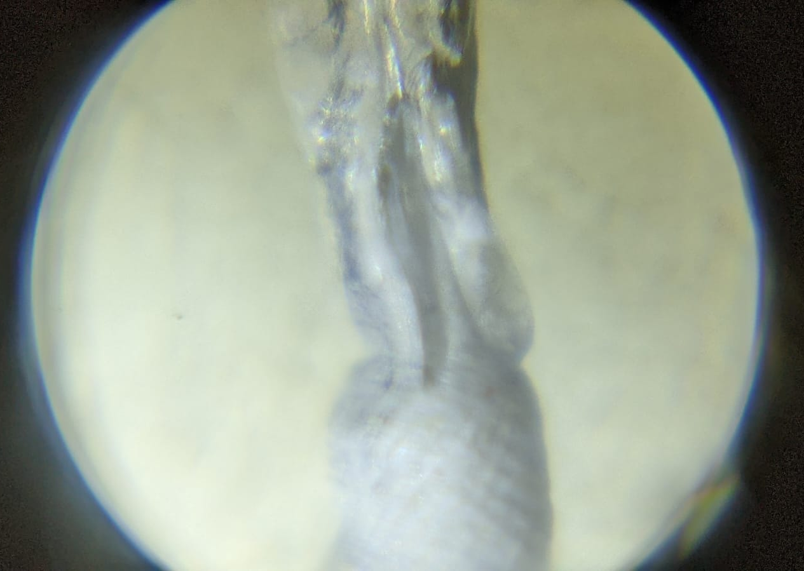
Supplemental 1. Clogged cylindrical channel of 0.6 mm diameter printed at diagonal orientation
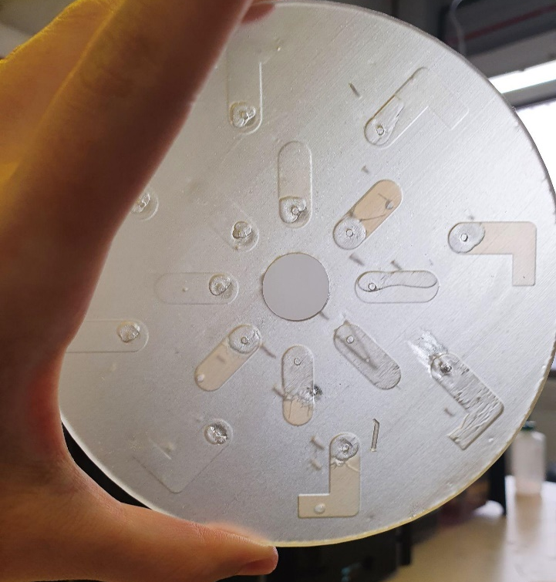
Supplemental 2. Disc printed at a 45° orientation regarding the y-axis and a disc thickness of 3 mm and a chamber height of 1 mm. None of the channels (0.2 mm width and 1.mm height) were printed, moreover, a low chamber printability was also observable, mainly due to collapsing of the walls.
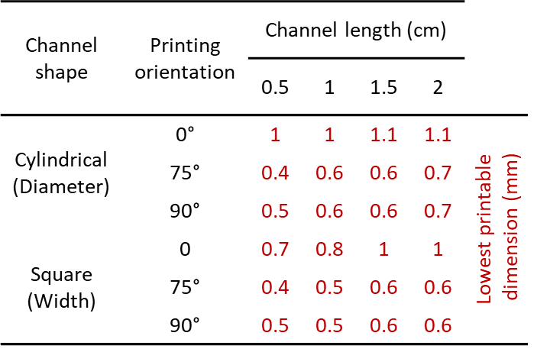
Supplemental 3. Straight embedded channels printed at different orientation regarding thett printing platform and channel length.
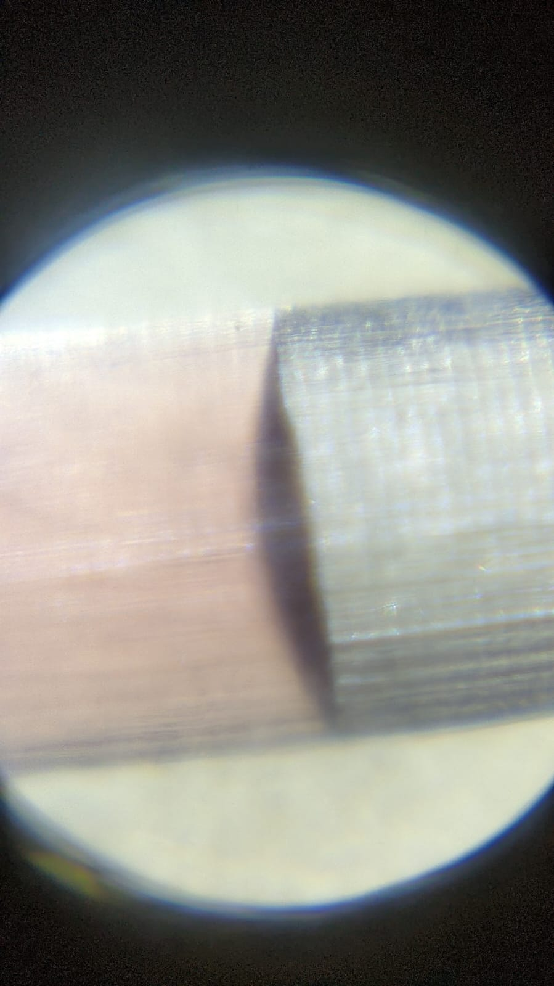
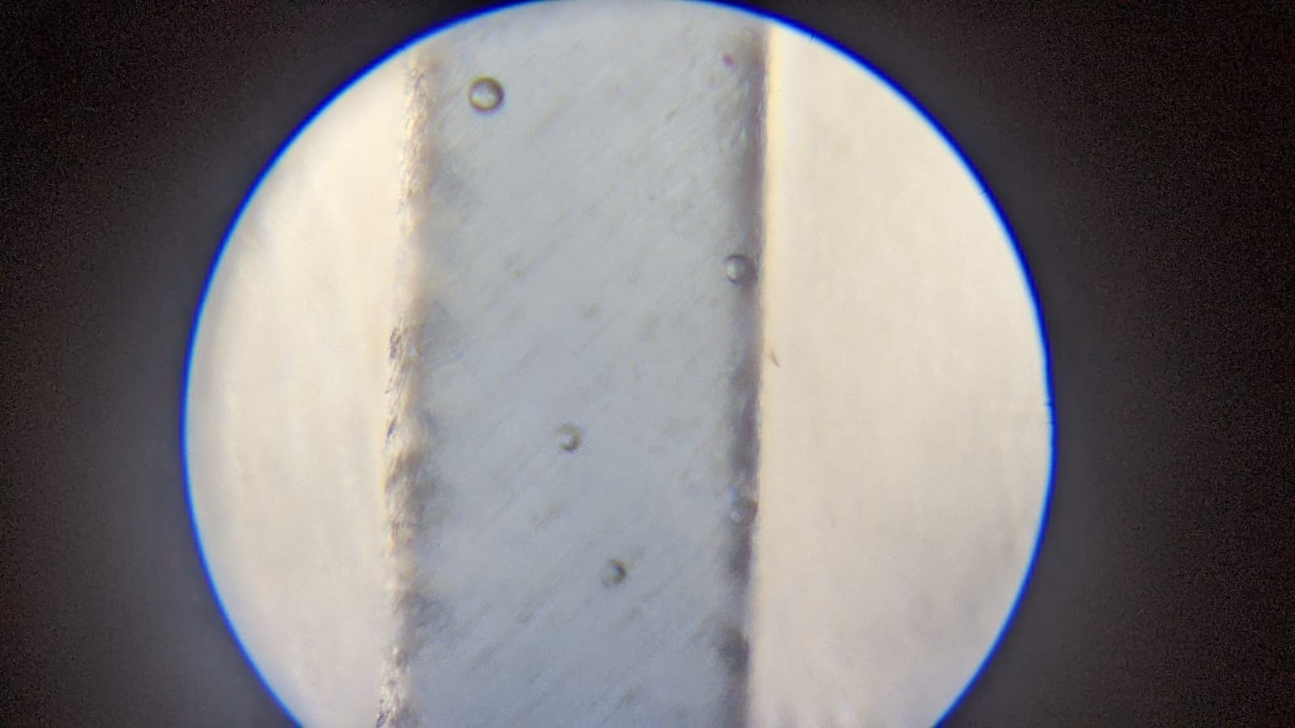
Supplemental 4. Channels observed in the microscope, length was measured and compared against the design set in the CAD software. a) Vertical 1.1 mm cylindrical channel, b) Diagonal 0.9 square channel.

(Video)
Supplemental 5. Video that shows the movement of methylene blue 0.75 mM when a 1000 rpm is applied for 10 seconds.

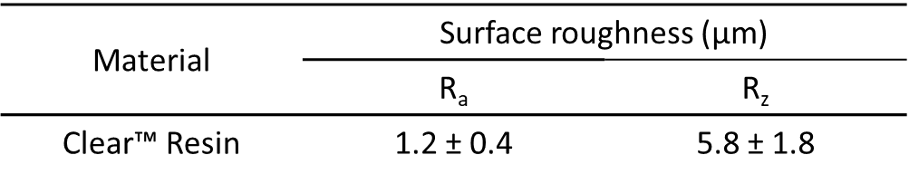
Supplemental 6. Surface roughness and contact angle preliminary values obtained in a flat object printed in Clear™ Resin. Surface roughness value were obtained following the same process in methodology.

Supplemental 7. Transmittance plot in the visible range of the different discs. NT (No Treatment), P (Polished), C (Coated), C+P (Coated and Polished)

