Supporting Information

S1. Placement of thermocouple during printing of DCB specimens, showing Kapton tape positioned outside the interlayer bonding region

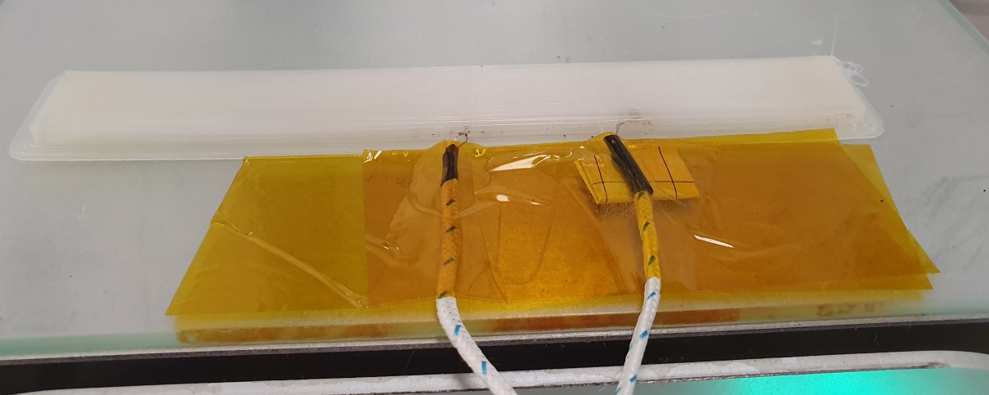

S2. GPC molecular weight distribution traces of PA12 grades and PA12 blend

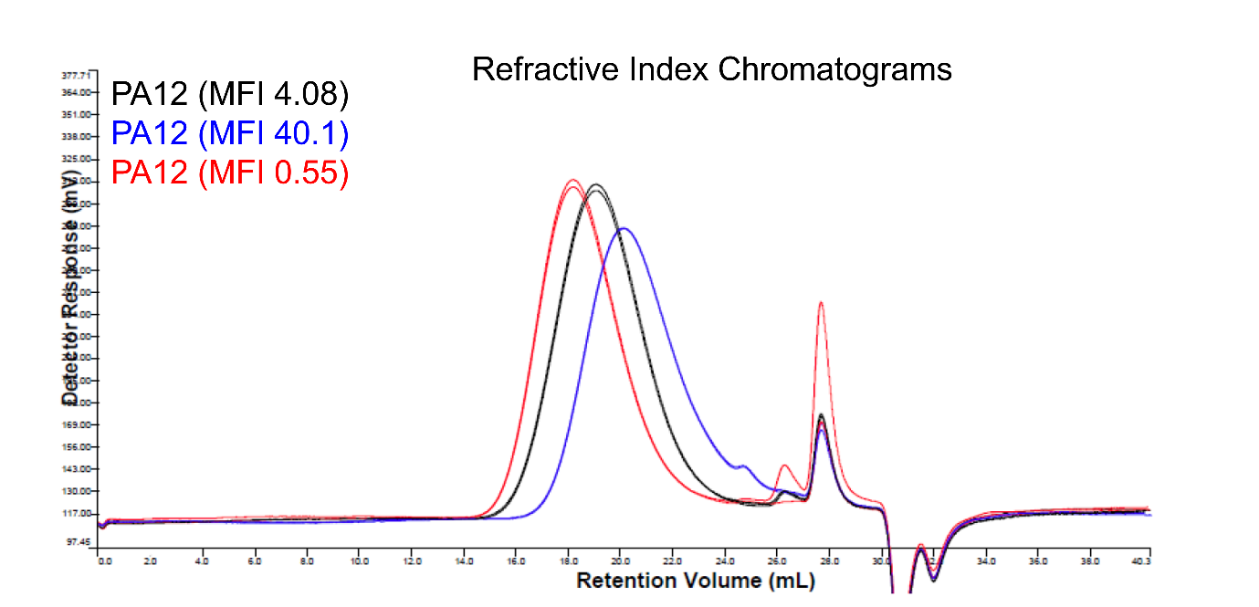
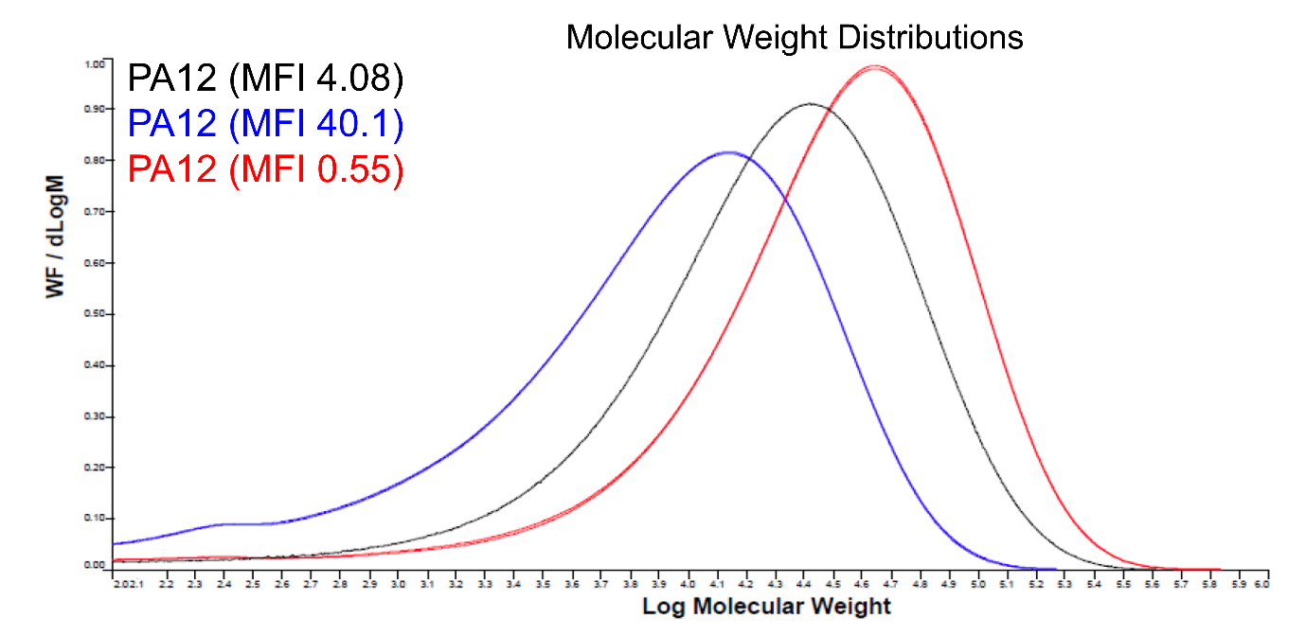
Figure S2.1 GPC derived MWD traces for the investigated PA12 grades (overlay; normalized by area)

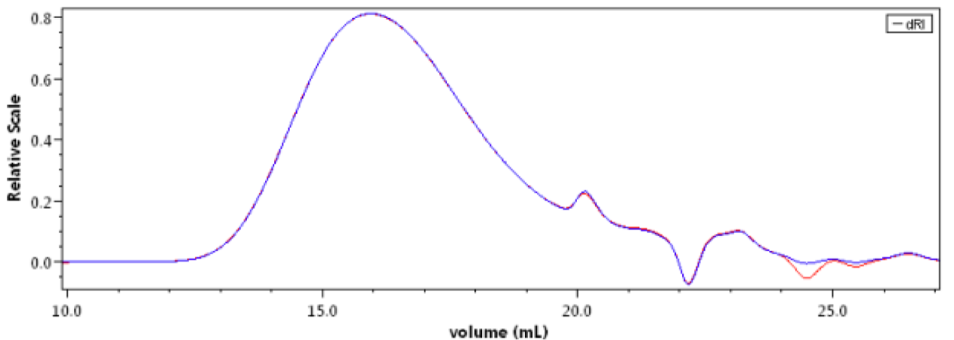
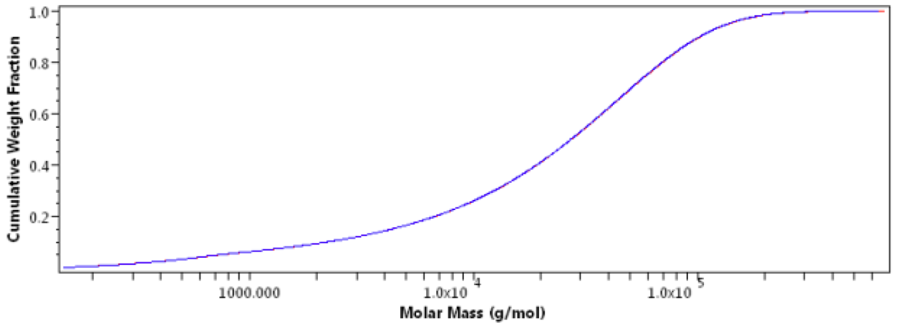
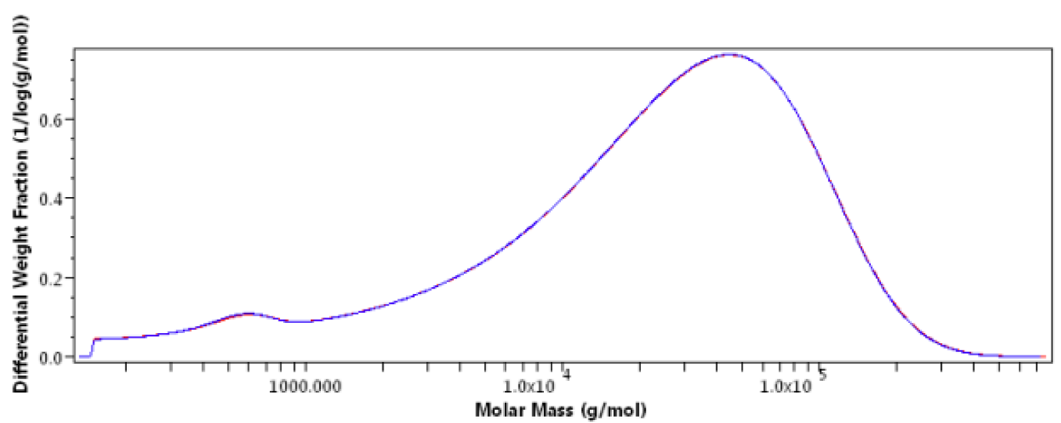
Figure S2.2 GPC results for the PA12 blend, showing the chromatogram, cumulative weight fraction distribution and differential MWD

S2.3 Estimation of weight fraction of chains above the entanglement molecular weight (M_{e}) for PA12 blend
For PA12 blend,
M_{e} = ~2000 g/mol (The M_{e} of PA12 has been reported to be on the order of ~2kDa in the literature [1, 2]. This value was used as the reference threshold for estimating w(M > M_{e}).
From Figure S10.2 (cumulative curve), the cumulative weight fraction at M_{e} is,
F(M_{e}) ~ 0.03 to 0.05
Therefore, the weight fraction above M_{e} is:
w(M > M_{e}) = 1 ‒ F(M_{e}) ~ 0.95 to 0.97
i.e., approximately 95–97 wt% of the PA12 blend is above M_{e} on a weight basis.

S3. DSC scans
Figure S3.1 DSC curves of PA12 (MFI 40.1), PA12 (MFI 4.08) and PA12 (MFI 0.55) for 210, 230 and 250 °C print temperatures (y-axis adjusted for visibility)

Figure S3.2 DSC curves of PA12 blended filament compared with components of blend PA12 (MFI 40.1) and PA12 (MFI 0.55)

Table S3.1 Summary of DSC results along with calculated crystallinity values

 | T_{m} (°C) | T_{g} (°C) | Crystallinity (%)
PA12 (MFI 40.1) | 179.4 | 40.4 | 31.8
PA12 (MFI 4.08) | 178.4 | 51.9 | 24.8
PA12 (MFI 0.55) | 178.0 | 41.5 | 22.1
PA12 (Blend) | 180.0 | - | 26.0

S4. Type I tensile testing specimens printed in transverse (90° raster angle) direction

S5. Type I tensile testing specimens printed in longitudinal (0° raster angle) direction

S6. a) Photographs of fracture surfaces of 3D printed all PA12 in 0° raster angles

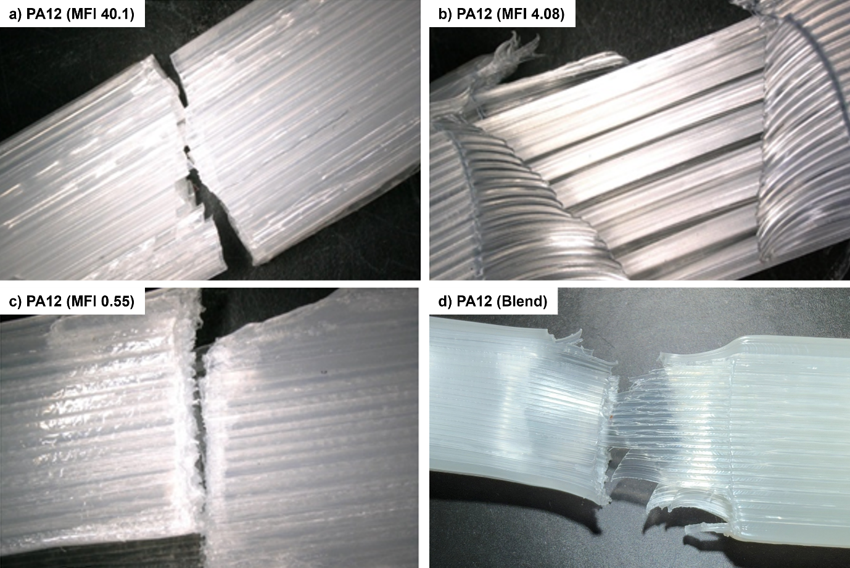

b) Photographs of fracture surfaces of 3D printed all PA12 in 90° raster angles
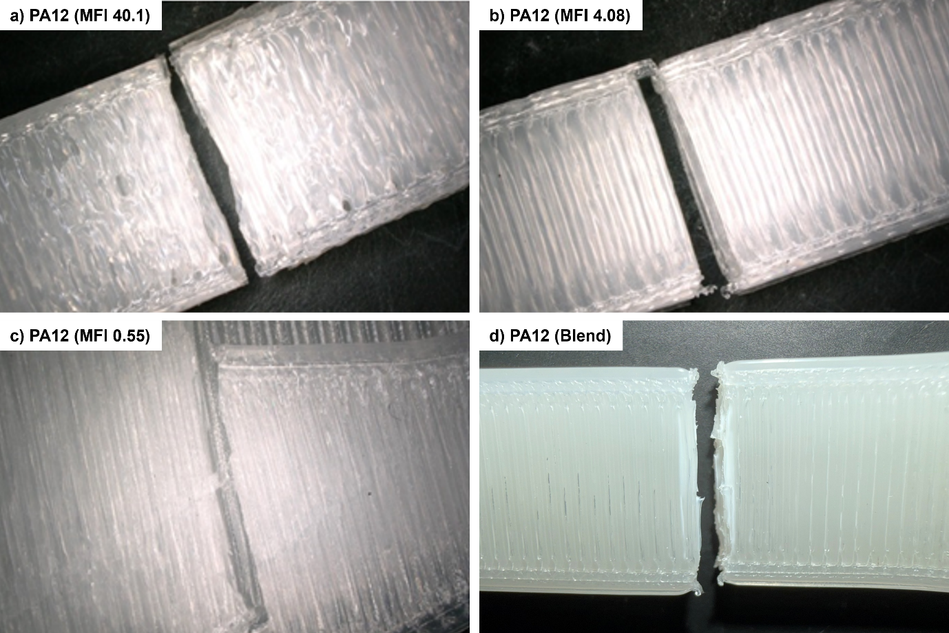
S7. Crack propagation behavior and fracture analysis

Crack propagation behavior is a key determinant of fracture toughness (G_{1C}) and interlayer adhesion in 3D printed PA12 samples. To track and measure crack growth, a camera was fixed to the Instron during the fracture toughness test. For the samples printed at 210 °C, PA12 (MFI 40.1) had greater arm displacement than the other grades, exhibited greater plastic deformation, indicating better energy absorption before failure. In addition, both PA12 (MFI 4.08) and PA12 (MFI 0.55) in Figures S7.1b and S7.1c had observable craze initiation occurring beyond the path of the crack, likely due to additional defect voids in the printed part because of printing at relatively low temperatures. PA12 (MFI 0.55) also appears to have a blunter crack tip compared to PA12 (MFI 40.1) and PA12 (MFI 4.08) which are sharper and is more indicative of a brittle material [3].
For samples printed at 250 °C (Figure S7.2), slip-stick behaviour appears in all samples to varying degrees. In addition, there is evidence of a progressed interlayer bond development with the appearance of drawn fibrillar bridges in the crack propagation region [4]. This suggests an increased proportion of polymeric chains have diffused through to develop the interlayer bond in these PA12 grades at higher print temperatures. In addition, there is a clear transition from brittle to ductile crack mechanisms in printed samples at 210 °C to 250 °C, indicating increased interlayer bonding lending its support to the validity of the initial G_{1C} values. This further supports the evidence that increasing print temperature further develops the interlayer bond and clarifies why fibrillation appeared in these samples and in none of the 210 °C printed samples. Furthermore, the appearance of voids ahead of the path of crack propagation is not obvious, likely due to reduction in defects because of reducing viscosity for all PA12 grades.

Figure S7.1 Crack propagation images of DCB samples printed at 210 °C at 50X magnification (a) PA12 (MFI 40.1) (b) PA12 (MFI 4.08) and (c) PA12 (MFI 0.55)
Figure S7.2 Crack propagation images of DCB samples printed at 250 °C at 50X magnification (a) PA12 (MFI 40.1) (b) PA12 (MFI 4.08) and (c) PA12 (MFI 0.55)

S8. Ratio of Tensile Strength in transverse to longitudinal Direction for PA12 Samples

PA12 Sample | Tensile Strength (MPa)  Transverse | Tensile Strength  (MPa)  Longitudinal | Tensile Strength Ratio  (Transverse / Longitudinal)
PA12 (MFI 40.1) | 38.21 ± 0.57 | 42.45 ± 0.52 | 0.90 ± 0.02
PA12 (MFI 4.08) | 41.75 ± 0.34 | 45.32 ± 0.29 | 0.92 ± 0.01
PA12 (MFI 0.55) | 42.63 ± 0.42 | 46.18 ± 0.31 | 0.92 ± 0.01
PA12 (Blend) | 43.18 ± 0.21 | 44.69 ± 1.14 | 0.97 ± 0.03

S9. Schematic of the DCB specimen used for Mode I fracture testing, showing 3 mm steel stiffening skins bonded to the specimen arms

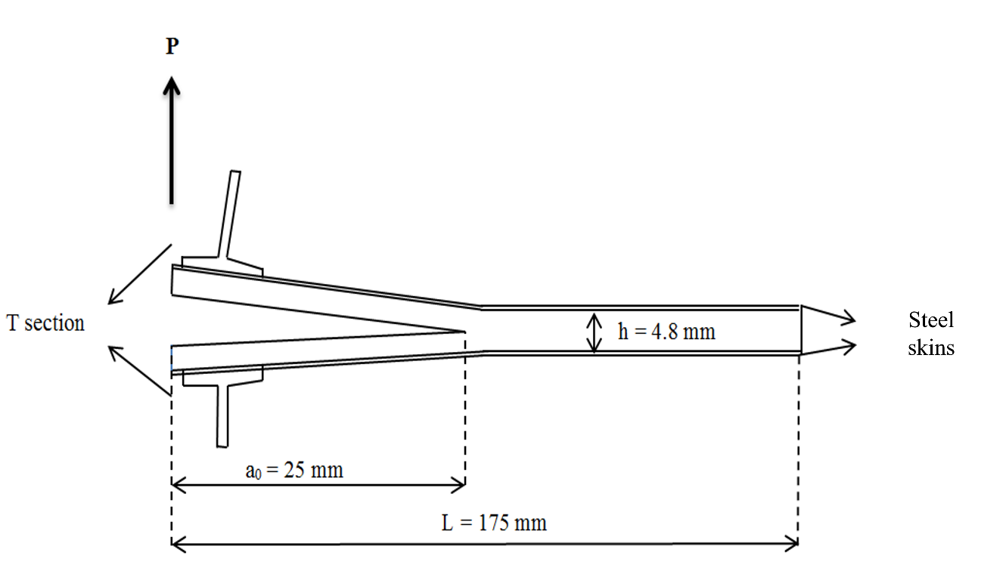

S10. Lumped Capacity Model and Thermocouples Data
S10.1 Lumped Capacity Model
$ρCAv \frac{dT}{dx}=A \frac{d(k\frac{dT}{dx})}{dx}-hP(T-T_{∞})$ (S10.1)
In order to model only in Phase 1, the starting temperature or the print temperature (e.g. T₀ = 250 °C) and T∞ is the melting point (180 °C). The distance of the deposited road relative to the origin is x with the origin located at the nozzle tip (mm) and time taken to reach x is t (seconds). Equation S10.2 is the analytical solution of the T value in Equation S10.1.
$T=T_{∞}+\left(T_{0}-T_{∞}\right)e^{-mx}$ (S10.2)
Where the m and x constants are calculated with Equations S10.3 and S10.4:
$m= \frac{\sqrt{1+4αβ}-1}{2α}$ (S10.3)
$x=vt$ (S10.4)
Constants α and β are calculated with Equation S10.5 and S10.6 below:
$α= \frac{k}{ρCv}$ (S10.5)
$β= \frac{hP}{ρCAv}$ (S10.6)
P and A constants are measurements of the perimeter and area of the cross section of each deposited layer using the CTan software. An average of 10 measurements were taken from each DCB grade and are shown in Table S10.1. The perimeter of the deposited rasters shows to increase with print temperature due to reduced viscosity as was observable in the MicroCT images. The value h is the thermal conductivity of the FDM nozzle taken as 140 W/m²K [5]. The terms k, C and v are thermal conductivity, specific heat capacity and velocity of the print head respectively (Table S10.2).
Table S10.1 Perimeter and area values of deposited roads taken from MicroCT cross sectional images
Grade | Print Temperature, T₀ (^{O}C) | Perimeter, P (mm) | Cross section area, A (mm²)
PA12 (MFI 40.1) | 250 | 1.50 | 1.14
PA12 (MFI 40.1) | 230 | 1.50 | 1.14
PA12 (MFI 40.1) | 210 | 1.15 | 0.13
PA12 (MFI 4.08) | 250 | 1.91 | 0.29
PA12 (MFI 4.08) | 230 | 1.95 | 0.27
PA12 (MFI 4.08) | 210 | 1.23 | 0.11
PA12 (MFI 0.55) | 250 | 1.32 | 0.11
PA12 (MFI 0.55) | 230 | 1.23 | 0.11
PA12 (MFI 0.55) | 210 | 1.17 | 0.10

Table S10.2 Constant values for Lumped Capacity Model

 | PA12 (MFI 40.1) | PA12 (MFI 4.08) | PA12 (MFI 0.55)
ρ (kg/m³) | 1010 | 1020 | 1030
v (m/s) | 0.015 | 0.015 | 0.008
h (W/m² K) | 140 | 140 | 140
k (W/m K) | 0.231 | 0.231 | 0.231
C (J/kg K) | 2100 | 2100 | 2100

S10.2 Bonding time variation between PA12 grades
To estimate the amount of time available for the interlayer bond to occur in PA12, the model is divided into two parts to represent the times when PA12 exists in its amorphous and semi-crystalline states (i.e., when it is above and below its melting point, respectively). This is done primarily because polymeric welding between these two states are completely different mechanisms. To simplify the modeling process for all PA12 grades, the amorphous and semicrystalline phases are set to occur between the selected print temperature, melting temperature (approximately 180 °C according to DSC scans) and the selected build plate temperature (set to 100 °C):
- Phase 1 (Amorphous state): between T₀ (initial print temperature) – 180 °C
- Phase 2 (Semicrystalline state): between 180 °C – 100 °C
Phase 1: Bonding time in the amorphous state – lumped capacity model
The lumped capacity model (S10.1) is utilized to estimate bonding time in phase 1 of the FDM printing process because the rate of cooling could not be accurately captured with the data acquisition devices due to time delay between the thermocouples and the DAQ device. The results of the LC model are shown in Figure S10.1a and S10.1b for both initial printing temperatures of 250 and 210 °C. It is clear that, PA12 grades printed at 250 °C retain their phase 1 configuration for much longer than samples printed at 210 °C (where PA12 grade could not retain this phase for more than 0.31 seconds) and this is corroborated by the initial G_{1C} results already discussed in the main manuscript.
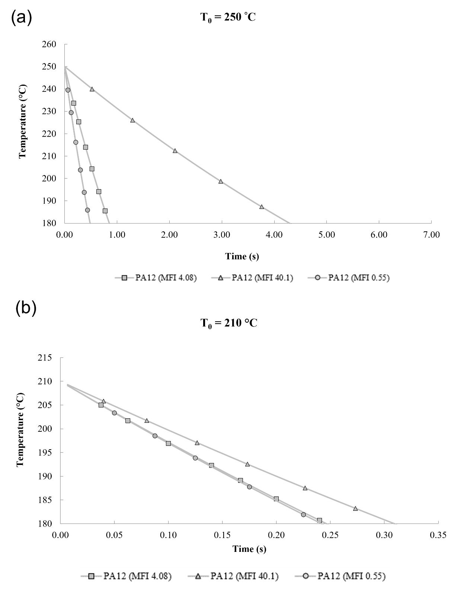
Figure S10.1 Lumped Capacity Model predictions of time-temperature relationship during FDM from extrusion temperature to melting temperature (180 °C) at (a) T₀ = 250 °C and (b) T₀ = 210 °C print temperature
Compared within each print temperature, PA12 (MFI 40.1) is able to remain above the melting point the longest, mainly due to its low viscosity, favourable to the LC model. Specifically, the LC model uses measured perimeter and cross section area of the rasters formed during the print which are combined in a constant designated β. Given that PA12 (MFI 40.1) had the highest melt flow, a greater volume of polymer was deposited into the raster configurations compared with lower melt flow PA12 (4.08) (printed at the same speed). Therefore, even when print speeds are identical, the increasing melt flow of the polymer results in higher heat retention due to a greater volume of deposited material as well as improved contact within the inter raster regions. This advantage also extended the bonding time more significantly for PA12 (MFI 40.1), which increased its bonding time from just over 0.3 s (at T₀ = 210 °C) to 4.3 s (at T₀ = 250 °C) (~1300 % improvement) whereas this increase was not as significant for PA12 (MFI 0.55) and PA12 (MFI 4.08) with improvements of 108% and 262% respectively.

Phase 2: Bonding time in the semi-crystalline state – thermocouples + DAQ
After the polymer cools below T_{m} but remains above the T_{g}, chain movement slows down, and crystallization begins, limiting further interlayer diffusion. Figure S10.2a and S10.2b show that the thermocouple registers a spike in the temperature signal following every nozzle passing over the thermocouple region showing an initial spike where material deposits directly over the thermocouple, followed by subsequent spikes in the additional layers. Due to response delays in the thermocouple, the temperature within the Phase 1 region cannot be captured, rather the temperature from the point at which the polymer goes below melting point is recorded, suitable for discussion of the Phase 2 period. The initial spike in the 15 mm/s could not be captured since the speed of the nozzle as well as the proximity between the build plate and nozzle effectively knocked the thermocouple slightly from position.
Thermocouple measurements confirmed that PA12 (MFI 40.1) retained higher temperatures for longer durations compared to PA12 (MFI 0.55) and PA12 (MFI 4.08), aligning with the Lumped Capacity Model predictions. The graphs show that regardless of print speed, this does not significantly change the temperature profiles when the polymers are below T_{m}. While the subsequent spikes in temperature may assist with thermal annealing of crystalline structures, according to the DSC scans (S3), there was no significant difference in the overall crystallinity levels of the printed Mode 1 fracture toughness samples. Therefore, the variation between PA12 (MFI 0.55) printed at 8 mm/s and the PA12 grades printed at 15 mm/s does not significantly affect the interlayer development in terms of the thermal profiles above or below melting point.
The variation in bonding time directly impacted fracture toughness and tensile strength. Higher print temperatures (250 °C) significantly increase bonding time, leading to stronger interlayer bonds. PA12 (MFI 40.1) had the longest bonding time in the amorphous phase, enabling superior diffusion and interfacial welding. PA12 (MFI 40.1) exhibited the highest initial fracture toughness values (G_{1C} = 5757 J/m² at 250 °C), indicating better developed interlayer bonds. Shorter bonding time in PA12 (MFI 0.55) resulted in weaker interlayer adhesion, evident from its lower G_{1C} (3210 J/m² at 250 °C) and brittle fracture characteristics.

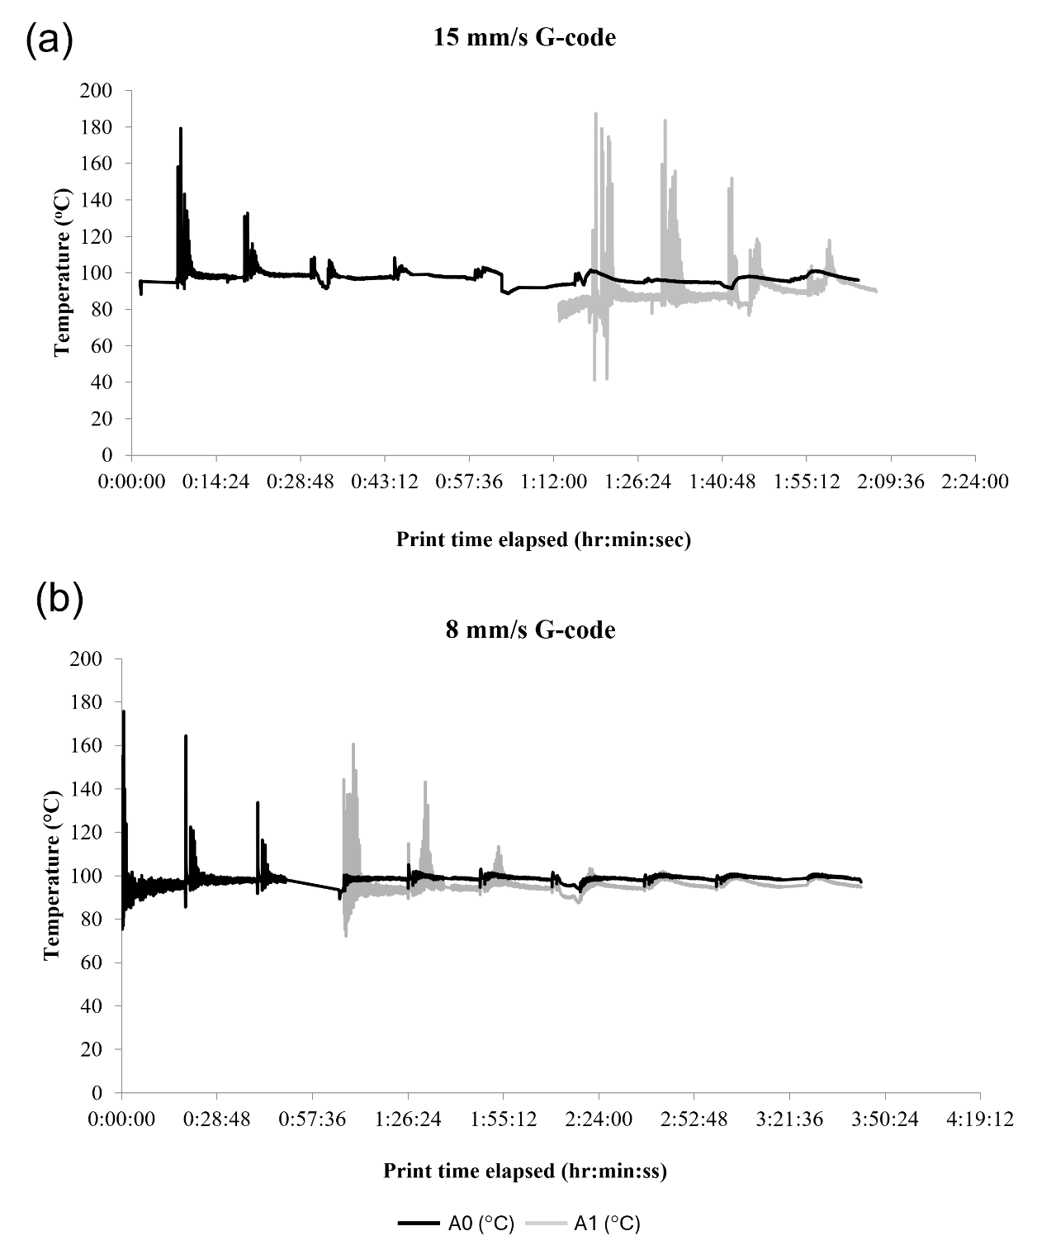
Figure S10.2 Thermocouple measurements of temperature over print time with A0 and A1 corresponding to thermocouples inserted at layers 1 and 4 respectively (a) PA12 (MFI 40.1), PA12 (MFI 4.08) (b) PA12 (MFI 0.55)

S11. Load vs Displacement plot for all PA12 used in this study

S12. ANOVA: relationship to start G_{1c}
S12.1 ANOVA for DCB fracture toughness testing
Source | Sum of Squares | df | Mean Square | F-value | p-value
A-Polydispersity | 5.47E+06 | 2 | 2.74E+06 | 0.737 | 0.4879
B-Print Temperature | 4.56E+07 | 2 | 2.28E+07 | 6.15 | 0.0065
AB | 1.86E+07 | 4 | 4.65E+06 | 1.25 | 0.3134
df – degree of freedom

S12.2 Raw ANOVA data for tensile testing
Run | A-Melt Flow Index (g/10min) | B-Layer Height (mm) | C-Build Orientation | Tensile Strength, MPa
1 | 4.08 | 0.3 | Long | 20.23
2 | 40.1 | 0.3 | Long | 36.45
3 | 0.55 | 0.3 | Trans | 8.320
4 | 0.55 | 0.4 | Trans | 14.95
5 | 4.08 | 0.4 | Long | 40.32
6 | 40.1 | 0.4 | Trans | 11.48
7 | 0.55 | 0.4 | Long | 41.06
8 | 0.55 | 0.3 | Long | 27.50
9 | 4.08 | 0.4 | Trans | 14.36
10 | 40.1 | 0.4 | Long | 36.16
11 | 4.08 | 0.3 | Trans | 36.22
12 | 40.1 | 0.3 | Trans | 19.22
13 | 4.08 | 0.4 | Long | 40.32
14 | 40.1 | 0.4 | Long | 28.22
15 | 40.1 | 0.3 | Trans | 14.88
16 | 0.55 | 0.3 | Long | 27.50
17 | 0.55 | 0.4 | Trans | 25.20
18 | 40.1 | 0.4 | Trans | 16.31
19 | 4.08 | 0.4 | Trans | 13.11
20 | 4.08 | 0.3 | Long | 18.85
21 | 0.55 | 0.3 | Trans | 10.10
22 | 40.1 | 0.3 | Long | 22.46
23 | 4.08 | 0.3 | Trans | 31.20
24 | 0.55 | 0.4 | Long | 40.91
(trans – transverse direction, long – longitudinal direction)

S12.3 Raw data for ANOVA analysis for mode-1 fracture toughness results
Run | A-Polydispersity | B-Print temperature (^{O}C) | start G_{1C} (J/m²)
1 | 5.2 | 230 | 1241
2 | 5.2 | 230 | 1367
3 | 5.2 | 210 | 15
4 | 5.2 | 250 | 5757
5 | 5.2 | 250 | 3722
6 | 5.2 | 230 | 1226
7 | 5.2 | 250 | 1979
8 | 5.2 | 210 | 12
9 | 5.2 | 250 | 5016
10 | 5.2 | 230 | 1364
11 | 5.2 | 210 | 35
12 | 5.2 | 230 | 1263
13 | 5.2 | 210 | 11
14 | 5.2 | 250 | 2175
15 | 6.3 | 210 | 598
16 | 6.3 | 250 | 1387
17 | 6.3 | 210 | 464.
18 | 6.3 | 230 | 1193
19 | 6.3 | 250 | 1143
20 | 6.3 | 230 | 4067
21 | 6.3 | 230 | 1111
22 | 6.3 | 250 | 2678
23 | 6.3 | 230 | 1541
24 | 6.3 | 230 | 11237
25 | 6.3 | 250 | 5063
26 | 6.8 | 210 | 64
27 | 6.8 | 230 | 1509
28 | 6.8 | 250 | 3961
29 | 6.8 | 210 | 98
30 | 6.8 | 230 | 1253
31 | 6.8 | 210 | 64
32 | 6.8 | 230 | 1000
33 | 6.8 | 250 | 2673
34 | 6.8 | 250 | 3210
35 | 6.8 | 230 | 1419

References
1. Touris A, Turcios A, Mintz E, et al (2020) Effect of molecular weight and hydration on the tensile properties of polyamide 12. Results in Materials 8:100149. https://doi.org/https://doi.org/10.1016/j.rinma.2020.100149
2. Wu S (1989) Chain structure and entanglement. J Polym Sci B Polym Phys 27:723–741. https://doi.org/https://doi.org/10.1002/polb.1989.090270401
3. Pippan R, Wurster S, Kiener D (2018) Fracture mechanics of micro samples: Fundamental considerations. Mater Des 159:252–267. https://doi.org/https://doi.org/10.1016/j.matdes.2018.09.004
4. Basu S, Mahajan DK, Van der Giessen E (2005) Micromechanics of the growth of a craze fibril in glassy polymers. Polymer (Guildf) 46:7504–7518. https://doi.org/https://doi.org/10.1016/j.polymer.2005.05.148
5. Bellehumeur C, Li L, Sun Q, Gu P (2004) Modeling of Bond Formation Between Polymer Filaments in the Fused Deposition Modeling Process. J Manuf Process 6:170–178. https://doi.org/https://doi.org/10.1016/S1526-6125(04)70071-7

