Supplementary Materials
Effect of Selective Rescanning Parameters on LPBF Ti-6Al-4V Parts

X-Ray Diffraction (XRD)
The phase analysis was performed using a Rigaku SmartLab X-ray diffractometer (XRD) with a step size of 0.01 degrees in scan angle. The crystallite size D was evaluated using the Scherrer equation [1]:
$$D=\frac{K λ}{B\cos{θ}}$$ | (S1)
where λ is the X-ray wavelength (1.5406 Å for Cu-Kα), K is the shape factor (0.9), B is the full width half maximum (FWHM) of the diffraction peak, and θ is the Bragg angle. The dislocation density (ρ) was calculated using the Williamson-Hall approach [2]:
$$ρ=14.4\frac{ε^{2}}{b^{2}}$$ | (S2)
where ε is the lattice strain, and b is the magnitude of the Burgers vector [3]. The ε is obtained using the relationship [4]:
$$B\frac{\cos{θ}}{λ}=\frac{0.9}{D}+2ε\frac{\sin{θ}}{λ}$$ | (S3)
By plotting Bcosθ against sinθ, ε was calculated from the slope of the straight line.
Electrochemical impedance spectroscopy (EIS)
Figure S1 summarizes the EIS measurements obtained from fabricated Ti-6Al-4V specimens. The initial findings indicate that the rescanned samples, R-LP and R-SS, performed better against electrochemical corrosion than the reference sample. However, the R-HD sample exhibited the lowest corrosion resistance. The corrosion resistance varies within the rescanned samples based on rescanning parameters. Figure S1a shows the Nyquist plot, which exhibits the capacitive behavior of the samples in a 3.5% NaCl solution. A single capacitance loop was observed in all samples. The R-LP sample was found to achieve the largest radius among the fabricated samples, followed by R-SS, Reference, and R-HD samples. The radius of the capacitive loop corresponds to the resistance of the passivation layer against ion transfer. The larger the radius of the loop, the higher the resistance [5]. A first-order equivalent circuit, such as the Randles circuit with a constant phase element (CPE), was used to fit the EIS data. The important parameters like charge resistance (R_{ct}), solution resistance (R_{s}), and the impedance of the constant phase element (Y₀) were extracted from the equivalent circuit fitting and listed in Table S1.
R_{ct} reflects the resistance to electrochemical reactions, whereas Y₀ denotes the thickness of the passive layer; higher R_{ct} and lower Y₀ correspond to greater corrosion resistance. The R-LP and R-SS samples were found to have the highest R_{ct} at 75.8 × 10⁴ MΩ·cm² and 49.4× 10⁴ MΩ·cm², and the lowest Y₀ values (0.620 10⁻⁴ μΩ⁻¹·s^{n}· cm⁻² and 0.655 10⁻⁴ μΩ⁻¹·s^{n}· cm⁻², respectively), indicating greater corrosion resistance. However, the R-HD sample exhibited values of 14.9 × 10⁴ MΩ·cm² and 1.22 μΩ⁻¹·s^{n}· cm⁻², which are lower than those of the reference sample (27.5 × 10⁴ MΩ·cm² and 0.851 μΩ⁻¹·s^{n}· cm⁻²), indicating poorer corrosion resistance among the samples. The minor variation in the radius of the capacitive loops between the R-LP and R-SS samples is attributable to differences in the Y₀ values, which specify variations in the thickness of the passive layer.

The Bode phase-angle plot is shown in Figure S1b. The peak in the phase angle was observed at mid-range frequencies (10¹–10³) across all fabricated samples. The R-LP and R-SS samples were found to have the highest phase angle. The phase angle corresponds to the density of the passivation layer formed; a denser passive layer offers higher polarization resistance. The findings suggest the formation of a denser passive layer in the R-LP and R-SS samples, as indicated by the extracted Y₀ values. Similarly, the Bode magnitude plot shown in Figure S1c was consistent with other EIS measurements. The R-HD sample exhibited the lowest corrosion resistance. The discrepancies observed in the R-HD sample at lower frequencies likely resulted from the lower E_{corr} and higher I_{corr} values. Despite forming a less dense and thinner passivation layer, the corrosion potential and current density required to initiate electrochemical corrosion are higher. Thus, the discrepancies at the lower frequencies. The higher impedance magnitude at lower frequencies suggests greater corrosion resistance.
The corrosion enhancement observed in the rescanned samples is likely to result from the increase in the fraction of the martensitic α`. The denser acicular martensitic α ′ structures increase nucleation site density for the passivation film, resulting in a stronger, more protective passivation layer and enhanced corrosion resistance. The R-LP sample was found to achieve a higher fraction of martensitic α` and relative density with fewer surface defects, explaining its superior performance. However, the R-HD sample was found to have obtained the lowest martensitic α` fraction and keyhole porosity, thereby performing poorly against electrochemical corrosion due to a less dense and weaker passive film formation. Nevertheless, electrochemical corrosion is a complex phenomenon; therefore, further detailed surface analysis is required to gain a deeper understanding of the mechanism. These microstructural modifications induced by the selective rescanning approach collectively enhance the surface properties of the rescanned samples (R-LP and R-SS) relative to the as-built reference sample. Therefore, selective rescanning of regions provides greater control over the microstructure within a layer, thereby enhancing site-specific properties.
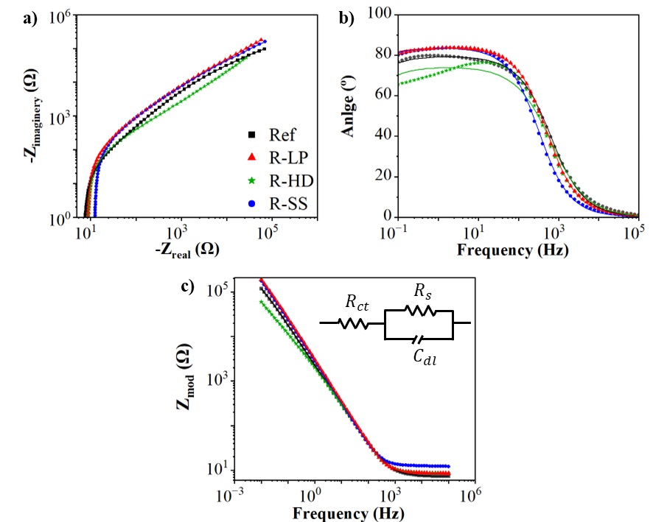
Figure S1. Electrochemical behavior of the Ti64 reference sample and rescanned samples fabricated by L-PBF. (a) Nyquist plot and b) Bode phase angle plots & (c) Bode plots obtained from the potentiostatic EIS measurements, used to extract electrochemical properties.
Table 4. Electrochemical parameters extracted from the EIS measurements.
Property | Ref | R-LP | R-SS | R-HD
R_{ct} (10⁴ MΩ-cm²) | 27.5 | 75.8 | 49.4 | 14.9
R_{s} (MΩ-cm²) | 7.521 | 8.703 | 12.43 | 8.339
Y₀ (10⁻⁴ μΩ⁻1.cm⁻²-s^{n}) | 0.851 | 0.620 | 0.655 | 1.22

References
1. Suryanarayana, C. and M.G. Norton, Practical aspects of X-ray diffraction, in X-ray diffraction: A practical approach. 1998, Springer. p. 63-94.
2. Mote, V.D., Y. Purushotham, and B. Dole, Williamson-Hall analysis in estimation of lattice strain in nanometer-sized ZnO particles. Journal of theoretical and applied physics, 2012. 6(1): p. 6.
3. Zhao, L., et al., Laser‐directed energy deposition of high‐strength Ti6Al4V with equiaxed grain via multi‐alloying CoCrMoSi. Rare Metals, 2025. 44(7): p. 5061-5077.
4. Venkateswarlu, K., et al., Estimation of crystallite size, lattice strain and dislocation density of nanocrystalline carbonate substituted hydroxyapatite by X-ray peak variance analysis. Procedia Materials Science, 2014. 5: p. 212-221.
5. Hu, K., et al., Solidification and corrosion mechanisms: A novel metallurgical bonding Ti-6Al-4V coating on mild steel. Surface and Coatings Technology, 2023. 476: p. 130258.

