Supplementary material
Mechanical Characterization and ML-Based Prediction of 3D-Printed PLA+: Effects of Infill Pattern, Infill Density, and Orientation

Section 1. Experimental Design
The factorial design and the corresponding experimental results for mechanical properties are summarized in Table S1.
Table S1 Factorial design and experimental results
Label | Z-Orientation | Infill pattern | Infill density | s_{max} (MPa) | Impact strength (kJ/m²)
H20A0 | 0 | H | 20 | 32.6 | 2
H20A45 | 45 | H | 20 | 35 | 2.5
H20A90 | 90 | H | 20 | 30.1 | 2
G20A0 | 0 | G | 20 | 31.2 | 1.3
G20A45 | 45 | G | 20 | 35.4 | 3.3
G20A90 | 90 | G | 20 | 28.2 | 1.6
T20A0 | 0 | T | 20 | 20.7 | 1.7
T20A45 | 45 | T | 20 | 33 | 2.8
T20A90 | 90 | T | 20 | 31.3 | 1.6
GY20A0 | 0 | GY | 20 | 32.4 | 1.8
GY20A45 | 45 | GY | 20 | 31.6 | 3.3
GY20A90 | 90 | GY | 20 | 30.2 | 2
H40A0 | 0 | H | 40 | 37.8 | 2.1
H40A45 | 45 | H | 40 | 38.3 | 6.3
H40A90 | 90 | H | 40 | 38.4 | 4.6
G40A0 | 0 | G | 40 | 31.8 | 2.1
G40A45 | 45 | G | 40 | 34.4 | 3.4
G40A90 | 90 | G | 40 | 29.5 | 2.9
T40A0 | 0 | T | 40 | 29 | 2.1
T40A45 | 45 | T | 40 | 35.2 | 4.6
T40A90 | 90 | T | 40 | 33.3 | 2.7
GY40A0 | 0 | GY | 40 | 35.7 | 3.9
GY40A45 | 45 | GY | 40 | 36.5 | 6.3
GY40A90 | 90 | GY | 40 | 33.9 | 4
H60A0 | 0 | H | 60 | 44.2 | 5.6
H60A45 | 45 | H | 60 | 42.6 | 7.8
H60A90 | 90 | H | 60 | 44.8 | 5.4
G60A0 | 0 | G | 60 | 40 | 3.3
G60A45 | 45 | G | 60 | 39.8 | 5.2
G60A90 | 90 | G | 60 | 38.8 | 3.4
T60A0 | 0 | T | 60 | 34 | 2.9
T60A45 | 45 | T | 60 | 36.6 | 5.3
T60A90 | 90 | T | 60 | 35 | 3.2
GY60A0 | 0 | GY | 60 | 40.9 | 3.9
GY60A45 | 45 | GY | 60 | 39.9 | 6.3
GY60A90 | 90 | GY | 60 | 39.1 | 4
H80A0 | 0 | H | 80 | 52.3 | 9.1
H80A45 | 45 | H | 80 | 47.2 | 9.8
H80A90 | 90 | H | 80 | 48.8 | 5.8
G80A0 | 0 | G | 80 | 40.8 | 4.6
G80A45 | 45 | G | 80 | 41.4 | 6.8
G80A90 | 90 | G | 80 | 39 | 4.2
T80A0 | 0 | T | 80 | 44.3 | 3.8
T80A45 | 45 | T | 80 | 40.6 | 6.9
T80A90 | 90 | T | 80 | 40.2 | 3.6
GY80A0 | 0 | GY | 80 | 48.7 | 5.8
GY80A45 | 45 | GY | 80 | 43.4 | 9.7
GY80A90 | 90 | GY | 80 | 42.2 | 5.3

Section 2. Stadistical analysis of maximum stress
The model was validated by assessing normality and homoscedasticity. The validity of the model was assessed by evaluating two key assumptions: normality and homoscedasticity of the residuals.
Normality was evaluated using a normal probability plot (Fig. S1), which indicated an approximately normal distribution, with minor deviations at the extremes. Descriptive statistics for maximum tensile strength are presented in Table S2, showing a mean of 37.29 MPa, standard deviation of 6.15 MPa, coefficient of variation of 16.5%, slight positive skewness (0.23), and slightly flattened kurtosis (0.46).
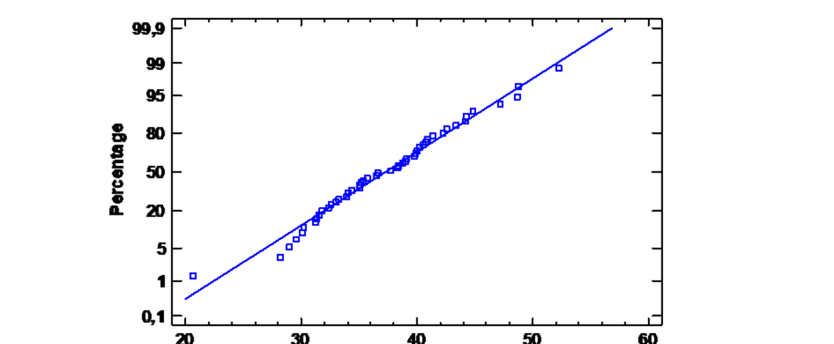
Fig. S1 Normal probability of the residuals for maximum stress
Table S2 Statistical summary for maximum stress
Summary of Data
Mean | 37.29
Standard Deviation | 6.15
Coefficient of Variation (%) | 16.50
Standardized Skewness | 0.23
Standardized Kurtosis | 0.46

Additional graphical and statistical results, including the box-and-whisker diagram (Fig. S2) and the Kolmogorov–Smirnov test (D = 0.0605, p = 0.9947; Table S3). The histogram of maximum tensile strength overlaid with a normal distribution curve to visualize the goodness-of-fit (Fig. S3). These results confirm that the residuals follow an approximately normal distribution at the 95% confidence level.
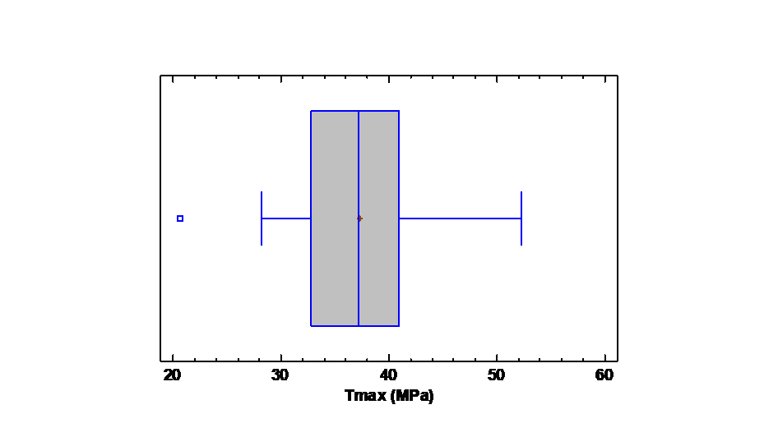
Fig. S2 Box-and-Whisker Diagram for maximum stress
Table S3 Goodness-of-Fit Tests for maximum stress
Normal distributions
DMAX | 0.06
DMENOS | 0.05
DN | 0.06
P-Value | 0.99
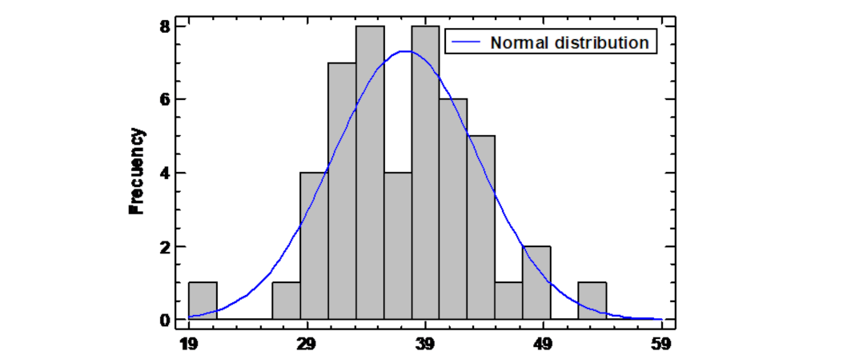
Fig. S3 Histogram of the maximum stress
The homoscedasticity assumption was evaluated using the residuals vs. predicted values plot (Fig. S4). The points were randomly scattered around the zero-residual line, without discernible patterns, indicating constant variance of errors. Some isolated points were observed but did not significantly affect the homogeneity of variance.
Overall, these results confirm that the model satisfies the homoscedasticity assumption, ensuring the robustness and reliability of the regression model.
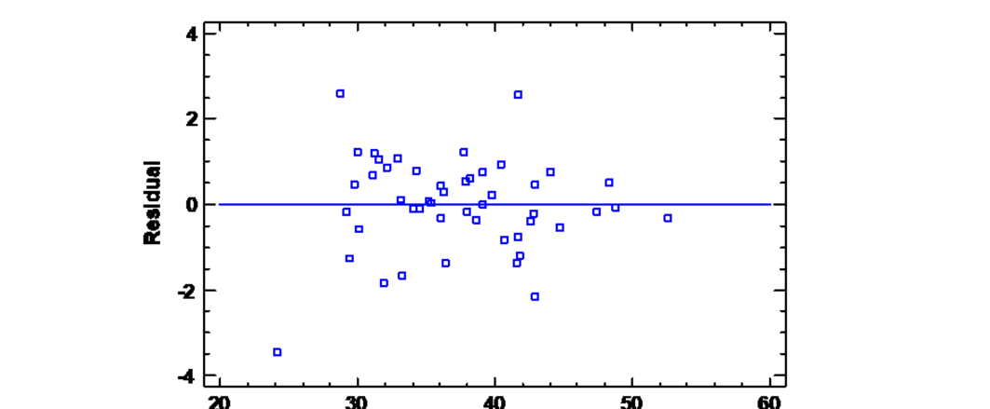
Fig. S4 Residuals vs. Predicted for maximum stress

Section 3. Stadistical analysis of impact strength
The residuals for impact strength were evaluated using a normal probability plot (Fig. S5). The distribution appears approximately normal, with minor deviations at the extremes. Descriptive statistics are summarized in Table S4, showing a mean of 4.22 kJ/m², standard deviation of 2.14 kJ/m², coefficient of variation of 50.78%, positive skewness of 2.58, and slightly elevated kurtosis of 0.62. The high skewness indicates a predominance of lower values with some higher outliers, while the moderate kurtosis suggests a slightly wider spread of extreme values.
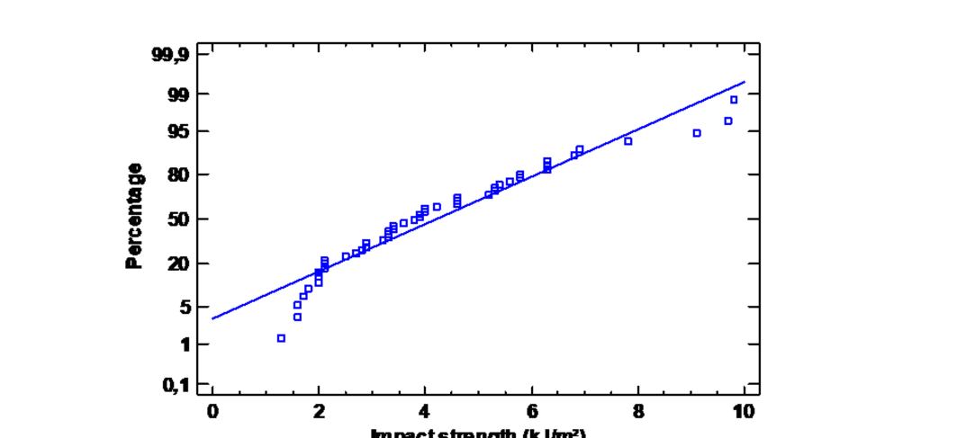
Fig. S5 Normal probability of the residuals for impact strength
Table S4 Statistical summary for impact strength
Summary of Data
Mean | 4.22
Standard Deviation | 2.14
Coefficient of Variation (%) | 50.78
Standardized Skewness | 2.58
Standardized Kurtosis | 0.62

Further details, including the box-and-whisker diagram (Fig. S6) and the Kolmogorov–Smirnov test (D = 0.12, p = 0.46; Table S5). The box-and-whisker diagram highlights the central distribution and variability of the data, with a median of 3.85 kJ/m², an interquartile range of 2.9 kJ/m² (Q1: 2.6 kJ/m²; Q3: 5.5 kJ/m²), and a total range from 1.3 kJ/m² to 9.8 kJ/m². This visualization also reveals potential outliers that may warrant further investigation but do not significantly compromise the assumption of normality.
The histogram of impact strength with an overlaid normal distribution curve, illustrating the overall fit (Fig. S7). These results indicate that, despite slight asymmetry, the residuals for impact strength can be considered approximately normal at the 95% confidence level.
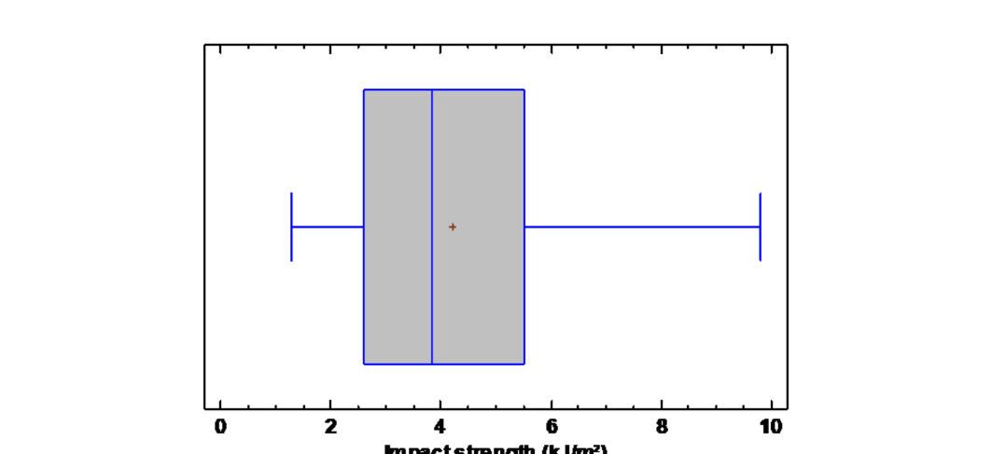
Fig. S6 Box-and-Whisker Diagram for maximum impact strength
Table S5 Goodness-of-Fit Tests for impact strength
Normal distributions
DMAS | 0.12
DMENOS | 0.09
DN | 0.12
P-Value | 0.46
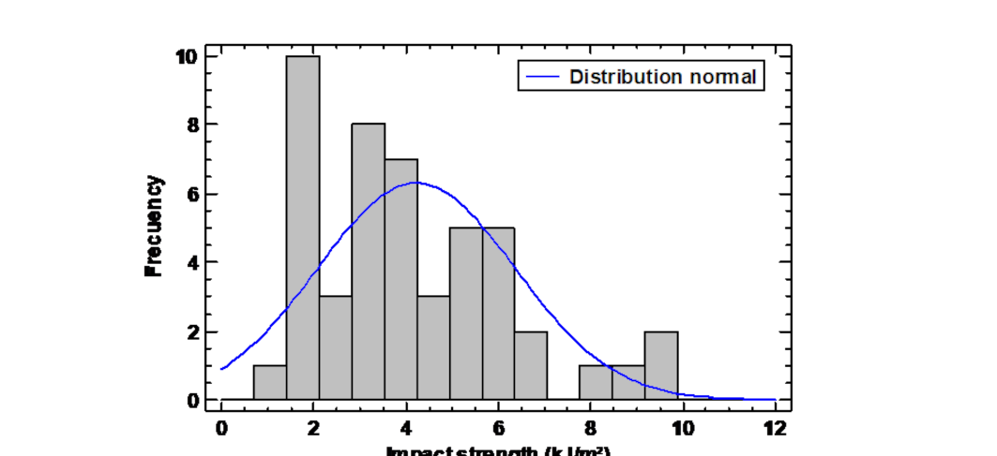
Fig. S7 Histogram of the impact strength
Homoscedasticity was assessed using the residuals versus predicted values plot (Fig. S8). Residuals were evenly distributed around zero, without patterns such as funnels or curvature that would suggest heteroscedasticity. Some isolated points were observed, indicating potential outliers; however, these did not meaningfully affect the overall variance structure. Therefore, the assumption of homoscedasticity is reasonably satisfied, supporting the reliability of the regression model applied to impact strength.
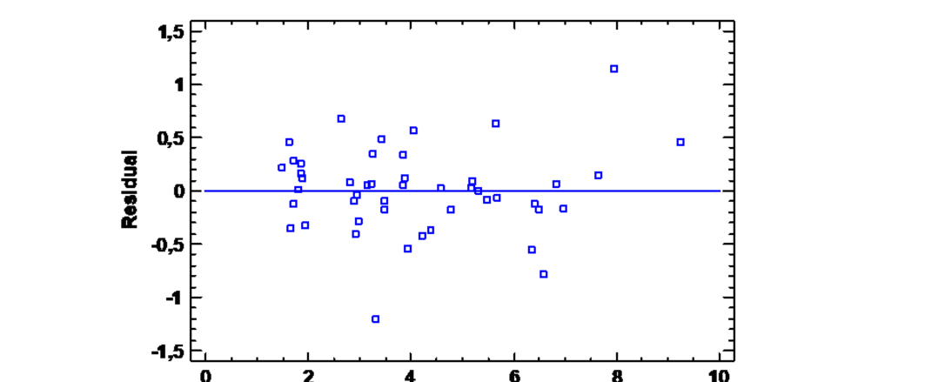
Fig. S8 Residuals vs. Predicted for impact strength

