Additional File 1 for “Out of my control”: Science undergraduates report mental health concerns and inconsistent conditions when using remote proctoring software

Appendix A: Survey Content
Appendix B: Supplemental Figures & Tables
Appendix C: Additional Data: Remote Proctoring Concerns
Appendix D: Codebooks
Appendix E: Perceptions of Cheating by Institution

Appendix A: Survey Content

Faculty Intake Survey
The following questions were included in the intake survey distributed to faculty participants. The format of the question is explained where necessary.
- By providing my information below, I consent to participate in the study as described above.
  - Full name
  - Email address
- Are you willing to provide students in your course with a small amount of extra credit to take our survey? The following research activity is optional, meaning that you do not have to agree to them in order to participate in the research study. Please indicate your willingness to participate in this optional activity.
  - Yes
  - No
- What online proctoring software or service do you use for the course you would like to have surveyed? In the questions throughout this survey, this software/service will be referred to as "proctoring software."
  - Textbox for open-ended survey response
- What is the name and course number of the course you would like to have surveyed about proctoring software? In the questions throughout this survey, this course will be referred to as the "course to be surveyed."
  - Textbox for open-ended survey response
- Approximately how many students are in the course to be surveyed?
  - Textbox for open-ended survey response
- Do you grade on a curve? (i.e., adjust student grades so that they fit a desired distribution across the course)
  - Yes
  - No
  - Other: ______
  - Prefer not to answer
- When taking exams in person with a live proctor, what percent of your students do you believe are cheating?
  - Approximate percent of classmates cheating: slider scale 0-100
- When taking exams remotely and with proctoring software, what percent of your students do you believe are cheating?
  - Approximate percent of classmates cheating: slider scale 0-100
- How do you use proctoring software in the course to be surveyed? For example, what settings do you use, how do you review information from the software, and how do you determine if a student was cheating. Please be descriptive.
  - Textbox for open-ended response
- What did/will you tell students in the course to be surveyed about how you use proctoring software? Alternatively or in addition, upload instructions provided to students in the next question.
  - Textbox for open-ended response
- If available, please upload an example of written instructions or explanations you provided or will provide to students regarding the use of proctoring software.

Student Survey
The following questions were included in the survey distributed to student participants. The format of the question is explained where necessary.
- Please provide the following information so that you can receive extra credit, if offered.
  - Full name
  - Institutional email address
  - Student ID Number (x500)
- I consent to participate in this study and I am over 18 years-old.
  - Yes, I consent to participate in this study
  - No, I do not consent to participate in this study
- During this survey, we are interested in your experiences during the Spring 2021 semester in [course].
- Which of the following types of proctoring have you experienced at any time? Please select all that apply.
  - Remote proctoring where you were recorded via a webcam
  - Remote proctoring where your computer screen was recorded
  - Remote proctoring using a lockdown browser
  - Remote proctoring by a live person (e.g., proctored via Zoom)
  - In-person proctoring where your computer screen was recorded
  - In-person proctoring using a lockdown browser
  - In-person proctoring by a live proctor (e.g., instructor or TA in the room)
  - Other: __________
  - None of the above
- Have you had any of the following technical challenges during an exam when using the proctoring software:[proctoring software]?
  - Internet connection was too slow
  - Proctoring software could not detect my face
  - Proctoring software disconnected
  - Proctoring software was incompatible with my computer or VPN
  - I was not familiar with how the software works
  - Proctoring software locked down when another person entered the room for a non-cheating reason
  - Other: _________
  - None of the above
- Each of the following statements represents a concern that you may have when taking an exam while using [proctoring software]. Please place each statement in the box that best represents your level of concern. The order of the items within each box does not matter.
  - Ranking categories: I am very concerned about…, I am somewhat concerned about…, and I am not concerned about…
    - Having a technological difficulty that impacts my ability to take the exam
    - Having a person enter the space that I am taking the exam, which could then be flagged as cheating
    - My classmates cheating on the exam
    - Being wrongfully identified as cheating on the exam by the proctoring software
    - Being wrongfully identified as cheating on the exam by the professor
    - Being distracted while taking the exam due to the lack of a quiet space
    - Needing something during the exam (such as water or medication) and not being able to get it due to potentially being flagged as cheating by the proctoring software
    - The instructor or other proctor seeing my room/home/work environment
    - The proctoring software having access to private data on my computer not related to the exam
    - Finding it hard to schedule time to take the exam because of work or other responsibilities
    - Other: ________
- Please elaborate on the statement above that you find the most concerning. What specifically do you find concerning about this issue?
  - Textbox for open-ended survey response
- When taking exams remotely and with [proctoring software], what percent of your classmates do you believe are cheating?
  - Approximate percent of classmates cheating: slider scale 0-100
- When taking exams in person with a live proctor, what percent of your classmates do you believe are cheating?
  - Approximate percent of classmates cheating: slider scale 0-100
- Do you think that the use of [proctoring software] makes it easier or more difficult for your classmates to cheat?
  - Much more difficult to cheat
  - Slightly more difficult to cheat
  - No impact on difficulty
  - Slightly easier to cheat
  - Much easier to cheat
  - Prefer not to answer
- How does the use of [proctoring software] impact your feelings about your relationship with the instructor?
  - Extremely negatively
  - Slightly negatively
  - It does not impact how I feel about my relationship with the instructor
  - Slightly positively
  - Extremely positively
  - Prefer not to answer
- Please explain your answer to the question above.
  - Textbox for open-ended survey response
- Did your instructor explain why they use [proctoring software]?
  - Yes
  - No
  - Prefer not to answer
- Did your instructor explain how they use [proctoring software]?
  - Yes
  - No
  - Prefer not to answer
- How did this explanation make you feel about the use of [proctoring software]?
  - The explanation made me feel worse about the use of the software.
  - The explanation did not impact how I felt about the use of the software.
  - The explanation made me feel better about the use of the software.
  - Prefer not to answer
- Do you have any specific concerns about how your instructor uses or explains their use of [proctoring software]? Please explain.
  - Textbox for open-ended response
- How does your experience with [proctoring software] in this class compare with other proctoring experiences you've had? For example, have you liked other experiences more or less and why or why not?
  - Textbox for open-ended response
- Many students have identities that influence students in social learning environments (e.g. race/ethnicity, gender, presentation, disability status, socioeconomic status). Please describe in detail how any of the identities that you hold impacted your experiences with [proctoring software] in the classroom.
  - Textbox for open-ended response
- Please provide the following information so that you can receive credit in your course for taking this survey.
  - Full name as listed on class roster
  - Institutional (e.g., .edu) email address
- What is your year in school?
  - First year
  - Sophomore
  - Junior
  - Senior
  - Other
    - Textbox for open-ended response
  - Prefer not to answer
- With which race(s) and ethnicity/ies do you most closely identify? Please select all that apply.
  - African American or Black
  - East Asian (e.g., China and Japan)
  - South Asian (e.g., the Indian subcontinent)
  - Southeast Asian (e.g., Vietnam)
  - Latinx or Hispanic
  - Middle Eastern or North African
  - Native American or Alaskan Native
  - Native Hawaiian or Pacific Islander
  - White
  - Not listed above
    - Textbox for open-ended response
  - Prefer not to answer
- What is your orientation/sexual identity? Please select all that apply.
  - Asexual
  - Aromantic
  - Bisexual
  - Gay
  - Heterosexual/Straight
  - Lesbian
  - Pansexual
  - Not listed above
    - Textbox for open-ended response
  - Prefer not to answer
- How do you describe your gender? Please select all that apply.
  - Agender
  - Gender nonconforming
  - Gender fluid
  - Man
  - Non-binary
  - Transgender
  - Two-spirit
  - Woman
  - Not listed above
    - Textbox for open-ended response
  - Prefer not to answer
- Are you taking classes from a home/location that you share with other people?
  - Yes
  - No
  - Prefer not to answer
- On average, how many people other than yourself are at your home/location while you are doing your coursework?
  - 0
  - 1
  - 2
  - 3
  - 4
  - 5+
  - Prefer not to answer
- Please describe the environment in which you usually take your exams/quizzes when using [proctoring software] for this class. (e.g., quality of internet, distractions such as other people or pets, the space, the technology you use such as a computer or tablet, and anything else you consider relevant).
  - Textbox for open-ended response
- Do you currently have a job while taking your courses?
  - Yes, I have a full time job or equivalent (30+ hours per week).
  - Yes, I have a part-time job where someone else usually decides when I have to be working (10-29 hours per week).
  - Yes, I have a part-time job where I can usually decide when I work (10-29 hours per week).
  - Yes, I have a minimal hour job where someone else usually decides when I have to be working (1-9 hours per week).
  - Yes, I have a minimal hour job where I can usually decide when I work (1-9 hours per week).
  - No, I am not working while taking classes.
  - Other
    - Textbox for open-ended response
  - Prefer not to answer
- Is there anything else about your identity or experience that you think we should know (e.g., disability status, presentation, religious beliefs, etc.)?

Faculty Reflection Survey
The following questions were included in the survey distributed to faculty participants after receiving collated and anonymized reports of their course data. The format of the question is explained where necessary.
- What did you find interesting/surprising from the reported data, if anything, and why?
  - Textbox for open-ended response
- What did you find unsurprising in the reported data, if anything, and why?
  - Textbox for open-ended response
- How did this data change or confirm your thoughts about using [proctoring software]?
  - Textbox for open-ended response
- How do you intend to use [proctoring software] in the future? What changes, if any, do you plan to make to how you use this software in your courses?
  - Textbox for open-ended response

Appendix B: Supplemental Figures & Tables

Table B1. Demographic information about student respondents.
Demographic Information | Percent of Responses
Race & Ethnicity
White | 67%
African American or Black | 8.8%
Southeast Asian | 4.4%
East Asian | 3.6%
Latinx or Hispanic | 2.2%
South Asian | 2.2%
Middle Eastern or North African | 1.1%
Mixed race or ethnicity | 6.6%
Other | 2.5%
Prefer not to answer | 1.6%
Sexual Identity
Heterosexual | 77.4%
Bisexual | 8.9%
Gay | 1.9%
Asexual | 1.9%
Pansexual | 1.1%
Other | 1.5%
Prefer not to answer | 7.4%
Gender Identity
Woman | 65.6%
Man | 29.5%
Nonbinary | 1.1%
Other | 2.2%
Prefer not to answer | 1.7%

Table B2. Employment status of student respondents during Spring 2021.
Employment Status | Percent of Students
Full-time job  (30+ hours per week) | 12.6%
Part-time job with scheduled hours (10-29 hours per week) | 23.8%
Part-time job with flexible hours  (10-29 hours per week) | 12.8%
Minimal hour job with scheduled hours  (1-9 hours per week) | 4.1%
Minimal hour job with flexible hours (1-9 hours per week) | 7.4%
Not employed | 36.6%
Other | 2.7%

Table B4. Detailed descriptions of the concern abbreviations used in Figure 3.
Abbreviation | Description
Access to private data | The proctoring software having access to private data on my computer not related to the exam
Classmates cheating | My classmates cheating on the exam
Flagged for basic needs | Needing something during the exam (such as water or medication) and not being able to get it due to potentially being flagged as cheating by the proctoring software
Flagged by proctoring service | Being wrongfully identified as cheating on the exam by the proctoring software
Flagged by professor | Being wrongfully identified as cheating on the exam by the professor
Lack of quiet space | Being distracted while taking the exam due to the lack of a quiet space
Person enters | Having a person enter the space that I am taking the exam, which could then be flagged as cheating
Scheduling | Finding it hard to schedule time to take the exam because of work or other responsibilities
Technological difficulty | Having a technological difficulty that impacts my ability to take the exam
View of workspace | The instructor or other proctor seeing my room/home/work environment

Appendix C: Additional Data: Remote Proctoring Concerns

Students were asked to sort ten elements of remote proctoring services on a three-point Likert scale by the categories “Not concerned,” “Somewhat concerned,” and “Very concerned.” Students were not required to sort every element in order to advance the survey, so some elements were ranked more frequently than others. Because we could not assume the meaning of an unranked element, we chose to report the dataset where each respondent sorted all ten concern elements to capture more complete comparison data (n=264). The following figure shows the full dataset of 375 respondents, compared to Figure 3 in the manuscript.

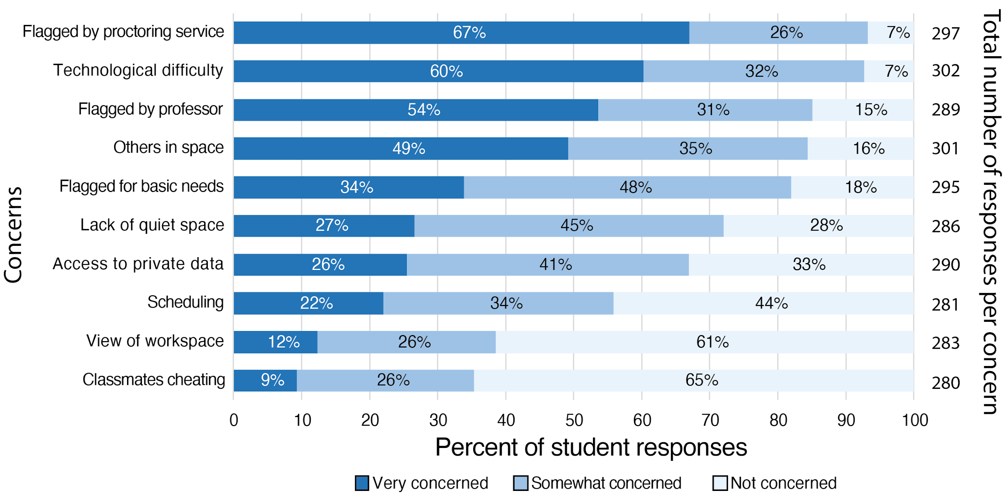
Figure 1C. Top concerns held by all respondents. Students who ranked at least one concern were included in these data. Concerns are ordered by the percent of respondents at the “Very Concerned” level. Numbers on the right side of the graph indicate the number of students that ranked each concern. Labels of the concerns have been abbreviated, and full labels can be found in Supplemental Appendix B.

Appendix D: Codebooks

Table D1. Codebook for respondents’ descriptions of assessment environments (n=305)
Category  Code | Number of Responses (%) | Definition  The student describes… | Example Quote
Environment quality
Adequate environment | 51  (16.7) | No problems with the assessment environment. | I live with one roommate and we both usually take our exams in our own private rooms, so we usually have minimum distractions.
Suboptimal environment | 163  (53.4) | Any problem with the assessment environment. | My room, the walls are very thin, and I can hear my roommates coming in and out of the door. My internet is also not strong and goes in and out.
No quality | 91  (29.8) | The assessment environment but does not qualify the space, positively or negatively. | My apartment living room
Positive aspects of environment
Quiet | 37  (12.1) | A quiet space. | I live in a single dorm on campus. Therefore, I am fortunate that I do not have to share a space with anyone, so my exam environments are always quiet, and my internet connection is always good.
Housemates are respectful | 7  (2.3) | Housemates being respectful of the student’s exam time and assessment environment. | When I am back home there are children and pets and family members who are often sharing the environment I am testing in. I have had several quizzes my nieces came busting in to find me, but overall, everyone does their best to be respectful.
Free of other individuals or distractions | 24  (7.9) | An assessment environment where others are not present, or distractions do not occur. | In my quiet room where no one interrupts me
Good device quality | 8  (2.6) | Having access to a good device for assessment and remote proctoring. | Home office, pets, coworkers coming in and out, Internet is exceptional, but will go out randomly, all devices are Apple and work great
Good internet | 59  (19.3) | Having strong, reliable internet. | In my dorm room which has very reliable internet. I always take my exams on my laptop and my roommate typically leaves the room while I am taking the exam.
Other positive aspects | 27  (8.9) | Some other aspect of space that positively contributes to their assessment environment. | I just take my tests inside my bedroom - I keep the door shut so there shouldn't be any disturbances!
Negative aspects of environment
Noise or other distractions | 135  (44.3) | A noisy assessment environment, either referring to the outdoor environment or noise created by housemates, and includes distractions. | I take exams in a room that has a closed door. My house has thin walls, so I can hear a lot of things like the house phone ringing, cars/traffic passing by, etc.
Poor device quality | 7  (2.3) | A poor-quality device for assessment and remote proctoring. | I have taken my exams at various apartments with various amounts of people present. My internet is usually always spotty no matter where I am. My laptop is a rather older laptop that can have trouble running certain software.
Internet problems | 65  (21.3) | Insufficient internet access, including unreliable connections. | I typically take tests in the room of my apartment, which I share with other people. The internet in the apartment is also not reliable.
Other negative aspects | 11  (3.6) | Some other negative aspect of the assessment environment that contributes to a suboptimal space. | However, I don't currently have a desk, so I set up a makeshift area with the bed.
Other
Scheduling | 11  (3.6) | Strategies for finding time to schedule or take exams. | I take exams in my room, but I have a roommate, so she and I have to talk about times to take exams where the other person is not present.
Sacrifices or concessions | 14  (4.6) | Sacrificing one positive aspect of the environment for another. | My internet quality isn’t the highest because the connection in my room isn’t amazing. But my room in my house is the only place I can have my family and pets not interact with me.
Concerned about being flagged for cheating | 14  (4.6) | Some aspect of their assessment environment that contributes to a concern about being flagged for cheating. | Good internet, but my bedroom is near the dining room and my roommates can be loud and distracting. I am always worried they will knock or come in and I will get flagged.
Removing others from the environment | 4  (1.3) | Needing to quiet or remove housemates from the assessment environment during the exam. | I usually take my exams in my dorms which makes it possible for my roommates or suitemates to walk in at any time, and I must simply tell them to leave.
Mitigating actions for a better environment | 18  (5.9) | Taking action to ensure a positive assessment space. | Other people are at home and I have to warn them beforehand that I will be taking the exam in order to have proper internet connection and no distractions.

Table D2. Codebook for respondents’ explanations of the most concerning element of using remote proctoring software (n=285)
Category  Code | Number of Responses (%) | Definition  The student describes… | Example Quote
Concerns specified in ranking question
Flagged for cheating by the professor | 14  (4.9) | A concern about being flagged for cheating specifically by the professor. The response may also relate to a concern about not knowing a professor’s reaction to cheating allegations. | When taking an exam online, I do worry about outside noises and activity affecting my proctoring. I worry that the proctoring software or the proctor may worry I'm cheating when I'm not.
Flagged for cheating by the proctoring service | 27  (9.5) | A concern about being flagged for cheating specifically by the proctoring software. | The thing that I find the most concerning is being wrongly identified as cheating by the exam software.
Classmates cheating | 8  (2.8) | A concern about other students in the course cheating in some way during the exam. | Mostly concerned about classmates cheating, I know lots of students who cheat during the semester, and it upsets me because I work so hard to study and they mess up the grading scale because they cheated.
Scheduling | 18  (6.3) | A concern relating to finding or coordinating time to take the exam. | I don't live alone, and it is hard to find a time when I am free and uninterrupted.
Distractions | 25  (8.8) | Broadly, distractions that may impact their assessment environment. | Being distracted while taking the exam due to the lack of a quiet space
Extremes
Equally worried about all concerns | 3  (1.1) | Being concerned about everything or cannot pick a top concern from the list. | I find all of these issues concerning because I have experienced almost all of them. I’ve gotten sick during my exam and thought I wouldn’t be able to finish it because I would get in trouble and that adds on to test anxiety I already had.
Not concerned | 10  (3.5) | No concerns about remote proctoring. | I'm not very concerned about any of the above, really.
Wrongfully flagged for cheating due to…
Disability or medical needs | 13  (4.6) | A concern about being flagged due to disabilities or health needs. | I have had health difficulties during exams before but did not want to leave the computer in worry of the rules of [proctoring service].
Non-cheating needs or movements | 66  (23.2) | A concern about being flagged due to regular movements or needs. | I'm worried about being accused of cheating because I talk to myself or because I sneeze or I'm humming or something during the exam, and the software thinks it's cheating.
Other people or pets | 41  (14.4) | A concern about being flagged for cheating due to other people or pets, and includes concerns about the possibility for this to occur. | I was very concerned that I would accidentally make a noise or look down or a family member would enter the room and I would be flagged as cheating even though I was not.
Unspecified or other | 50  (17.5) | A concern of being wrongfully accused of cheating but does not elaborate further. | I am very concerned about being wrongfully identified as cheating by [proctoring service].
Technological challenges
Internet problems | 29  (10.2) | A concern about internet problems, including speed or reliability. | The only concerning thing about these systems would be internet problems due to Wi-Fi issues.
Compatibility or software problems | 29  (10.2) | Concerns about the device, the software, or the software's compatibility with the device. | I have a pretty old laptop that the [proctoring software] sometimes does not like to deal with. My biggest concern is having some sort of technical issue with my laptop or the [proctoring software] that causes me to have problems with my exam.
Unspecified | 31  (10.9) | Technological concerns but does not specifically qualify them. | I would worry that my exam would shut down, and I wouldn't get full credit due to tech issues.
Privacy
Physical privacy | 13  (4.6) | A concern about physical privacy based on what information the software is collecting. | I am the most concerned about the privacy issues associated with having a software monitor not only my screen but also my home environment.
Data privacy | 22  (7.7) | A concern about the software's ability to access private data stored on a personal device. | I find that information from my computer being taken is the most alarming, as I don't fully trust [the proctoring software].
Unspecified | 7  (2.5) | A concern about privacy but does not qualify the type of privacy. | I think that the use of [proctoring software] is an invasion of privacy.
Impacts
Grades and performance | 28  (9.8) | A concern about having grades impacted in the class, in general, or the possibility of performing worse due to the stress of being proctored. | I have had people enter my space or my space was not quiet. It is hard to control some of these things and I have scored worse on tests because of it.
Long-term consequences | 5  (1.8) | Long-term impacts of cheating allegations on opportunities and standings. | Cheating is a serious accusation that can cause serious long-term effects and essentially ruin a student's entire future. It makes me very nervous that an automated software could find something "suspicious" and invalidate not only my test score but all of my hard work in college.
Time | 12  (4.2) | A concern about the amount of time to take the exam being decreased by unforeseen circumstances. | I have had issues where the [proctoring service] would kick me out of the test for no reason, which made me worried about being accused of cheating and about losing time for my test due to having to log back in.
Emotional distress | 61  (21.4) | Psychological and emotional impacts of remote assessment and proctoring software, such as stress or anxiety. | I already have anxiety for tests, so when I am proctored by my eye movement it stresses me out more and makes me nervous when I’m not doing anything wrong.
Other
Difficulty focusing | 16  (5.6) | The feeling of having trouble focusing because of the circumstances of the exam environment. | When at home it seems hard to focus with so many distractions from your dog walking on by to a family member being loud. These distractions on many others on my computer cause it to be hard to focus and stay attentive to the test I am taking.
Mitigate possibility of being wrongfully flagged for cheating | 7  (2.5) | Ways to mitigate the possibility of being flagged for cheating. | I felt I had to keep my eyes directly on the screen at all times, so I don't get wrongfully accused of cheating. Normally when taking a test, I would look into space if I got stuck which helped me, but if I would do that on [proctoring software] I would probably be counted as cheating.
Kicked from the exam | 22  (7.7) | A concern about being kicked from the exam. | I am concerned about technological difficulty, because on two occasions, I was kicked out of my test before I was finished.
True other | 30  (10.5) | Anything outside of specific concerns or ideas coded.

Appendix E: Perceptions of Cheating by Institution

In the manuscript, Figure 5 shows the students’ perceptions of cheating during in-person and remotely proctored exams. These data are collated across all participating universities, and to ensure that one institution did not unduly impact the results, we explored the perceptions of cheating by respondents from each university. Three public, doctoral, research-focused institutions were used for data collection, and the breakdown of participants, the number of students who were sent the recruitment email, and enrolled courses can be seen in Table 1E.

Table 1E. General information about courses and participants by university.
University | Courses Enrolled | Number of Participants | Number of potential participants*
1 | 3 | 156 | 444
2 | 6 | 125 | 339
3 | 1 | 94 | 219
*Number is approximate based on either assigned grades at the end of the semester or original enrollment numbers depending on the institution and course

The following figures show students’ perceptions of cheating by university (Fig 1E). All universities show that students predict that their peers are cheating more during remotely proctored exams than in-person exams. Percentages reported are averaged from participant responses. Predictions about cheating during in-person exams ranged from 9.0% to 13.6%, while predictions of cheating during remotely proctored exams ranged from 19.1% to 22.9%. Students from University 1 predicted that 13.6% of students were cheating during in-person exams (n=140) compared to 22.9% during remotely proctored exams (n=147; t₂₈₆=4.45, p<0.0001; Fig 1E-A). Students from University 2 predicted that 9.0% of students were cheating during in-person exams (n=97) compared to 20.8% during remotely proctored exams (n=100; t₁₉₆=4.95, p<0.0001; Fig 1E-B). Finally, students from University 3 predicted that 11.8% of students were cheating during in-person exams (n=79) compared to 19.1% during remotely-proctored exams (n=89; t₁₆₇=3.46, p=0.0007; Fig 1E-C).

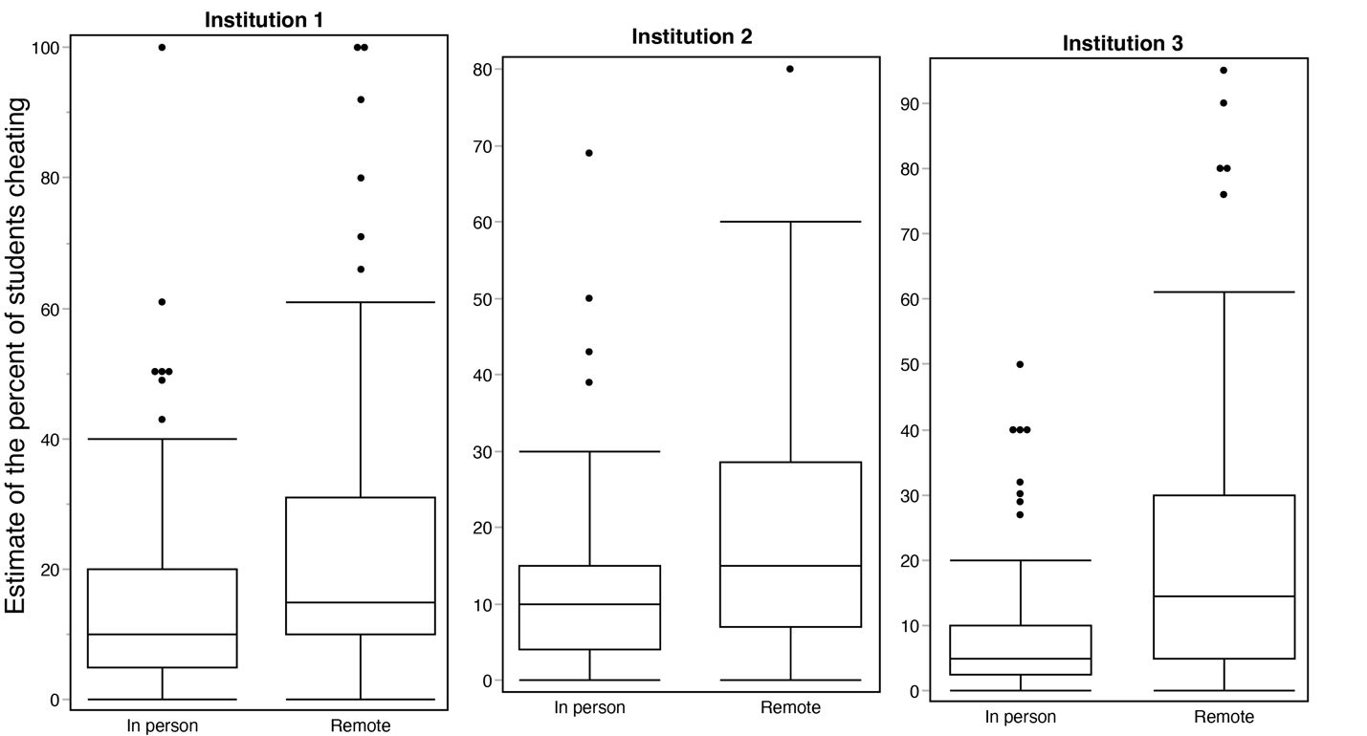
Figure 1E. Students’ perceptions of the percent of classmates cheating by proctoring type by university. Boxplots showing respondent estimations of the percent of classmates cheating during remotely proctored and in-person exams by university. The boxplot shows the median value within the interquartile range of responses. The dots represent outlier estimates that were greater than three standard deviations from the mean.
Faculty were also asked to estimate the number of students cheating during in-person or remotely proctored exams. Faculty estimated that an average of 5.6% of students were cheating during in-person exams (n=10) compared to an average of 12.2% during remotely proctored exams (n=8). Likely due in part to the small sample size, this difference was not statistically significant (t₁₈=1.47, p=0.175).

Table E2. Faculty estimations of percent students cheating during
in-person and remote exams.
Instructor | Assessment Environment (Percent Cheating)
 | In person (%) | Remote (%)
1 | 1 | -
2 | 2 | 2
3 | 2 | 5
4 | 2 | 39
5 | 5 | -
6 | 5 | 5
7 | 5 | 10
8 | 9 | 4
9 | 10 | 10
10 | 15 | 30
Average | 5.6 | 12.2

