Appendices
Confusion Matrix Illustration
To illustrate how the metrics are derived from confusion matrix, consider the class AI and how the classifier correctly or incorrectly labels instances of this class. For this explanation, we treat AI-generated texts to represent the positive class.
Figure 4 depicts the classification outcomes related to the AI-generated class in terms of TP, TN, FP, and FN, defined below.
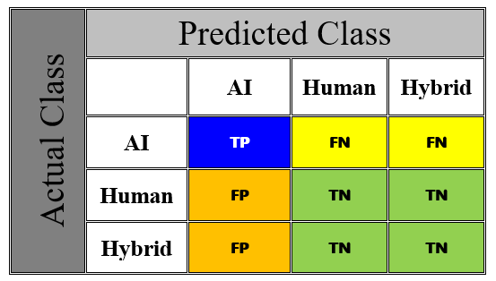
Figure 4. Confusion matrix for class AI and all possible classification outcomes
- True Positives (TP) represents the number of samples correctly identified by the classifiers as AI-authored.
- True Negatives (TN) represents the number of samples the detector correctly classifies a non-AI text (Human or Hybrid) as not AI-authored.
- False Positives (FP) represents the number of samples the detector incorrectly classifies a non-AI-authored text as AI-authored.
- False Negatives (FN) represents the number of samples the detector incorrectly classifies an AI-authored text as non-AI.
It is important to note that in binary or one-vs-rest classifications, the positive or negative designation depends on the class under consideration; in this case, it is AI-generated.
The above-mentioned performance measures are mathematically expressed by: :
Sensitivity (Sen) /Recall : This measure describes out of all actual AI-authored texts, how many were correctly identified by the detector.
$$Sen = \frac{TP}{TP+\sum{FN}} (1)$$
Specificity (Spec): Specificity indicates out of all non-AI texts; how many were correctly identified as not AI-authored.
$$Spec = \frac{\sum{TN}}{\sum{TN}+\sum{FP}} (2)$$
Precision: Precision indicates out of all texts predicted as AI-authored, how many were actually AI-authored.
$$Precision= \frac{TP}{TP+\sum{FP}} (3)$$
F1-Score_{AI}: F1-score is the harmonic mean of Precision and Recall. It balances both false positives and false negatives.
$$F1-score= 2× \frac{Precision*Sen}{Precision+Sen} (4)$$
Accuracy (Acc): The accuracy indicates the overall rate at which the detector correctly classifies both AI and non-AI texts
$$Acc = \frac{TP+\sum{TN}}{TP+\sum{TN}+\sum{FP}+\sum{FN}} (5)$$
These metrics together provide a comprehensive evaluation of the model's performance. Relying on accuracy alone, for example, can be misleading, especially in the presence of class imbalance.

