Figure Legends
Figures 3 & 4: Classification outcomes for AI detection tools in Fully AI-generated papers (figure 3) and Fully Human papers (figure 4).
Note. Bars represent the percentage of papers in each classification category according to the defined accuracy scale. Fully AI-generated papers were produced with GPT-4o-Deep-Research (100% AI ground truth). Fully Human papers were graduate theses written before the release of ChatGPT (0% AI ground truth).
Figure 5 & 6: Classification outcomes for AI detection tools in Hybrid papers (figure 5) and Humanised papers (figure 6)
Note. Bars represent the percentage of papers in each classification category according to the defined accuracy scale. Hybrid papers combined human-written sections with AI-generated sections produced by GPT-4o (ground truth range: 32.1–63.1% AI). Humanised papers were derived from the Hybrid set, with AI-generated sections edited using a “humanising” prompt to make them appear more like student writing (ground truth range: 35.0–62.8% AI).

Table Legends
Table 7 Descriptives for types of papers and % AI detected across detection tools
Note: Turnitin classifies papers with an AI score between 0% and 20% as uncertain and marks them with an asterisk rather than a numerical score. Because we use the percentage scores in this analysis, these uncertain cases could not be included. Consequently, 19 fully AI-generated papers, 7 hybrid papers, 6 humanised papers, and 3 fully human papers were coded as missing.
Table 8 Estimated Marginal Prediction Error for AI Detection Tools by Paper Type
Note. Mean Error calculated as (Ground Truth Score - Tool Score). *** p < .001.
Note: Turnitin classifies papers with an AI score between 0% and 20% as uncertain and marks them with an asterisk rather than a numerical score. Because we use the percentage scores in this analysis, these uncertain cases could not be included. Consequently, 19 fully AI-generated papers, 7 hybrid papers, 6 humanised papers, and 3 fully human papers were coded as missing.

Appendix
Appendix A
Table 7 presents descriptive statistics for the percentage of AI detected across four AI detection tools -Turnitin, GPTzero, Copyleaks, and Pangram- for four categories of papers (Fully AI-generated, Hybrid, Humanised, and Fully Human). The ground truth percentage for each category is included for comparison.
For fully AI-generated papers (Groundtruth = 100% AI), the average percentage of AI detected varies substantially across AI detection tools: Turnitin (0.0%), GPTzero (14.3%), Copyleaks (14.0%), and Pangram (85.7%). For each tool the variation around the mean score, expressed by the standard deviation, is also substantial and in general higher when compared to the other type of texts (except for the Copyleaks tool).
For Hybrid papers (Groundtruth average 46.3%), average AI detected ranged from 21.9% for GPTzero to 45.5% for Pangram with Copyleaks (32.2%) and Turnitin (33.9%) in between.
For Humanised papers (Groundtruth average 44.8%), a similar pattern emerged. GPTZero (21.2%) had the lowest detection rate, while Pangram (43.6%) was closest to the ground truth.
For Fully Human papers (Groundtruth = 0% AI), Turnitin, Copyleaks, and Pangram all accurately detected the groundtruth of 0.0% AI present. GPTzero indicated a small average percentage of AI (1.9%).
Across AI detection tools, Pangram has the highest AI detection scores for Fully AI generated, Hybrid, and Humanised papers, closely aligning with ground truth in each category.
From a more general perspective, it is interesting that all AI-tools except for Pangram have more difficulties in detecting AI-use when a text is fully AI generated when compared to hybrid texts or humanized texts. This may be due to the fact that the fully AI-generated papers were produced using GPT-4o-DeepResearch module in webversion, the most advanced model available at the time, whereas the hybrid and humanised texts incorporated sections generated by GPT-4o.

Table 7
Paper type | Variable | N | Mean  (% AI) | SD | Median  (% AI) | Min | Max
Fully generated  (GPT-4o-Deep-Research) | Groundtruth | 40 | 100.0 | 0.0 | 100.0 | 100.0 | 100.0
 | Turnitinª | 21 | 0.0 | 0.0 | 0.0 | 0.0 | 0.0
 | GPTzero | 40 | 14.3 | 8.6 | 15.5 | 2.0 | 27.0
 | Copyleaks | 40 | 14.0 | 10.3 | 11.5 | 0.0 | 39.0
 | Pangram | 40 | 85.7 | 15.6 | 85.5 | 33.0 | 99.9
Hybrid (GPT-4o) | Groundtruth | 40 | 46.3 | 7.0 | 44.6 | 32.1 | 63.1
 | Turnitinª | 33 | 33.9 | 9.6 | 34.0 | 20.0 | 60.0
 | GPTzero | 40 | 21.9 | 6.5 | 25.0 | 7.0 | 28.0
 | Copyleaks | 40 | 23.2 | 16.6 | 17.0 | 4.0 | 68.0
 | Pangram | 40 | 45.5 | 7.8 | 44.0 | 31.0 | 68.0
Humanised (GPT-4o) | Groundtruth | 40 | 44.8 | 7.1 | 44.0 | 35.0 | 62.8
 | Turnitinª | 34 | 35.3 | 9.6 | 33.0 | 21.0 | 70.0
 | GPTzero | 40 | 21.2 | 8.1 | 25.0 | 7.0 | 41.0
 | Copyleaks | 40 | 23.4 | 14.7 | 20.0 | 5.0 | 66.0
 | Pangram | 40 | 43.6 | 7.5 | 42.0 | 30.0 | 64.0
Fully human | Groundtruth | 40 | 0.0 | 0.0 | 0.0 | 0.0 | 0.0
 | Turnitinª | 37 | 0.0 | 0.0 | 0.0 | 0.0 | 0.0
 | GPTzero | 40 | 1.9 | 1.3 | 1.0 | 1.0 | 5.0
 | Copyleaks | 40 | 0.0 | 0.0 | 0.0 | 0.0 | 0.0
 | Pangram | 40 | 0.0 | 0.0 | 0.0 | 0.0 | 0.0

Appendix B
Appendix B contains visualisations of the classification outcomes for each AI detection tool by paper category, based on the accuracy scales defined in Table 2 of the main text. Figures are provided for:
- Fully AI-generated (figure 3) and Fully Human papers (figure 4)
- Hybrid and Humanised papers.
These figures break down the proportion of papers falling into each classification type (e.g., True Positive, (Partially) True Positive, Unclear, (Partially) False Negative) and illustrate the distribution of detection results underlying the accuracy scores reported in the main text.
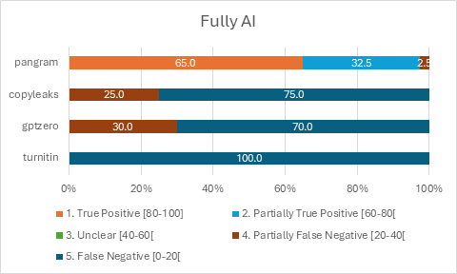
Figure 3

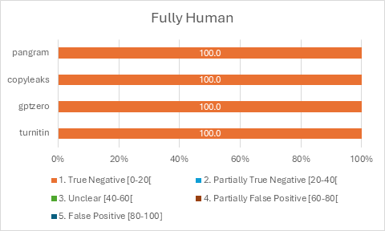
Figure 4
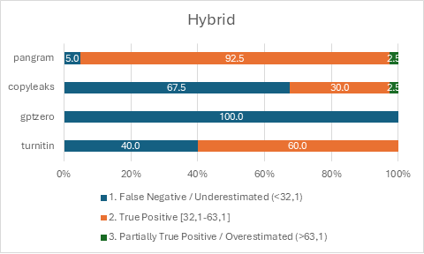
Figure 5
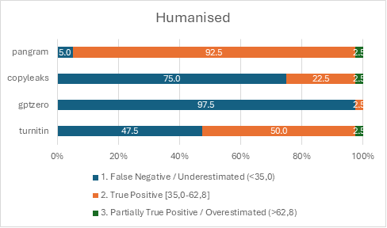
Figure 6

Appendix C
Table 8 shows the results from the linear mixed-effects model as presented in the Results section. It reports the estimated marginal means (how large was the average estimation error of the tool compared to the ground truth), and 95% confidence intervals for each tool across all four paper types.

Table 8
Paper Type | Tool | Mean Error | 95% Confidence Interval
Fully Generated | Copyleaks | -85.97*** | [-88.54, -83.39]
(GPT-4o-Deep-Research) | GPTZero | -85.70*** | [-88.27, -83.13]
 | Pangram | -14.32*** | [-16.89, -11.75]
 | Turnitin | -99.63*** | [-103.16, -96.10]
Hybrid | Copyleaks | -23.08*** | [-25.66, -20.51]
(GPT-4o) | GPTZero | -24.41*** | [-26.98, -21.84]
 | Pangram | -0.81 | [-3.38, 1.76]
 | Turnitin | -12.93*** | [-15.76, -10.10]
Humanised | Copyleaks | -21.42*** | [-23.99, -18.85]
(GPT-4o) | GPTZero | -23.60*** | [-26.17, -21.02]
 | Pangram | -1.12 | [-3.69, 1.45]
 | Turnitin | -10.16*** | [-12.94, -7.37]
Fully Human | Copyleaks | 0 | [-2.57, 2.57]
 | GPTZero | 1.95 | [-0.62, 4.52]
 | Pangram | 0 | [-2.57, 2.57]
 | Turnitin | 0 | [-2.68, 2.67]

