Epidemiology of pulmonary fibrosis - a cohort study using health care data in Sweden

Electronic Supplementary Material

Table S1: Comorbidities/symptoms occurring in pulmonary fibrosis/IPF patients during the pre-index period as well as throughout the study period

 | Cohort 1 |  | Cohort 2
 | Pre-index (N=17,247) | Ever (N=17,247) | Pre-index (N=1,755) | Ever (N=1,755)
Reflux related disorders | 2,001 (11.6%) | 3,056 (17.7%) | 287 (16.4%) | 419 (23.9%)
COPD | 1,433 (8.3%) | 2,846 (16.5%) | 202 (11.5%) | 434 (24.7%)
Emphysema | 202 (1.2%) | 563 (3.3%) | 60 (3.4%) | 175 (10.0%)
Bacterial pneumonia | 1,304 (7.6%) | 2,955 (17.1%) | 125 (7.1%) | 317 (18.1%)
Other respiratory tract infections | 3,509 (20.3%) | 6,962 (40.4%) | 418 (23.8%) | 836 (47.6%)
Diabetes type II | 900 (5.2%) | 1,457 (8.4%) | 192 (10.9%) | 340 (19.4%)
Congestive heart failure | 2,094 (12.1%) | 3,894 (22.6%) | 254 (14.5%) | 560 (31.9%)
Ischemic heart disease | 2,987 (17.3%) | 4,340 (25.2%) | 344 (19.6%) | 475 (27.1%)
Myocardial infarction | 1,381 (8.0%) | 2,408 (14.0%) | 137 (7.8%) | 223 (12.7%)
Angina | 1,977 (11.5%) | 2,541 (14.7%) | 251 (14.3%) | 311 (17.7%)
Cerebrovascular disease | 1,657 (9.6%) | 2,655 (15.4%) | 189 (10.8%) | 290 (16.5%)
Atrial fibrillation | 1,847 (10.7%) | 2,695 (15.6%) | 228 (13.0%) | 376 (21.4%)
Cough | 638 (3.7%) | 936 (5.4%) | 303 (17.3%) | 441 (25.1%)
Dyspnoea | 2,109 (12.2%) | 3,911 (22.7%) | 386 (22.0%) | 669 (38.1%)
Fatigue | 267 (1.5%) | 678 (3.9%) | 134 (7.6%) | 240 (13.7%)
Musculoskeletal pain | 1,586 (9.2%) | 2,485 (14.4%) | 423 (24.1%) | 614 (35.0%)

Figure S1: Age-specific (A) incidence and (B) prevalence of pulmonary fibrosis in Sweden

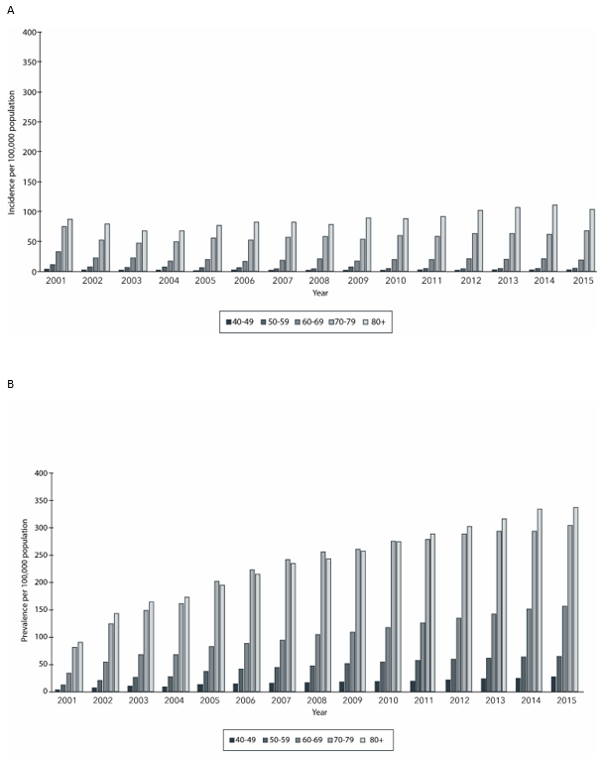

Figure S2: Gender-specific (A) incidence and (B) prevalence of pulmonary fibrosis in Sweden

