Appendix

Appendix 1. Sample search strategy for Pubmed
1 | "pulmonary disease, chronic obstructive"[MeSH Terms]
2 | "COPD"[All Fields]
3 | "Chronic obstructive pulmonary disease"[All Fields]
4 | "COAD"[All Fields]
5 | "Chronic obstructive airway disease"[All Fields]
6 | "Chronic obstructive lung disease"[All Fields]
7 | “Chronic”[All Fields] AND “Obstruction”[All Fields] AND (“Airflow”[All Fields] OR “Airway”[All Fields])
8 | #1 OR #2 OR #3 OR #4 OR #5 OR #6 OR #7
9 | “PCT”[All Fields]
10 | "Calcitonin"[MeSH Terms] OR "Calcitonin"[All Fields] OR "Procalcitonin"[All Fields]
11 | “Pro-calcitonin”[All Fields]
12 | “Pro calcitonin”[All Fields]
13 | "Calcitonin precursor"[All Fields]
14 | "Calcitonin precursors"[All Fields]
15 | #9 OR #10 OR #11 OR #12 OR #13 OR #14
16 | #8 AND #15

Appendix 2. Excluded studies
No. | Excluded studies | Reasons for exclusion
1 | Effectiveness and safety of procalcitonin-guided antibiotic therapy in lower respiratory tract infections in "real life": an international, multicenter poststudy survey (ProREAL). Arch Intern Med 172(9): 715-722. | No COPD-specific data available
2 | Utility of unique procalcitonin dosage in patients with acute exacerbation of chronic obstructive pulmonary disease in emergency wards. Clinical Microbiology and Infection 15: S190-S191. | Not relevant
3 | Efficacy and safety of procalcitonin-guided antibiotic therapy in lower respiratory tract infections. Antibiotics (Basel) 2(1): 1-10. | No COPD-specific data available
4 | Point-of-care procalcitonin test to reduce antibiotics in COPD exacerbation: A quasi-randomized control trial. European Respiratory Journal 46. | Duplicate
5 | Antibiotic treatment interruption of suspected lower respiratory tract infections based on a single procalcitonin measurement at hospital admission--a randomized trial. Clin Microbiol Infect 15(5): 481-487. | No COPD exacerbations data available
6 | Hospital procalcitonin testing and antibiotic treatment of patients admitted for chronic obstructive pulmonary disease exacerbation. Ann Am Thorac Soc 14(12): 1779-1785. | No PCT-guided protocol intervention
7 | Impact of procalcitonin-guided antibiotic management in chronic obstructive pulmonary disease exacerbation and community-acquired pneumonia. Open Forum Infectious Diseases. 2019;6:S483-S484. | Include patients without COPD exacerbations

Appendix 3 - Characteristics of included studies
Reference | Study design, Primary outcome, and Country | Participants and Study setting | PCT-based protocol | Sample size | Anthonisen criteria | Initial PCT levels | First-dose antibiotics | GOLD stage |  | Baseline FEV1% predicted
 |  |  |  |  |  |  |  | Intervention | Control | Intervention | Control
Bremmer 2018[1] | Retrospective cohort study, duration of antibiotics, U.S. | COPD exacerbation,  Hospital | <0.1 μg·L⁻¹: strongly discouraged; 0.1-0.25 μg·L⁻¹: discouraged; 0.25-0.5 μg·L⁻¹: recommended; >0.5 μg·L⁻¹l: strongly recommended. PCT was obtained within 24 hr of admission. If antibiotics were withheld, we recommended repeating PCT testing 6–24 hr later. | 305 | NR | 16/139 have elevated PCT (>0.25 μg·L⁻¹) | Yes | NR | NR | NR | NR
Christ-Crain 2004[2] | Single-blind, cluster randomized controlled study, antibiotic exposure, Switzerland | COPD exacerbation,  Hospital | <0.1 μg·L⁻¹: strongly discouraged; 0.1-0.25 μg·L⁻¹: discouraged; 0.25-0.5 μg·L⁻¹: advised; >0.5 μg·L⁻¹: strongly recommended. For patients on antimicrobial therapy at the time of admission, we recommended discontinuation of antibiotics if procalcitonin concentrations were less than 0.25 μg·L⁻¹. Re-evaluation 6–24 hr after admission was possible in patients in whom antibiotics were withheld. | 60 | 55/60 have dyspnea; 34/60 have purulent sputum; 53/60 have increased sputum production | 0.15±0.23ª μg·L⁻¹ | Yes | NR | NR | 45.2±15.8ª | 44.3±18.8ª
Corti 2016[3] | Randomized controlled study, antibiotic exposure, Denmark | COPD exacerbation,  Hospital | <0.15 μg·L⁻¹: strongly discouraged; 0.15-0.25 μg·L⁻¹: discouraged; >0.25 μg·L⁻¹: encouraged. Blood samples for PCT measurements were collected within 24 hr of admission and on days 3, 5, and 7 of admission. In patients with PCT over 5 μg·L⁻¹ on admission, the algorithm recommended stopping antibiotics when PCT levels decreased by 80% of the peak value. | 120 | 44/120 have purulent sputum;  61/120 have increased sputum; 113/120 have dyspnea | 0.06 (0, 0.25)^{b} μg·L⁻¹ | No | III or IV | III or IV | 43 (32, 54)^{b} | 35 (28, 51)^{b}
Daubin 2018[4] | Randomized controlled study, 3-month mortality, France | COPD exacerbation,  ICU | <0.1 μg·L⁻¹: strongly discouraged; 0.1-0.25 μg·L⁻¹: encouraged; >0.25 μg·L⁻¹: strongly encouraged. Circulating PCT levels were sequentially assessed at inclusion (PCT-H0), at 6 h after inclusion (PCT-H6), and on days 1, 3 and 5 after inclusion. In addition, the investigators were encouraged to discontinue antibiotics when the PCT concentration was less than 90% of the peak concentration. | 302 | NR | 0.28 (0.1, 0.9)^{b} μg·L⁻¹ for PCT group; 0.19 (0.08, 0.79)^{b} μg·L⁻¹ for control group | Yes/no | 0: 4%; I: 4%; II: 16.6%; III: 27.2%; IV: 38.4%; Unknown: 9.9% | 0: 3%; I: 5.3%; II: 14.6%; III: 33.1%; IV: 35.1%; Unknown: 9.3% | 41±15.5ª | 39±16.5ª
Huang 2018[5] | Randomized controlled study, antibiotic exposure, U.S. | COPD exacerbation, Emergency Department | <0.1 μg·L⁻¹: strongly discouraged; 0.1-0.25 μg·L⁻¹: discouraged; 0.25-0.5 μg·L⁻¹: advised; >0.5 μg·L⁻¹: strongly recommended. | 524 | NR | <0.1 μg·L⁻¹: 389/507; 0.1-0.25 μg·L⁻¹: 73/507; 0.25-0.5 μg·L⁻¹: 18/507; >0.5 μg·L⁻¹: 27/507. | No | NR | NR | NR | NR
Liu 2015[6] | Randomized controlled study, NR, China | COPD exacerbation,  Hospital | <0.25 μg·L⁻¹: discouraged; >0.25 μg·L⁻¹: recommended. PCT was obtained at 1,4,7 and 10 day after admission. | 108 | Type I: 67/108; Type II: 30/108; Type III: 11/108 | 37/52 have elevated PCT (>0.25 μg·L⁻¹) | No | II: 13.5%; III: 65.4%; IV: 21.1% | II: 17.9%; III: 67.1%; IV: 25% | NR | NR
Medveczky 2011[7] | Prospective cohort study, antibiotic exposure, UK | COPD exacerbation,  Hospital | Antibiotic use was discouraged if initial PCT level <0.25 μg·L⁻¹ or 80-90% fall of peak PCT value after 72 hr. | 30 | NR | NR | Yes | NR | NR | NR | NR
Nangia 2012[8] | Randomized controlled study, antibiotic exposure, India | COPD exacerbation,  Hospital | NR | 100 | NR | NR | Yes | NR | NR | NR | NR
Picart 2016[9] | Retrospective before-after study, antibiotic exposure, Reunion | COPD exacerbation,  Hospital | <0.25 μg·L⁻¹: discouraged; >0.25 μg·L⁻¹: recommended. PCT level <20% of initial PCT: discontinue antibiotics. PCT was obtained at 1, 2-3 and 4-5 day after admission. | 245 | 35/245 have purulent sputum | 47/231 have elevated PCT (>0.25 μg·L⁻¹) | Yes | I: 0.8%; II: 5%; III: 19%; IV: 46.3%; Unknown: 28.9% | I: 3.2%; II: 8.9%; III: 20.2%; IV: 40.3%; Unknown: 27.4% | NR | NR
Sabrine 2018[10] | Retrospective, before-after study, NR, Tunisia | COPD exacerbation,  ICU requiring mechanical ventilation | <0.25 μg·L⁻¹: discouraged; >0.25 μg·L⁻¹: recommended. | 92 | NR | NR | No | NR | NR | NR | NR
Schuetz 2009[11] | Randomized controlled study, adverse clinical outcomes including death, re-infection Switzerland | COPD exacerbation, Emergency department | <0.1 μg·L⁻¹: strongly discouraged; 0.1-0.25 μg·L⁻¹: discouraged; 0.25-0.5 μg·L⁻¹: recommended; >0.5 μg·L⁻¹: strongly recommended. If antibiotics were withheld, PCT measurement was repeated after 6 to 24 hr. In patients in the PCT group with increased PCT values and antibiotic therapy, PCT measurements were repeated after 3, 5, and 7 days and antibiotic treatment was discontinued using the same cutoff ranges. In patients with high PCT values on admission (ie, 10 μg·L⁻¹), the algorithm recommended stopping antibiotics if PCT levels decreased by 80% and we strongly recommended stopping antibiotics if PCT levels decreased by 90% of the initial value. | 228 | Type I or II | NR | Yes | NR | NR | NR | NR
Stolz 2007[12] | Randomized controlled study, antibiotic exposure at index hospitalization and within 6 months for COPD exacerbation, Switzerland | COPD exacerbation,  Hospital | <0.1 μg·L⁻¹: discouraged; 0.1-0.25 μg·L⁻¹: discouraged or encouraged; >0.25 μg·L⁻¹: encouraged. Reevaluation of circulating procalcitonin levels and clinical status was recommended after 6 to 24 hr if antibiotic therapy was withheld. | 208 | 120/208 have purulent sputum;  144/208 have increased sputum; 193/208 have dyspnea | 0.096 (0.07, 0.2)^{b} μg·L⁻¹ | Yes | I: 5.9%; II: 14.7%; III: 46.1%; IV: 33.3% | I: 4.7%; II: 23.6%; III: 48.1%; IV: 23.6% | 38.7±17.7ª | 43.5±16.4ª
Townsend 2018[13] | Pre-post controlled intervention study, antibiotic exposure, U.S. | COPD exacerbation,  Hospital | <0.1 μg·L⁻¹: strongly discouraged; 0.1-0.25 μg·L⁻¹: discouraged; 0.25-0.5 μg·L⁻¹: advised; >0.5 μg·L⁻¹: strongly recommended. Repeat PCT levels daily in ICU or every 48 hr on the floor. | 100 | All had at least one symptom | 7/36 have elevated PCT (>0.25 μg·L⁻¹); 0.07 (0.05– 0.17) ^{b} μg·L⁻¹ | Yes | NR | NR | NR | NR
Verduri 2015[14] | Randomized controlled study, rate of COPD exacerbations at 6 months, Italy | COPD exacerbation,  Hospital | Patients continued antibiotic treatment for 10 days if one or more of the PCT values on the first 3 days of hospitalization were >0.25 μg·L⁻¹. When PCT values were <0.25 μg·L⁻¹ but >0.1 μg·L⁻¹ on any occasion, antibiotic treatment was continued for 10 days, but only if patients were clinically unstable or had acute respiratory failure; otherwise, treatment was stopped on Day 3. If all PCT values were consistently <0.1 μg·L⁻¹, treatment was stopped on Day 3. | 178 | 128/169 have purulent sputum;  144/170 have increased sputum; 169/173 have dyspnea | 0.41±2.7ª μg·L⁻¹ | Yes | I: 2.4%; II: 24.7%; III: 47.1%; IV: 25.9% | I: 1.2%; II: 28.1%; III: 37.8%; IV: 32.9% | 41.3^{c} | 42.7^{c}
PCT: Procalcitonin; GOLD: Global Initiative for Chronic Obstructive Lung Disease; FEV1: Forced Expiratory Volume; NR: Not reported; ICU: Intensive Care Units
ªMean ± standard deviation; ^{b}Median (Interquartile range); ^{c}Mean

Reference:
1. Bremmer DN, DiSilvio BE, Hammer C, et al. Impact of procalcitonin guidance on management of adults hospitalized with chronic obstructive pulmonary disease exacerbations. Journal of General Internal Medicine. 2018;33(5):692-697.
2. Christ-Crain M, Jaccard-Stolz D, Bingisser R, et al. Effect of procalcitonin-guided treatment on antibiotic use and outcome in lower respiratory tract infections: cluster-randomised, single-blinded intervention trial. Lancet. 2004;363(9409):600-607.
3. Corti C, Fally M, Fabricius-Bjerre A, et al. Point-of-care procalcitonin test to reduce antibiotic exposure in patients hospitalized with acute exacerbation of COPD. International Journal of Chronic Obstructive Pulmonary Disease. 2016;11:1381-1389.
4. Daubin C, Valette X, Thiolliere F, et al. Procalcitonin algorithm to guide initial antibiotic therapy in acute exacerbations of COPD admitted to the ICU: a randomized multicenter study. Intensive Care Medicine. 2018;44(4):428-437.
5. Huang DT, Yealy DM, Filbin MR, et al. Procalcitonin-guided use of antibiotics for lower respiratory tract infection. The New England Journal of Medicine. 2018;379(3):236-249.
6. Liu SS, Zhang YB. The value of serum procalcitonin level in guiding the use of antibiotic in patients with acute exacerbation of chronic obstructive pulmonary disease. Chinese Journal of Antibiotics. 2015;40(6):459-463.
7. Medveczky T, Jackson M. Procalcitonin use in acute exacerbations of COPD. Paper presented at: European Respiratory Society Annual Congress; 2011 Sep 24-28; Amsterdam, Netherlands.
8. Nangia V, Gandhi K. Use of procalcitonin to guide the antibiotic therapy in patients with an acute exacerbation of COPD in a resource-limited setting: A case-control study. Paper presented at: 22nd European Congress of Clinical Microbiology and Infectious Diseases; 2012 Mar 31-Apr 3; London, United Kindom.
9. Picart J, Moiton MP, Gauzere BA, et al. Introduction of a PCT-based algorithm to guide antibiotic prescription in COPD exacerbation. Medecine et Maladies Infectieuses. 2016;46(8):429-435.
10. Sabrine N, Nejla T, Habiba S, et al. Procalcitonin guided antibiotic therapy during severe acute exacerbation of chronic obstructive pulmonary disease requiring mechanical ventilation: a before after study. Paper presented at: French Intensive Care Society, International Congress; 2018 Jan 24-26; Paris, France.
11. Schuetz P, Christ-Crain M, Thomann R, et al. Effect of procalcitonin-based guidelines vs standard guidelines on antibiotic use in lower respiratory tract infections: the ProHOSP randomized controlled trial. Jama. 2009;302(10):1059-1066.
12. Stolz D, Christ-Crain M, Bingisser R, et al. Antibiotic treatment of exacerbations of COPD: a randomized, controlled trial comparing procalcitonin-guidance with standard therapy. Chest. 2007;131(1):9-19.
13. Townsend J, Adams V, Galiatsatos P, et al. Procalcitonin-guided antibiotic therapy reduces antibiotic use for lower respiratory tract infections in a United States medical center: results of a clinical trial. Open Forum Infectious Diseases. 2018;5(12):ofy327.
14. Verduri A, Luppi F, D'Amico R, et al. Antibiotic treatment of severe exacerbations of chronic obstructive pulmonary disease with procalcitonin: a randomized noninferiority trial. PloS One. 2015;10(3):e0118241.

Appendix 4. Raw data included in meta-analysis

References | Antibiotics duration |  | Length of hospital stay |  | Treatment failure
References | Intervention | Comparison | Intervention | Comparison | Intervention | Comparison | Definition
Bremmer 2018[1] | 3±2.9 | 5.3±3.2 | 2.9±2 | 4.1±3.9 | NR | NR | NR
Christ-Crain 2004[2] | 8.7±2.1 | 9.1±2.8 | 13.7±7.3 | 10.8±7 | NR | NR | NR
Corti 2016[3] | 6.1±7.6ª | 9±7.6ª | 4.5±3ª | 5.1±4.6ª | 22/62 | 15/58 | Readmission, ICU admission, or death, all within 28 days after inclusion
Daubin 2018[4] | 7.9±8 | 7.7±5.7 | 18.85±18.29 | 14.82±9.48 | NR | NR | NR
Huang 2018[5] | 5.3±6.1 | 5.2±5.3 | 5.4±4.8 | 4.6±3.1 | 57/265 | 53/259 | Adverse outcomes that could be attributable to withholding antibiotics
Liu 2015[6] | NR | NR | 16.06±4.73 | 19.41±6.74 | 10/52 | 9/56 | Clinical symptoms remain or worsen, or patient switched to another antimicrobial regimen 72 hr after initial dose
Medveczky 2011[7] | NR | NR | NR | NR | NR | NR | NR
Nangia 2012[8] | 3±5.63 | 10.42±5.59 | 7.5±2.5 | 7.3±2.3 | 0/50 | 6/50 | Absence of attenuation or worsening of symptoms, readmission of the patient within 21 days of index exacerbation or death
Picart 2016[9] | NR | NR | 8.3±5.6 | 8.5±5.6 | 12/121 | 14/124 | NR
Sabrine 2018[10] | NR | NR | NR | NR | NR | NR | NR
Schuetz 2009[11] | 2.5±3ª | 5.1±6ª | 8.8±4.5ª | 9.2±6ª | 15/115 | 21/113 | Death from any cause, ICU admission for any reason, disease-specific complications, and recurrence of LRTI in need of antibiotics within 30 days of ED admission
Stolz 2007[12] | NR | NR | 8.3±10.5ª | 8.6±10.5ª | 18/102 | 17/106 | The absence of the attenuation  of symptom, the worsening of symptoms, or death at 14-21 days follow-up visit
Townsend 2018[13] | 3±0.74ª | 4±2.22ª | 4±2.22ª | 3±2.97ª | 6/36 | 14/64 | New antibiotic prescription for LRTI, transfer to an ICU, death, antibiotic side effects, disease-specific, and Clostridium difficile infection.
Verduri 2015[14] | NR | NR | 5.4±2.3ª | 5.4±2.3ª | 30/88 | 39/90 | Lack of resolution, lack of attenuation of signs and symptoms, worsening of signs and symptoms, or death
NR: Not reported; ICU: Intensive Care Units; ED: Emergency Department; LRTI: Lower respiratory tract infection
ªConverted from median and/or interquartile
References | All-cause mortality |  |  | Respiratory-related mortality |  |  | All-cause readmission rate |  |  | Respiratory-related readmission rate
References | Intervention | Comparison | Follow up | Intervention | Comparison | Follow up | Intervention | Comparison | Follow up | Intervention | Comparison | Follow up
Bremmer 2018[1] | 0/139 | 0/166 | 30 days | 0/139 | 0/166 | 30 days | 23/139 | 24/166 | 30 days | 13/139 | 18/166 | 30 days
Christ-Crain 2004[2] | 5/29 | 4/31 | 5.3 months | NR | NR | NR | NR | NR | NR | NR | NR | NR
Corti 2016[3] | 1/62 | 2/58 | 28 days | 1/62 | 1/58 | 28 days | 21/62 | 13/58 | 28 days | 12/62 | 12/58 | 28 days
Daubin 2018[4] | 30/151 | 21/151 | 3 months | NR | NR | NR | NR | NR | NR | 24/151 | 24/151 | 3 months
Huang 2018[5] | 7/265 | 3/259 | 30 days | NR | NR | NR | 38/265 | 37/259 | 30 days | NR | NR | NR
Liu 2015[6] | 1/44 | 0/46 | 6 months | 0/44 | 0/46 | 6 months | NR | NR | NR | NR | NR | NR
Medveczky 2011[7] | NR | NR | NR | NR | NR | NR | 1/10 | 2/20 | NR | NR | NR | NR
Nangia 2012[8] | 1/50 | 2/50 | 21 days | 1/50 | 2/50 | 21 days | 1/50 | 7/50 | 6 months | NR | NR | NR
Picart 2016[9] | 7/121 | 6/124 | 30 days | NR | NR | NR | 32/121 | 26/124 | 30 days | NR | NR | NR
Sabrine 2018[10] | 8/41 | 5/52 | NR | NR | NR | NR | 7/41 | 20/52 | 90 days | NR | NR | NR
Schuetz 2009[11] | 4/115 | 5/113 | 30 days | NR | NR | NR | NR | NR | NR | NR | NR | NR
Stolz 2007[12] | 5/102 | 9/106 | 6 months | NR | NR | NR | NR | NR | NR | 18/102 | 22/106 | 6 months
Townsend 2018[13] | 1/36 | 2/64 | 30 days | NR | NR | NR | 10/36 | 21/64 | 30 days | NR | NR | NR
Verduri 2015[14] | 3/88 | 2/90 | 6 months | NR | NR | NR | 15/88 | 10/90 | 6 months | 13/88 | 8/90 | 6 months
NR: Not reported

Reference:
1. Bremmer DN, DiSilvio BE, Hammer C, et al. Impact of procalcitonin guidance on management of adults hospitalized with chronic obstructive pulmonary disease exacerbations. Journal of General Internal Medicine. 2018;33(5):692-697.
2. Christ-Crain M, Jaccard-Stolz D, Bingisser R, et al. Effect of procalcitonin-guided treatment on antibiotic use and outcome in lower respiratory tract infections: cluster-randomised, single-blinded intervention trial. Lancet. 2004;363(9409):600-607.
3. Corti C, Fally M, Fabricius-Bjerre A, et al. Point-of-care procalcitonin test to reduce antibiotic exposure in patients hospitalized with acute exacerbation of COPD. International Journal of Chronic Obstructive Pulmonary Disease. 2016;11:1381-1389.
4. Daubin C, Valette X, Thiolliere F, et al. Procalcitonin algorithm to guide initial antibiotic therapy in acute exacerbations of COPD admitted to the ICU: a randomized multicenter study. Intensive Care Medicine. 2018;44(4):428-437.
5. Huang DT, Yealy DM, Filbin MR, et al. Procalcitonin-guided use of antibiotics for lower respiratory tract infection. The New England Journal of Medicine. 2018;379(3):236-249.
6. Liu SS, Zhang YB. The value of serum procalcitonin level in guiding the use of antibiotic in patients with acute exacerbation of chronic obstructive pulmonary disease. Chinese Journal of Antibiotics. 2015;40(6):459-463.
7. Medveczky T, Jackson M. Procalcitonin use in acute exacerbations of COPD. Paper presented at: European Respiratory Society Annual Congress; 2011 Sep 24-28; Amsterdam, Netherlands.
8. Nangia V, Gandhi K. Use of procalcitonin to guide the antibiotic therapy in patients with an acute exacerbation of COPD in a resource-limited setting: A case-control study. Paper presented at: 22nd European Congress of Clinical Microbiology and Infectious Diseases; 2012 Mar 31-Apr 3; London, United Kindom.
9. Picart J, Moiton MP, Gauzere BA, et al. Introduction of a PCT-based algorithm to guide antibiotic prescription in COPD exacerbation. Medecine et Maladies Infectieuses. 2016;46(8):429-435.
10. Sabrine N, Nejla T, Habiba S, et al. Procalcitonin guided antibiotic therapy during severe acute exacerbation of chronic obstructive pulmonary disease requiring mechanical ventilation: a before after study. Paper presented at: French Intensive Care Society, International Congress; 2018 Jan 24-26; Paris, France.
11. Schuetz P, Christ-Crain M, Thomann R, et al. Effect of procalcitonin-based guidelines vs standard guidelines on antibiotic use in lower respiratory tract infections: the ProHOSP randomized controlled trial. Jama. 2009;302(10):1059-1066.
12. Stolz D, Christ-Crain M, Bingisser R, et al. Antibiotic treatment of exacerbations of COPD: a randomized, controlled trial comparing procalcitonin-guidance with standard therapy. Chest. 2007;131(1):9-19.
13. Townsend J, Adams V, Galiatsatos P, et al. Procalcitonin-guided antibiotic therapy reduces antibiotic use for lower respiratory tract infections in a United States medical center: results of a clinical trial. Open Forum Infectious Diseases. 2018;5(12):ofy327.
14. Verduri A, Luppi F, D'Amico R, et al. Antibiotic treatment of severe exacerbations of chronic obstructive pulmonary disease with procalcitonin: a randomized noninferiority trial. PloS One. 2015;10(3):e0118241.

Appendix 5 - Quality appraisal of included observational studies

References | Quality appraisal (indicators from New-Castle-Ottawa scale) |  |  |  |  |  |  |  |  | Total points
References | 1 | 2 | 3 | 4 | 5A | 5B | 6 | 7 | 8 | Total points
Bremmer 2018[1] | * | * | * | * | NR | NR | * | * | * | 7
Picart 2016[2] | * | - | * | * | * | - | * | * | * | 7
Townsend 2018[3] | * | - | * | * | NR | NR | * | * | * | 6
NR: Not reported
1. Indicates exposed cohort truly representative.
2. Non-exposed cohort drawn from a same source.
3. Ascertainment of exposure from a secure record.
4. Outcome of interest not present at start of study.
5A. Cohorts comparable on basis of main factor
5B. Cohorts comparable on other factors
6. Assessment of outcome of record linkage or independent blind assessment.
7. Follow-up long enough for outcomes to occur.
8. Complete accounting for cohorts

Reference:
1. Bremmer DN, DiSilvio BE, Hammer C, et al. Impact of procalcitonin guidance on management of adults hospitalized with chronic obstructive pulmonary disease exacerbations. Journal of General Internal Medicine. 2018;33(5):692-697.
2. Picart J, Moiton MP, Gauzere BA, et al. Introduction of a PCT-based algorithm to guide antibiotic prescription in COPD exacerbation. Medecine et Maladies Infectieuses. 2016;46(8):429-435.
3. Townsend J, Adams V, Galiatsatos P, et al. Procalcitonin-guided antibiotic therapy reduces antibiotic use for lower respiratory tract infections in a United States medical center: results of a clinical trial. Open Forum Infectious Diseases. 2018;5(12):ofy327.

Appendix 6. Additional forest plots
Forest plot of PCT-based protocol versus standard treatment on length of hospital stay

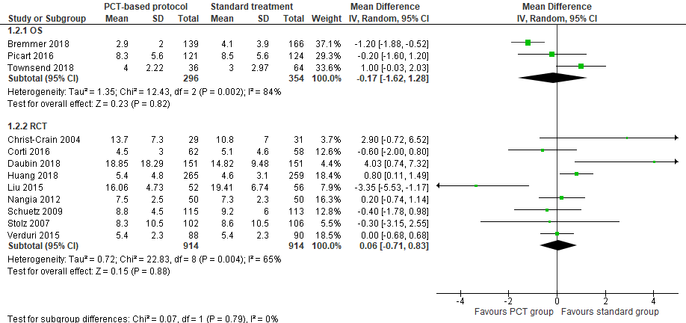
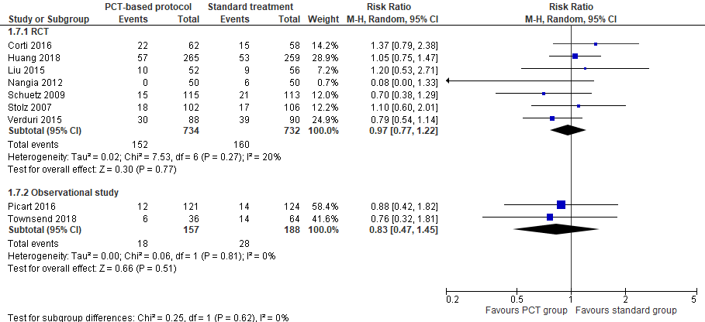
Forest plot of PCT-based protocol versus standard treatment on treatment failure

Forest plot of PCT-based protocol versus standard treatment on all-cause mortality

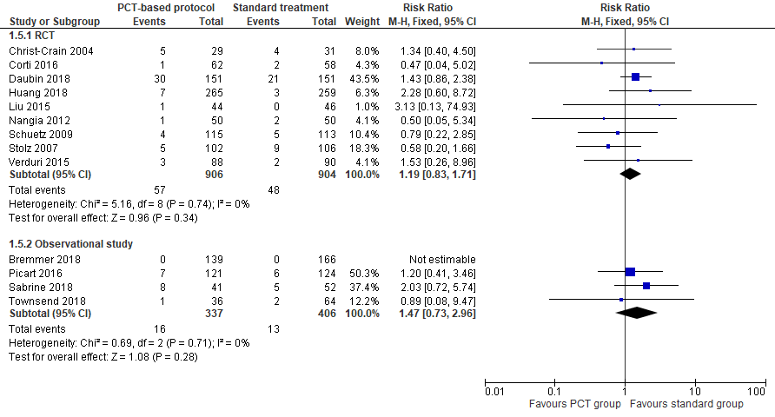
Forest plot of PCT-based protocol versus standard treatment on respiratory-related mortality

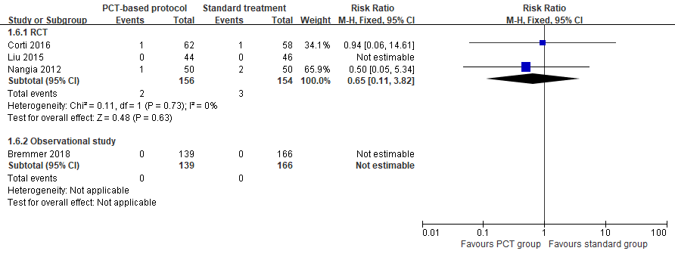

Forest plot of PCT-based protocol versus standard treatment on all-cause readmission

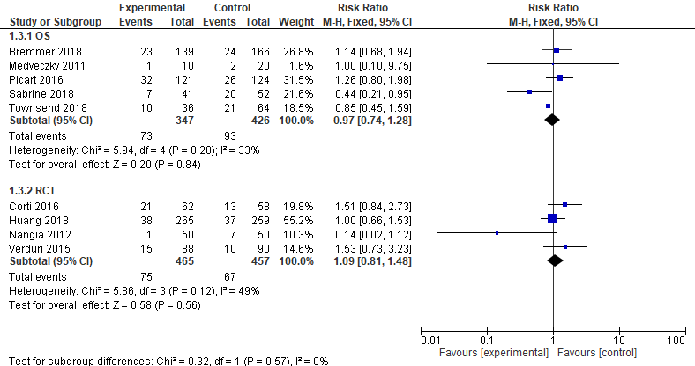
Forest plot of PCT-based protocol versus standard treatment on respiratory-related readmission

