Supplementary Materials (S1)
For
Article: “Psychological Flow Scale (PFS): Development and preliminary validation of a new flow instrument that measures the core experience of flow to include recent conceptual advancements of the flow state”.

Table S1. Descriptive Statistics for Initial 28 Items Based on Full Dataset (N = 913)

Original Item Number | PFS Item Number | Item Content | M | SD | Observed Range | Skewness | Kurtosis
1 |  | I was totally engaged in what I was doing | 5.93 | 1.05 | 1 to 7 | -1.41 | 2.87
2 | PFS1 | I was absorbed in the act/task | 5.84 | 1.14 | 1 to 7 | -1.34 | 2.24
3 |  | I felt a sense of immersion in the task/activity | 5.70 | 1.17 | 1 to 7 | -1.12 | 1.45
4 | PFS2 | I was highly focused on the task/activity | 5.83 | 1.18 | 1 to 7 | -1.20 | 1.41
5 |  | I felt a deep state of concentration on the task/activity | 5.38 | 1.40 | 1 to 7 | -0.87 | 0.26
6 | PFS3 | All my attention was on the task/activity | 5.35 | 1.43 | 1 to 7 | -0.84 | -0.02
7 | † | I didn't think about what I needed to do, I just did it | 4.69 | 1.74 | 1 to 7 | -0.40 | -0.98
8 |  | I was preoccupied with thoughts other than the task/activity | 4.45 | 1.70 | 1 to 7 | -0.23 | -1.09
9 | † | I acted spontaneously without having to think about it | 4.13 | 1.70 | 1 to 7 | -0.12 | -1.03
10 |  | I was so involved in the act/task, nothing else mattered | 4.29 | 1.70 | 1 to 7 | -0.10 | -1.04
11 |  | I was distracted | 5.12 | 1.61 | 1 to 7 | -0.74 | -0.45
12 |  | I felt concerned about my actions/performance | 5.01 | 1.82 | 1 to 7 | -0.74 | -0.65
13 |  | There was a sense of ease to my actions | 5.09 | 1.32 | 1 to 7 | -0.80 | 0.42
14 | † | It felt like I was letting it happen rather than making it | 3.63 | 1.78 | 1 to 7 | 0.22 | -1.14
15 | PFS4 | I felt like I could easily control what I was doing | 5.71 | 1.10 | 1 to 7 | -1.20 | 2.37
16 | PFS5 | My actions flowed effortlessly | 5.19 | 1.36 | 1 to 7 | -0.81 | 0.27
17 | PFS6 | There was a sense of fluidity to my actions | 5.32 | 1.21 | 1 to 7 | -0.75 | 0.64
18 |  | My performance/actions felt intuitive | 5.35 | 1.21 | 1 to 7 | -0.87 | 0.82
19 |  | There was a sense of effortlessness to what I was doing | 4.80 | 1.57 | 1 to 7 | -0.56 | -0.51
20 | PFS7 | I found the experience rewarding | 5.68 | 1.42 | 1 to 7 | -1.28 | 1.36
21 | PFS8 | The experience felt satisfying | 5.73 | 1.36 | 1 to 7 | -1.30 | 1.49
22 | PFS9 | I would like the feeling of that experience again | 5.57 | 1.47 | 1 to 7 | -1.15 | 0.93
23 |  | The experience felt somewhat unfulfilling | 5.44 | 1.53 | 1 to 7 | -1.08 | 0.47
24 |  | I really enjoyed the experience | 5.23 | 1.51 | 1 to 7 | -0.83 | 0.25
25 |  | The experience felt fulfilling | 5.40 | 1.43 | 1 to 7 | -1.05 | 0.79
26 |  | The experience felt dissatisfying | 5.82 | 1.33 | 1 to 7 | -1.43 | 1.83
27 |  | Simply participating in the task/activity felt pleasing | 5.24 | 1.44 | 1 to 7 | -0.90 | 0.36
28 |  | I felt alert | 5.52 | 1.24 | 1 to 7 | -1.17 | 1.68
† indicates that item was included for CFA testing, but not retained in the final scale.

Figure S1. Observed and 95th Percentile Parallel Eigenvalues

Figure S2. Model 1: Single Global Factor

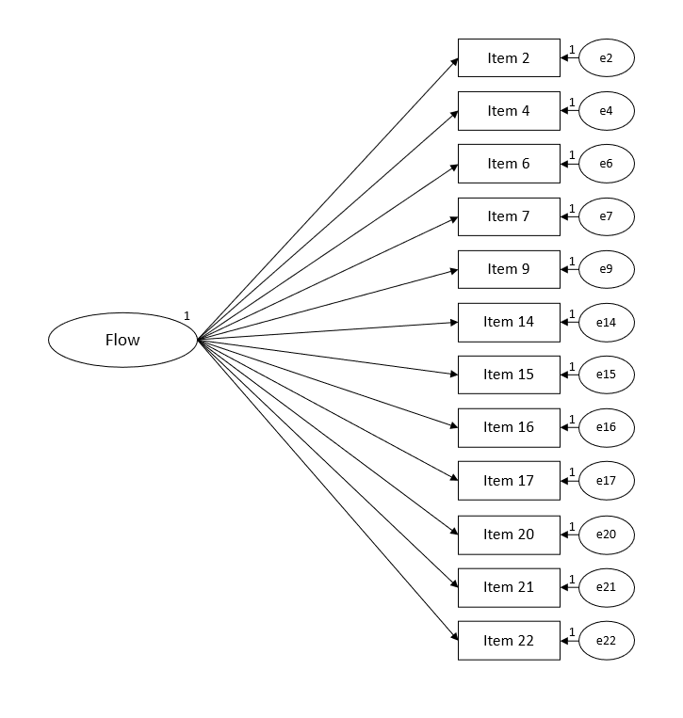

Figure S3. Model 2: Four Orthogonal Factors

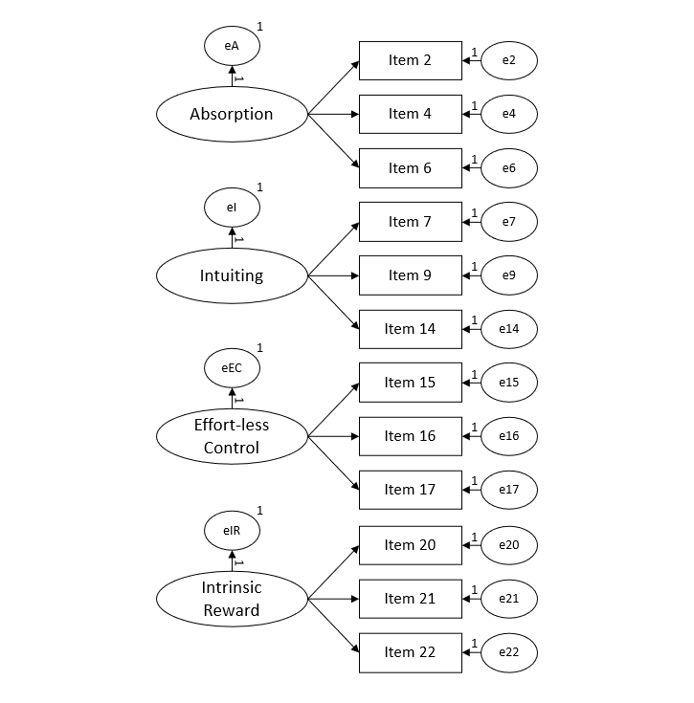

Figure S4. Model 3: Higher-Order Model (Four First-Order Factors)

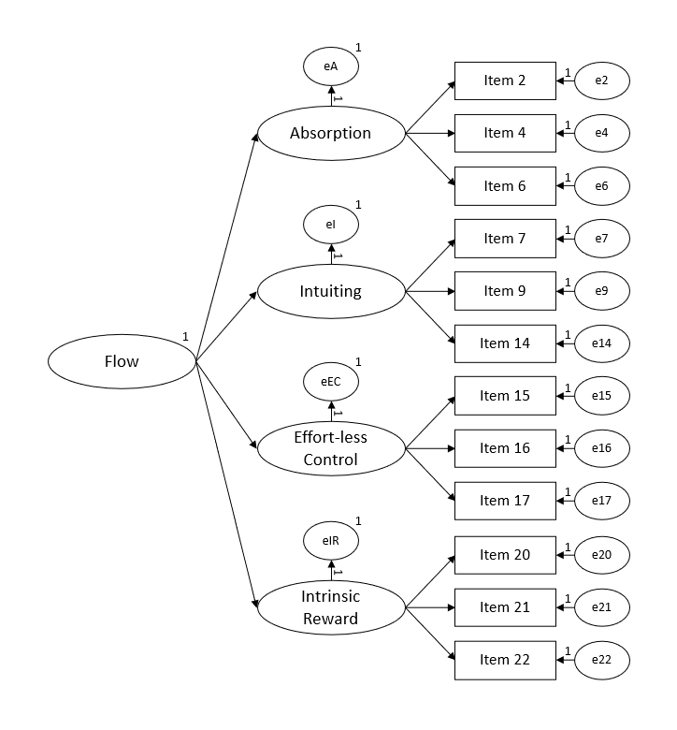

Figure S5. Modified Higher-Order Model (Three First-Order Factors)

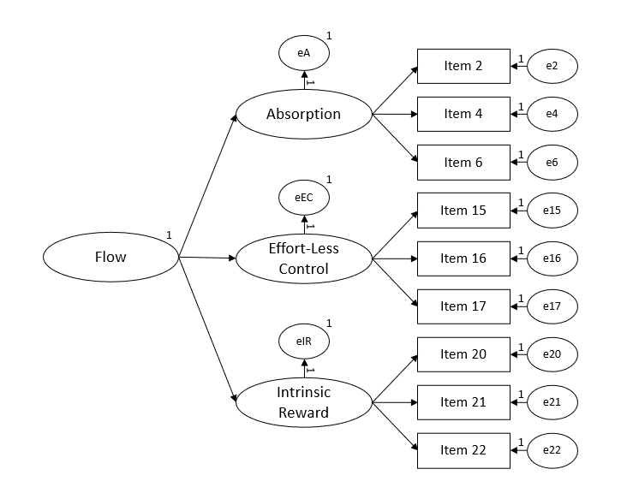

Table S2. Factor Loadings for Models 1-3
Factor loading | Unstandardized | SE |  | Standardized
Model 1: Single global factor
Flow → Item 2 | 0.61*** | 0.05 |  | 0.55
Flow → Item 4 | 0.61*** | 0.05 |  | 0.52
Flow → Item 6 | 0.64*** | 0.07 |  | 0.44
Flow → Item 7 | 0.31*** | 0.08 |  | 0.18
Flow → Item 9 | 0.23*** | 0.08 |  | 0.14
Flow → Item 14 | -0.03** | 0.09 |  | -0.02
Flow → Item 15 | 0.41 | 0.05 |  | 0.36
Flow → Item 16 | 0.46*** | 0.06 |  | 0.34
Flow → Item 17 | 0.52*** | 0.06 |  | 0.44
Flow → Item 20 | 1.19*** | 0.05 |  | 0.87
Flow → Item 21 | 1.24*** | 0.05 |  | 0.93
Flow → Item 22 | 1.26*** | 0.05 |  | 0.89
Model 2: Four orthogonal factors
Absorption→ Item 2 | 0.85*** | 0.05 |  | 0.77
Absorption → Item 4 | 1.06*** | 0.05 |  | 0.91
Absorption → Item 6 | 1.16*** | 0.06 |  | 0.79
Intuiting → Item 7 | 1.42*** | 0.11 |  | 0.82
Intuiting → Item 9 | 1.26*** | 0.10 |  | 0.75
Intuiting → Item 14 | 0.74*** | 0.09 |  | 0.41
Effort-less Control → Item 15 | 0.80*** | 0.05 |  | 0.71
Effort-Less Control → Item 16 | 1.22*** | 0.05 |  | 0.91
Effort-Less Control → Item 17 | 1.00*** | 0.05 |  | 0.83
Intrinsic Reward → Item 20 | 1.19*** | 0.05 |  | 0.87
Intrinsic Reward → Item 21 | 1.28*** | 0.05 |  | 0.96
Intrinsic Reward → Item 22 | 1.26*** | 0.05 |  | 0.89
Model 3: Higher-order model (four first-order factors)
Flow → Absorption | 0.93*** | 0.12 |  | 0.68
Flow → Intuiting | 0.33*** | 0.07 |  | 0.32
Flow → Effort-less Control | 0.78*** | 0.10 |  | 0.62
Flow → Intrinsic Reward | 0.97*** | 0.13 |  | 0.70
Absorption→ Item 2 | 0.64*** | 0.05 |  | 0.78
Absorption → Item 4 | 0.77*** | 0.05 |  | 0.90
Absorption → Item 6 | 0.85*** | 0.06 |  | 0.79
Intuiting → Item 7 | 1.39*** | 0.10 |  | 0.85
Intuiting → Item 9 | 1.16*** | 0.09 |  | 0.73
Intuiting → Item 14 | 0.68*** | 0.09 |  | 0.40
Effort-less Control → Item 15 | 0.63*** | 0.05 |  | 0.71
Effort-less Control → Item 16 | 0.92*** | 0.06 |  | 0.88
Effort-less Control → Item 17 | 0.82*** | 0.05 |  | 0.86
Intrinsic Reward → Item 20 | 0.86*** | 0.06 |  | 0.87
Intrinsic Reward → Item 21 | 0.92*** | 0.06 |  | 0.95
Intrinsic Reward → Item 22 | 0.91*** | 0.06 |  | 0.89
Note. Item numbering in table refers to the initial 28 items
** p < .01; *** p < .001

Table S3. Model Fit Indices for Final Higher-Order Model (Model 4) When Tested with Full Dataset (N = 913)

Fit Measure | Value
χ² test | χ² (24) = 96.35, p < .001
CFI | .986
TLI | .979
RMSEA | .057
RMSEA 90% CI | .046, .070
SRMR | .036
AIC | 138.35
BIC | 239.50

Table S4. Factor Loadings for Final Higher-Order Model (Model 4) When Tested with Full Dataset (N = 913)

Factor loading | Unstandardized | SE | Standardized
Flow → Absorption | 0.78*** | 0.09 | 0.61
Flow → Effort-less Control | 1.26*** | 0.21 | 0.78
Flow → Intrinsic Reward | 0.50*** | 0.06 | 0.45
Absorption→ Item 2 | 0.73*** | 0.04 | 0.81
Absorption → Item 4 | 0.83*** | 0.04 | 0.90
Absorption → Item 6 | 0.92*** | 0.05 | 0.81
Effort-less Control → Item 15 | 0.63*** | 0.03 | 0.65
Effort-less Control → Item 16 | 1.05*** | 0.04 | 0.87
Effort-less Control → Item 17 | 0.92*** | 0.04 | 0.86
Intrinsic Reward → Item 20 | 0.79*** | 0.08 | 0.90
Intrinsic Reward → Item 21 | 0.80*** | 0.08 | 0.95
Intrinsic Reward → Item 22 | 0.79*** | 0.08 | 0.86
Note. Item numbering in table refers to the initial 28 items
p < .001

General Flow Appraisal for External Aspects of Validity

1) Please state the task/activity that you used to answer the above questions:
_____________________________

2) Please state in minutes how long the task/activity lasted for:
_____________________________

3) The questions above are designed to measure ‘flow’ experiences. Flow is described as "A total engagement in which nothing else matters, actions seem to flow effortlessly—simply participating in the act feels satisfying."
Based on your experience and responses to the above items, do you think that you experienced ‘flow’ in your recent task/activity? Please circle your answer:
Yes / No / Unsure

If you answered ‘NO’, please go to question 19. If you answered ‘YES’, continue below (18b).

3b) What percentage of the time where you in flow in relation to the total time (length) of the activity?
___________% of the time

3c) Was the flow experience a single experience or did you experience it or enter and exit it on multiple occasions within the activity?
No, just once / on two or three occasions / multiple occasions

3d) Referring back to the experience of flow, how strongly did you experience flow?
If the experience occurred more than once, please answer the below questions in relation to your strongest experience.

1 2 3 4 5 6 7 8 9 10
(very weak) (very strong)

3e) What would be the words you would use to describe the experience of flow?
___________________________ ______________________________
___________________________ ______________________________
___________________________ ______________________________
___________________________ ______________________________

4) Lastly please provide any comments on your experience; anything you deem to be of influence:

Comments:

Table S5. Pearson’s Correlations Between Validity Variables, Based on Full Dataset (N = 913)

 | Perceived Anxiety | Perceived Competence | Perceived Stress | Self-Reported Performance | Autotelic Personality | Flow Short Scale | Flow Intensity | Flow Duration
Perceived Anxiety | -
Perceived Competence | -.40 | -
Perceived Stress | .69 | -.49 | -
Self-Reported Performance | -.32 | .69 | -.40 | -
Autotelic Personality | -.16 | .36 | -.22 | .32 | -
Flow Short Scale | -.36 | .57 | -.42 | .53 | .42 | -
Flow Intensity | -.13ª | .36ª | -.16ª | .39ª | .32ª | .50ª | -
Flow Duration | -.13^{b} | .29^{b} | -.13^{b} | .25^{b} | .20^{b} | .34^{b} | .47^{c} | -
Note. All correlations significant at p < .001
ªN = 743; ^{b}N = 742; ^{c}N = 736; in all other cases N = 913

Table S6. Pearson’s Correlations for Between PFS Global Flow and Subcomponents of Autotelic Personality, Based on Full Dataset (N = 913)

 | GF | AU | CU | PE | L-SC | IM | EC | EB | AC
Global Flow (GF) | -
Autotelic Total (AU) | .38*** | -
Curiosity (CU) | .21*** | .53*** | -
Persistence (PE) | .30*** | .76*** | .39*** | -
Low Self-Centeredness (L-SC) | .10** | .55*** | .01 | .20*** | -
Intrinsic Motivation (IM) | .28*** | .47*** | .36*** | .28*** | -.02 | -
Enjoyment/Transformation of Challenge (EC) | .20*** | .63*** | .39*** | .51*** | .15*** | .23*** | -
Enjoyment/Transformation of Boredom (EB) | .28*** | .55*** | .33*** | .33*** | .00 | .33*** | .33*** | -
Attentional Control (AT) | .25*** | .58*** | .01 | .50*** | .36*** | .03 | .18*** | .12*** | -
Note. N = 913 in all cases.
* p < .05; ** p < .01; *** p < .001

Table S7. Mean (SD) PFS Scores Across Levels of Self-Reported Flow Entry
Subscale | Yes (n = 648) | Unsure (n = 101) | No (n = 164)
Global Flow | 5.86 (0.70) | 5.21 (0.80) | 4.68 (0.86)
Absorption | 5.94 (0.94) | 5.40 (1.13) | 4.77 (1.22)
Effort-less Control | 5.67 (0.90) | 4.97 (1.02) | 4.62 (1.18)
Intrinsic Reward | 5.98 (1.08) | 5.25 (1.45) | 4.66 (1.53)

Figure S6. Histogram for Self-Reported Percentage of in Time in Flow During Activity (Flow Duration)

Figure S7. Histogram for Self-Reported Intensity of Flow During Activity (Flow Intensity)

Table S8. Self-Reported Frequency with Which Participants Went in and out of Flow Experience During Activity (Flow Frequency)

 | N | %
Just Once | 279 | 30.6%
On two or three occasions | 278 | 30.4%
Multiple occasions | 192 | 21.0%
Note. Question limited to those who reported experiencing flow

