Supplementary Material

Article Title: The Search for Meaning at Work: A Randomized Controlled Trial of a Cognitive Crafting Intervention
Journal: International Journal of Applied Positive Psychology
Corresponding Author: XXX

Table S1
Instructions for the Reflection Exercises
Intervention Condition
Introduction
People differ in how they think about their work.
Some people think of their work as a collection of disjointed individual tasks, which can make it seem less meaningful to them. Others place the tasks at work in a larger context and thus give them more meaning. This is achieved by linking tasks to personal benefits (e.g., self-fulfilment, career development), achievement of organisational goals (e.g., the organisational vision) or added value for others (e.g., benefits for colleagues, customers, society).
So, it is very individual how meaningful one finds one's work. This perception can change over time.
We would like to illustrate this with an example: A person in the sales department of an Internet provider markets broadband Internet in rural areas. She might see the task of signing a new customer contract as a single and insignificant task. However, she might also recognise the benefits that the contract has for local people (e.g., working in a home office becomes possible) and thus experience her work as more significant.
The short reflection exercise that you do after work each of the coming five days is about thinking about the meaningfulness of your work. You will reflect on what added value you see for yourself and for others in the concrete activities of your work (approx. 5 minutes each).
Daily Instruction
Take a moment and think back to your working day today. Remember what tasks you did today and/or what projects you worked on. Think of three specific activities.
Then think about what meaning each of these activities fulfilled from your point of view. The meaning can be for yourself (e.g., self-fulfilment, self-
development), for your company (e.g., company success or goals) or for others (e.g., added value for customers, colleagues or society). An activity can be meaningful in one or more of these areas.
Here are examples of what the results of such a reflection might look like:
"By leading today's meeting, I was able to develop my facilitation skills."
"By preparing the quarterly figures, my company can better position itself strategically in the future."
"By repairing an elderly lady's heating system, she no longer freezes in winter."
Now write down your thoughts on 3 specific
activities of today (one sentence each, at least 100 characters in total). Be sure to briefly describe both the activity and the meaning you found.
Note: In some professions, activities can be very repetitive. In this case, too, we ask you to name them again and reflect on their meaning in writing.

Table S1 (continued)
Control Conditionª
Introduction
Of all the memories we have accumulated over a lifetime, very few remain from early childhood. Careful consideration of these early memories can help us understand who we are today.
The 5-minute exercise you will do in the next five days after work is designed to help you better understand your own history and to be able to integrate your own experiences into an overall context. Even if you already deal with this from time to time, take the opportunity to further train this strength
Daily Instruction
Now take a moment. Recall an early childhood memory and write it down in as much detail as you can.
Try to remember exactly what you did, how you felt, and which people were also involved (if you can't remember all the details, this is not a problem, just write down everything you can think of).

Note. Participants received the introduction on the first day of the intervention week prior to performing the reflection exercise for the first time. They were able to reread the introduction on each of the following days of the intervention week.
Instructions were originally presented in German and were translated using DeepL Translator (deepl.com/translator). The original instructions can be requested from the corresponding author.
ª ‘Early memories’-exercises (Original from Seligman et al., 2005; German version by Gander et al. 2016)

Table S2

Fixed Effects of the Intervention Conditionª on Work-Related Well-Being.
Post-intervention |  |  |  |  |  |  |  |  | One-month follow-up
 | Estimate | SE | df | t | p | f2 |  | Estimate | SE | df | t | p | f2
Cognitive Crafting | 0.11 | 0.06 | 709.19 | 1.93 | .055 | 0.02 |  | 0.11 | 0.06 | 722.17 | 1.81 | .071 | 0.02
Meaningful work | 0.09 | 0.04 | 684.74 | 2.22 | .027** | 0.01 |  | 0.08 | 0.04 | 703.86 | 2.03 | .043* | 0.01
Person-job fit | 0.07 | 0.05 | 689.11 | 1.56 | .119 | 0.01 |  | 0.04 | 0.05 | 707.31 | 0.84 | .400 | 0.01
Work engagement | 0.11 | 0.05 | 701.39 | 2.31 | .022* | 0.02 |  | 0.07 | 0.05 | 716.27 | 1.33 | .186 | 0.01
Job satisfaction | 0.20 | 0.06 | 684.60 | 3.12 | .002** | 0.03 |  | 0.24 | 0.07 | 703.88 | 3.51 | <.001*** | 0.04
Note. ª Estimates represent the Time × Condition interaction (intervention vs. control at each post-baseline time point).
*p < .05. **p < .01. ***p < .001

Table S3
Explorative Analysis of Group Differences in Intervention and Control Group
 | Intervention |  | Control
Variable | Mean (SD) |  | Mean (SD) | t(df) | χ²(df) | p
Liking | 5.14 (1.27) |  | 4.81 (1.34) | -2.01 (250.16) |  | .045*
Perceived value | 4.74 (1.45) |  | 4.02 (1.44) | -4.03 (254.49) |  | <.001***
Conscientiousness | 6.32 (0.76) |  | 6.25 (0.71) | -0.71 (257.32) |  | .480
Engagement after intervention |  |  |  |  | 1.35 (3) | .716

Note. Engagement was measured categorically (e.g., "not at all", "occasionally", etc.).
*p < 0.05. **p < 0.01. ***p < 0.001.

Table S4
Results of the Explorative Qualitative Data Analysis
Theme | Positive Impact on Others
Theme | Assisting or Supporting Others | Serving Others | Building Relationships and Collaboration | Contributing to the Education and Development of Others | Impacting the Emotions of Others
Description | The activity provides assistance or support to other individuals, for example, by answering questions, reducing workload burdens, or assisting in problem-solving. | The activity is carried out for the benefit of other individuals, without reference to specific requests or prompts such as questions or problems. | The activity is aimed at expanding or improving one's own or others' relationships or collaboration, as well as establishing new contacts. | The activity serves to convey knowledge or to develop and assess the knowledge or skills of others. | The activity positively impacts the emotions of others, including eliciting positive feelings or reducing negative emotions.
Example | Through processing emails, I was able to assist others and provide feedback. | Through my contribution in the morning meeting, my colleagues have a better overview of the status of the tasks. | The team teaching with my colleague was helpful for both of us and had positive effects on our relationship. | I have created a product training for our new apprentices. Through this, I provide them with the necessary technical information they need for their daily work. | Through my encouragement, I was able to reduce my client's fears.
Similarities with Existing Research | Serving others (Lips-Wiersma & Morris, 2009), competence in the SDT (Ryan & Deci, 2000), contribution (Bailey et al., 2024; Martikainen et al., 2022; Pavlish & Hunt, 2012; Rosso et al., 2010) | Serving others (Lips-Wiersma & Morris, 2009), competence in the SDT (Ryan & Deci, 2000), contribution (Bailey et al, 2024; Martikainen et al., 2022; Pavlish & Hunt, 2012; Rosso et al., 2010) | Unity with others (Lips-Wiersma & Morris, 2009), unification (Rosso et al., 2010), relatedness in the SDT (Ryan & Deci, 2000), connection (Martikainen et al., 2022; Pavlish & Hunt, 2012), relationality (Trittin-Ulbrich & Glozer, 2024) | Serving others (Lips-Wiersma & Morris, 2009), competence in the SDT (Ryan & Deci, 2000), contribution (Bailey et al., 2024; Martikainen et al., 2022; Pavlish & Hunt, 2012; Rosso et al., 2010) | Serving others (Lips-Wiersma & Morris, 2009), competence in the SDT (Ryan & Deci, 2000), contribution (Bailey et al., 2024; Martikainen et al., 2022; Pavlish & Hunt, 2012; Rosso et al., 2010)
Table S4
Results of the Explorative Qualitative Data Analysis
Theme | Achievement and Organizational Contribution
Theme | Efficient Work Practices | Contributing to Organizational Success | Goal Achievement and Progress | Maintenance of Operations | Quality Management
Description | The activity serves to enhance efficiency, such as streamlining future work processes, saving time, or making preparatory arrangements. | The activity contributes to the success of the organization, for example in terms of revenue, maintaining and building reputation, strategic alignment, or attracting employees or customers. | The activity is related to goal achievement, task completion or progress. | The activity contributes towards upholding operational integrity, for example, maintaining structures within the organization or ensuring seamless organizational procedures. | The activity is directed towards upholding quality standards, including fixing errors and improving the quality of products or services.
Example | Through my intensive training of my apprentice, I will save more time in the future. | I worked on a loading plan today to ship food to Europe from Vietnam. This contributes to the well-being and revenue of the company. | Through conscientious input of index cards, I am getting closer to the project goal. | By discussing the currently upcoming courses in my field and deciding on their implementation and modalities, I ensure a smooth course progression. | Through error correction, I was able to improve product stability.
Similarities with Existing Research | Expressing full potential (Lips-Wiersma & Morris, 2009), competence in the SDT (Ryan & Deci, 2000), individuation (Rosso et al., 2010) | Expressing full potential (Lips-Wiersma & Morris, 2009), competence in the SDT (Ryan & Deci, 2000), individuation (Rosso et al., 2010), daily work as a symbol of the organization’s vision (Carton, 2018), cognitive crafting (Slemp & Vella-Brodrick, 2014) | Expressing full potential (Lips-Wiersma & Morris, 2009), competence in the SDT (Ryan & Deci, 2000), individuation (Rosso et al., 2010) | Expressing full potential (Lips-Wiersma & Morris, 2009), competence in the SDT (Ryan & Deci, 2000), individuation (Rosso et al., 2010) | Expressing full potential (Lips-Wiersma & Morris, 2009), competence in the SDT (Ryan & Deci, 2000), individuation (Rosso et al., 2010)

Table S4
Results of the Explorative Qualitative Data Analysis
Theme | Personal Growth and Need fulfilment
Theme | Acquiring Knowledge and Skill Enhancement | Fulfilling Personal Needs | Career Growth and Professional Development
Description | Through the activity, new knowledge is acquired or skills are trained or improved. | The activity helps to fulfil personal needs, such as promoting well-being or providing enjoyment. | The activity serves to improve of career prospects or to develop professionally.
Example | By conducting a counselling session, I was able to enhance my communication skills. | By training a new employee, I feel socially fulfilled and competent. | By elaborating on various topics for my mentoring, I was able to further plan my personal objectives/goals within the company.
Similarities with Existing Research | Developing and becoming self (Lips-Wiersma & Morris, 2009), competence in the SDT (Ryan & Deci, 2000), individuation (Rosso et al., 2010), conversion (Martikainen et al., 2022) | Autonomy, relatedness, competence, and intrinsic motivation within SDT (Ryan & Deci, 2000), conversion (Martikainen et al., 2022), recognition (Pavlish & Hunt, 2012) | Developing and becoming self (Lips-Wiersma & Morris, 2009), competence in the SDT (Ryan & Deci, 2000), individuation (Rosso et al., 2010), conversion (Martikainen et al., 2022)

Figure S1
Spaghetti Plot and Mean Trend Over Time for Meaningful Work
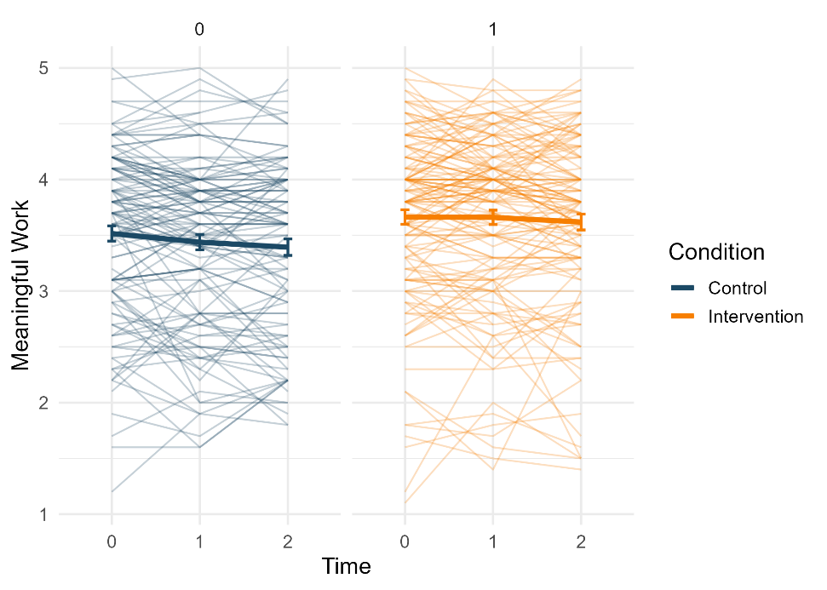
Note. For time, 0 = baseline, 1 = post-intervention, 2 = one-month follow-up.

Figure S2
Spaghetti Plot and Mean Trend Over Time for Person-Job Fit
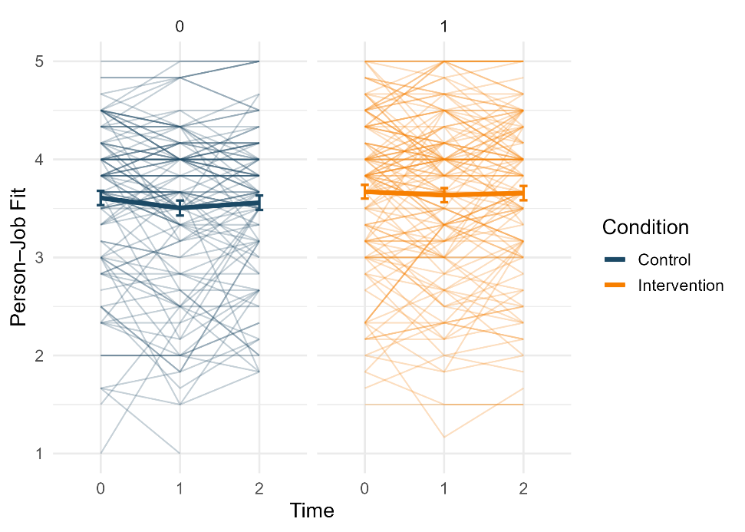
Note. For time, 0 = baseline, 1 = post-intervention, 2 = one-month follow-up.

Figure S3
Spaghetti Plot and Mean Trend Over Time for Work Engagement
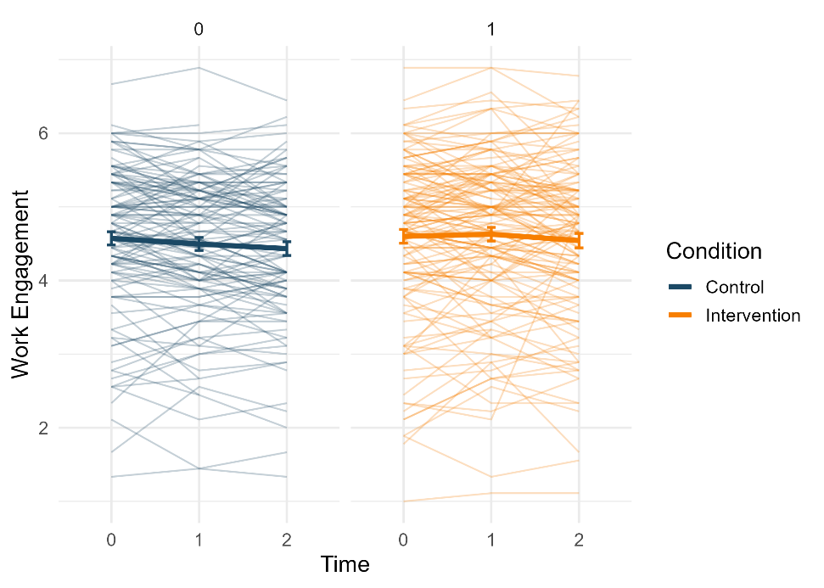
Note. For time, 0 = baseline, 1 = post-intervention, 2 = one-month follow-up.

Figure S4
Spaghetti Plot and Mean Trend Over Time for Job Satisfaction
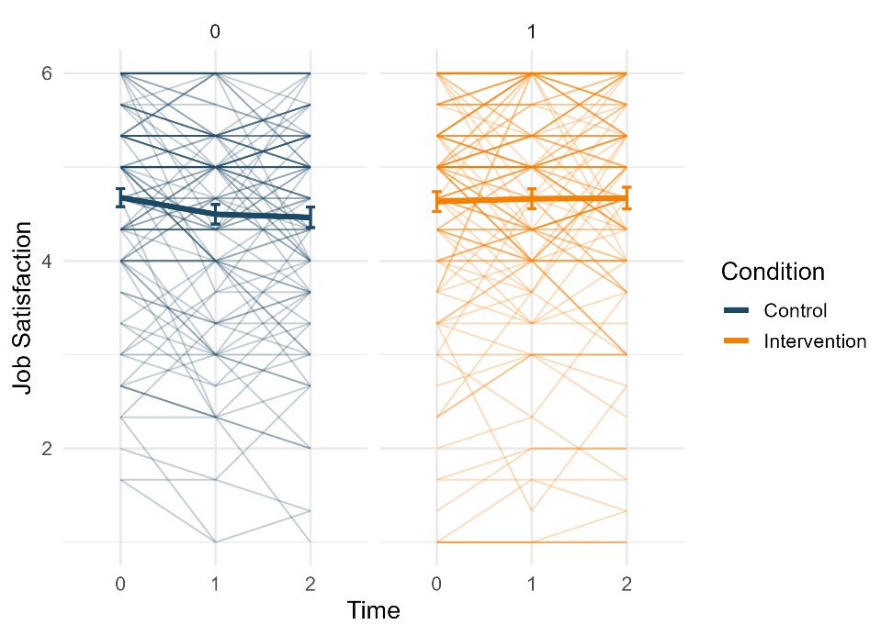
Note. For time, 0 = baseline, 1 = post-intervention, 2 = one-month follow-up.

