Supplementary files
Supplementary File 1. Inclusion/exclusion criteria.
 | Inclusion | Exclusion
Population | Enrolled or registered nurses who provided direct nursing care | Student nurses, nurse assistants, or nurses who do not provide direct patient care
Exposure | Healthcare settings | Non-healthcare settings
Outcome | Studying resilience and its associated factors as the primary outcome | Resilience and its associated factors were not the primary outcome
Type of study | Systematic reviews that involved cross-sectional studies | - Non-systematic reviews  - Systematic reviews that only involved qualitative studies  - Systematic reviews that only involved intervention studies  - Systematic reviews did not involve cross-sectional studies

Supplementary File 2. Search strategies
Population 1 | Population 2 | Exposure | Outcomes | Type of study
- Nurs* | - Work* |  | 7. Resilien* | 10. systematic review
 | - Employ* |  | 8. Hardiness
 | - Occupation*
 | - Job*
1 | - Combine 2–5 using OR |  | 9. Combine 7–8 using OR | 10
Note: Combining 1, 6, 9, and 10 with “AND” to identify the results.
Supplementary File 3: Search in each database
CINAHL search:
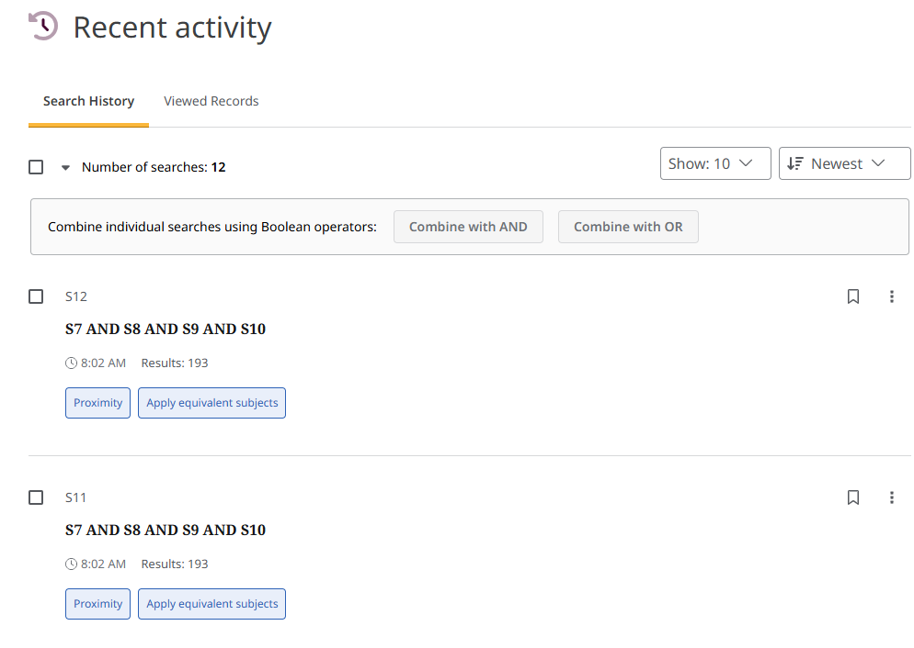
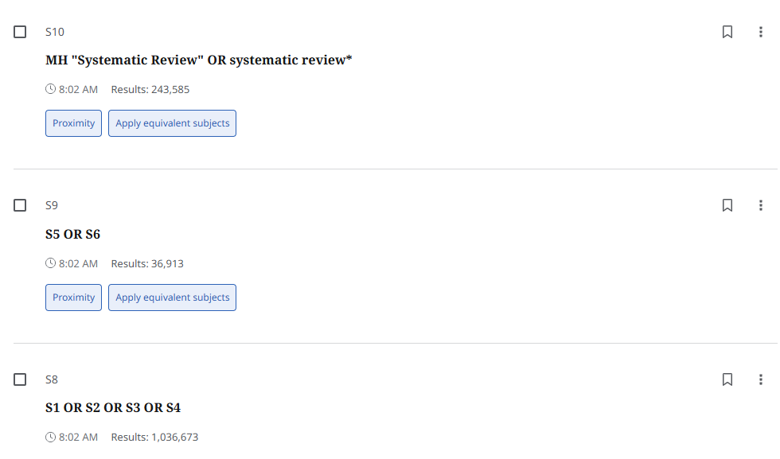
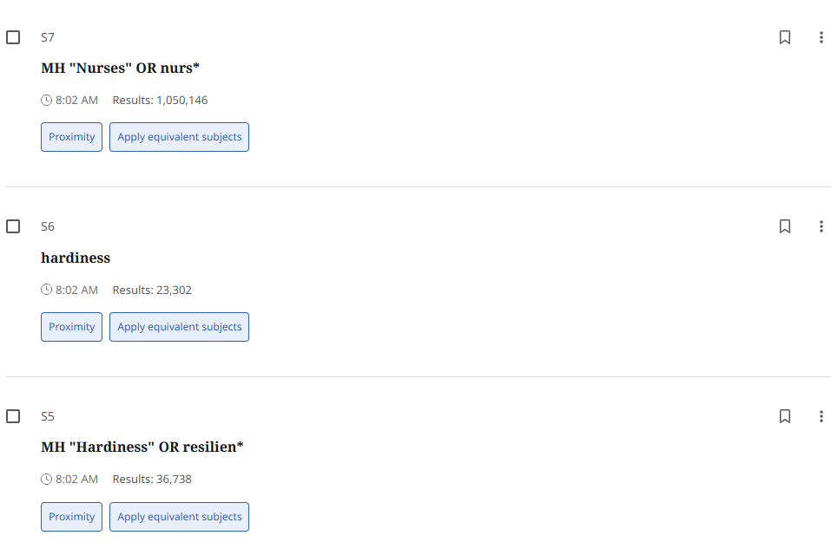
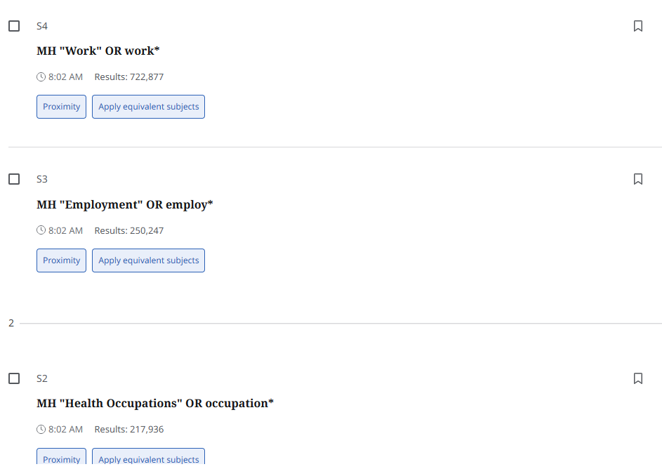

Medline search:
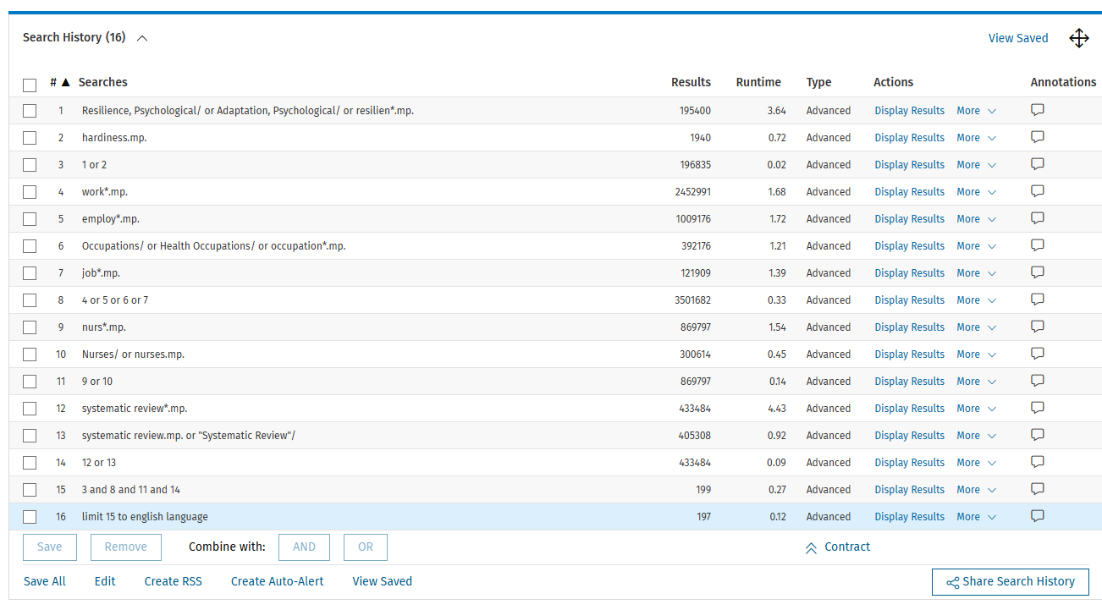
PsycINFO search
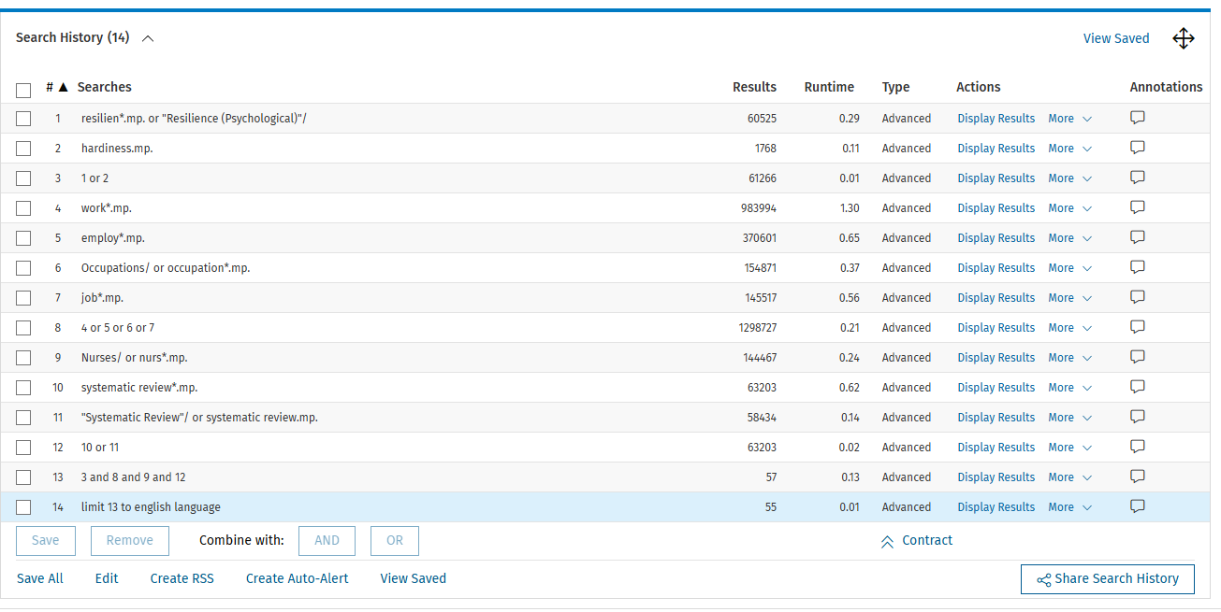
Embase search
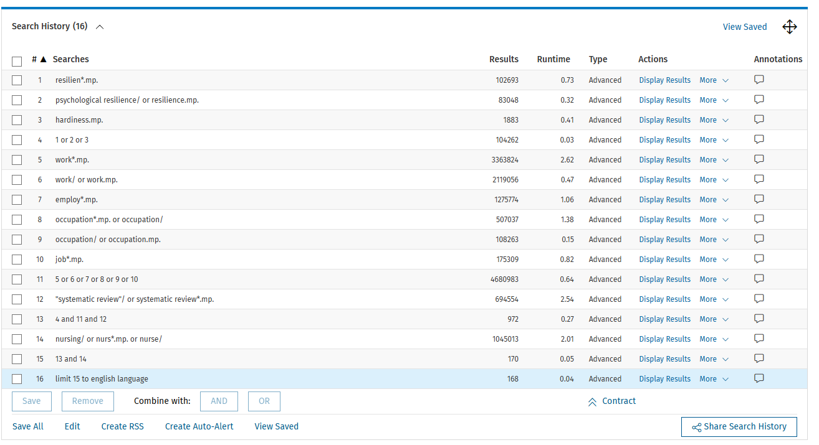
Cochrane Library search
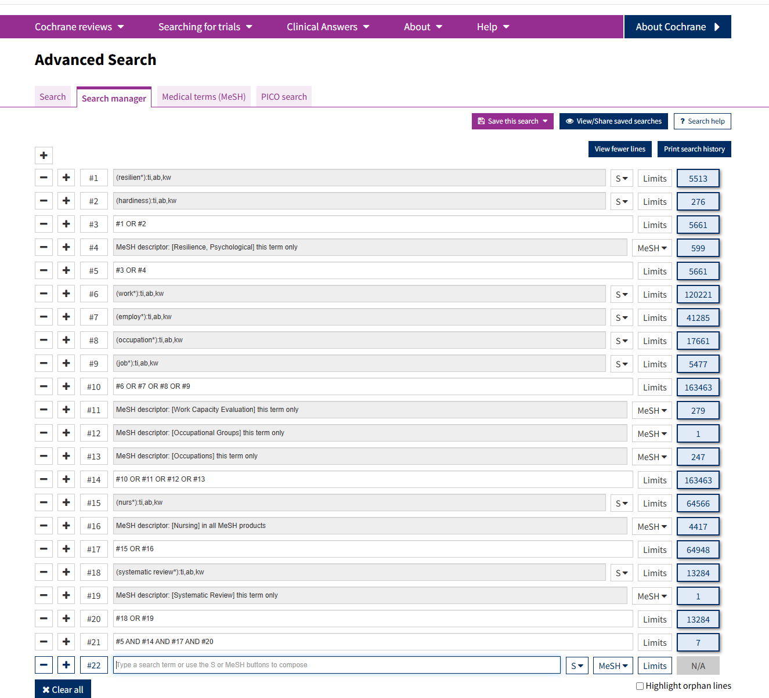
Scopus:
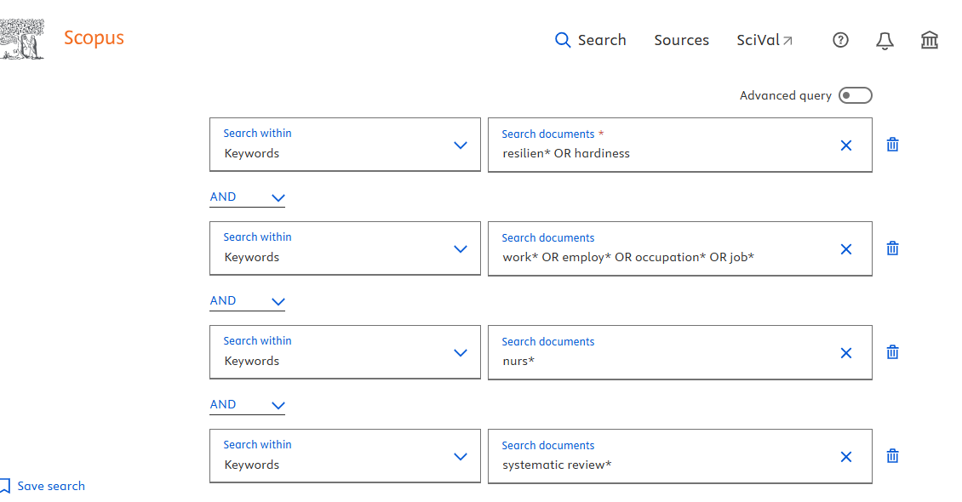
Or:
( KEY ( resilien* OR hardiness ) AND KEY ( work* OR employ* OR occupation* OR job* ) AND KEY ( nurs* ) AND KEY ( systematic review* ) ) AND ( LIMIT-TO ( LANGUAGE , "English" ) )
Supplementary File 4. Synthesised resilience, associated factors, and overlap analysis
Resilience and its associated factors | Systematic reviews included (Author, year),  Number of primary studies involved in each systematic review (n) | Overlap analysis:  Number of index publications (r)  Number of included primary studies (including double counting) (N)  Corrected Covered Area (CCA%)  Interpretation of overlap
Sociodemographic
Sex | Castillol-Gonzalez 2024 (n = 3)  Sierra-Garcia 2022 (n = 5)  Sirois 2020 (n = 3)  Unjai 2022 (n = 1)  Yu 2019 (n = 1)  Yu 2025 (n = 2) | r = 14  N = 15  CCA = 1.43%  Slight overlap
Age | Kunjavara 2025 (n = 3)  Sierra-Garcia 2022 (n = 6)  Sirois 2020 (n = 8)  Unjai 2022 (n = 1)  Yu 2019 (n = 4)  Yu 2025 (n = 9) | r = 31  N = 31  No overlap
Marital status | Sirois 2020 (n = 5)  Unjai 2022 (n = 1)  Yu 2019 (n = 1)  Yu 2025 (n = 6) | r = 13  N = 13  No overlap
Education | Castillo-González 2024 (n = 27)  Kunjavara 2025 (n = 1)  Sirois 2020 (n = 9)  Yu 2019 (n = 7)  Yu 2025 (n = 4) | r = 47  N = 48  CCA = 0.53%  Slight overlap
Years of nursing experience | Castillo-González 2024 (n = 27)  Sierra-Garcia 2022 (n = 6)  Sirois 2020 (n = 2)  Yu 2019 (n = 4)  Yu 2025 (n = 8) | r = 45  N = 47  CCA = 1.11%  Slight overlap
Income | Castillo-González 2024 (n = 27)  Sierra-Garcia 2022 (n = 3)  Yu 2019 (n = 1)  Yu 2025 (n = 1) | r = 31  N = 32  CCA = 1.08%  Slight overlap
Negative psychology
Burnout | Castillo-González 2024 (n = 8)  Orgambidez 2025 (n = 18)  Sirois 2020 (n = 7)  Unjai 2022 (n = 3)  Yu 2019 (n = 10)  Yu 2025 (n = 9) | r = 54  N = 55  CCA = 0.37%  Slight overlap
Emotional exhaustion | Castillo-González 2024 (n = 16)  Kunjavara 2025 (n = 5)  Orgambidez 2025 (n = 8)  Yu 2025 (n = 1) | r = 28  N = 30  CCA = 2.38%  Slight overlap
Stress | Kunjavara 2025 (n = 5)  Sirois 2020 (n = 8)  Yu 2019 (n = 8)  Yu 2025 (n = 10) | r = 31  N = 31  No overlap
Anxiety | Kunjavara 2025 (n = 4)  Sirois 2020 (n = 7)  Unjai 2022 (n = 1)  Yu 2019 (n = 3)  Yu 2025 (n = 5) | r = 19  N = 20  CCA = 1.32%  Slight overlap
Depression | Sirois 2020 (n = 7)  Unjai 2022 (n = 1)  Yu 2019 (n = 3)  Yu 2025 (n = 8) | r = 18  N = 19  CCA = 1.85%  Slight overlap
Posttraumatic stress disorder | Sirois 2020 (n = 7)  Unjai 2022 (n = 1)  Yu 2019 (n = 3) | r = 10  N = 11  CCA = 5.00%  Moderate overlap
Positive psychology
Coping skills | Kunjavara 2025 (n = 1)  Sirois 2020 (n = 9)  Yu 2019 (n = 6)  Yu 2025 (n = 4) | r = 20  N = 20  No overlap
Self-efficacy/perceived control | Sirois 2020 (n = 10)  Yu 2019 (n = 5)  Yu 2025 (n = 2) | r = 17  N = 17  No overlap
Overall psychosocial health | Kunjavara 2025 (n = 5)  Sirois 2020 (n = 1)  Yu 2019 (n = 3)  Yu 2025 (n = 7) | r = 16  N = 16  No overlap
Interpersonal and organisational support | Castillo-González 2024 (n = 27)  Galanis 2022 (n = 6)  Sierra-Garcia 2022 (n = 5)  Sirois 2020 (n = 28)  Yu 2019 (n = 5)  Yu 2025 (n = 10) | r = 81  N = 81  No overlap

