Supplementary Files

Supplementary File 1. Search strategies
Population 1 | Population 2 | Exposure | Outcomes | Type of study
- Nurs* | - Work* |  | 7. Resilien* | 10. systematic review
 | - Employ* |  | 8. Hardiness
 | - Occupation*
 | - Job*
1 | - Combine 2-5 using OR |  | 9. Combine 7-8 using OR | 10
Note: Combining 1, 6, 9, and 10 with “AND” to identify the results.

Supplementary File 2: Search in each database
Note: The search strategy was developed for the broader registered umbrella review and intentionally broadened to identify both resilience-related factors and interventions among nurses.
CINAHL:
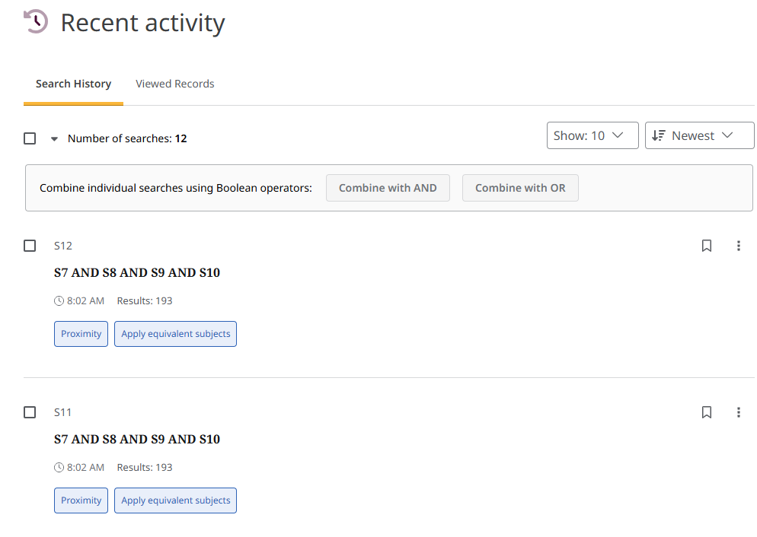
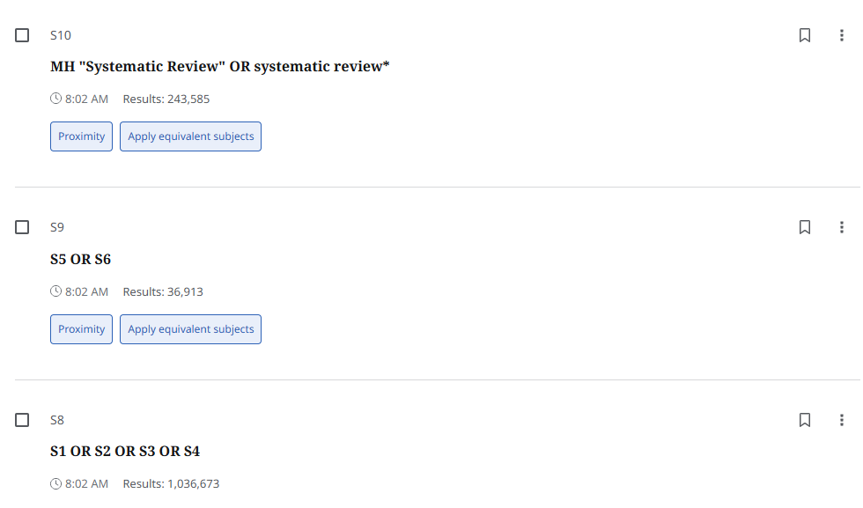
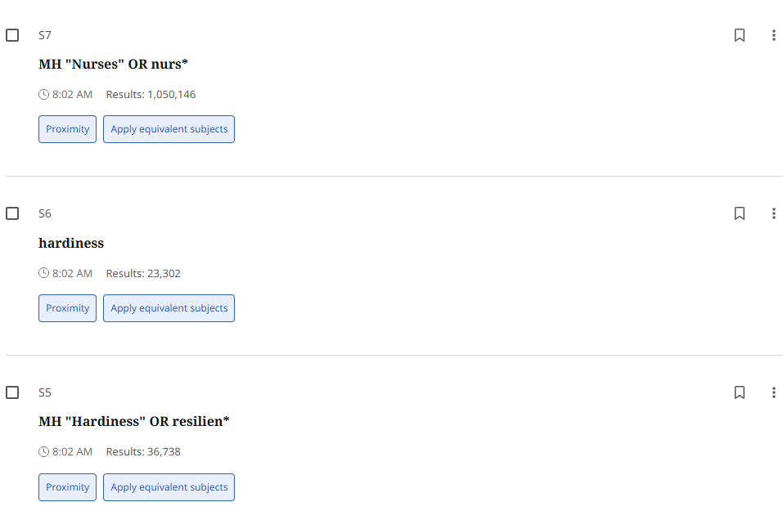
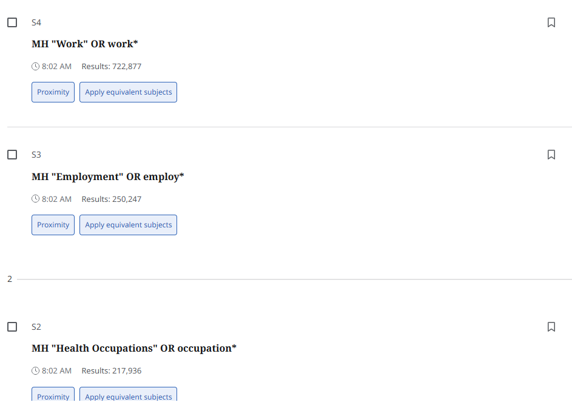

Medline:
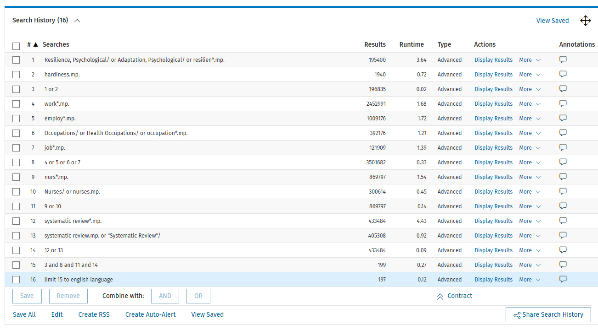

PsycINFO:
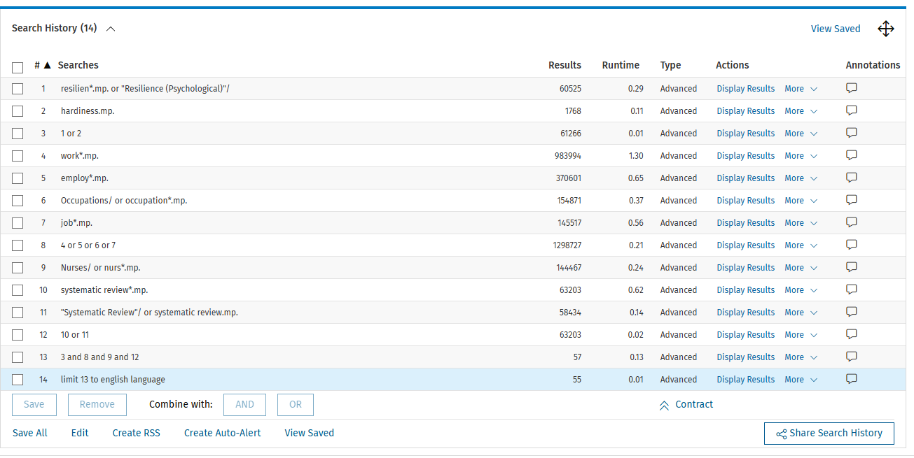

Embase:
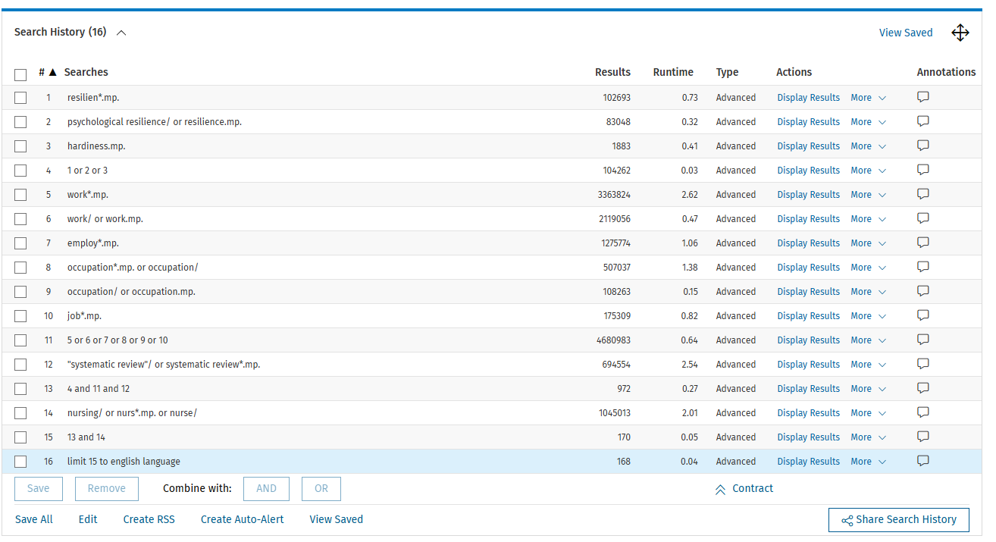

Cochrane Library:
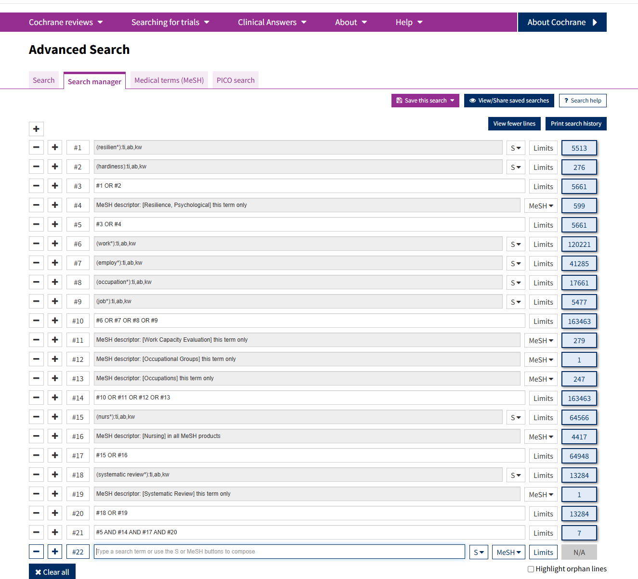

Scopus:
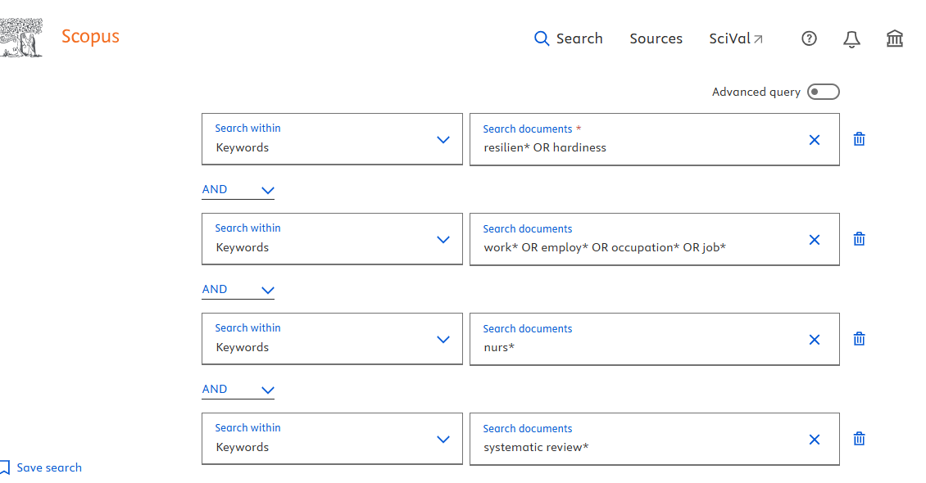
Or:
( KEY ( resilien* OR hardiness ) AND KEY ( work* OR employ* OR occupation* OR job* ) AND KEY ( nurs* ) AND KEY ( systematic review* ) ) AND ( LIMIT-TO ( LANGUAGE , "English" ) )

Supplementary File 3: Inclusion/exclusion criteria.
 | Inclusion | Exclusion
Population | Enrolled or registered nurses who provided direct nursing care | Student nurses, nurse assistants, and nurses who do not provide direct patient care
Intervention | Resilience interventions/of mindfulness-based interventions, aimed at improving resilience or positive psychological outcomes | Studies that did not evaluate the effectiveness of resilience or mindfulness-based interventions
Comparator | Any comparator, including usual care, no intervention, waitlist, alternative intervention, or not applicable | Not applicable
Outcome | Effectiveness of mindfulness-based resilience interventions as the primary outcome | Studies that did not identify the effectiveness of mindfulness-based resilience interventions
Study | Systematic reviews that involved intervention studies (RCTs as the primary study type) and provided quantitative data. | - Non-quantitative systematic review  - Qualitative systematic reviews  - Systematic reviews that involved intervention studies but did not provide the quantitative data, although they involved RCTs.

Supplementary File 4. Data collated from individual systematic reviews
Outcome | Effects of post-intervention up to 3 months (≤ 3 months follow-ups) | Effects of post-intervention > 3 months (> 3 months follow-ups)
Negative psychology
Burnout | - Dou 2025 (SMD = -1.43, 95% CI [-1.94 to -0.92], p < 0.001) (n = 13)  - Liu, Guo 2025 SMD = -1.28, 95% CI: [-2.31 to -0.25], I² = 92%, p = 0.01 (n = 3)  - Zhai 2021 (SMD = -1.01; 95% CI [-1.25 to -0.76]; p <0 .0001) (n = 3)
Stress | - Kang 2022 (SMD = −0.61; 95% CI [−1.03 to −0.19]; I2 = 70.0%; n = 4).  - Kunzler 2022 (SMD = −0.49, 95% CI [-0.84 to -0.14]; p = 0.006) (n = 5)  - Liu, Guo 2025 (SMD = -0.75, 95% CI [-1.34 to -0.17], I² = 79%, p = 0.01) (n = 3)  - Zhai 2021 (SMD = -0.60; 95% CI [-0.80 to -0.40]; p <0 .00001) (n = 9) | - Liu, Guo 2025 (MD = -9.69, 95% CI [-10.18 to -9.21] I² = 0%, p < 0.0001) (n = 2)*  - Kunzler 2022 SMD = −0.27, p = .24, 95% CI [-0.71, 0.17]) (n = 1)
Anxiety | - Kang 2022 (SMD = −0.37; 95% CI [-0.58 to −0.16], I² = 15.2%. n = 6  - Kunzler 2022 (SMD = - 0.59, 95% CI [-1.09, -0.10]; I² = 0%, p =0.02) (n = 2)  - Liu, Guo 2025 (SMD = -1.97, 95% CI [-4.18 to 0.24], I² = 99%, P = 0.08) (N = 5)  - Zhai 2021 (SMD = -0.50; 95% CI [ -0.80 to -0.20]; p = 0.001) (n = 7) | - Liu, Guo 2025 (MD = -10.80, 95% CI [-16.76 to -4.83], I² = 78%, p < 0.001) (n = 2)
Depression | - Kang 2022 (SMD = −0.46; 95% CI [-0.85 to -0.07]; I² = 47.6%; n = 3)  - Kunzler 2022 (SMD = - 0.13, 95% CI [-0.52 to 0.27]; I² = 0%,) (n = 2)  - Liu, Guo 2025 (SMD = -2.72, 95% CI [-6.02 to 0.58], I² = 99%, p = 0.11) (n = 4)  - Zhai 2021 (SMD = -0.43; 95% CI [-0.67 to -0.19]; p < 0.0001) (n = 5) | - Liu, Guo 2025 (MD = -12.02, 95% CI [-12.43, to -11.61], I² = 0%, p < 0.001) (n = 2)*  - Kunzler 2022 (SMD = -0.10, p = .65, 95% CI [- 0.54, 0.34]) (n = 1)
Negative affect | - Zhai 2021 (SMD = -0.22; 95% CI [-0.37 to -0.06]; p = 0.007) (n = 2)
Positive psychology
Resilience | - Dou 2025 (MD = 9.78, 95% CI [0.38 to 19.17], p = 0.04) (n = 6)  - Kunzler 2022 (SMD = 0.26; 95% CI [-0.05 to 0.58], p = 0.10) (n = 5)  - Liu, Yan 2025 (SMD = 1.01; 95% CI [0.61 to 1.41], p < 0.00001) (n = 21)  - Liu, Guo 2025 (MD: 14.41, 95% CI: [9.71 to 19.11], I² = 91%, p < 0.001) (n = 3)  - Zhai 2021(SMD = 0.58; 95% CI [0.23 to 0.94]; p = 0.001) (n = 8) (pre-and post) | - Yu 2024 (SMD = 0.71; 95 % CI [0.13 to 1.29]; p = 0.02) (n = 1)  - Kunzler 2022 (SMD = -0.11; 95% CI [-0.55 to 0.33], p = 0.63) (n = 1)
Well-being | - Kang 2022 (SMD = 0.28; 95% CI [0.11 to 0.46]; I² = 0.00) (n = 5) (psychological well-being, such as resilience, wellbeing, mindfulness, quality of life, and positive affect)  - Kunzler 2022 (SMD=0.30, 95% CI [0.03 to 0.56]; p = 0.03) (n = 3)  - Liu, Guo 2025 (SMD = 0.54, 95% CI [0.10 to 0.99], I2 = 43%, p = 0.02) (n = 2)  - Zhai 2021 (SMD = 0.43; 95% CI [0.08 to 0.78]; p = 0 .017) (n = 2) | - Kunzler 2022 (SMD = 0.43, p = 0.13, 95% CI [-0.13, 0.99]) (n = 1)
Mindfulness | - Kang 2022 (SMD = 0.45; 95% CI [0.05 to 0.85]; I² = 0 %) (n = 3)  - Liu, Guo 2025 (SMD = 1.29, 95% CI [0.63, 1.94], I² = 81%, p = 0.0001) (n = 3)  - Zhai 2021 (SMD = 0.80; 95% CI [0.35 to 1.25]; p = 0.001) (n = 2) | - Liu, Guo 2025 (MD = 9.28, 95% CI [7.20, 11.37], I² = 0%, p < 0.001) (n = 2)
Self-efficacy | - Zhai 2021 (SMD = 0.44; 95% CI [0.21 to 0.66]; p <0 .0000) (n = 3)
Sleep quality | - Dou 2025 (SMD = -1.10, 95% CI [-1.79 to -0.41], P = 0.002) (n = 3)  - Liu, Guo 2025 (MD = 1.19, 95% CI [-2.32, to 0.05], I² = 50%, p = 0.04) (n = 2)
Job-related outcomes | - Kang 2022 (SMD = 0.23; 95% CI [-0.01 to 0.47]; I² = 20.5 %) (n = 5), such as job satisfaction, job control, workability, work safety (compliance, participation), and  caring efficacy
Positive affect | - Zhai 2021 (SMD = 0.55; 95% CI [-0.11 to 1.21]; p= 0.102) (n = 2)
Note: n refers to the number of RCTs involved in the review. All the reviews are the RCTs with intervention & control groups, except for Zhai 2021, which is a pre- and post-
intervention study.
*MD and SMD conversion in Liu, Guo 2025
Outcome | Time point | Review | Studies used for conversion | Original pooled MD reported by Liu, Guo et al. | Experimental data entered into RevMan | Control data entered into RevMan | Combined data generated in RevMan | Converted SMD
Stress | >3 months / medium term | Liu, Guo et al. (2025) | Cui et al. (2023); He et al. (2022) | MD = −9.69, 95% CI [−10.18, −9.21] | Cui: mean 35.67, SD 2.18, n = 200; He: mean 29.68, SD 6.38, n = 22 | Cui: mean 45.37, SD 2.78, n = 200; He: mean 38.91, SD 8.77, n = 23 | Experimental: mean 35.0764, SD 3.3712, n = 222; Control: mean 44.7037, SD 4.2927, n = 223 | SMD = −3.6685, SE = 0.1557, 95% CI [−3.9737, −3.3633]; report as −3.67 [−3.97, −3.36]
Depression | >3 months / medium term | Liu, Guo et al. (2025) | Cui et al. (2023); He et al. (2022) | MD = −12.02, 95% CI [−12.43, −11.61] | Cui: mean 43.45, SD 2.57, n = 200; He: mean 41.23, SD 8.83, n = 22 | Cui: mean 55.48, SD 1.44, n = 200; He: mean 51.57, SD 10.89, n = 23 | Experimental: mean 43.23, SD 3.7146, n = 222; Control: mean 55.0767, SD 3.8771, n = 223 | SMD = −3.1148, SE = 0.1414, 95% CI [−3.3919, −2.8377]; report as −3.11 [−3.39, −2.84]
Note: Conversions were conducted in RevMan using the individual study-level means, standard deviations and sample sizes reported in Liu, Guo et al. (2025). The converted estimates were independently checked by re-entering the individual study data into RevMan and confirmed by the co-authors.

Burnout:
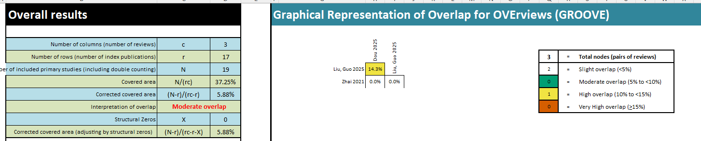
Supplementary File 5. Overlap analysis –effects of post-intervention up to 3 months

Stress:
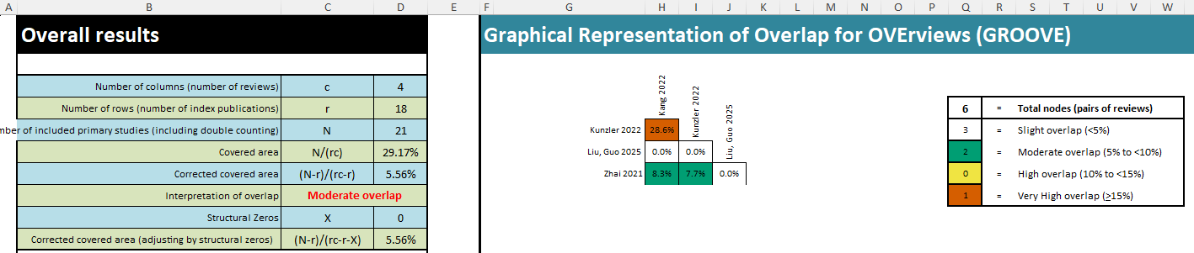

Anxiety
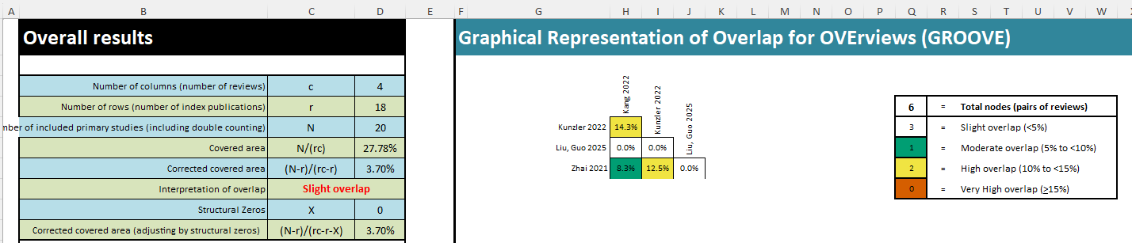

Depression
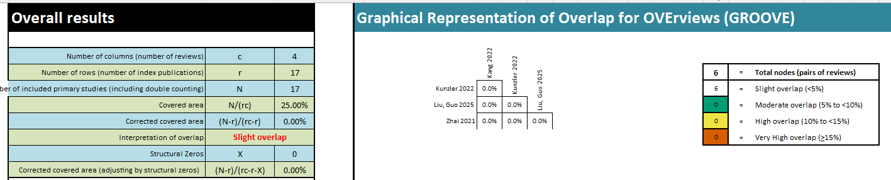

Resilience
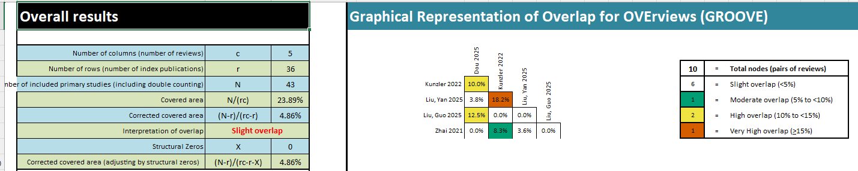

Well-being:
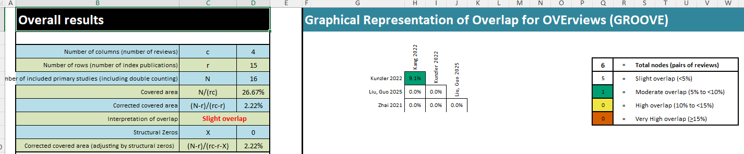

Mindfulness:

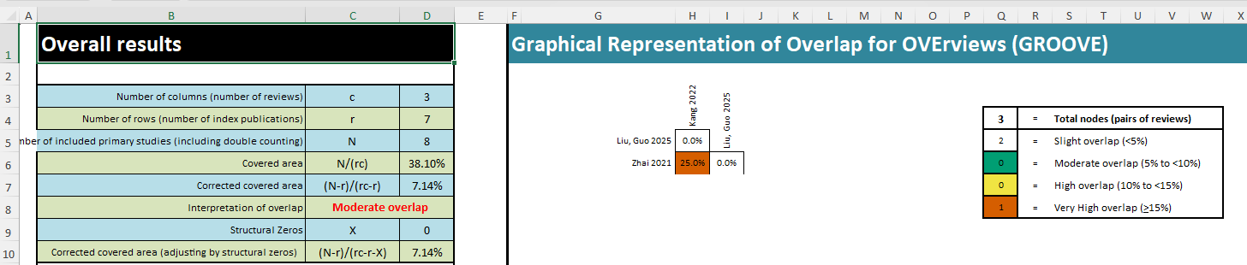

Supplementary File 6. GRADE certainty of evidence for outcomes included in this umbrella review
Outcome | Contributing reviews | Pooled effect SMD (95% CI) | Risk of bias | Inconsistency | Indirectness | Imprecision | Publication bias | Certainty | Footnotes
Burnout – up to 3 months | Dou 2025; Liu, Guo 2025 | -1.40 (-1.86, -0.94) | Serious | Not serious (I² = 0%) | Not serious | Not serious | Serious | ⨁⨁◯◯  Low | a, b
Stress – up to 3 months | Liu, Guo 2025; Kang 2022; Kunzler 2022 | -0.58 (-0.82, -0.33) | Serious | Not serious (I² = 0%) | Not serious | Not serious | Serious | ⨁⨁◯◯  Low | a, b
Stress – >3 months | Liu, Guo 2025; Kunzler 2022 | -1.97 (-5.30, 1.36) | Serious | Very serious (I² = 99%) | Not serious | Very serious | Serious | ⨁◯◯◯  Very low | a, c, d, b
Anxiety – up to 3 months | Liu, Guo 2025; Kang 2022; Kunzler 2022 | -0.46 (-0.75, -0.16) | Serious | Not serious (I² = 22%) | Not serious | Not serious | Serious | ⨁⨁◯◯  Low | a, b
Depression – up to 3 months | Liu, Guo 2025; Kang 2022; Kunzler 2022 | -0.33 (-0.76, 0.09) | Serious | Not serious (I² = 42%) | Not serious | Serious | Serious | ⨁◯◯◯  Very low | a, d, b
Depression – >3 months | Liu, Guo 2025; Kunzler 2022 | -1.61 (-4.57, 1.43) | Serious | Very serious (I² = 99%) | Not serious | Very serious | Serious | ⨁◯◯◯  Very low | a, c, d, b
Resilience – up to 3 months | Dou 2025; Kunzler 2022; Liu, Guo 2025; Liu, Yan 2025 | 0.49 (0.18, 0.81) | Serious | Serious (I² = 85%) | Not serious | Not serious | Not assessed | ⨁⨁◯◯  Low | a, e
Resilience – >3 months | Kunzler 2022; Yu 2024 | 0.28 (-0.53, 1.08) | Not serious | Serious (I² = 79%) | Not serious | Serious | Not assessed | ⨁⨁◯◯  Low | e, d
Mindfulness – up to 3 months | Kang 2022; Liu, Guo 2025 | 0.83 (0.01, 1.65) | Serious | Serious (I² = 78%) | Not serious | Serious | Undetected | ⨁◯◯◯  Very low | a, e, d
Sleep quality – up to 3 months | Dou 2025; Liu, Guo 2025 | -0.66 (-1.39, 0.07) | Serious | Serious (I² = 73%) | Serious | Serious | Not assessed | ⨁◯◯◯  Very low | a, e, f, d
Note.
a. Risk of bias: Downgraded due to inclusion of studies with methodological limitations, including mixed RCT and quasi-experimental designs and concerns regarding blinding or allocation concealment.
b. Publication bias: Downgraded as reporting/publication bias could not be ruled out or was not formally assessed.
c. Inconsistency (very serious): Downgraded two levels due to high heterogeneity (I² ≈ 99%).
d. Imprecision: Downgraded due to wide confidence intervals and/or crossing the line of no effect.
e. Inconsistency (serious): Downgraded one level due to substantial heterogeneity (I² > 50%).
f. Indirectness: Downgraded because one contributing review for this outcome was restricted to ICU nurses, whereas this umbrella review addressed nurses across clinical settings; therefore, applicability to the broader nursing population may be limited.

