Supplementary Material

The application of tannic acid-coated magnetite nanoparticles for recovery of microplastics from the water system
Amoudjata Sacko*ª, Jemal Fito Nureª, Hlengilizwe Nyoni^{b}, Bhekie Mambaª, Thabo Nkambuleª, Titus A.M. Msagati^{a*}
ªInstitute of Nanotechnology and Water Sustainability Research Unit, College of Science, Engineering, and Technology, University of South Africa, Florida Campus, 1709, Johannesburg, South Africa
^{b}Institute for Energy and Environmental, Pennsylvania State University, University Park, PA 16802, United States
*Corresponding authors Emails: 58563237@mylife.unisa.ac.za, +27 71 13 69 6 91 (Amoudjata Sacko) and msagatam@unisa.ac.za, +27 72 31 10 693 (Titus A.M. Msagati)

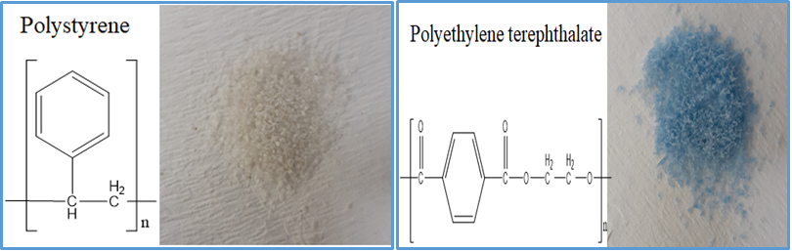
Figure S1. The schematic representation of PS and PET microplastics

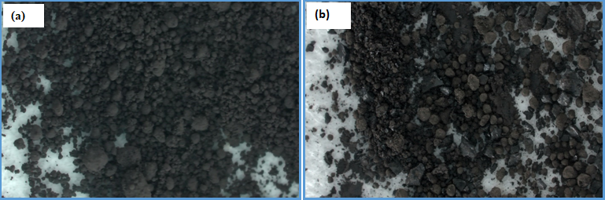
Figure S2. Images of nano adsorbents (a) magnetite and (b) tannic acid-coated magnetite

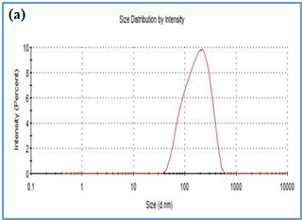
Figure S3. Measurement of the zetasizer nano range size adsorbents distribution of tannic acid-coated magnetite

Table S1. Concentrations of interfering species
Ions |  | Concentration (mg/L)
 | Chloride (Cl⁻) | 292
 | Sulfate (SO₄²⁻) | 710
 | Carbonate (CO₃²⁻) | 530
 | Phosphate (PO₄³⁻) | 710
 | Nitrate (NO₃⁻) | 425
 | Humic acid (DOM) | 20

Kinetic and isotherm studies

$\ln\left(q_{e}-q_{t}\right)=\ln{q_{e}-k_{1}}t$ (S1)
$\frac{t}{q_{t}}=\frac{1}{{k_{2}q}_{e }^{2}}+ \frac{t}{q_{e}}$ (S2)
Where k₁ and k₂ represent the rate constants of the pseudo-first-order and pseudo-second-order kinetic models respectively, t is the reaction time (min), and q_{e} (mg/mg) and q_{t} are the MPs adsorption quantity adsorbed at equilibrium and at the time t respectively.
Langmuir: $\frac{C_{e}}{q_{e}}=\frac{1}{q_{m}}C_{e}+ \frac{1}{q_{mk_{l}}}$ (S3)
Freundlich: $\ln{q_{e}}=\ln{k_{F}}+ \frac{1}{n}\ln{C_{e}}$ (S4)

Where C_{e} (mg) and q_{e} (mg/mg) represent the mass of MPs at equilibrium and the adsorption capacity at equilibrium respectively, q_{m} (mg/mg) is the maximum adsorption capacity of the adsorbent, k_{L} is the Langmuir constant, k_{F} is the Freundlich constant and n represents the adsorption strength constant.

