Supporting Information
Fragility of a multilayer network of intranational supply chains

Michael Gomez¹, Susana Garcia^{1,2}, Sarah Rajtmajer^{3,4}, Caitlin Grady^{1,4}, and Alfonso Mejia^{1*}

¹Department of Civil and Environmental Engineering, The Pennsylvania State
University, USA
²Postdoctoral Research Associate, Energy and Transportation Science Division, Oak Ridge National Laboratory, USA
³College of Information Sciences and Technology, The Pennsylvania State University, USA
⁴The Rock Ethics Institute, The Pennsylvania State University, USA

*Corresponding Author: aim127@psu.edu
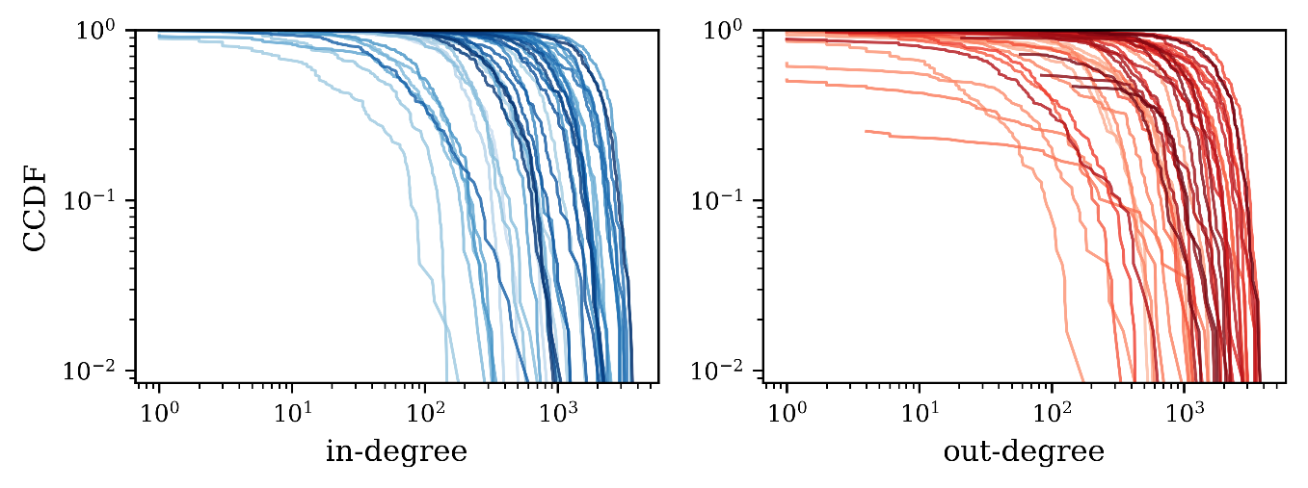
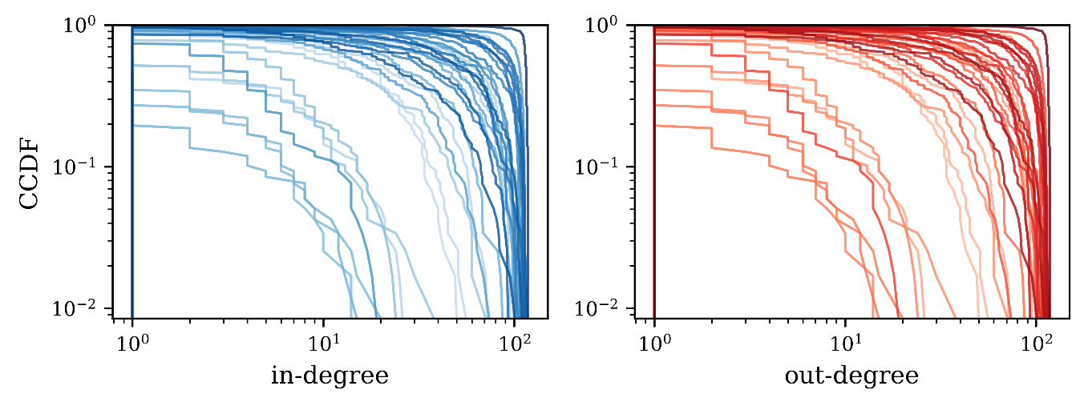
Fig. S1 Complementary cumulative distribution function of the interlayer in-degree (a) and out-degree (b) for each layer.
Fig. S2 Complementary cumulative distribution function of the intralayer in-degree (a) and out-degree (b) for each layer.
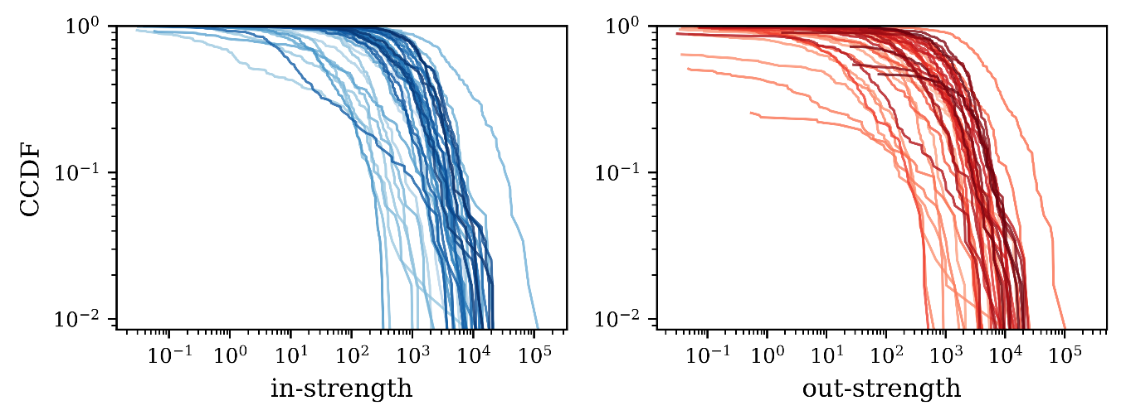
Fig. S3 Complementary cumulative distribution function of the interlayer in-strength (a) and out-strength (b) for each layer.

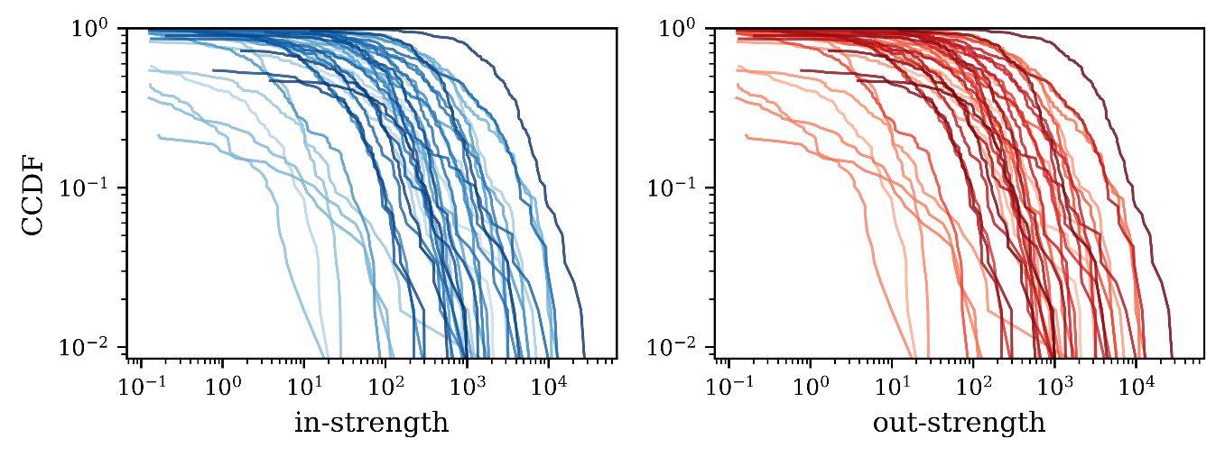
Fig. S4 Complementary cumulative distribution function of the intralayer in-strength (a) and out-strength (b) for each layer.

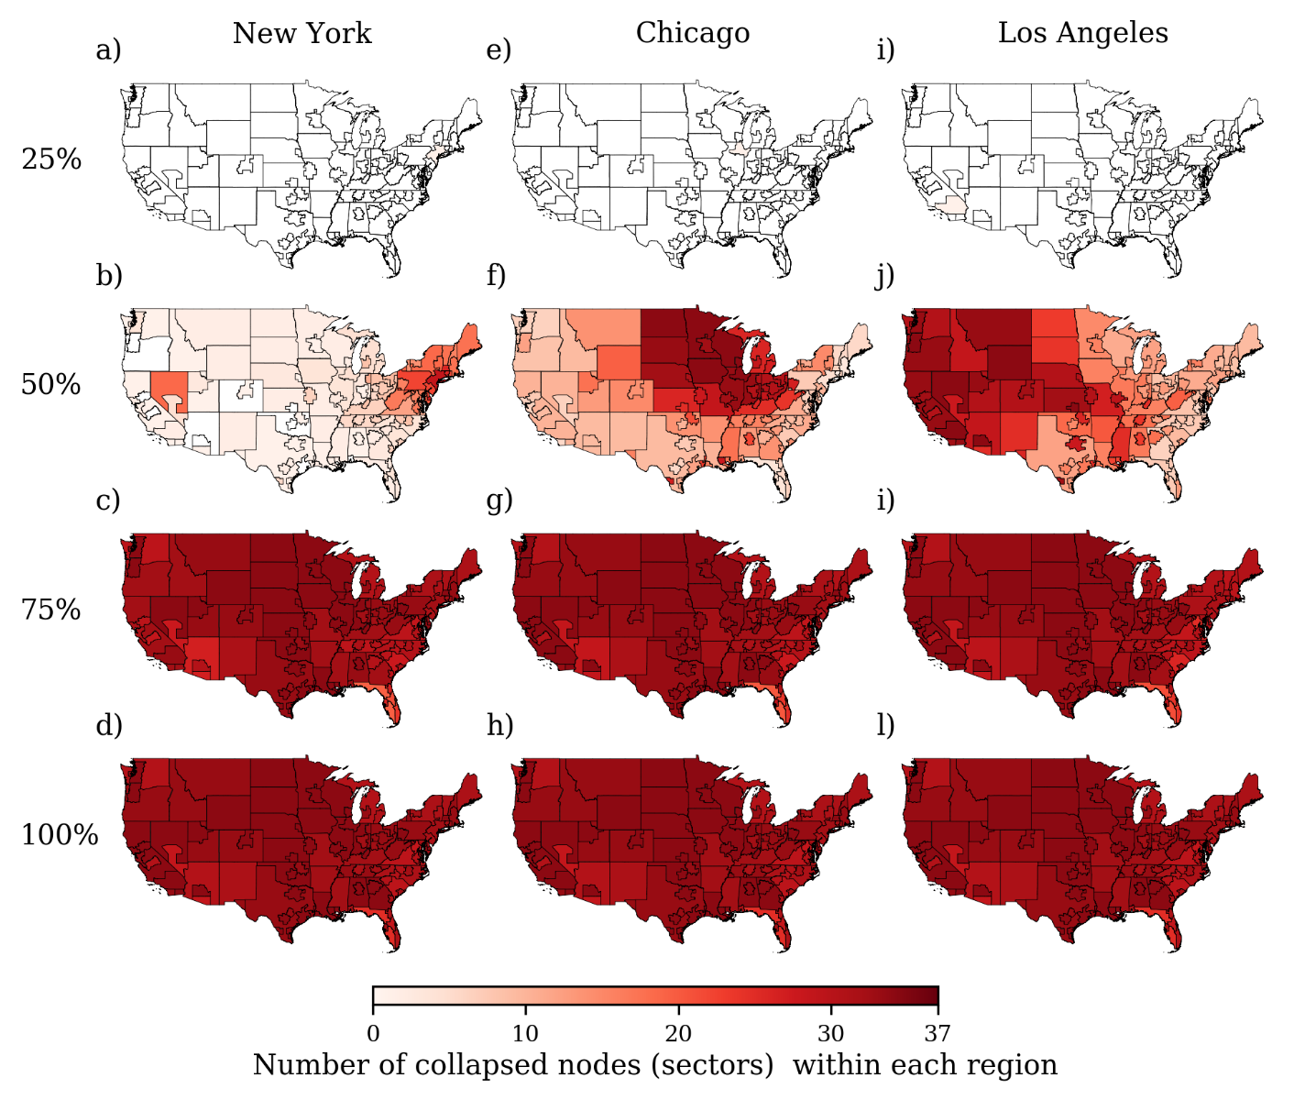
Fig. S5 Spatial evolution of a shock initiated in the government sector of New York City (a-d), Chicago (e-h), and Los Angeles (i-l) for Ω=0.02. The shock is shown at the 25, 50, 75 and 100% level of propagation relative to the total number of time steps or iterations required for the shock to be completely absorbed.

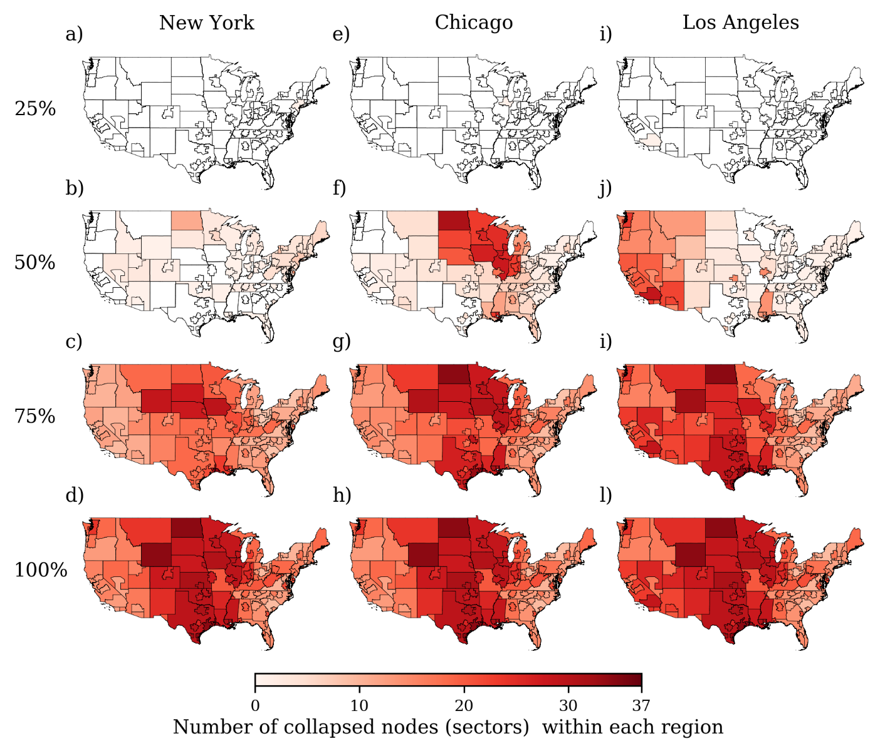
Fig. S6 Spatial evolution of a shock initiated in the government sector of New York City (a-d), Chicago (e-h), and Los Angeles (i-l) for Ω=0.04. The shock is shown at the 25, 50, 75 and 100% level of propagation relative to the total number of time steps or iterations required for the shock to be completely absorbed.

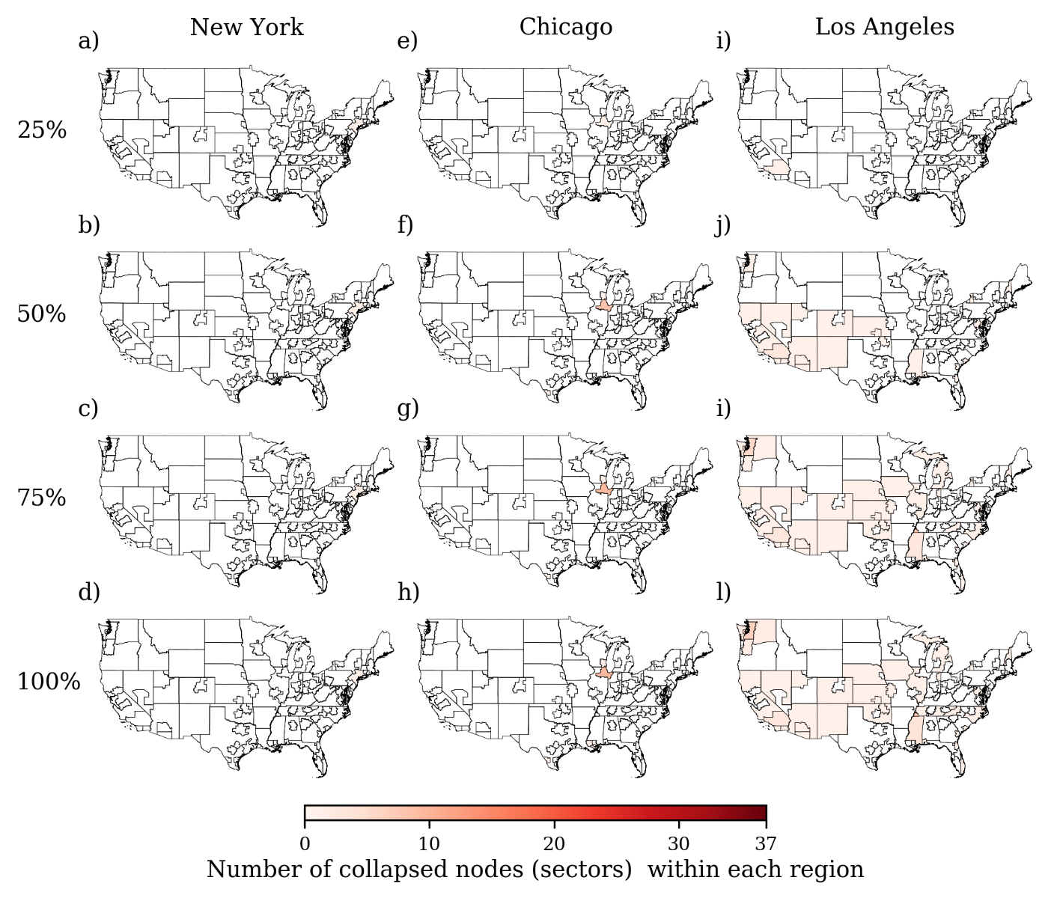
Fig. S7 Spatial evolution of a shock initiated in the government sector of New York City (a-d), Chicago (e-h), and Los Angeles (i-l) for Ω=0.08. The shock is shown at the 25, 50, 75 and 100% level of propagation relative to the total number of time steps or iterations required for the shock to be completely absorbed.

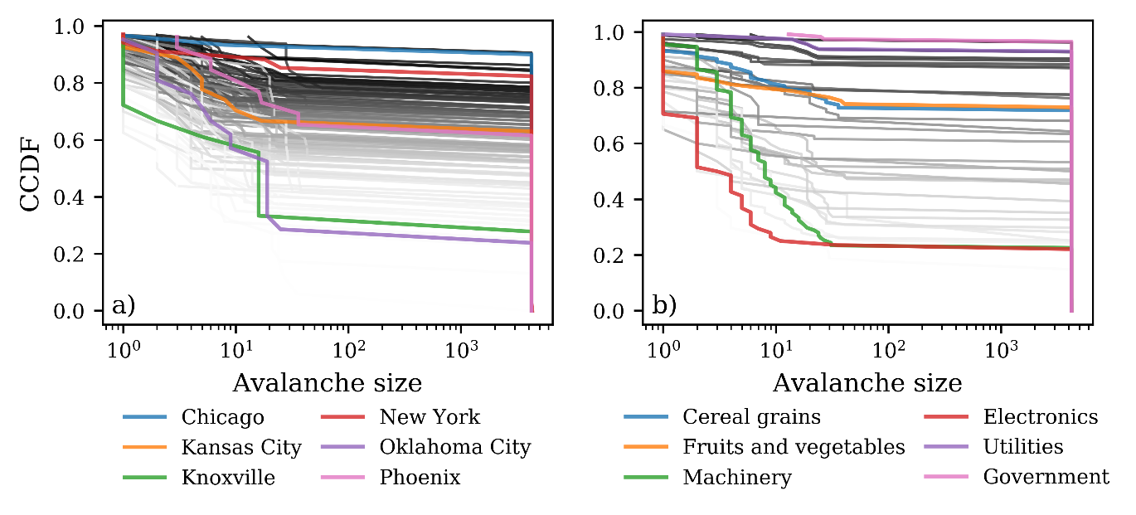
Fig. S8 Complementary cumulative distribution function (ccdf) of avalanche sizes for the 115 regions (a) and 37 layers (b) in our multilayer network. The ccdfs are for Ω=0.02.

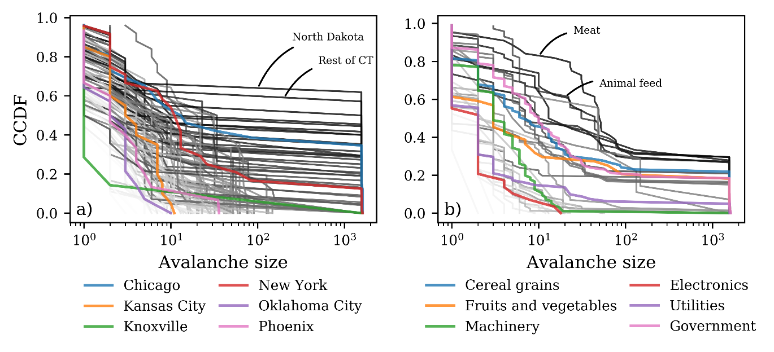
Fig. S9 Complementary cumulative distribution function (ccdf) of avalanche sizes for the 115 regions (a) and 37 layers (b) in our multilayer network. The ccdfs are for Ω=0.06.
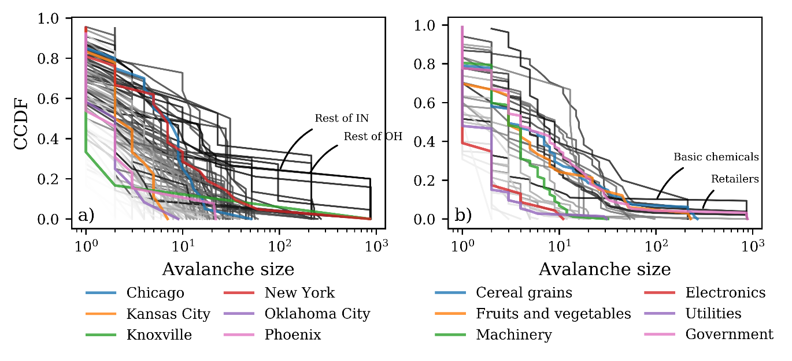
Fig. S10 Complementary cumulative distribution function (ccdf) of avalanche sizes for the 115 regions (a) and 37 layers (b) in our multilayer network. The ccdfs are for Ω=0.08.

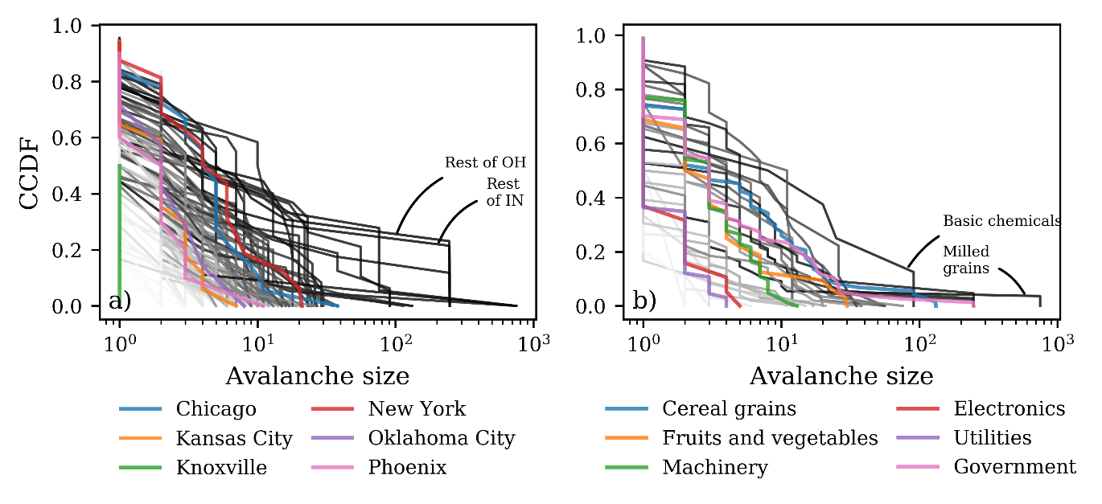
Fig. S11 Complementary cumulative distribution function (ccdf) of avalanche sizes for the 115 regions (a) and 37 layers (b) in our multilayer network. The ccdfs are for Ω=0.10.

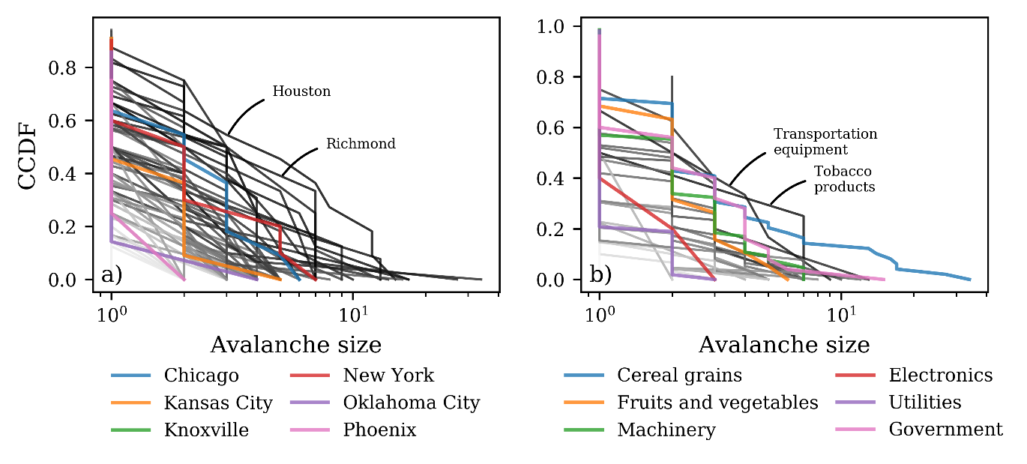
Fig. S12 Complementary cumulative distribution function (ccdf) of avalanche sizes for the 115 regions (a) and 37 layers (b) in our multilayer network. The ccdfs are for Ω=0.20.

