SUPPLEMENTAL MATERIALS
Unity with close others and distant Americans CFA
We conducted a pilot study to test a set of items for measuring close other unity that included unity with both family and friends. We tested a factor structure in which unity with family, friends, and distant Americans formed distinct factors. This model fit the data well, X²(210) = 678.80, p < .001, RMSEA = .10, SRMR = .05, CFI = .92, TLI = .91. The model with family and friend unity split into distinct factors fit significantly better than the model with them combined as a single factor, X²difference = 1151.00, p < .001. Accordingly, we divided family and friend unity into two separate latent variables in the present studies.

Social network density and global unity
Using the same scales we used to measure unity with close others and distant Americans, we also measured self-reported unity with people all over the world. We found that people in denser social networks reported feeling more unity with people around the world than people in sparser social networks. This suggests that future research investigating the potential link between social network density and xenophobia could be beneficial.
Study | Standardized beta | df | t value | p value
Study 1 | .12 | 536 | 2.77 | .006
Study S1 | .35 | 193 | 5.15 | < .001
Study S2 | .12 | 371 | 2.32 | .02
All studies combined | .15 | 1104 | 5.10 | < .001

Perceived social network density
We initially thought that perceived social network density may be an important step in the model from social network density to partisan animosity, and examined perceived social network density in Studies 1 and 2. We predicted that people in dense social networks would perceive their social network as more interconnected, this would lead them to feel more unity with close others that they would project onto distant Americans, and projected unity would lead to reduced partisan animosity. However, we found through structural equation model analyses that the model fit better without the added step of perceived social network density. Nonetheless, we found that participants who perceive their social networks as denser often felt less animosity for political opponents. This lends further credence to the prediction that dense networks provide a sense of unity that reduces partisan animosity.

Perceived social network density and unity with close others

Study | Standardized beta | df | t value | p value
Study 1 | .46 | 536 | 12.04 | < .001
Study 2 | .42 | 465 | 10.07 | < .001
Both studies combined | .44 | 1003 | 15.57 | < .001

Perceived social network density and openness towards political opponents

Study | Standardized beta | df | t value | p value
Study 1 | .12 | 536 | 2.77 | .006
Study 2 | .07 | 465 | 1.50 | .13
Both studies combined | .09 | 1003 | 2.70 | .007

Perceived social network density and warmth towards political opponents

Study | Standardized beta | df | t value | p value
Study 1 | .07 | 536 | 1.70 | .09
Study 2 | .10 | 465 | 2.18 | .03
Both studies combined | .13 | 1003 | 4.25 | < .001

Pilot study 1
We conducted an initial convenience sample survey to investigate whether people with denser social networks show less partisan animosity by way of projected unity. We predicted that participants with denser social networks would feel a greater sense of unity with their close others that they would project onto distant Americans, and that this would lead them to feel warmer and more open towards political opponents.
Methods
Participants
We recruited 195 participants (M_{age} = 38.24, SD_{age} = 10.84) from Amazon’s Mechanical Turk. 107 were men, 86 were women, 1 was non-binary, and 1 did not specify their gender. 72.0% were White, 12.0% were Black, 9.2% were Asian or Pacific Islander, 4.6% were Hispanic or Latino/a/x, 2.1% were multiracial, and .5% were Native American.
Results
Main model
As predicted, the model supported the proposed relationships from social network density to reduced partisan animosity. Participants with denser networks reported feeling greater unity with close others (direct effect: β = .39, z(195) = 4.74, p < .001), which led to greater national unity (direct effect: β = 1.04, z(195) = 6.95, p < .001; indirect effect of network density through unity with close others: β = .41, z(195) = 4.03, p < .001). In turn, participants who felt greater national unity reported more openness towards political opponents (direct effect: β = .28, z(195) = 3.51, p < .001; indirect effect of close unity through unity with distant Americans: β = .20, z(195) = 3.37, p = .001), and warmth towards political opponents (direct effect: β = .18, z(195) = 2.30, p = .02; indirect effect of close unity through unity with distant Americans: β = .13, z(195) = 2.26, p = .02). This suggests that feelings of unity with close others were projected onto feelings of unity with distant Americans, thereby lowering partisan animosity.
The mediational pathways from network density to partisan animosity supported the prediction that dense social networks can lower partisan animosity through feelings of unity with close others that are projected onto distant Americans. The total indirect pathways from social network density to openness (total indirect effect: β = .08, z(195) = 2.79, p = .005) and warmth (total indirect effect: β = .05, z(195) = 2.06, p = .04) were significant, indicating that social network density indirectly impacted partisan animosity by fostering projected unity. When factoring in all pathways from network density to partisan animosity, social network density was associated with greater openness to political opponents (total effect: β = .22, z(195) = 2.98, p = .003), and greater warmth towards political opponents (total effect: β = .24, z(195) = 3.41, p = .001). This further supported the hypothesis that people in dense networks show less partisan animosity.
We also examined the direct effects of network density on partisan animosity after accounting for the mediational pathways of projected unity. Projected unity fully mediated the relationship between density and openness such that the direct effect of social network density on openness was not significant, β = .14, z(195) = 1.89, p = .058. Projected unity partially mediated the relationship between density and warmth such that the direct effect of social network density on warmth was still significant, β = .19, z(195) = 2.61, p = .009. This suggests that there may be other mechanisms aside from projected unity that account for dense social networks increasing warmth towards political opponents, but that projected unity appears to fully explain the relationship between social network density and openness towards political opponents.
Overall, the findings suggest that people in dense social networks project feelings of unity with their close others onto feelings of unity with distant Americans, and thereby feel more warmth and openness towards political opponents.
Robustness checks
We conducted robustness checks on the relationships between social network density and partisan animosity to better contextualize the model results.
Political affiliation. First, we tested whether the relationships between social network density and partisan animosity remained after accounting for political affiliation. Social network density remained a significant predictor of warmth (β = .22, t(189) = 3.15, p = .002) and openness (β = .25, t(189) = 3.68, p < .001) after controlling for political affiliation and strength of political affiliation. This suggests that the association between dense networks and reduced partisan animosity is consistent across political ideologies.
Local population demographics. We next examined the potential impacts of local demographic factors on the relationship between social network density and partisan animosity. First, it is possible that participants in smaller towns have denser social networks, and that the impact of network density on partisan animosity is simply due to differences in animosity between cities and towns. To test this possibility, we added population size and population density as control variables in linear regressions with density and partisan animosity. Controlling for population size and population density, social network density remained a significant predictor of openness (β = .25, t(188) = 3.60, p < .001) and warmth (β = .21, t(188) = 2.99, p = .003). This suggests that the impact of social network density on partisan animosity is not merely due to regional population size, but instead by the interconnections among people’s proximate social circles.
Additionally, regional racial diversity, political demographics, and economic inequality are factors that could impact community group relations and partisan animosity. To test the robustness of our results against regional factors, we added political composition, racial diversity, economic inequality, population size, and population density as control variables in linear regressions of density and partisan animosity. Controlling for these variables, social network density remained a significant predictor of openness (β = .25, t(185) = 3.50, p < .001) and warmth (β = .20, t(185) = 2.83, p = .005). It is particularly noteworthy that network density remained significantly associated with lower partisan animosity even among participants living in highly politically polarized regions.
Physical distance from close others. We were curious whether participants who lived closer to their seven closest others would demonstrate lower partisan animosity. This would further suggest that local feelings of unity with a strong social support system lowers negative sentiment towards political opponents. Supporting this exploratory prediction, participants who lived closer to their closest relationships showed greater warmth to political opponents (β = -.19, t(191) = -2.74, p = .007). However, physical distance from close others was not significantly related to openness (β = -.11, t(191) = -1.50, p = .14).

Pilot study 2
We conducted second convenience sample survey to attempt to replicate our findings from our first pilot study. The pilot study procedure was identical to that of Study S1, with the exception of the updated measure of close other unity.
Methods
Participants
We recruited 373 participants (M_{age} = 42.16, SD_{age} = 13.21) from Amazon’s Mechanical Turk. 160 of the participants were men, 207 were women, 1 was non-binary, 1 was transgender, and 4 did not specify their gender. 8.0% of participants were Hispanic or Latino/a/x. 71.8% were White, 11.3% were Black, 5.1% were Asian, 1.0% were Native American or Alaskan Native, and 1.9% were mixed race, and 1.1% did not specify their race.
Procedure
Our procedure was identical to Study S1. We tested the proposed model from density to partisan animosity using a structural equation model. In the model, social network density predicted unity with close others, unity with close others predicted unity with Americans, and unity with distant Americans predicted warmth and openness towards political opponents. The structural equation model allowed us to assess the fit of these proposed relationships and to test for the indirect effects of unity on the relationships between density and partisan animosity. The model fit the data adequately, X2(373) = 1102.70, p < 0.001, RSMEA = 0.078, SRMR = .096, CFI = .92, TLI = .92.
Main measures
Social network density. To measure social network density, we first asked participants to list the seven people interpersonally closest to them. We then asked them to report the interpersonal closeness among these seven people on a 6-pt scale ranging from complete strangers to extremely close. This was a symmetric measure of closeness between each pair (rather than a perceived closeness rating for each individual person). Density was calculated as the sum of the strengths of the relationships between each pair in the network divided by the total number of pairs.
Unity with close others. To assess unity with close others, we adapted items from the Identification with all Humanity scale, and the pictorial and text identity fusion measures. Unlike in Study S1, we measured feelings of unity separately for both family and friends. We removed the items from Study S1 about unity with one’s community due to the ambiguity of the term “community” (i.e. it could be interpreted to mean one’s proximate close others, a specific community like a church, or one’s wider social group like a town or city). We replaced items about community with items about friends. We tested the new unity measure in a pilot survey examining the relationship between projected unity and warmth (see Supplementary Materials). A CFA factor analysis indicated that the items used to assess close other unity formed separate family and friend factors.
Unity with distant Americans. We measured unity with distant Americans using the same items from the Identification with all Humanity scale and the pictorial identity fusion measures that were used to measure unity with close others.
Partisan animosity. To assess partisan animosity, we measured both how open participants were to engaging with political opponents, and how warmly participants felt towards political outgroup members.
Openness to engage. Participants rated their openness to engaging with a political
opponent on a 6-point, 5-item Likert scale.
Warmth towards political outgroup members. Participants rated their warmth towards
a political outgroup member on a feeling thermometer from 1 (very cold) to 10 (very
warm).
Robustness measures
Political affiliation. We asked participants to rate their political affiliation on a scale from “1: Extremely liberal” to “9: Extremely conservative.”
Local population demographics. We used zip code census data to measure participants’ local population size, population density, racial diversity, and economic inequality. As a measure of local political composition, we also calculated the ratio of Democrats to Republicans in participants’ local communities based on voting data from the 2020 presidential election.
Results
Main model
The model did not support the proposed relationships from social network density to reduced partisan animosity. Participants with denser networks reported feeling greater unity with family (β = .25, z(373) = 4.85, p < .001), but not with friends (β = .04, z(373) = .75, p = .45). Close unity with family led to greater feelings of unity with distant Americans (direct effect: β = .19, z(373) = 3.37, p = .001; indirect effect of network density through unity with family: β = .05, z(373) = 2.80, p = .005), as did close unity with friends (direct effect: β = .36, z(373) = 6.05, p < .001; indirect effect of network density through unity with friends: β = .01, z(373) = .75, p = .46). In turn, participants who felt greater national unity reported more openness towards political opponents (direct effect: β = .15, z(373) = 2.97, p = .003; total indirect effect of close unity through unity with distant Americans: β = .08, z(373) = 2.73, p = .006), and warmth towards political opponents (direct effect: β = .38, z(373) = 3.64, p < .001; total indirect effect of close unity through unity with distant Americans: β = .21, z(373) = 3.24, p = .001). This suggests that feelings of unity with close others were projected onto feelings of unity with distant Americans, thereby lowering partisan animosity.
The total indirect pathways from social network density to warmth was significant (total indirect effect: β = .02, z(373) = 2.04, p = .04). However, the total indirect pathways from social network density to openness was not significant (total indirect effect: β = .01, z(373) = 1.89, p = .059). When factoring in all pathways from network density to partisan animosity, social network density was not significantly associated with openness (total effect: β = .05, z(373) = .92, p = .36) or warmth to political opponents (total effect: β = −.13, z(373) = −1.25, p = .21).
Given the null findings for close-other density, we explored the relationship between community-level density and partisan animosity using the same procedures as in Study 3. Supporting our prediction that people in denser networks have lower animosity, community-level density was significantly associated with warmth (β = .16, z(373) = 3.09, p = .002) and openness (β = .15, z(373) = 2.95, p = .003) towards political opponents. In other words, participants who lived in zip codes with denser social networks showed more warmth and openness to political opponents. Although the relationships between close other social network density and partisan animosity were not significant, the community-level analysis supported the prediction that people with denser social networks tend to feel less partisan animosity.
Robustness effects
Physical distance from close others. We were curious whether participants who lived closer to their seven closest others would demonstrate lower partisan animosity. This would further suggest that local feelings of unity with a strong social support system lowers negative sentiment towards political opponents. Supporting this exploratory prediction, participants who lived closer to their closest relationships showed greater openness to political opponents (β = -.27, t(371) = -2.84, p = .005). However, physical distance from close others was not significantly related to warmth (β = -.16, t(371) = -1.70, p = .09).
Results of combined pilot data from Studies S1 and S2
Because our second pilot study did not replicate the findings from our initial pilot study, we examined the data from the two pilot studies combined. Our goal was to assess the likely effect sizes of density on partisan animosity with a larger sample and determine whether we were likely to find significant relationships in a larger representative sample. The combined data consisted of a sample of 568 participants.
As predicted, social network density was significantly related to openness towards political opponents (β = .13, t(566) = 3.03, p = .003), but was not related to warmth towards political opponents (β = .04, t(566) = .92, p = .36). We also investigated the relationships between social network density and partisan animosity using the same structural equation model used in Study 1.
As predicted, the model supported the proposed relationships from social network density to reduced partisan animosity. Participants with denser networks reported feeling greater unity with close others (direct effect: β = .26, z(566) = 6.41, p < .001), which led to greater national unity (direct effect: β = .36, z(566) = 8.99, p < .001; indirect effect of network density through unity with close others: β = .09, z(566) = 5.22, p < .001). In turn, participants who felt greater national unity reported more openness towards political opponents (direct effect: β = .18, z(566) = 4.28, p < .001; indirect effect of close unity through unity with distant Americans: β = .07, z(566) = 3.86, p < .001), and warmth towards political opponents (direct effect: β = .22, z(566) = 5.18, p < .001; indirect effect of close unity through unity with distant Americans: β = .08, z(566) = 4.49, p < .001). This suggests that feelings of unity with close others were projected onto feelings of unity with distant Americans, thereby lowering partisan animosity.
The mediational pathways from network density to partisan animosity supported the prediction that dense social networks can lower partisan animosity through feelings of unity with close others that are projected onto distant Americans. The total indirect pathways from social network density to openness (total indirect effect: β = .017, z(566) = 3.31, p = .001) and warmth (total indirect effect: β = .02, z(566) = 3.68, p < .001) were significant, indicating that social network density indirectly impacted partisan animosity by fostering projected unity. When factoring in all pathways from network density to partisan animosity, social network density was associated with greater openness to political opponents (total effect: β = .10, z(566) = 2.46, p = .01). However, although network density indirectly influenced warmth through projected unity, the total effect of network density on warmth was not significant (total effect: β = .02, z(566) = 0.58, p = .56).
We also examined the direct effects of network density on partisan animosity after accounting for the mediational pathways of projected unity. Projected unity fully mediated the relationship between density and warmth such that the direct effect of social network density on warmth was not significant, β = .09, z(566) = 2.04, p = .04. Projected unity partially mediated the relationship between density and openness such that the direct effect of social network density on openness was still significant, β = .004, z(566) = .09, p = .93. This suggests that there may be other mechanisms aside from projected unity that account for dense social networks increasing openness towards political opponents, but that projected unity appears to fully explain the relationship between social network density and warmth towards political opponents.
Overall, the findings suggest that people in dense social networks project feelings of unity with their close others onto feelings of unity with distant Americans, and this projected unity corresponds with more warmth and openness towards political opponents.

Internal meta-analysis of all studies combined
Because we found inconsistent results regarding the direct relationships between social network density and partisan animosity in our pilot studies, we conducted an internal meta-analysis to see whether social network density was significantly related to warmth and openness towards political opponents across all studies combined. The total combined data consisted of a sample of 1106 participants.
As predicted, social network density was significantly related to warmth (β = .07, t(1104) = 2.19, p = .03) and openness (β = .15, t(1104) = 4.96, p < .001) towards political opponents. This suggests that people with denser social networks tend to feel less partisan animosity. We also investigated the relationships between social network density and partisan animosity using the same structural equation model used in Study 1.
As predicted, the model supported the proposed relationships from social network density to reduced partisan animosity. Participants with denser networks reported feeling greater unity with close others (direct effect: β = .31, z(1104) = 10.80, p < .001), which led to greater national unity (direct effect: β = .38, z(1104) = 13.07, p < .001; indirect effect of network density through unity with close others: β = .12, z(1104) = 8.33, p < .001). In turn, participants who felt greater national unity reported more openness towards political opponents (direct effect: β = .20, z(1104) = 6.34, p < .001; indirect effect of close unity through unity with distant Americans: β = .07, z(1104) = 5.70, p < .001), and warmth towards political opponents (direct effect: β = .16, z(1104) = 5.35, p < .001; indirect effect of close unity through unity with distant Americans: β = .06, z(1104) = 4.95, p < .001). This suggests that feelings of unity with close others were projected onto feelings of unity with distant Americans, thereby lowering partisan animosity.
The mediational pathways from network density to partisan animosity supported the prediction that dense social networks can lower partisan animosity through feelings of unity with close others that are projected onto distant Americans. The total indirect pathways from social network density to openness (total indirect effect: β = .02, z(1104) = 5.04, p < .001) and warmth (total indirect effect: β = .02, z(1104) = 4.50, p < .001) were significant, indicating that social network density indirectly impacted partisan animosity by fostering projected unity. When factoring in all pathways from network density to partisan animosity, social network density was associated with greater openness to political opponents (total effect: β = .14, z(1104) = 4.47, p < .001). However, although network density indirectly influenced warmth through projected unity, the total effect of network density on warmth was not significant (total effect: β = .06, z(1104) = 1.88, p = .06).
We also examined the direct effects of network density on partisan animosity after accounting for the mediational pathways of projected unity. Projected unity fully mediated the relationship between density and warmth such that the direct effect of social network density on warmth was not significant, β = .04, z(1104) = 1.23, p = .22. Projected unity partially mediated the relationship between density and openness such that the direct effect of social network density on openness was still significant, β = .113, z(1104) = 3.682, p < .001. This suggests that there may be other mechanisms aside from projected unity that account for dense social networks increasing openness towards political opponents, but that projected unity appears to fully explain the indirect relationship between social network density and warmth towards political opponents.
Overall, the findings suggest that people in dense social networks project feelings of unity with their close others onto feelings of unity with distant Americans, and this projected unity corresponds with more warmth and openness towards political opponents.
Associations Between Social Network Density and Demographic Variables
We examined the associations between social network density and various demographic factors, including political ideology, party identification, income, ethnicity, age, gender, and religiosity. Results indicate that religiosity is the only significant predictor of social network density. Specifically, more religious participants tended to have denser social networks.
Predictor | beta | Std. Error | t/F Value | p-value
Political ideology | 0.02 | 0.03 | 0.69 | 0.49
Political party | -0.14 | 0.10 | -1.39 | 0.17
Income | -0.005 | 0.02 | -0.24 | 0.81
Ethnicity | N/A | N/A | 1.37 | 0.23
Age | -0.001 | 0.003 | -0.35 | 0.73
Gender | N/A | N/A | 2.52 | 0.08
Religiosity | 0.06 | 0.02 | 2.47 | 0.01

Study 1 Correlation Matrix of Key Variables
Here we show the Pearson correlation coefficients between six key variables: social network density, feelings of unity with family, feelings of unity with friends, feelings of national unity, warmth towards political opponents, and openness towards political opponents. Darker blue shades indicate stronger positive correlations, while lighter shades represent weaker correlations.
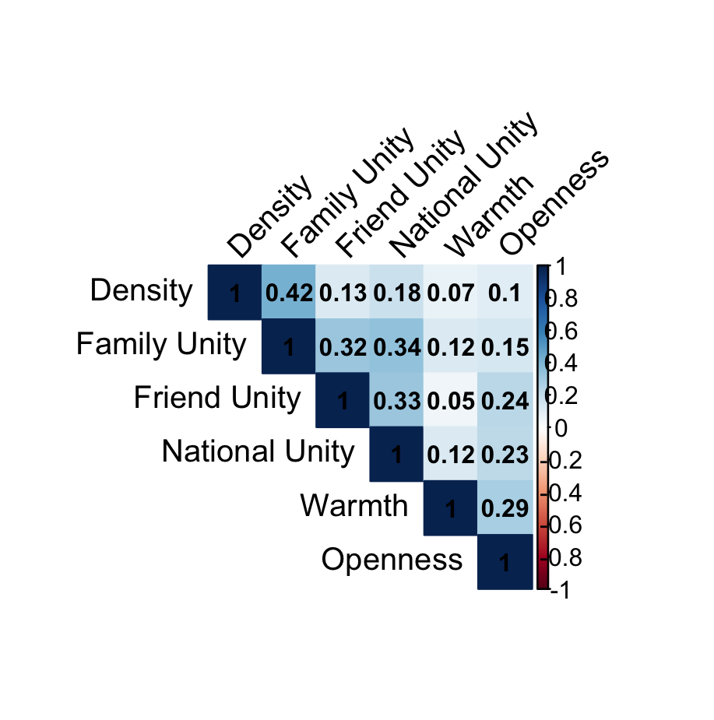
Comparison of Studies 1 and 2 Sample Demographics with 2022 U.S. Census Benchmarks

Demographic Category | US POPULATION 2022 (%) | STUDY 1 (%) | STUDY 2 (%)
Gender
Men | 49.5% | 47.59% | 49.44%
Women | 50.5% | 50.37% | 49.22%
Non-binary | 0.5-1.6% | 1.7% | 0.45%
Non-specified | N/A | 0.37% | 0.89%
Ethnicity
Hispanic or Latino/a/x | 19.1% | 18.6%* | 7.3%
White | 58.9% | 71.4% | 68.8%
Black | 12.6% | 9.3% | 8.9%
Asian | 6.1% | 6.9% | 9.8%
Native American or Alaskan Native | 2% | 1.0% | 0.68%
Multiracial | 2.4% | 7.1% | 3.3%
Non-specified | N/A | 4.3 % | 1.1%
Political Party
Democrat | 28% | 42.8% | 62.8%
Republican | 28% | 57.2% | 37.2%
Mean Age | 38.9 years | 45.34 years | 40.16 years

*Measured as a separate question

