Supporting Information
Multi-year Study of Environmental Stability of Ti₃C₂T_{x} MXene Films
Asaph Lee, Mikhail Shekhirev, Mark Anayee, Yury Gogotsi
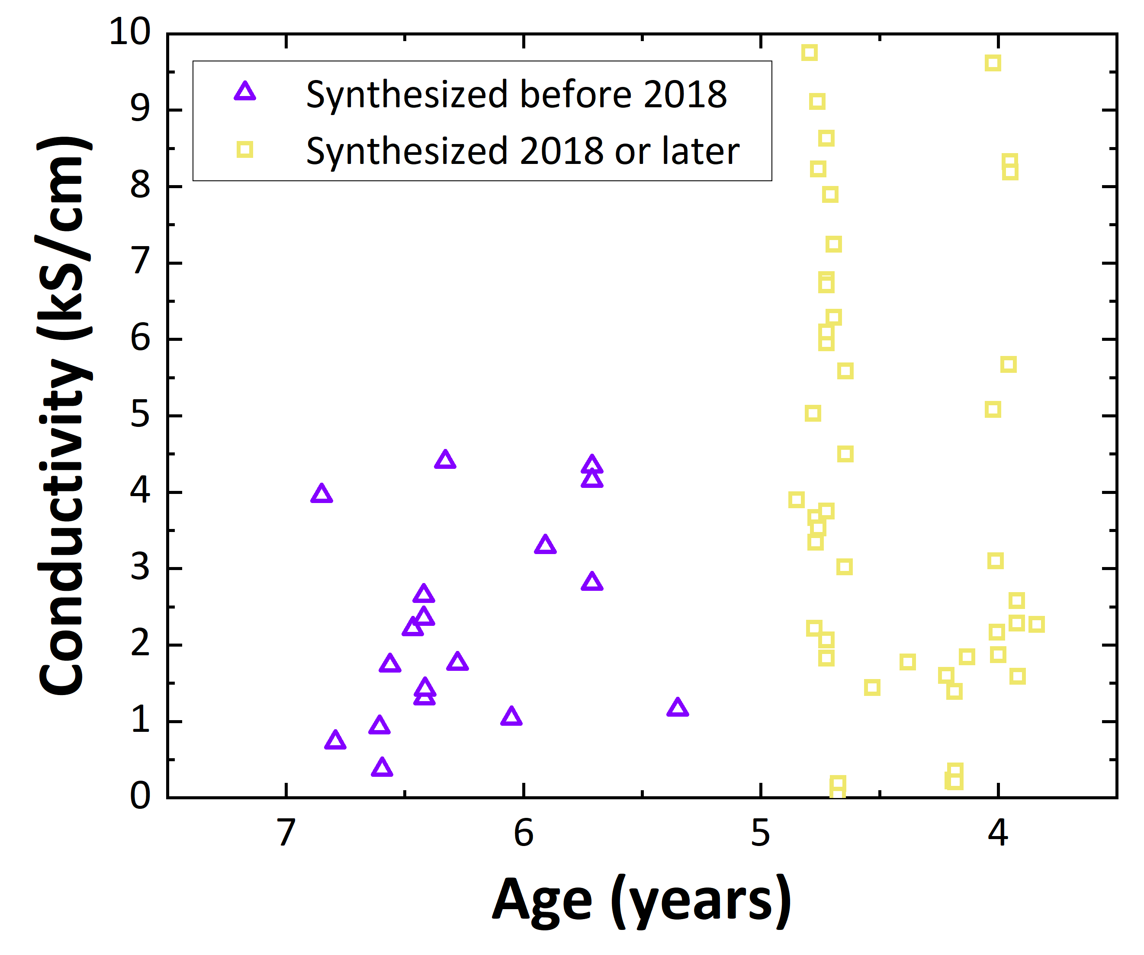
A. J. Drexel Nanomaterials Institute, and Department of Materials Science and Engineering, Drexel University, Philadelphia, Pennsylvania 19104, United States
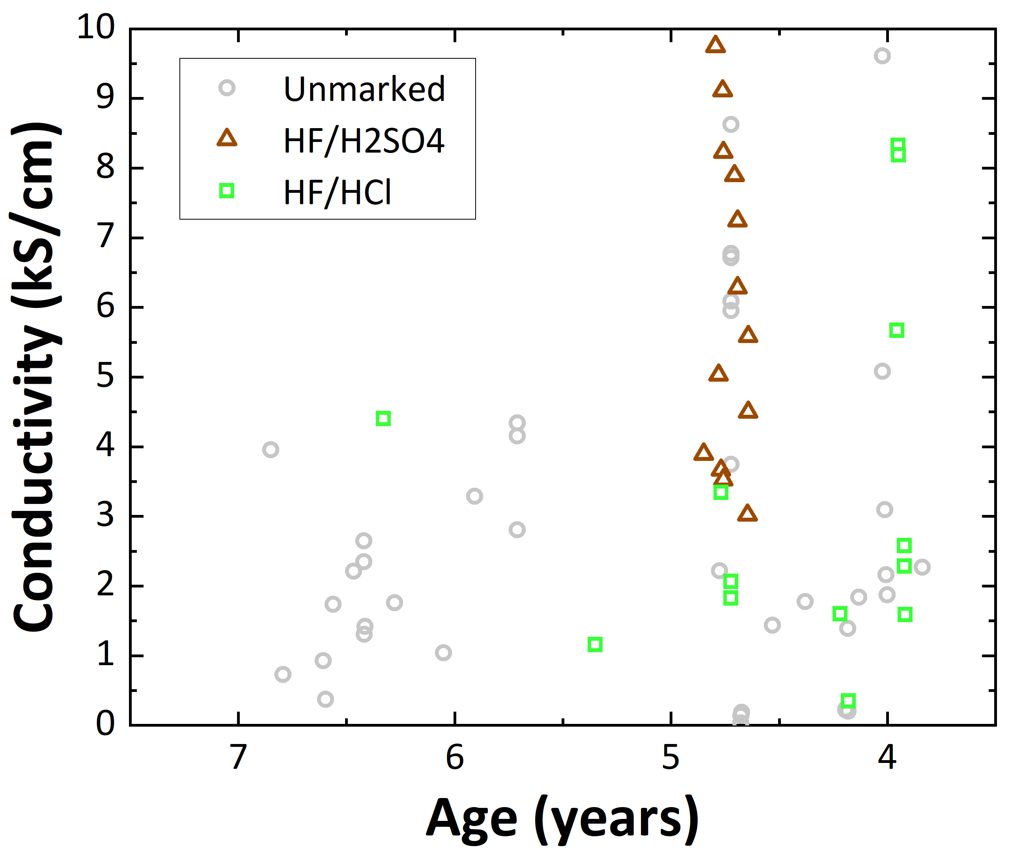
Fig. S1 Conductivity difference between the MXene samples prepared before and after 2018, showing improvements in MAX phase synthesis and etching process.
Fig. S2 Conductivity difference between HF/H₂SO₄ and HF/HCl-etched Ti₃C₂T_{x} due to differences in the surface chemistry

