Article title: Population genetic analysis of the wild hard-shelled mussel, Mytilus unguiculatus (Valenciennes 1858) in South Korea using a microsatellite multiplex assay
Journal name: Thalassas: An International Journal of Marine Sciences
Author names: Jiyoung Woo, Jung Soo Heo, Keun-Yong Kim, Keun-Sik Kim, Hyun-Ju-Hwang, Moongeun Yoon, Hyesuck An, Kook Hee Kang, Jeong Su Park, Ki-Woong Nam, Insong Koh* and Biet Thanh Tran*
*Co-corresponding author: Biet Thanh Tran and Insong Koh
Biet Thanh Tran
Department of Genetic Analysis, AquaGenTech Co., Ltd., Busan 48228, Republic of Korea
Tel: +82-10-4612-4278; Fax: +82-51-623-0307
E-mail address: tranthanhbiet2502@gmail.com
Insong Koh
Department of Biomedical Informatics, Hanyang University, Seoul 04763, Republic of Korea
E-mail address: insong@hanyang.ac.kr

Supplementary Figures

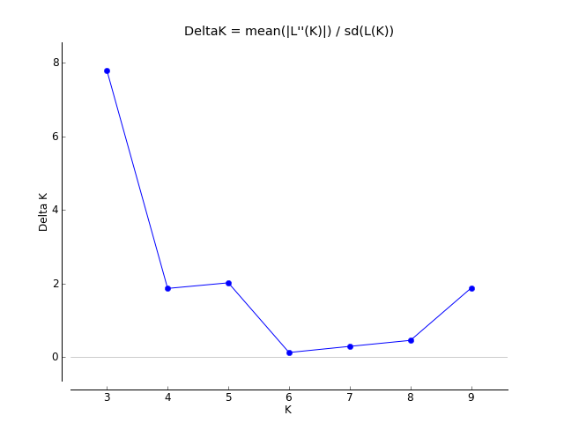
Figure S1. Evanno's delta K plots based on the finally selected eleven microsatellite loci of 246 M. unguiculatus samples from the seven populations in South Korea.

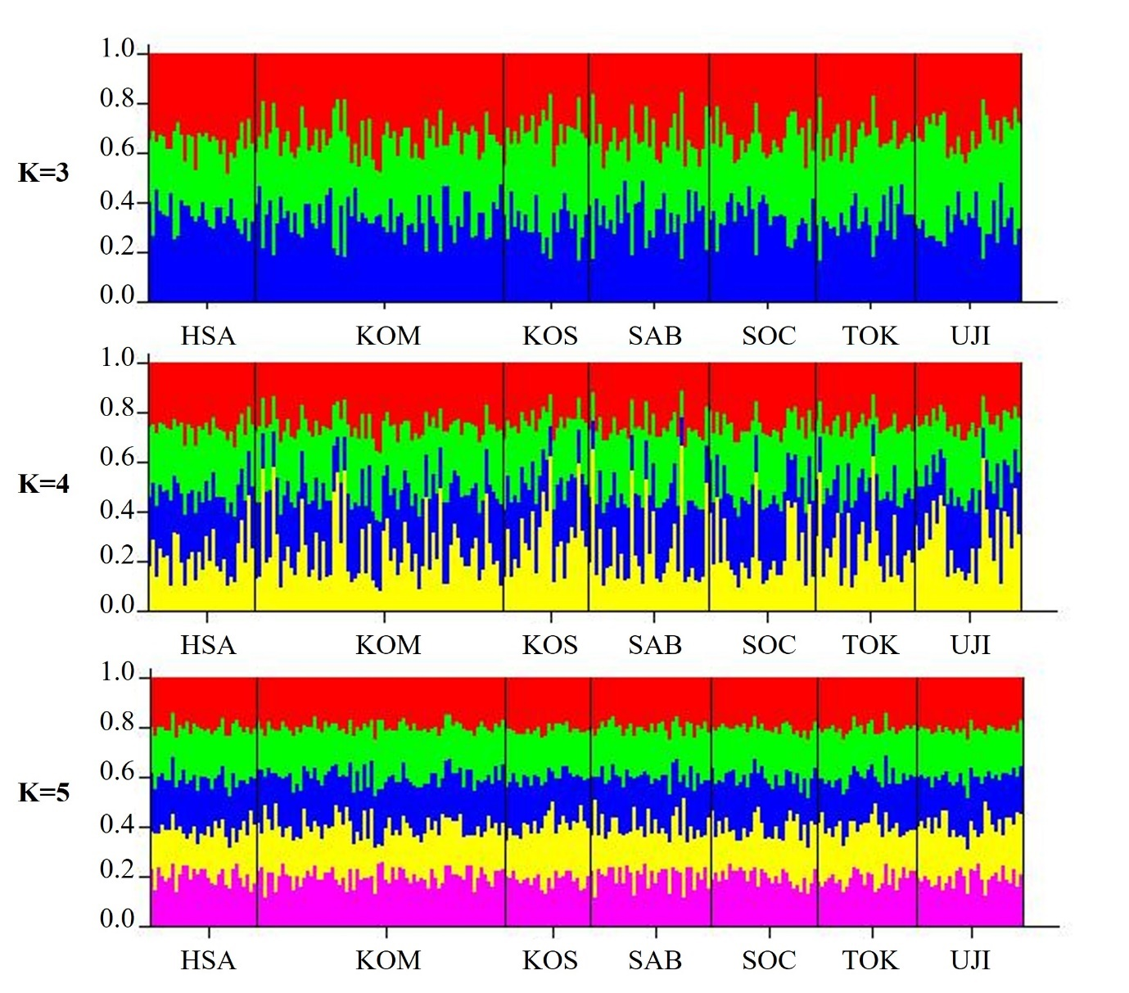
Figure S2. Bar plots of the genetic structure of the seven M. unguiculatus populations in South Korea based on the finally selected eleven microsatellite markers. Each individual is represented by a vertical line with distinct color proportion associated with the probabilities of membership proportional to each of the inferred K groups at K = 3, 4, and 5. HSA, Hansan-do; KOM, Geomun-do; KOS, Goseong-do; SAB, Sapsi-do; SOC, Socheong-do; TOK, Dokdo; UJI, Uljin.

