SUPPLEMENTARY MATERIAL
Table A: Spatial data of the surveyed tide pools.
Tide pool | Latitud e  [º] | Longitude  [º] | Length  [m] | Width  [m] | Surface  area [m²] | Depth  [m] | Region
Agaete 1* | 28.1067 | -15.7110 | 50.52 | 21.96 | 678.23 | 2.0 | Northwest
Agaete 2* | 28.1067 | -15.7110 | 38.90 | 21.29 | 488.08 | 2.0 | Northwest
Agaete 3* | 28.1067 | -15.7110 | 25.77 | 24.91 | 342.41 | 2.0 | Northwest
Playa  Canaria | 28.1626 | -15.7091 | 26.46 | 16.74 | 241.65 | 1.3 | Northwest
Espejos | 28.1654 | -15.7057 | 27.78 | 14.81 | 354.52 | 1.6 | Northwest
Sobradillo 1 | 28.1650 | -15.6946 | 23.51 | 12.40 | 156.53 | 1.2 | Northwest
Sobradillo 2 | 28.1649 | -15.6954 | 43.53 | 40.01 | 773.65 | 1.5 | Northwest
Bufadero | 28.1670 | -15.6809 | 27.18 | 14.78 | 311.59 | 1.5 | Northwest
La Furnia | 28.1611 | -15.6736 | 56.60 | 29.78 | 1098.49 | 1.8 | Northwest
Cueva de la  Furnia | 28.1602 | -15.6733 | 29.89 | 10.78 | 204.50 | 1.4 | Northwest
Bocabarranco | 28.1597 | -15.664 | 92.13 | 41.26 | 3100.55 | 2.0 | Northwest
El Agujero | 28.1616 | -15.6606 | 50.12 | 24.78 | 927.28 | 1.4 | Northwest
Estrecho | 28.1714 | -15.6375 | 34.02 | 30.23 | 660.51 | 1.0 | Northwest
Roque Prieto | 28.1698 | -15.6354 | 99.59 | 34.82 | 2120.46 | 2.5 | Northwest
El Altillo | 28.1462 | -15.5654 | 40.18 | 20.15 | 750.70 | 1.4 | North
Puertillo | 28.1513 | -15.5375 | 116.16 | 109.35 | 6408.29 | 1.4 | North
Sombrero | 28.1542 | -15.5304 | 31.45 | 16.07 | 345.46 | 1.8 | North
La Laja 1 | 28.0649 | -15.4180 | 28.39 | 21.05 | 333.60 | 1.2 | Northeast
La Laja 2 | 28.0641 | -15.4183 | 50.29 | 12.85 | 625.11 | 1.5 | Northeast
La Laja 3 | 28.0638 | -15.4186 | 30.69 | 14.21 | 367.04 | 1.5 | Northeast
* These three tide pools are further known as Agaete, and they are connected with underwater tunnels.
Table B1: Total abundance of fish species in natural tide pools (summary of mean from February to April)
Species | Habitat_mean | Relative | Relative_percent
C. labrosus | 54.67 | 0.36 | 35.75
P. parvicornis | 48.33 | 0.32 | 31.6
M. maderensis | 23.53 | 0.15 | 15.39
T. pavo | 17.33 | 0.11 | 11.33
O. atlanticus | 2.73 | 0.02 | 1.79
O. melanurus | 1.27 | 0.01 | 0.83
B. boops | 1 | 0.01 | 0.65
S. lurida | 0.73 | 0 | 0.48
D. cadenati | 0.6 | 0 | 0.39
G. paganellus | 0.6 | 0 | 0.39
S. salpa | 0.47 | 0 | 0.31
E. marginatus | 0.33 | 0 | 0.22
G. thompsoni | 0.27 | 0 | 0.17
S. cretense | 0.27 | 0 | 0.17
M. fusca | 0.2 | 0 | 0.13
S. cristata | 0.2 | 0 | 0.13
V. canariensis | 0.2 | 0 | 0.13
T. ovatus | 0.13 | 0 | 0.09
P. pagrus | 0.07 | 0 | 0.04
B. belone | 0 | 0 | 0
B. podas | 0 | 0 | 0
C. capistrata | 0 | 0 | 0
D. annularis | 0 | 0 | 0
D. cervinus | 0 | 0 | 0
D. vulgaris | 0 | 0 | 0
E. encrasicolus | 0 | 0 | 0
K. sectatrix | 0 | 0 | 0
L. nuchipinnis | 0 | 0 | 0
P. incisus | 0 | 0 | 0
P. incognitus | 0 | 0 | 0
P. saltatrix | 0 | 0 | 0
S. cantharus | 0 | 0 | 0
S. colias | 0 | 0 | 0
S. dumerili | 0 | 0 | 0
S. maderensis | 0 | 0 | 0
S. papilionaceus* | 0 | 0 | 0
S. porcus | 0 | 0 | 0
S. synodus | 0 | 0 | 0
S. trutta | 0 | 0 | 0

Table B2: Total abundance of fish species in artificial tide pools (summary of mean from February to April)
Species | Habitat_mean | Relative | Relative_percent
C. labrosus | 200.08 | 0.34 | 34.14
S. salpa | 137.28 | 0.23 | 23.42
D. cadenati | 83.08 | 0.14 | 14.18
T. pavo | 30.15 | 0.05 | 5.15
P. parvicornis | 29.79 | 0.05 | 5.08
M. maderensis | 24.03 | 0.04 | 4.1
S. lurida | 13.92 | 0.02 | 2.38
D. cervinus | 8.9 | 0.02 | 1.52
O. atlanticus | 8.05 | 0.01 | 1.37
E. encrasicolus | 7.95 | 0.01 | 1.36
T. ovatus | 5.92 | 0.01 | 1.01
G. thompsoni | 5.1 | 0.01 | 0.87
K. sectatrix | 4.69 | 0.01 | 0.8
S. colias | 4.46 | 0.01 | 0.76
O. melanurus | 4.08 | 0.01 | 0.7
D. vulgaris | 4 | 0.01 | 0.68
E. marginatus | 3.97 | 0.01 | 0.68
S. cretense | 3.46 | 0.01 | 0.59
B. boops | 1.46 | 0 | 0.25
M. fusca | 1.28 | 0 | 0.22
P. incisus | 1.13 | 0 | 0.19
S. cristata | 0.72 | 0 | 0.12
S. papilionaceus* | 0.64 | 0 | 0.11
S. dumerili | 0.49 | 0 | 0.08
G. paganellus | 0.36 | 0 | 0.06
B. belone | 0.23 | 0 | 0.04
C. capistrata | 0.18 | 0 | 0.03
V. canariensis | 0.13 | 0 | 0.02
S. maderensis | 0.13 | 0 | 0.02
L. nuchipinnis | 0.1 | 0 | 0.02
P. saltatrix | 0.1 | 0 | 0.02
S. synodus | 0.05 | 0 | 0.01
B. podas | 0.03 | 0 | 0
D. annularis | 0.03 | 0 | 0
P. incognitus | 0.03 | 0 | 0
S. cantharus | 0.03 | 0 | 0
S. porcus | 0.03 | 0 | 0
S. trutta | 0.03 | 0 | 0
P. pagrus | 0 | 0 | 0
*earlier known as Serranus scriba (Vella et al., 2021)

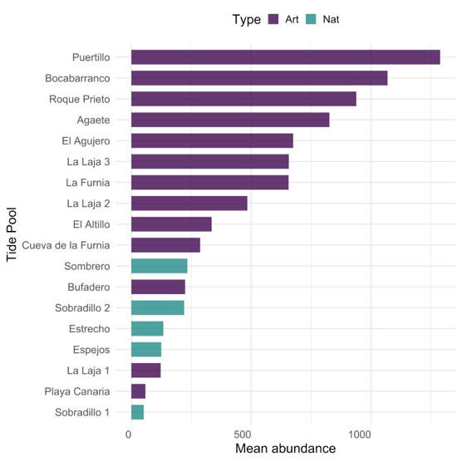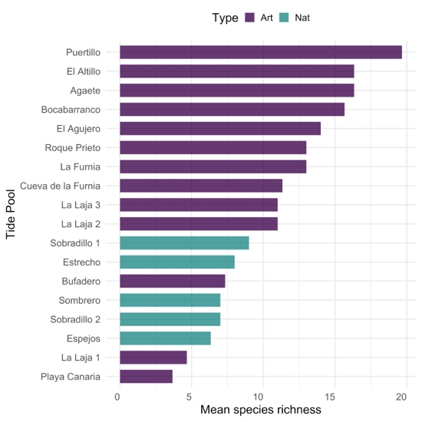
Figure A: 1) The mean number of individuals and 2) the mean number of fish species in each studied tide pool.

Table C: List of all species found in the tide pools, including their mean and standard deviation of abundance, and endemic status.

Fish Family | Fish Species | Mean ± SD | Endemic  (Brito et al.,  2007)
Belonidae | Belone belone | 3.00 ± 1.73 | -
Blenniidae | Ophioblennius atlanticus | 8.07 ± 10.00 | Yes
Blenniidae | Parablennius incognitus | 1.00 ± 0.00 | -
Blenniidae | Parablennius parvicornis | 33.70 ± 35.69 | -
Blenniidae | Scartella cristata | 2.07 ± 2.05 | -
Bothidae | Bothus podas | 1.00 ± 0.00 | Yes
Carangidae | Seriola dumerili | 6.33 ± 6.66 | -
Carangidae | Trachinotus ovatus | 23.30 ± 21.90 | -
Engraulidae | Engraulis encrasicolus | 310.00 ± 0.00 | -
Gobiidae | Gobius paganellus | 1.92 ± 1.00 | -
Gobiidae | Gnatholepis thompsoni | 11.94 ± 11.59 | -
Gobiidae | Mauligobius maderensis | 24.81 ± 31.56 | Yes
Gobiidae | Vanneaugobius canariensis | 1.60 ± 0.55 | -
Haemulidae | Pomadasys incisus | 8.80 ± 6.98 | -
Kyphosidae | Kyphosus sectatrix | 18.30 ± 22.24 | -
Labridae | Symphodus trutta | 1.00 ± 0.00 | Yes
Labridae | Thalassoma pavo | 25.19 ± 25.88 | -
Labrisomidae | Labrisomus nuchipinnis | 1.33 ± 0.58 | -
Mugilidae | Chelon labrosus | 146.15 ± 148.01 | -
Pomacentridae | Similiparma lurida | 18.47 ± 23.74 | Yes
Pomatomidae | Pomatomus saltatrix | 4.00 ± 0.00 | -
Scaridae | Sparisoma cretense | 6.04 ± 6.23 | -
Scombridae | Scomber colias | 87.00 ± 103.24 | -
Scorpaenidae | Scorpaena maderensis | 1.00 ± 0.00 | -
Scorpaenidae | Scorpaena porcus | 1.00 ± 0.00 | -
Serranidae | Epinephelus marginatus | 4.85 ± 5.39 | -
Serranidae | Mycteroperca fusca | 2.94 ± 2.10 | Yes
Serranidae | Serranus papilionaceus * | 2.50 ± 1.78 | -
Sparidae | Boops boops | 5.54 ± 4.52 | -
Sparidae | Diplodus annularis | 1.00 ± 0.00 | -
Sparidae | Diplodus cadenati | 69.13 ± 86.70 | -
Sparidae | Diplodus cervinus | 12.39 ± 12.83 | -
Sparidae | Diplodus vulgaris | 9.75 ± 8.84 | -
Sparidae | Oblada melanurus | 11.87 ± 9.95 | -
Sparidae | Pagrus pagrus | 1.00 ± 0.00 | -
Sparidae | Spondyliosoma cantharus | 1.00 ± 0.00 | -
Sparidae | Sarpa salpa | 141.08 ± 135.13 | -
Synodontidae | Synodus synodus | 1.00 ± 0.00 | -
Tetradontidae | Canthigaster capistrata | 1.40 ± 0.89 | -

Table D: Fixed effects estimates from generalized linear mixed models (GLMMs) testing the effect of tide pool type (artificial vs. natural) on total fish abundance and species richness. Models were fitted with a negative binomial distribution and included tide pool identity as a random effect to account for repeated monthly sampling.
Response | Term | Estimate | Std.error | z-value | p-value
Abundance | (Intercept) | 6.11 | 0.22 | 27.97 | 3.6E-172
Abundance | TypeNat | -1.18 | 0.41 | -2.86 | 0.004276
Richness | (Intercept) | 2.43 | 0.10 | 23.52 | 2.5E-122
Richness | TypeNat | -0.44 | 0.20 | -2.17 | 0.029742

Table E: Results of the PERMANOVA including the interaction between habitat type and surface area. Analyses were based on Bray–Curtis dissimilarities and 9999 permutations. Marginal tests were applied to assess independent effects.
 | Df | SumOfSqs | R2 | F | Pr(>F)
Type:Surface_area | 1 | 0.46 | 0.04 | 2.96 | 0.0178
Residual | 50 | 7.75 | 0.67
Total | 53 | 11.63 | 1

Table F: Results of one-way ANOVAs testing differences in substrate cover between artificial and natural tide pools. Significant predictors are marked (* p < 0.05; ** p < 0.01; *** p < 0.001). SS = Sum of squares.
Substrate | Type SS | Residual SS | F-value | p-value | Significance
Rock | 2281.15 | 1787.65 | 20.42 | 0.00035 | ***
Brown Algae | 639.21 | 1515.77 | 6.75 | 0.019 | *
Pebble | 311.08 | 984.46 | 5.06 | 0.039 | *
Red Algae | 2519.47 | 9651.32 | 4.18 | 0.058 | .
Sand | 889.14 | 6002.05 | 2.37 | 0.143 | ns
Green Algae | 629.58 | 7053.40 | 1.43 | 0.249 | ns
*ns = not significant; “.” denotes a marginal/trend-level effect (p < 0.1).

Table G: Results of PERMANOVA testing the relationship between substrate types, surface area and fish community structure. Df = degrees of freedom, SumOfSqs = sum of squares, R² = explained variance, F = model mean square / residual mean square, p = significance level. Significant predictors are marked (* p < 0.05; ** p < 0.01; *** p < 0.001).
Predictor | Df | SumOfSqs | R² | F | Pr(>F) | Significance
Surface_area | 1 | 0.29 | 0.08 | 2.70 | 0.0283 | *
Brown_algae | 1 | 0.07 | 0.02 | 0.67 | 0.5843 | ns
Green_algae | 1 | 0.16 | 0.04 | 1.49 | 0.2094 | ns
Rock | 1 | 0.32 | 0.09 | 2.99 | 0.045 | *
Red_algae | 1 | 0.14 | 0.04 | 1.30 | 0.2594 | ns
Sand | 1 | 0.12 | 0.03 | 1.12 | 0.3161 | ns
Residual | 11 | 1.17 | 0.33 |  |  | -
Total | 17 | 3.53 | 1 |  |  | -
*ns = not significant

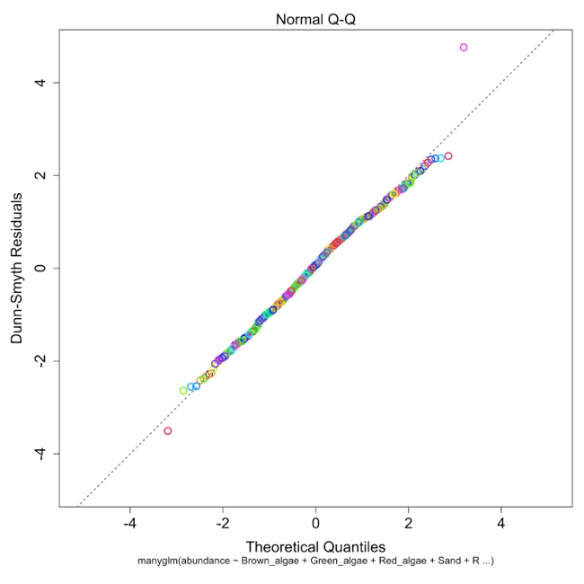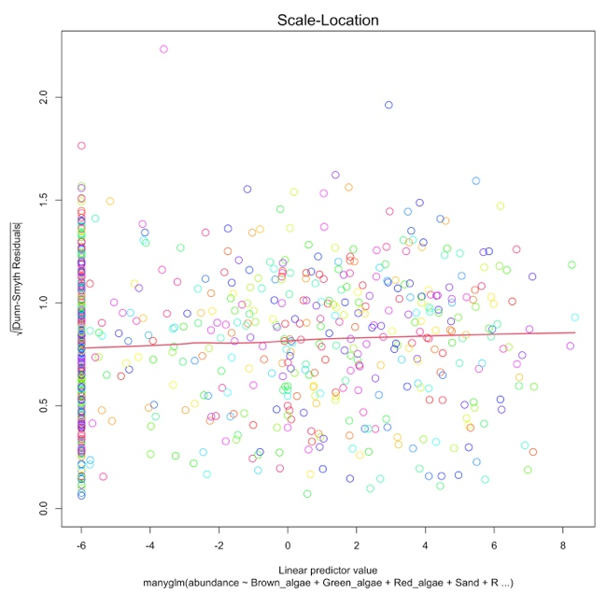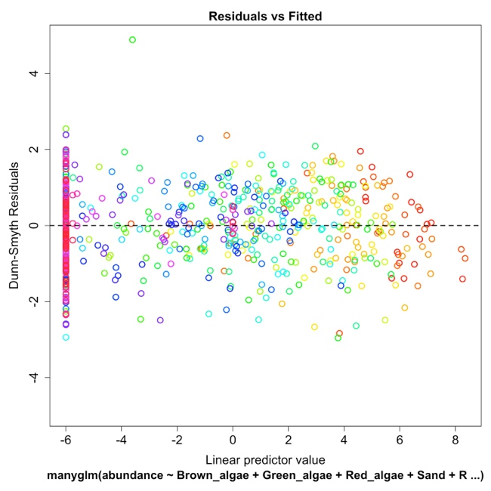
Figure B: Diagnostic Plots for the Generalized Linear Model (GLM) Assessing Abundance
(Dependent Variable) in Relation to Substrate Types (Independent Variables) with C1) Q-Q Plot
Comparing Residuals to the Theoretical Normal Distribution, C2) Cook’s Distance Evaluating the Influence of Individual Data Points on Regression Coefficient Estimates, and C3) Residuals vs. Predicted (Fitted) Values

