Supplementary Material for Paper: Ore grade and depth impacts on copper energy inputs
Journal: Biophysical Economics and Resource Quality
Authors: R.H.E.M. Koppelaar, H. Koppelaar
Supplement C: Mine-depth data

Contents
1. Escondida 4
2. Chuquicamata + Norte Mina Sur 6
3. Radomiro Tomic 7
4. Los Pelambres 8
5. El-Salvador (Inca, Damiana + Campamento Antiguo) 9
6. Bingham Canyon 12
7. Andina (Rio Blanco + Sur Sur) 13
8. Northparkes 14
9. Michilla 15
10. Palabora 16
11. Candelaria 17
12. El-Tesoro / Centinela Cathodes 18
13. Esperanza / Centinela concentrate 19
14. Cuajone 20
15. Toquepala 21
16. La Caridad 22
17. Collahuasi (Ujino, Rosario, Capella) 23
18. Mantoverde 25
19. Mantos Blancos 26
20. El Soldado (El Morro) 27
21. Los Bronces 28
22. Prominent Hill 30
23. El-Teniente 31
24. Nerves Corvo 32
25. Mount Lyell 33
26. Mount Isa 34
27. Cerro Colorado 35
28. Spence 36

Escondida

Mine depth References:
Cifuentes, G. & Cereceda, E.C., 2010. Escondida va a aumento de capacidad en serie. Nueva Mineria & Energia.
Hustrulid, W.A., McCarter, M.K. & Van Zyl, D.J.A., 2000. Slope stability in surface mining, Society for Mining, Metallurgy, and Exploration.
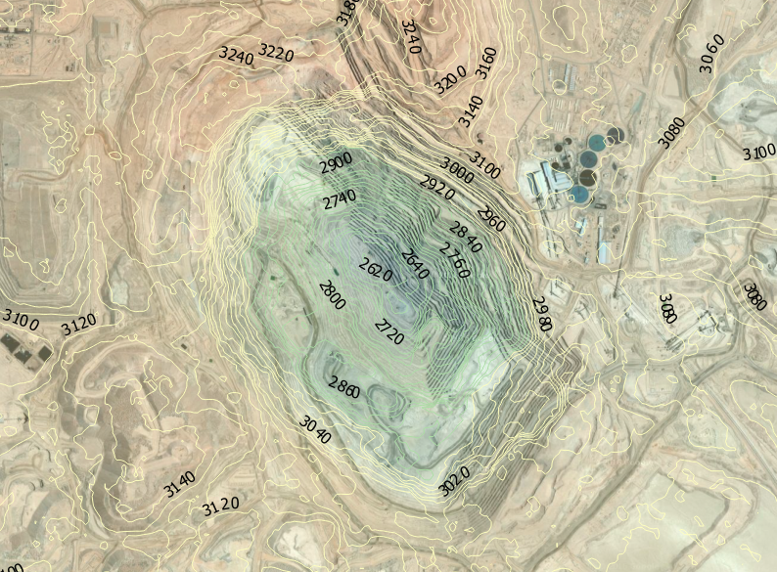 Figure 1. Contour map for Escondida generated in QGIS from ASTER GDEM v2 elevation data.

Chuquicamata + Norte Mina Sur

Mine depth References:
Olavarría, S., Consultant, G. & Karzulovic, A., 2015. Transition from open pit to underground mining at chuquicamata, Antofagasta, Chile. In International Symposium of Stability of Rock Slopes in Open Pit Mining and Civil Engineering. The South African Institute of Mining and Metallurgy, pp. 421–434.
Hustrulid, W.A., McCarter, M.K. & Van Zyl, D.J.A., 2000. Slope stability in surface mining, Society for Mining, Metallurgy, and Exploration.
Staniewska, K., 2012. Copper Mining in Chile. TU International 69, pp.24–27.
Arze, E. et al., 2013. Detalles technicos de Andina 244. Mineria Chilena, 390, pp.161–165.
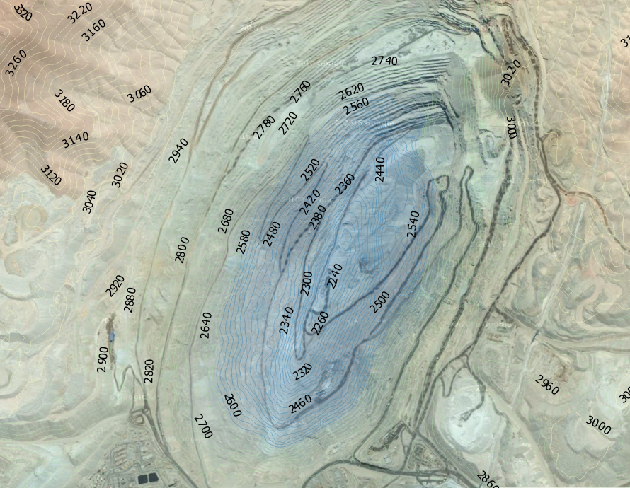
Figure 2. Contour map for Chuquicamata generated in QGIS from ASTER GDEM v2 elevation data.

Radomiro Tomic

Mine depth References:
Hustrulid, W.A., McCarter, M.K. & Van Zyl, D.J.A., 2000. Slope stability in surface mining, Society for Mining, Metallurgy, and Exploration.
Einarsson, C. et al., 2012. Blasthole Drilling in Open Pit Mining 3rd ed., Ulf Linder Atlas Copco.
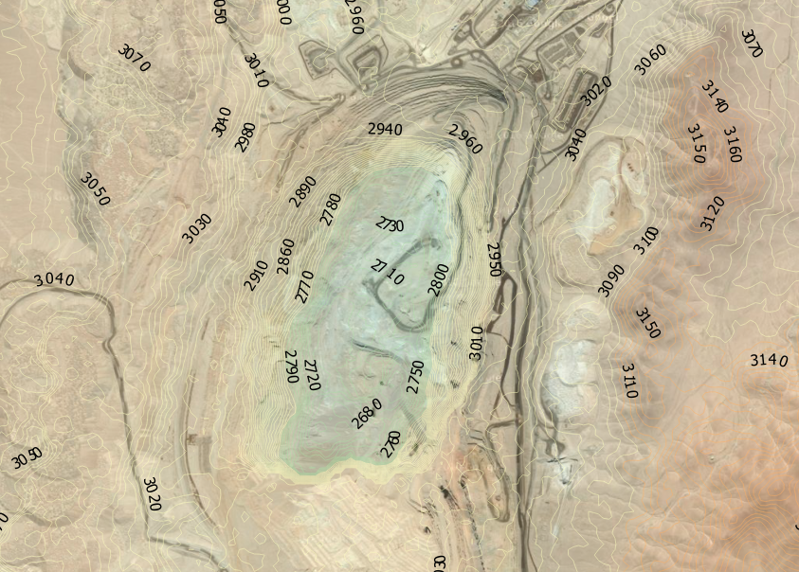
Figure 3. Contour map for Radomiro Tomic generated in QGIS from ASTER GDEM v2 elevation data.

Los Pelambres

Mine depth References:
Orellana, C.G., 2015. Innovacion en el calculo de la densidad de fracturas y su utilidad en el modelo estructural de la mina los pelambres. Universidad de Chile.

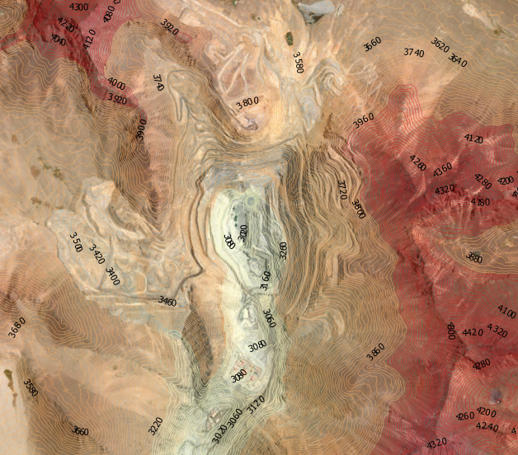
Figure 4. Contour map for Los Pelambres generated in QGIS from ASTER GDEM v2 elevation data.

El-Salvador (Inca, Damiana + Campamento Antiguo)

Mine depth References:

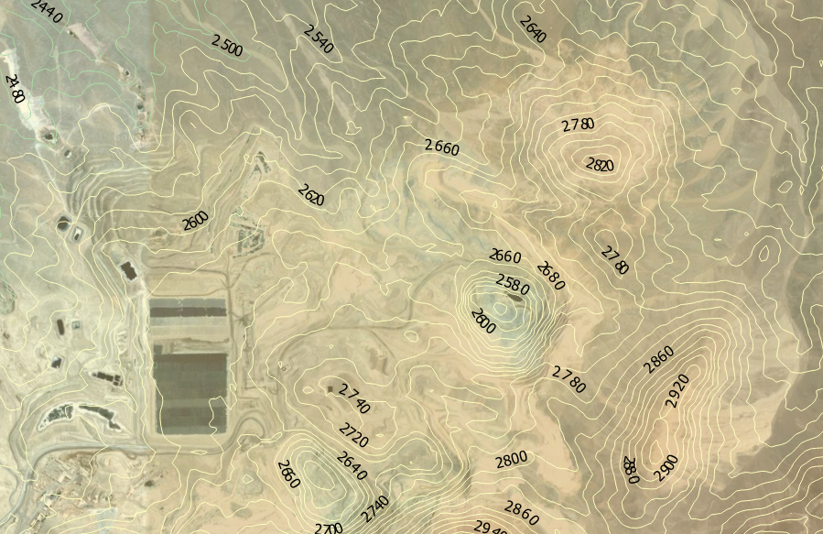
Figure 5. Contour map for Campamento Antiquoe and the hydro-metallurgical plant at El Salvador generated in QGIS from ASTER GDEM v2 elevation data.

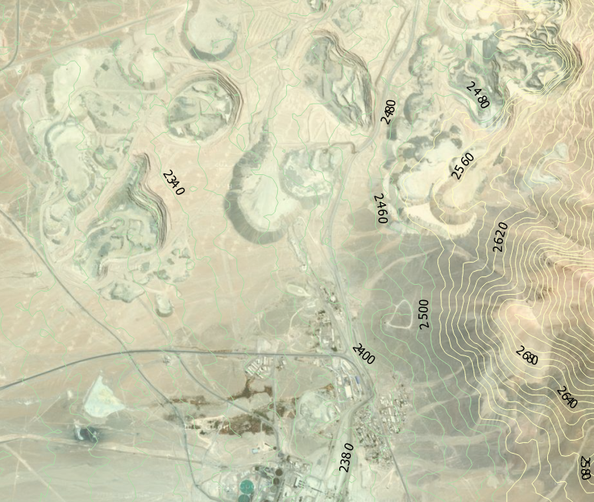
Figure 6. Contour map for Minas Rajos Oxidos and the Milling and Flotation plant at El Salvador generated in QGIS from ASTER GDEM v2 elevation data.
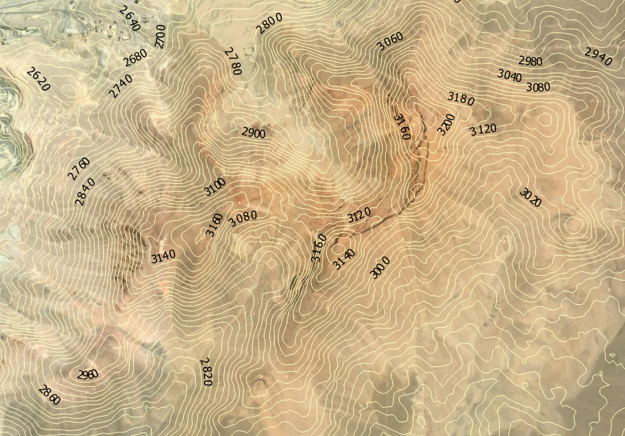
Figure 7. Contour map for the surface of the Inca underground Mine at El Salvador generated in QGIS from ASTER GDEM v2 elevation data.

Bingham Canyon

Mine depth References:
Pankow, K.L. et al., 2014. Massive landslide at Utah copper mine generates wealth of geophysical data. GSA Today, 24(1), pp.4–9.
Atlas Copco, 2007. Mining Methods in Underground Mining 2nd ed., Ulf Linder Atlas Copco.
Rio Tinto, 2009. Kennecott Utah Copper ’ s Bingham Canyon Mine Teacher Guide, Available at: http://www.kennecott.com/library/media/TeacherGuide.pdf.
Einarsson, C. et al., 2012. Blasthole Drilling in Open Pit Mining 3rd ed., Ulf Linder Atlas Copco.
Rajant Corporation, 2008. Kennecott Utah Copper Mine: Mining Communications Using Wireless Mesh Networking,
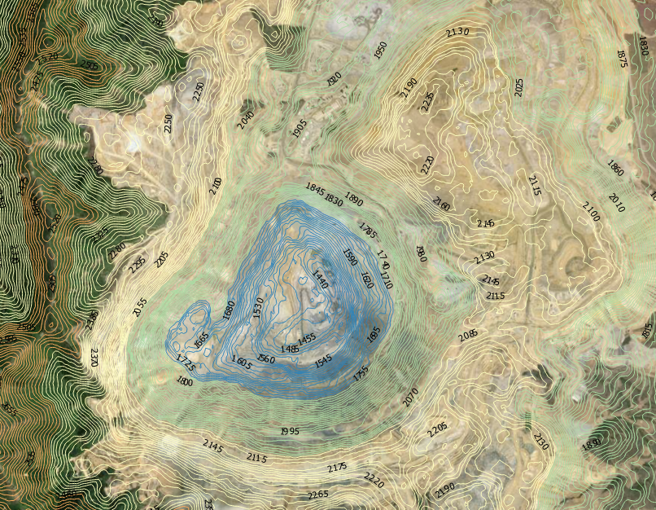
Figure 8. Contour map for Bingham Canyon generated in QGIS from ASTER GDEM v2 elevation data.

Andina (Rio Blanco + Sur Sur)

Mine depth References:
Hustrulid, W.A., McCarter, M.K. & Van Zyl, D.J.A., 2000. Slope stability in surface mining, Society for Mining, Metallurgy, and Exploration.

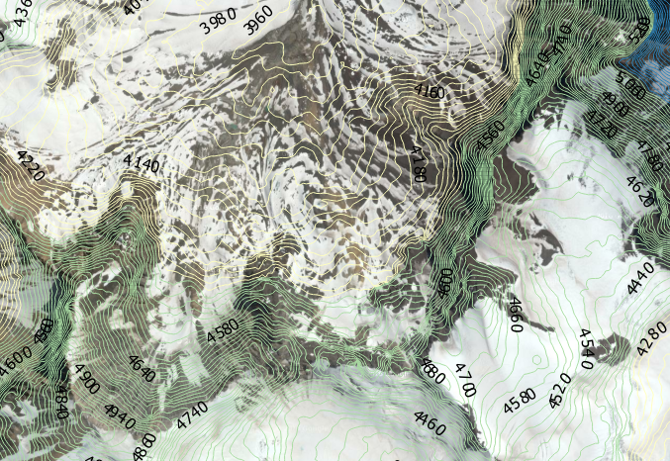
Figure 9. Contour map for Mina Sur generated in QGIS from ASTER GDEM v2 elevation data. Mine not visible on underlying google-maps satellite image

Northparkes

Mine depth References:
Butcher, A. et al., 2013. Northparkes Mines. In Australasian Mining and Metallurgical Operating Practices. pp. 861–878.

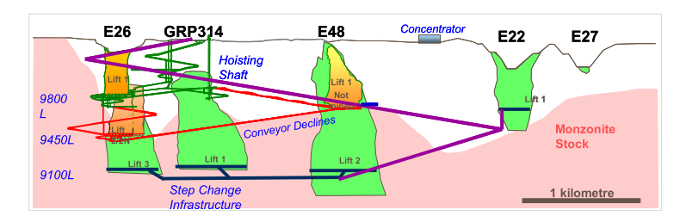
Figure 10. Mine schematic with depth values in feet for Northparkes mine from Butcher (2013)
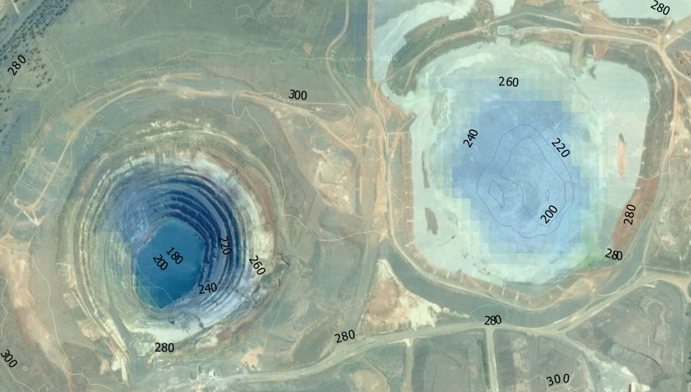
Figure 11. Contour map for Northparkes generated in QGIS from ASTER GDEM v2 elevation data.

Michilla

Mine depth References:
Zagal, O.T., Ojeda, A.L. & Arbitro, J., 2013. Arbitration in the Chilean Chamber of Commerce of Santiago for Antofagasta Minerals SA. , pp.11. Available at: http://www.nic.cl/cgi-bin/get-fallo?f=estmet-17888.pdf

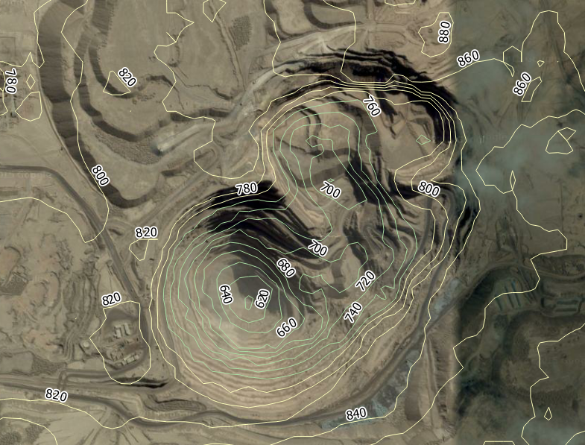
Figure 12. Contour map for Michilla generated in QGIS from ASTER GDEM v2 elevation data.

Palabora

Mine depth References:
Moss, A., Diachenko, S. & Townsend, P., 2006. Interaction between the block cave and the pit slopes at Palabora mine. Journal of the Southern African Institute of Mining and Metallurgy, 106(7), pp.479–484.
Brummer, R.K., Li, H. & Moss, A., 2004. The transition from open pit to underground mining an unusual slope failure mechanism at Palabora. International Symposium on Stability of Rock Slopes in Open Pit Mining and Civil Engineering, pp.411–420.
Hustrulid, W.A., McCarter, M.K. & Van Zyl, D.J.A., 2000. Slope stability in surface mining, Society for Mining, Metallurgy, and Exploration.
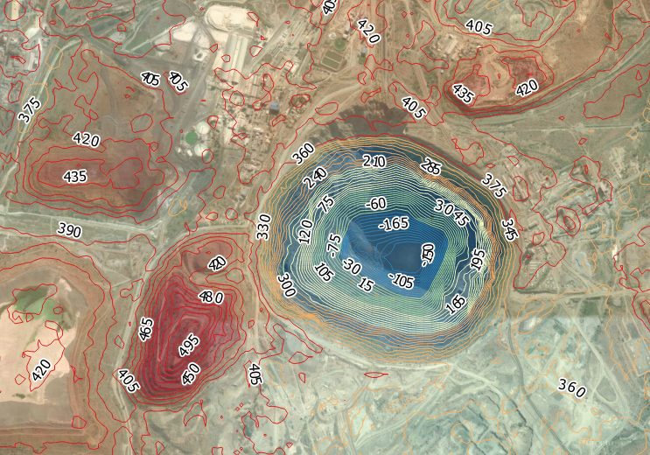
Figure 13. Contour map for Palabora generated in QGIS from ASTER GDEM v2 elevation data.

Candelaria

Mine depth References:
Couture, J. et al., 2015. Technical Report for the Candelaria Copper Mining Complex , Technical Report for the Atacama Province , Region III , Chile, Report prepared by SRK consulting for Lundin Mining Corporation, 162 pages.
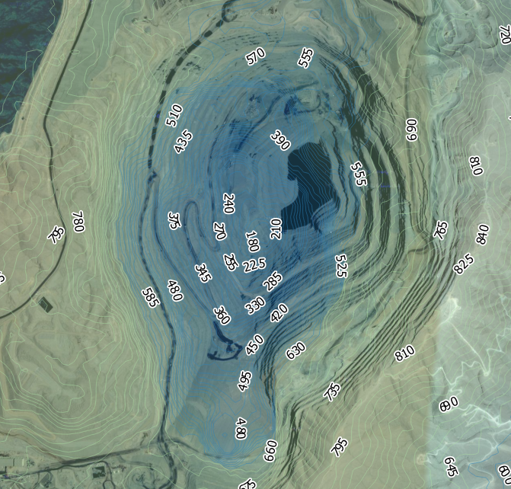
Figure 14. Contour map for Candelaria generated in QGIS from ASTER GDEM v2 elevation data.

El-Tesoro / Centinela Cathodes

Mine depth References:
Zagal, O.T., Ojeda, A.L. & Arbitro, J., 2013. Arbitration in the Chilean Chamber of Commerce of Santiago for Antofagasta Minerals SA. , p.11. Available at: http://www.nic.cl/cgi-bin/get-fallo?f=estmet-17888.pdf.

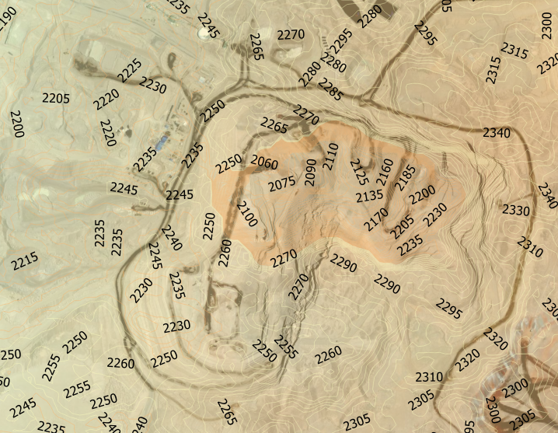
Figure 15. Contour map for El-Tesoro generated in QGIS from ASTER GDEM v2 elevation data.

Esperanza / Centinela concentrate

Mine depth References:
Einarsson, C. et al., 2012. Blasthole Drilling in Open Pit Mining 3rd ed., Ulf Linder Atlas Copco.
Krarup, S., 2011. Objetive ambicioso en Minera Esperanza. Mining & Construction, (2), pp.8–9.

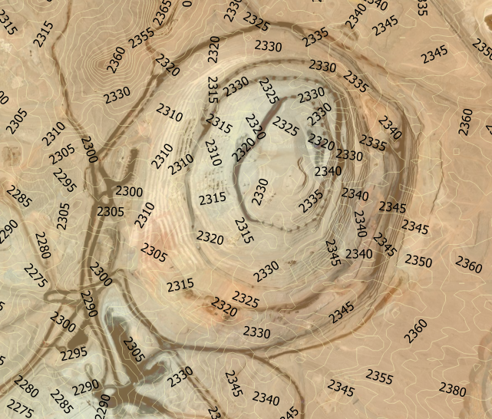
Figure 16. Contour map for Esperanza/Centinela generated in QGIS from ASTER GDEM v2 elevation data.

Cuajone

Mine depth References:
Takoradi Limited, 2010. Significant Upgrade at Los Colatos. , pp.1–9.
Corp, S.C., 2014. Southern Copper Corp Form 10-K 2013, pp. 180
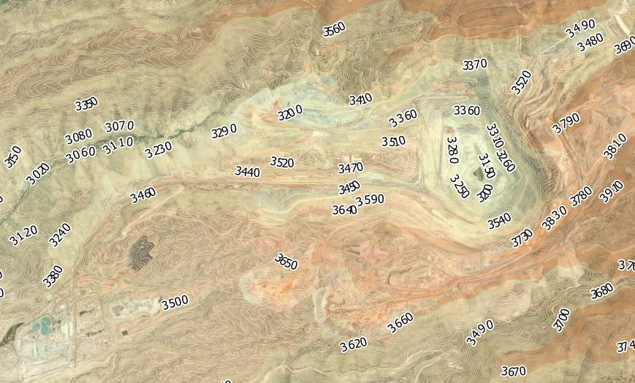
Figure 17. Contour map for Cuajone generated in QGIS from ASTER GDEM v2 elevation data.

Toquepala

Mine depth References:
Takoradi Limited, 2010. Significant Upgrade at Los Colatos. , pp.1–9.
Corp, S.C., 2014. Southern Copper Corp Form 10-K 2013, pp. 180

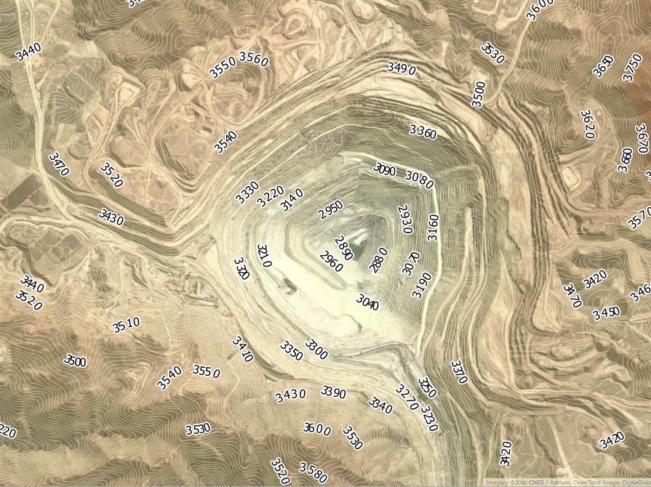
Figure 18. Contour map for Toquepala generated in QGIS from ASTER GDEM v2 elevation data.

La Caridad

Mine depth References:

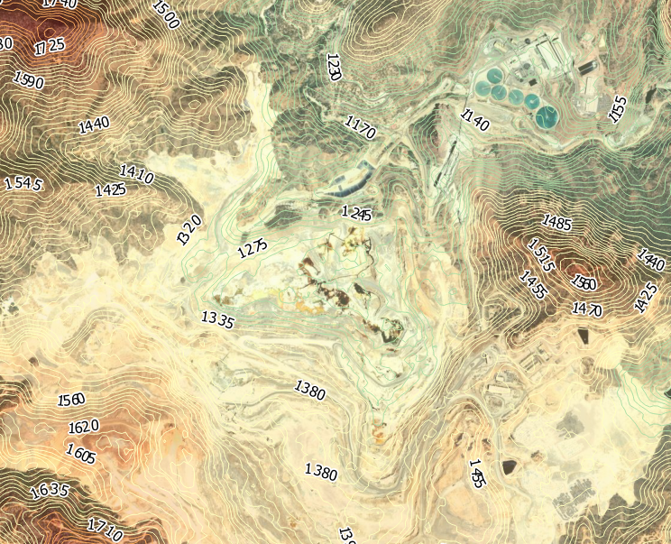
Figure 19. Contour map for La Caridad generated in QGIS from ASTER GDEM v2 elevation data.

Collahuasi (Ujino, Rosario, Capella)

Mine depth References:
Hustrulid, W.A., McCarter, M.K. & Van Zyl, D.J.A., 2000. Slope stability in surface mining, Society for Mining, Metallurgy, and Exploration.
Einarsson, C. et al., 2012. Blasthole Drilling in Open Pit Mining 3rd ed., Ulf Linder Atlas Copco.
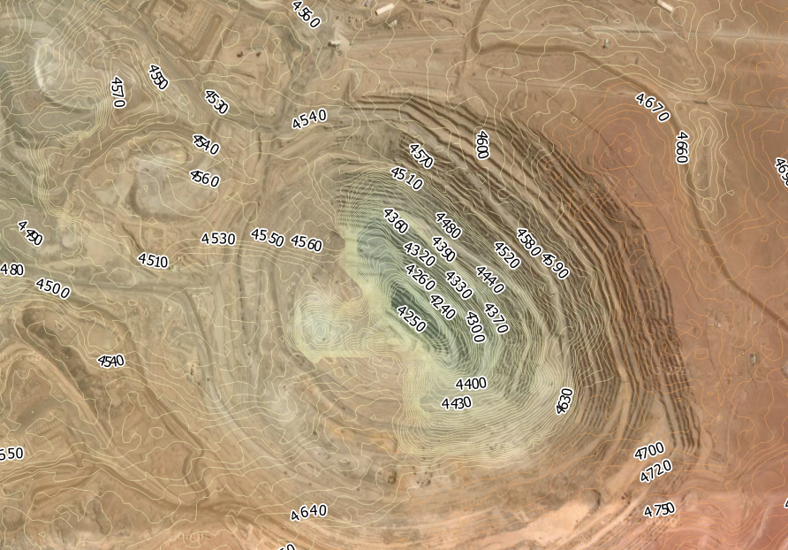
Figure 20. Contour map for Collahuasi generated in QGIS from ASTER GDEM v2 elevation data.
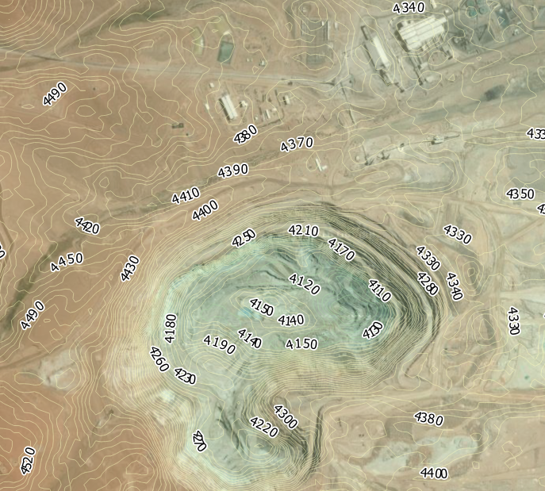
Figure 21. Contour map for Ujino generated in QGIS from ASTER GDEM v2 elevation data.

Mantoverde

Mine depth References:

Schellman, M., Sepulveda, R. & Karzulovic, A., 2015. Slope Design for the East Wall of Mantoverde Mine, Chanaral, Chile. In M. Shellmann, ed. International Symposium on Stability of Rock Slopes in Open Pit Mining and Civil Engineering. The South African Institute of Mining and Metallurgy, pp. 451–470.

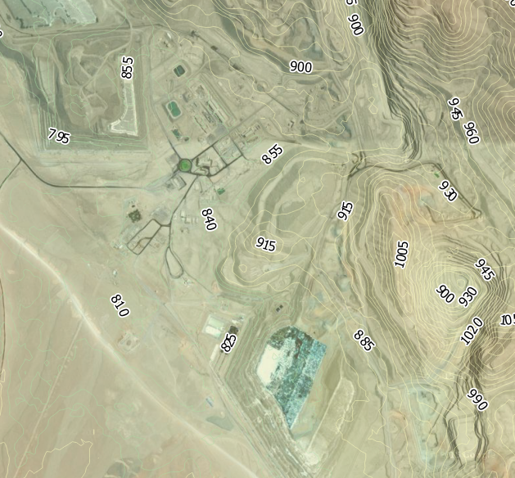
Figure 22. Contour map for Mantoverde generated in QGIS from ASTER GDEM v2 elevation data.

Mantos Blancos

Mine depth References:
Ramírez, L.E. et al., 2006. The Mantos Blancos copper deposit: An upper Jurassic breccia-style hydrothermal system in the Coastal Range of Northern Chile. Mineralium Deposita, 41(3), pp.246–258.
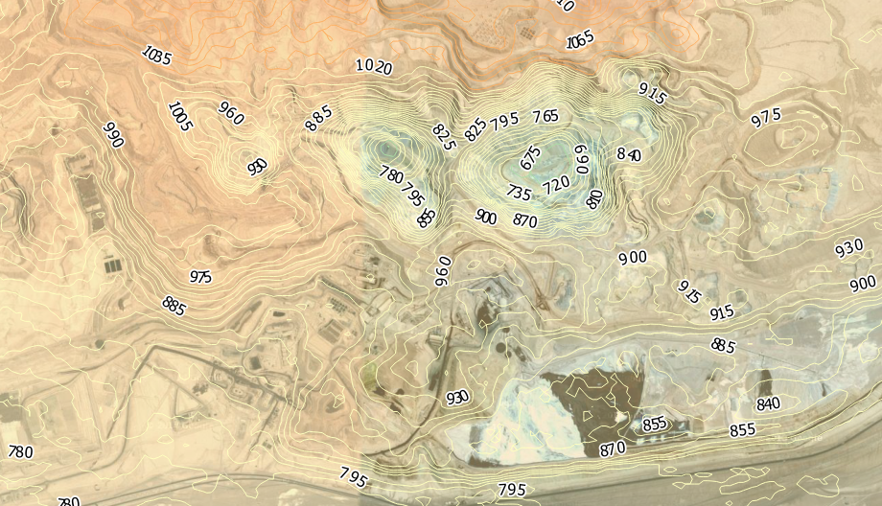
Figure 23. Contour map for Mantos Blancos generated in QGIS from ASTER GDEM v2 elevation data.

El Soldado (El Morro)

Mine depth References:
Atlas Copco, 2007. Mining Methods in Underground Mining 2nd ed., Ulf Linder Atlas Copco.

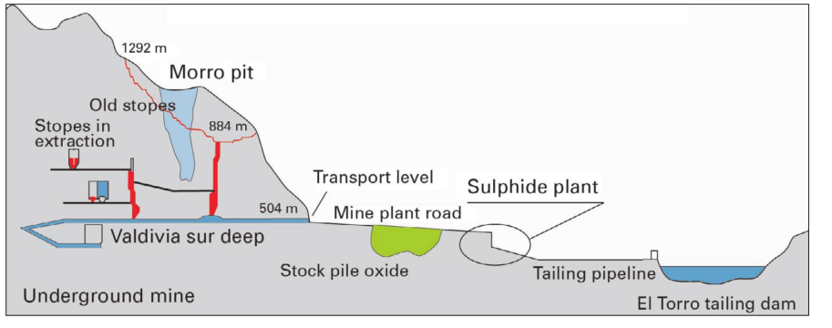
Figure 24. Schematic outline of El-Soldado mine from Atlas Copco (2007)

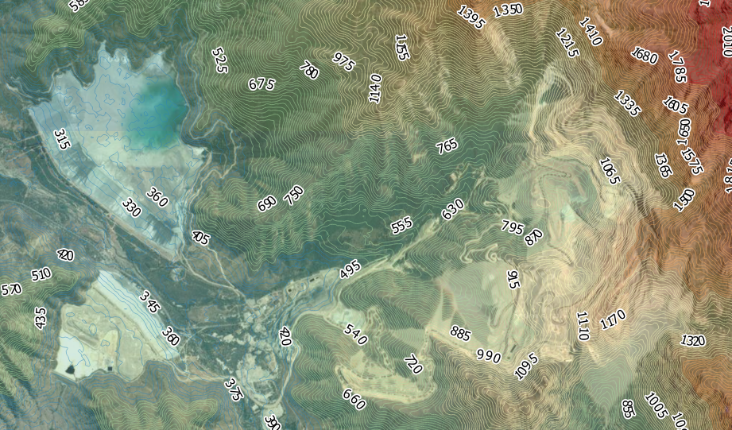
Figure 25. Contour map for El Soldado Morro Pit and Tailings Dam generated in QGIS from ASTER GDEM v2 elevation data.

Los Bronces

Mine depth References:
Schellman, M., Sepulveda, R. & Karzulovic, A., 2015. Slope Design for the East Wall of Mantoverde Mine, Chanaral, Chile. In M. Shellmann, ed. International Symposium on Stability of Rock Slopes in Open Pit Mining and Civil Engineering. The South African Institute of Mining and Metallurgy, pp. 451–470.
Beamish, B., Wanblad, D. & Duran, M., 8 October 2009. Copper Unlocking value from a world-class deposit. Presentation. Anglo-American Chile pp.37.
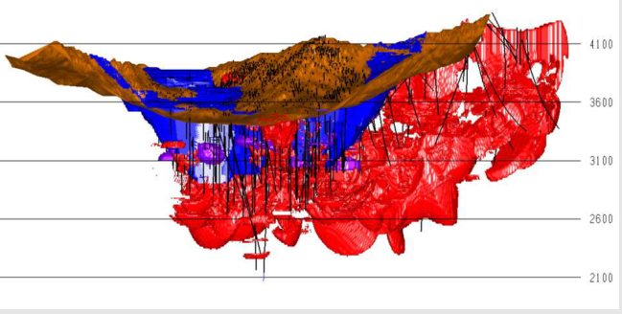
Figure 26 – Los Bronces geophysical map from Beamish et al. (2009)
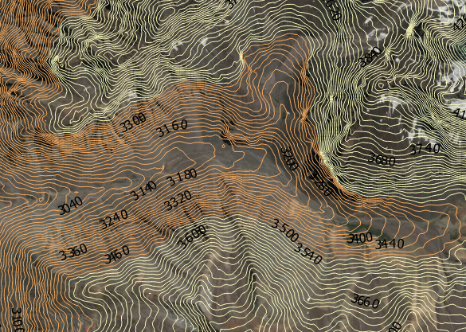
Figure 27. Contour map for Los Bronces generated in QGIS from ASTER GDEM v2 elevation data.

Prominent Hill

Mine depth References:
OZ Minerals, 2012. The Commencement of the Ankata Underground Mine Marks an Important Milestone for Prominent Hill. pp. 2
OZ Minerals, 2014. OZ Minerals Prominent Hill Site Visit., 15 & 16 May, presentation, pp.86.
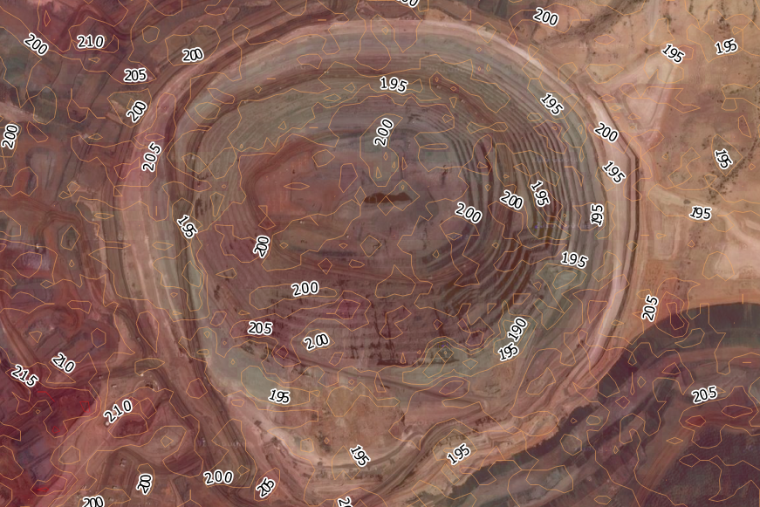
Figure 28. Contour map for Prominent Hill generated in QGIS from ASTER GDEM v2 elevation data.

El-Teniente

Mine depth References:
Atlas Copco, 2007. Mining Methods in Underground Mining 2nd ed., Ulf Linder Atlas Copco.
International Mining, 2010. El Teniente goes deeper. International Mining, pp.10–15.

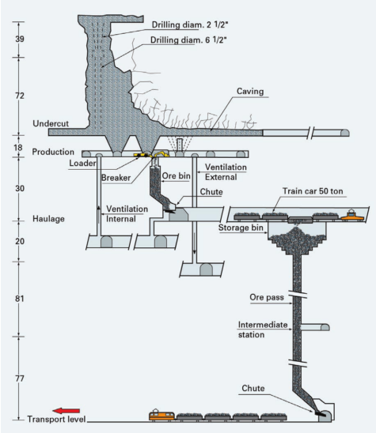
Figure 29. El-Teniente mine-schematic from Atlas-Copco (2007)

Neves Corvo

Mine depth References:
Wardell Armstrong, 2013. LUNDIN MINING NI 43-101 Technical Report for Neves-Corvo Mine and Semblana Deposit, Portugal January 2013, 224 pages
Lundin Mining, 2016. Neves-Corvo Mine, 5 pages.

Mount Lyell

Mine depth References:
McQuade, C.V., Johnston, J.F. & Innes, S.M., 1995. Mount Lyell Remediation: Review of historical literature and data on the sources and quality of effluent from the Mount Lyell lease site 1st ed., Australian Government Department of Environment and Land management.

Mount Isa

Mine depth References:
Mining-technology.com, 2016. Mount Isa Mine Longitudinal Section. Webpage. Available at: http://www.mining-technology.com/projects/mount_isa_copper/mount_isa_copper3.html
Gallagher, 2010. Mount Isa Mines Queensland,
Atlas Copco, 2007. Mining Methods in Underground Mining 2nd ed., Ulf Linder Atlas Copco.
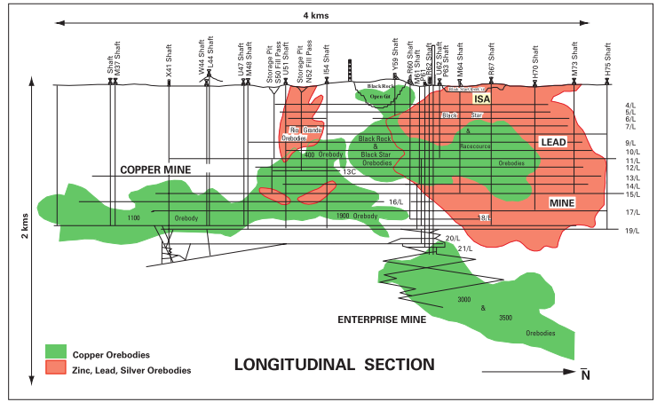
Figure 30. Mount Isa mine schematic from Atlas Copco (2007).

Cerro Colorado

Mine depth References:
Joranada Europeas de Patrimonio Historico, Collegio Official de Arquitectos de Huelva & Rio Tinto, 2015. Guia de la Visita a la Mina de Rio tinto,

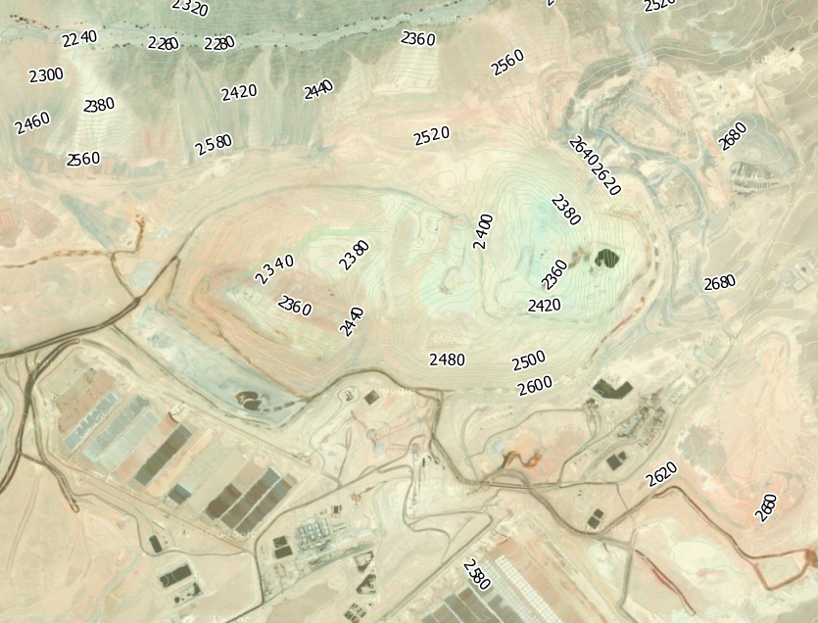
Figure 31. Contour map for Cerro Colorado generated in QGIS from ASTER GDEM v2 elevation data.

Spence

Mine depth References:
Catterpilar Global Mining, 2008. Spence mine: from greenfield to major producer in a few short years. Viewpoint Perspectives on Modern Mining, (4), pp.16–21.
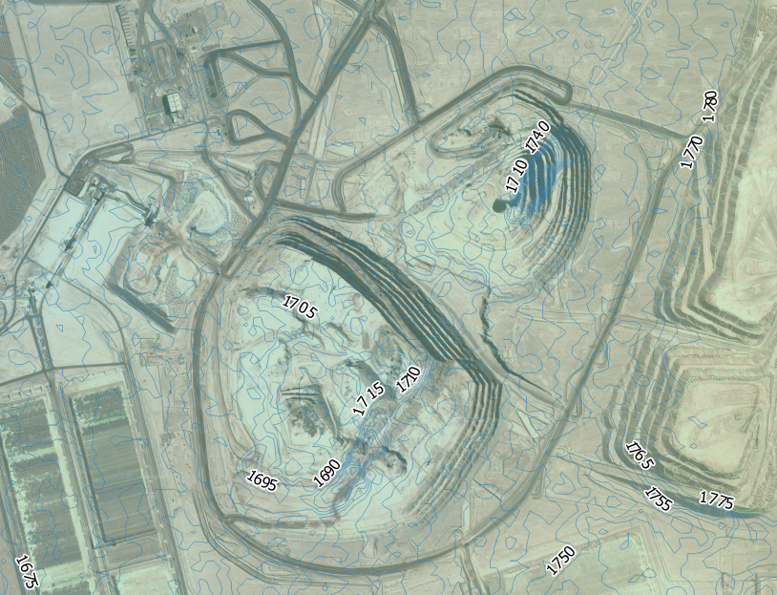
Figure 32. Contour map for Spence generated in QGIS from ASTER GDEM v2 elevation data.

¹Centre for Environmental Policy, Faculty of Natural Science, Imperial College London, South Kensington Campus, London SW7 2AZ, England, UK.,
Institute for Integrated Economic Research, The Broadway W5 2NR, London
Faculty of Electrical Eng., Math. and Computer Science, Delft University of Technology, Mekelweg 4, 2628 CD Delft

