RQ1 Do findings in this second study replicate those we have found previously?

Comparison of valence and importance for general (not related to DCD) identities in the dDCD compared to sDCD groups, this was previously found to be non-significant but Bayesian analysis suggests no evidence of a non-significant effect. Data can be found in Figure 3. No significant group difference was found for either the valence (F(1,129) = 3.86, p =.052, BF_{inc} = 1.18) or the importance (F(1,129) = 1.34, p =.248, BF_{inc} = .391) of the non-DCD related identities. Please note once again Bayesian analysis suggests insufficient evidence to conclude an effect in either direction.

Comparison of valence and importance for DCD related identities, this was previously found to be significant but Bayesian analysis suggests insufficient evidence to conclude an effect in either direction: Data can be found in Figure 3. No significant group difference was found for either the valence (F(1,129) = 0.05, p =.819, BF_{inc} = .221) or the importance (F(1,129) = 1.17, p =.281, BF_{inc} = .362) of the DCD related identities. Please note that for valence this is strong evidence of a non-significant effect.

Comparison of valence and importance across DCD related and non-DCD related identities, previously a significant interaction between type of identity and group was found for valence but not identity. A main effect was found for identity type but not for group: Data can be found in Supplementary Figure. For valence, there was a significant main effect of identity (F(1,129) = 160.29, p < .001, partial η² = .554, BF_{inc} = ∞) with DCD related identities being rated as significantly more negative compared to non-DCD related identities. Neither group nor the interaction were significant (group: F(1,129) = 1.62, p = .205, partial η² = .012, BF_{inc} = .570, interaction: F(1,129) = 1.57. p =.213, partial η² = .012, BF_{inc} = .406). For importance, again there was a significant effect of statement type with the DCD statements being rated as less important than the non-DCD related statements (F(1,129) = 41.52, p < .001, partial η² = .243, BF_{inc} =4.98 x 10⁹). The interaction between group and statement type was not significant (F(1,129) = .0349, p =.852, partial η² = .000, BF_{inc} = .385) nor was the effect of group (F(1,129) = 1.90, p = .171, partial η² = .014, BF_{inc} = .277).

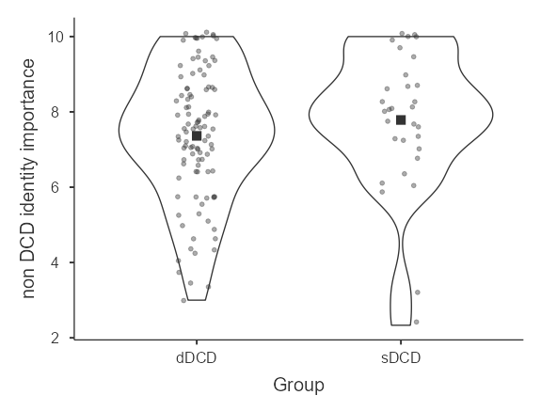
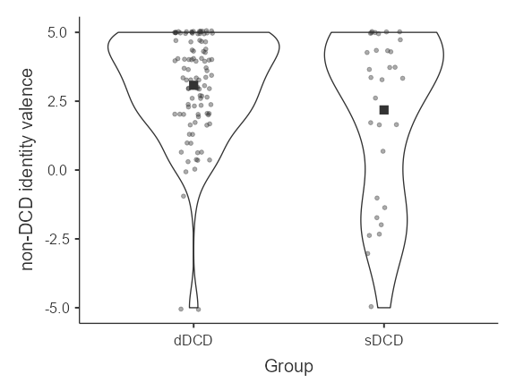
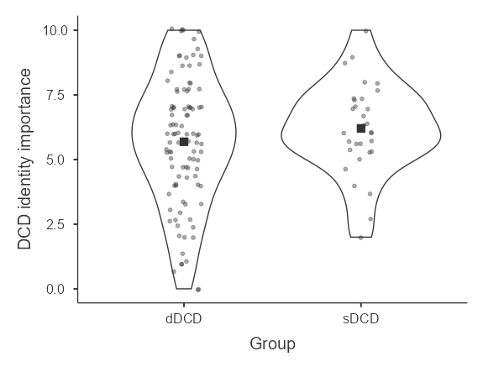
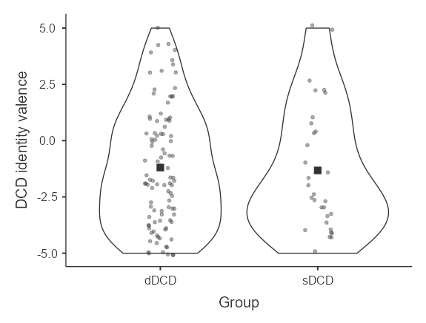
Supplementary Figure. Violin plots showing the valence and importance of both the non-DCD and the DCD related identities. The mean value is represented by a black square

Consideration of differences in wellbeing measures across the two groups, previously no differences were found: No difference was found in the PWB scores across the dDCD (mean = 80.5, standard deviation = 16.4) and the sDCD group (mean = 79.3, standard deviation = 13.7) [F(1,129) = 0.134, p = .715, BF_{incl} = .229].

Consideration of relationships between valence and importance of statements for the dDCD and age of diagnosis. Previously no relationships with age of diagnosis were found: Spearman correlations found non-significant relationships between age of diagnosis and valence of DCD statements [N = 97, ρ = -.120, p = .243, BF₁₀ = .130], importance of the DCD statements [N = 97, ρ = .091, p = .377, BF₁₀ = .367] and wellbeing [N=97, ρ = .047, p = .648, BF₁₀ = .137]

