Appendix A

Appendix B
Search Strategy
Search Set | Search Terms
1 | Reality OR VR OR Virtual Reality intervention* OR Virtual Reality implementation*
2 | mental health OR mental health service* OR mental healthcare
3 | clinician* OR practitioner* OR therapist* OR doctor* OR nurse*
4 | Psychologist* OR psychiatrist* OR psychotherapist*
5 | perception* OR attitude* OR knowledge* OR opinion* OR view*
6 | #2 AND #3
7 | #4 OR #6
8 | #7 AND #1 AND #5

Appendix C
PRISMA flowchart for study selection
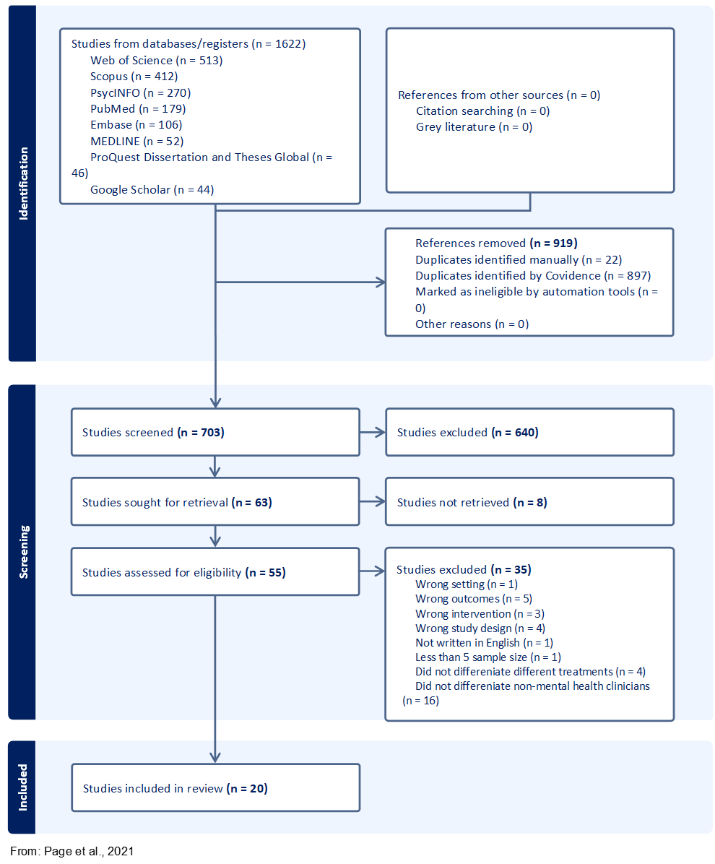

Appendix D
List of Included Studies
Authors | Year | Title | Journal | DOI / Reference
Alzahrani, S. | 2021 | Assessing the Readiness of Using Virtual Reality in Mental Health Practice in Australia | ACIS 2021 Proceedings | https://aisel.aisnet.org/acis2021/84
Baghaei, N., Ahmadi, A., Khaliq, I., & Liang, H.-N. | 2021 | Individualised Virtual Reality for Supporting Depression: Feedback from Mental Health Professionals | IEEE ISMAR-Adjunct | DOI: 10.1109/ISMAR-Adjunct54149.2021.00022
Chung, O. S., et al. | 2022 | Are Australian Mental Health Services Ready for Therapeutic Virtual Reality? | Frontiers in Psychiatry | DOI: 10.3389/fpsyt.2022.792663
García, A. S., et al. | 2020 | Acceptance and Use of a Multi-Modal Avatar-Based Tool for Remediation of Social Cognition Deficits | Journal of Ambient Intelligence and Humanized Computing | DOI: 10.1007/s12652-019-01418-8
García, A. S., et al. | 2022 | Behavioral Intention of Mental Health Practitioners Toward the Adoption of Virtual Humans in Affect Recognition Training | Frontiers in Psychology | DOI: 10.3389/fpsyg.2022.934880
García, A. S., et al. | 2023 | Co-Design of Avatars to Embody Auditory Hallucinations of Patients with Schizophrenia | Virtual Reality | DOI: 10.1007/s10055-021-00558-7
Guillén, V., Baños, R. M., & Botella, C. | 2018 | Users’ Opinion About a Virtual Reality System as an Adjunct to Psychological Treatment for Stress-Related Disorders | Frontiers in Psychology | DOI: 10.3389/fpsyg.2018.01038
Haeyen, S., Jans, N., Glas, M., & Kolijn, J. | 2021a | VR Health Experience: A Virtual Space for Arts and Psychomotor Therapy | Frontiers in Psychology | DOI: 10.3389/fpsyg.2021.704613
Haeyen, S., Jans, N., & Heijman, J. | 2021b | The Use of VR Tilt Brush in Art and Psychomotor Therapy: An Innovative Perspective | The Arts in Psychotherapy | DOI: 10.1016/j.aip.2021.101855
Kramer, T. L., et al. | 2010 | Clinician Perceptions of Virtual Reality to Assess and Treat Returning Veterans | Psychiatric Services | DOI: 10.1176/ps.2010.61.11.1153
Lindner, P., et al. | 2019 | Attitudes Toward and Familiarity with Virtual Reality Therapy Among Practicing Cognitive Behavior Therapists | Frontiers in Psychology | DOI: 10.3389/fpsyg.2019.00176
Nijman, S. A., et al. | 2020 | Dynamic Interactive Social Cognition Training in Virtual Reality (DiSCoVR) for People With a Psychotic Disorder | JMIR Mental Health | DOI: 10.2196/17808
Ong, T., et al. | 2024 | Therapist Perspectives on Telehealth-Based Virtual Reality Exposure Therapy | Virtual Reality | DOI: 10.1007/s10055-024-00956-7
Riches, S., et al. | 2023 | Integrating a Virtual Reality Relaxation Clinic within Acute Psychiatric Services: A Pilot Study | Psychiatry Research | DOI: 10.1016/j.psychres.2023.115477
Rimer, E., Husby, L. V., & Solem, S. | 2021 | Virtual Reality Exposure Therapy for Fear of Heights: Clinicians’ Attitudes Become More Positive After Trying VRET | Frontiers in Psychology | DOI: 10.3389/fpsyg.2021.671871
Sarnin, E. F., et al. | 2022 | Clinicians’ Perception of Virtual Reality Therapy in Treating Patients with Obsessive Compulsive Disorder | Medicine & Health | DOI: 10.17576/MH.2022.1702.17
Schwartzman, D., Segal, R., & Drapeau, M. | 2012 | Perceptions of Virtual Reality Among Therapists Who Do Not Apply This Technology in Clinical Practice | Psychological Services | DOI: 10.1037/a0026801
Segal, R., Bhatia, M., & Drapeau, M. | 2011 | Therapists’ Perception of Benefits and Costs of Using Virtual Reality Treatments | Cyberpsychology, Behavior, and Social Networking | DOI: 10.1089/cyber.2009.0398
Van Pelt, B. J., et al. | 2022 | Dynamic Interactive Social Cognition Training in Virtual Reality (DiSCoVR) for Adults with Autism Spectrum Disorder | Research in Autism Spectrum Disorders | DOI: 10.1016/j.rasd.2022.102003
Wray, T. B., & Emery, N. N. | 2022 | Feasibility, Appropriateness, and Willingness to Use Virtual Reality as an Adjunct to Counseling Among Addictions Counselors | Substance Use & Misuse | DOI: 10.1080/10826084.2022.2092148

Appendix E
CASP Quality Assessment – Qualitative Studies (n = 4)
Study | 1. Was there a clear statement of the aims of the research? | 2. Is a qualitative methodology appropriate? | 3. Was the research design appropriate to address the aims of the research? | 4. Was the recruitment strategy appropriate to the aims of the research? | 5. Was the data collected in a way that addressed the research issue? | 6. Has the relationship between researcher and participants been adequately considered? | 7. Have ethical issues been taken into consideration? | 8. Was the data analysis sufficiently rigorous? | 9. Is there a clear statement of findings?
Baghaei et al. (2021) | Yes | Yes | Yes | Can’t tell | Can’t tell | Can’t tell | Can’t tell | Can’t tell | Yes
Kramer et al. (2010) | Yes | Yes | Yes | Can’t tell | Yes | Can’t tell | Yes | Yes | Yes
Ong et al. (2024) | Yes | Yes | Yes | Yes | Yes | Can’t tell | Yes | Yes | Yes
Sarnin et al. (2022) | Yes | Yes | Yes | Yes | Yes | Yes | Yes | Yes | Yes
Appendix F
MMAT Quality Assessment – Qualitative Studies (n = 4)
Study | 1. Is the qualitative approach appropriate to answer the research question? | 2. Are the qualitative data collection methods adequate to address the research question? | 3. Are the findings adequately derived from the data? | 4. Is the interpretation of results sufficiently substantiated by data? | 5. Is there coherence between qualitative data sources, collection, analysis and interpretation?
Baghaei et al. (2021) | Yes | Yes | Yes | Yes | Yes
Kramer et al. (2010) | Yes | Yes | Yes | Yes | Yes
Ong et al. (2024) | Yes | Yes | Yes | Yes | Yes
Sarnin et al. (2022) | Yes | Yes | Yes | Yes | Yes

Appendix G
MMAT Quality Assessment – Quantitative Studies (n = 7)
Study | - Is the sampling strategy relevant to address the research question? | - Is the sample representative of the target population? | - Are the measurements appropriate? | - Is the risk of nonresponse bias low? | - Is the statistical analysis appropriate to answer the research question?
García et al. (2020) | Partially met | Partially met | Yes | Yes | Partially met
García et al. (2022) | Partially met | Partially met | Yes | Can’t tell | Yes
García et al. (2023) | Partially met | Partially met | Yes | Can’t tell | Yes
Lindner et al. (2019) | Partially met | Partially met | Yes | Can’t tell | Yes
Schwartzman et al. (2012) | Partially met | Partially met | Yes | Can’t tell | Yes
Segal et al. (2011) | Partially met | Partially met | Partially met | Can’t tell | Yes
Wray & Emery, (2022) | Partially met | Partially met | Yes | Can’t tell | Yes

Appendix H
MMAT Quality Assessment – Mixed-Method Studies (n = 9)
Study | 1. Is there an adequate rationale for using a mixed methods design to address the research question? | 2. Are the different components of the study effectively integrated to answer the research question? | 3. Are the outputs of the integration of qualitative and quantitative components adequately interpreted | 4. Are divergences and inconsistencies between quantitative and qualitative results adequately addressed? | 5. Do the different components of the study adhere to the quality criteria of each tradition of the methods involved?
Alzahrani (2021) | Yes | Yes | Yes | Can’t tell | Partially met
Chung et al. (2022) | Yes | Yes | Yes | Yes | Partially met
Guillén et al. (2018) | Yes | Yes | Yes | Yes | Partially met
Haeyen et al. (2021a) | Yes | Partially met | Partially met | Can’t tell | Partially met
Haeyen et al. (2021b) | Yes | Partially met | Partially met | Can’t tell | Partially met
Riches et al. (2023) | Yes | Yes | Yes | Can’t tell | Partially met
Rimer et al. (2021) | Can’t tell | Partially met | Partially met | Can’t tell | Partially met
Nijman et al. (2020) | Yes | Yes | Yes | Yes | Partially met
Van Pelt et al. (2022) | Yes | Yes | Yes | Yes | Partially met

Appendix R
Mental Health Professionals' Attitudes Towards VR Interventions
Attitudes | Number of Studies | Studies
Positive | 19 | Alzahrani (2021); Baghaei et al. (2021); Chung et al. (2022); García et al. (2020, 2022, 2023); Guillén et al. (2018); Haeyen et al. (2021a, 2021b); Kramer et al. (2010); Lindner et al. (2019); Nijman et al., (2020); Ong et al. (2024); Riches et al. (2023); Rimer et al. (2021); Sarnin et al. (2022); Segal et al. (2011); Van Pelt et al. (2022); Wray & Emery (2022)
Neutral | 4 | Baghaei et al. (2021); Chung et al. (2022); Ong et al. (2024)
Negative | 3 | Chung et al. (2022); Ong et al. (2024); Schwartzman et al. (2012); Wray & Emery (2022)

