Supplementary Material
Supplementary Table 1. Wearables for Kids (W4K) Protocol
Activity | Intensity | Description | Minutes Spent in Activity
Resting,  Lying down | Sedentary  ≤ 1.5 METs | Lying down in supine position - on a blanket on the ground; playing on iPad (playing games) | 10
Video viewing | Sedentary  ≤ 1.5 METs | Sitting in a chair at a table playing on iPad (playing games). Instructed to minimize body movements | 5
Walking casual | Light  >1.5 METs to < 3 METs | Walking self-selected pace casual with a research assistant | 5
Walking Brisk | Moderate  ≥ 3.0 METs to < 6 METs | Walking self-selected pace brisk with a research assistant | 5
Obstacle course | Vigorous  ≥ 6.0 METs | Participants will run through an obstacle course led by a research assistant | 5
Break | Sedentary  ≤ 1.5 METs | Seated research assistant is describing next block | 3
Highlighted portion denotes portion of the protocol used for the current study.

Supplementary Table 2. List of All 56 Features
Feature Name
Maximum yaw
Maximum roll
Mean yaw
Mean roll
Minimum roll
Minimum yaw
Mean acceleration along the Y axis
Minimum pitch
Maximum acceleration along the Y axis
Mean acceleration along the X axis
Mean acceleration along the Z axis
Maximum acceleration along the Z axis
Mean vector magnitude
Minimum acceleration along the Y axis
Mean pitch
Maximum acceleration along the X axis
Maximum pitch
Minimum acceleration along the X axis
Root mean square of pitch
Minimum acceleration along the Z axis
Variance of pitch
Standard deviation of roll
Standard deviation of acceleration along the Z axis
Root mean square of acceleration along the Z axis
Variance of acceleration along the Z axis
Standard deviation of yaw
Variance of roll
Root mean square of roll
Minimum vector magnitude
Standard deviation of acceleration along the X axis
Standard deviation of pitch
Maximum vector magnitude
Standard deviation of vector magnitude
Variance of yaw
Kurtosis of acceleration along the X axis
Skewness of vector magnitude
Standard deviation of acceleration along the Y axis
Root mean square of acceleration along the X axis
Kurtosis of acceleration along the Y axis
Root mean square of yaw
Root mean square of vector magnitude
Root mean square of acceleration along the Y axis
Variance of vector magnitude
Skewness of acceleration along the X axis
Kurtosis of yaw
Variance of acceleration along the Y axis
Variance of acceleration along the X axis
Kurtosis of acceleration along the Z axis
Kurtosis of vector magnitude
Skewness of yaw
Skewness of roll
Kurtosis of roll
Skewness of pitch
Skewness of acceleration along the Y axis
Skewness of acceleration along the Z axis

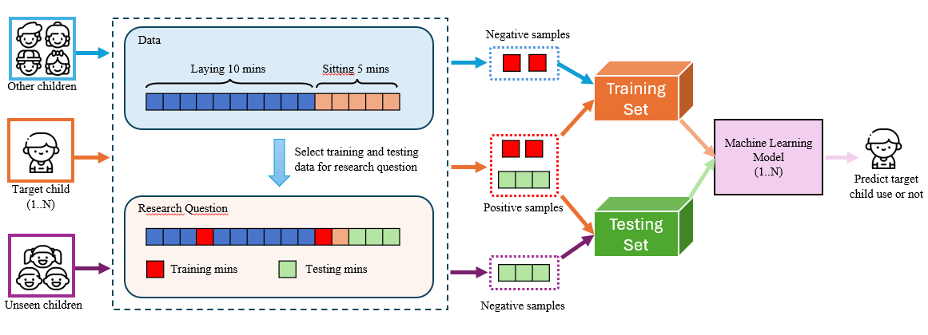
Supplementary Figure 1. Training and Testing Data Creation Process

