Appendix A
Figure 1
Layout and components of the KKGG app
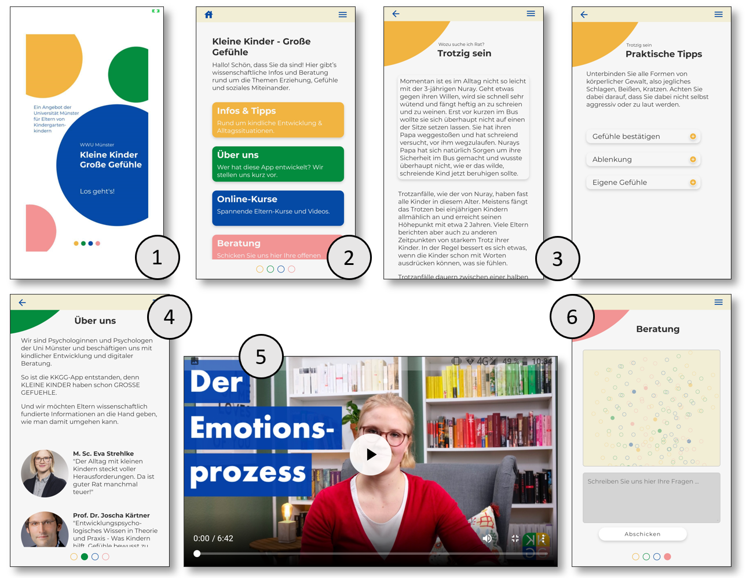
Note. Figure shows main components of the app during data assessment, namely (1) Start screen (2) Main menu (3) Psychoeducational texts (4) About us (5) Video tutorials and (6) Individual Counseling.

