Supplementary Information

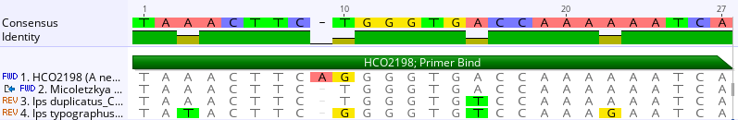Supplementary figure 1: HCO2198 primer binding sites of Ips duplicatus, I. typographus and Micoletzkya buetschlii. According to its circularized mt genome sequence the number of mismatches between Ips typographus and primer LCO1490 sequence is even higher and has not been determined for other species of the genus yet (see also Figure 1).

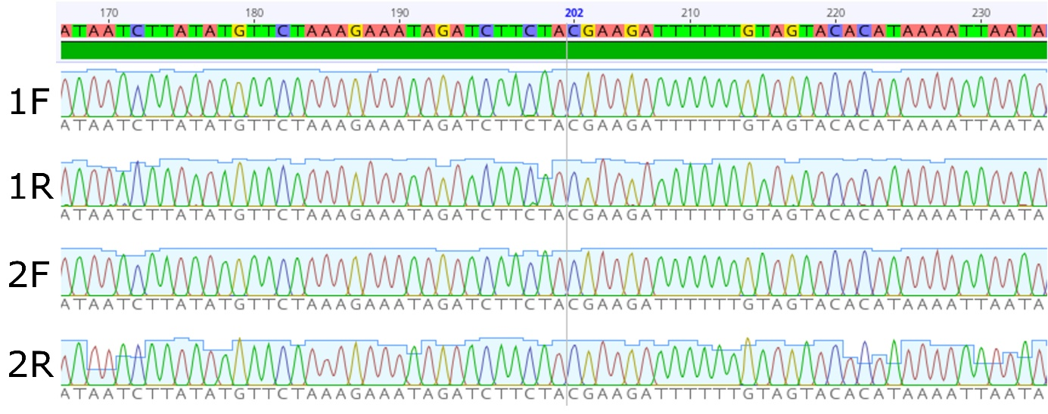Supplementary figure 2: Chromatograms of high quality PCR-DNA of Micoletzkya buetschlii after DNA-amplification with EPPO barcoding primers.

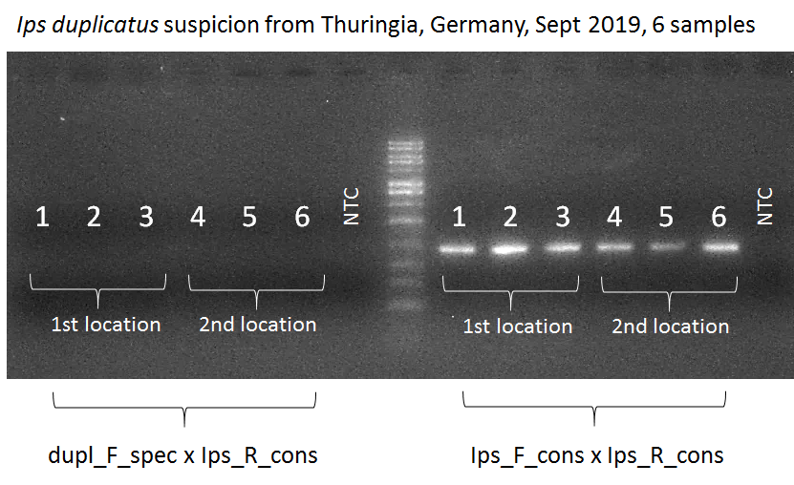
Supplementary figure 3: Diagnosis of Pityogenes chalcographus using the new primer pairs. The PCR results (no DNA amplification with I. duplicatus specific primer „dupl_F_spec“, but DNA amplification with bark beetle primer „Ips_F_cons“) suggested the presence of another bark beetle than I. duplicatus. Therefore, the PCR-DNA fragments shown on the right hand side were sequenced and unambiguously identified as Pityogenes chalcographus.

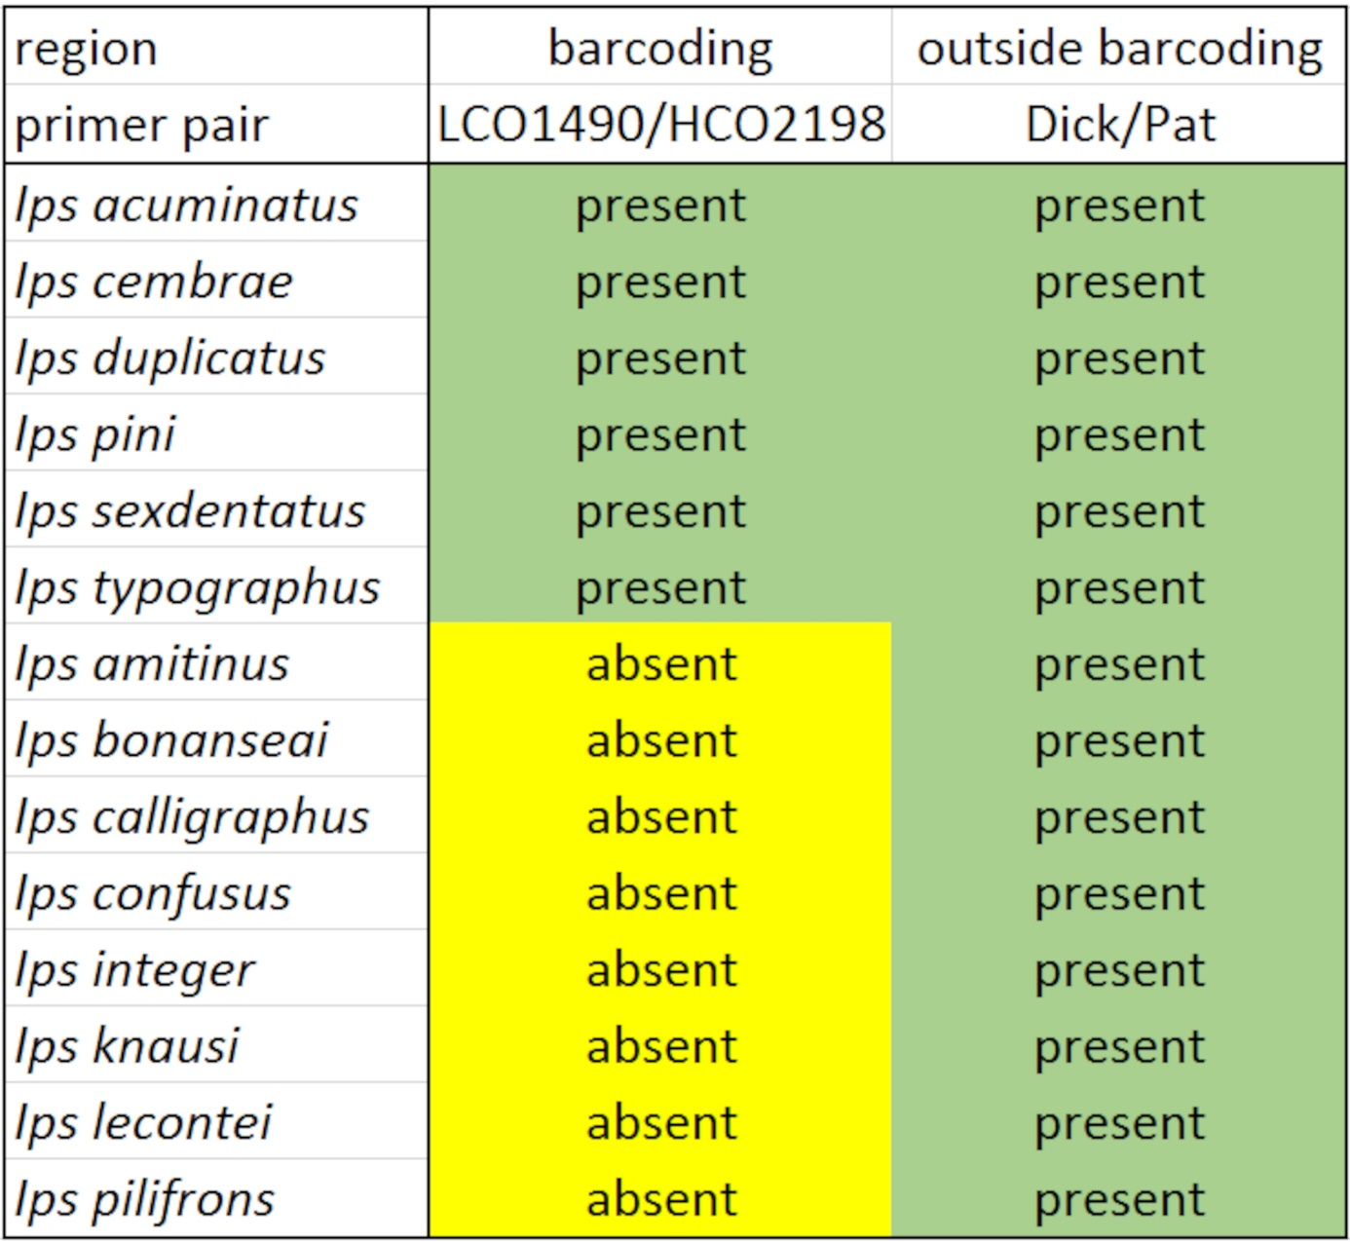Supplementary figure 4: Absence (neg) and presence (pos) of COI nucleotide sequences of Ips spp. in NCBI databases

