Appendix S1
The massification of an atypical field symptom: damaged oilseed rape caused by Aulacobaris coerulescens (Col.: Curculionidae) using computed tomography approaches
FIGURE A1: Aulacobaris coerulescens larvae in the dissected stem
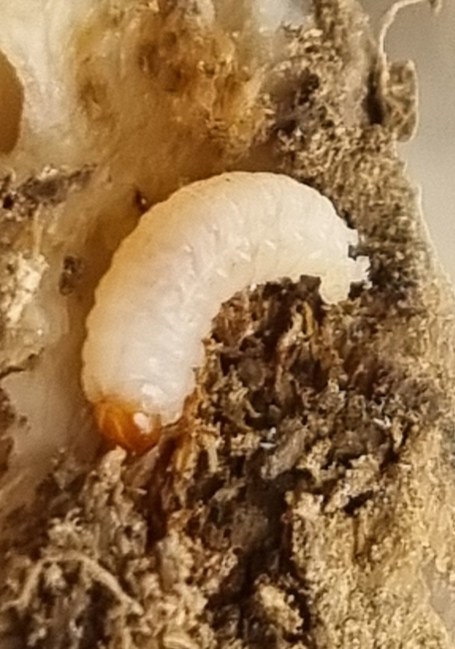
FIGURE A2: Aulacobaris coerulescens larvae and the formed tunnels in the dissected stem
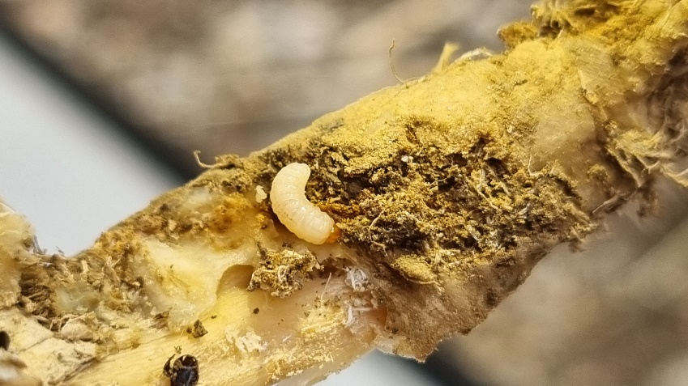
FIGURE A3: The different developmental stages of Aulacobaris coerulescens in the mined stem
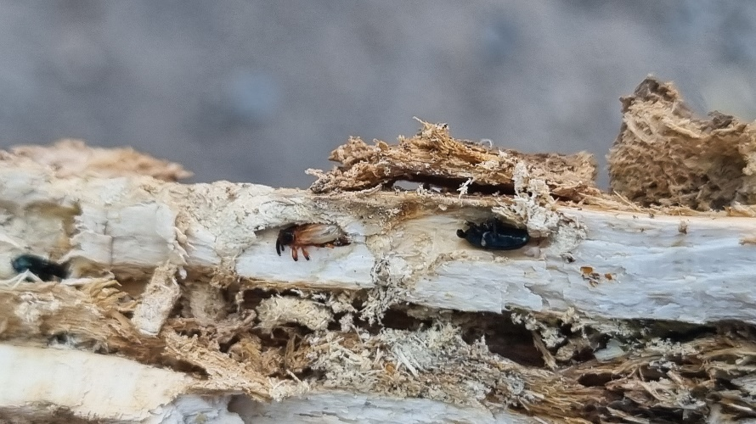
FIGURE A4: Aulacobaris coerulescens pupae
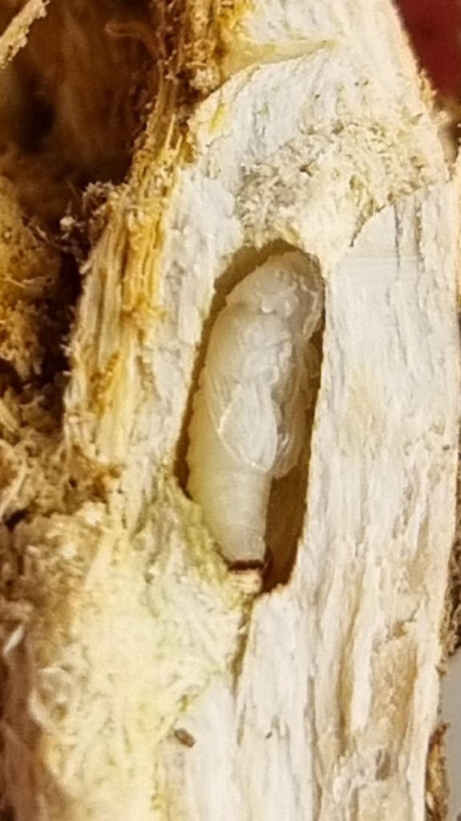
FIGURE A5: Aulacobaris coerulescens adult
