Appendix
Figure A1: Issue emphasis on national sovereignty over time (per country in the sample)
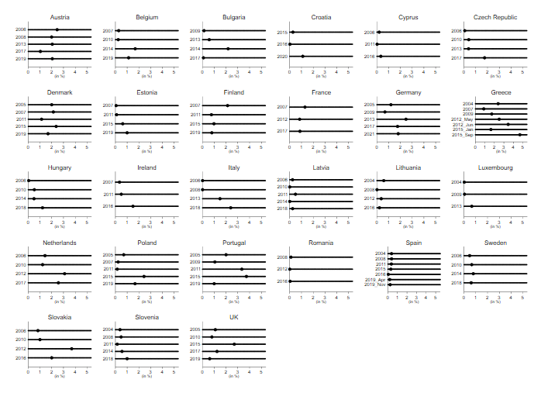
Note: The values shown are mean values for all elections held in that year. The figures reflect the percentage of national sovereignty issues addressed by all relevant European political parties (compared to all issues).

Roughly speaking, we can distinguish here between four different development patterns:
1) Time-consistent countries: These include Austria, Cyprus, France, Latvia, Lithuania, Luxembourg, Romania, Spain and Sweden. For all these countries, the desire for more national sovereignty has not shifted or has shifted only minimally over the crisis years. This seems particularly surprising in the case of Cyprus, a country battered by the euro crisis. The same applies to Sweden, which took in many refugees during the years of high migration numbers.
2) Increase during the euro crisis followed by a decline: These are countries in which claims for sovereignty increased during the years of the euro crisis, but this trend declined (slightly) again afterwards. Among these countries we find so-called creditor nations but also economically weaker countries that received bailout packages during the euro crisis. These include: Bulgaria, Belgium, Germany, the Netherlands, Poland, Portugal, Slovakia and the United Kingdom. Although national sovereignty concerns seem to have increased here during the years of the euro crisis, the crisis did not leave any longer-term imprint.
3) Increase during and after the “migration crisis”: Two eastern European countries, the Czech Republic and Hungary, show an increase in their demands for sovereignty only during or after the migrations in the summer of 2015. This could be due to the refusal to accept more refugees there.
4) Steady increase since the euro crisis: Since 2009, five countries have seen a steady increase in the discussion of sovereignty aspirations in their election programmes: Denmark, Estonia, Greece, Ireland and Italy. Greece, the largest debtor country in the euro crisis, is the most extreme case, with the highest average sovereignty values across the entire sample. Ireland also received financial assistance from the EU and fellow member states during the euro crisis years. Denmark and Italy are countries where the EU and international cooperation generally have a poorer reputation than in other countries. Recent challenges seem to have further encouraged this development.

Table A1: Elections covered in our analyses per country and year
Country | Elections
Austria | 2006, 2008, 2013, 2017, 2019
Belgium | 2007, 2010, 2014, 2019
Bulgaria | 2009, 2013, 2014, 2017
Croatia | 2015, 2016, 2020
Cyprus | 2006, 2011, 2016
Czech Republic | 2006, 2010, 2013, 2017
Denmark | 2005, 2007, 2011, 2015, 2019
Estonia | 2007, 2011, 2015, 2019
Finland | 2007, 2011, 2015, 2019
France | 2007, 2012, 2017
Germany | 2005, 2009, 2013, 2017, 2021
Greece | 2004, 2007, 2009, 05/2012, 06/2012, 01/2015, 09/2015
Hungary | 2006, 2010, 2014, 2018
Rep. Ireland | 2007, 2011, 2016
Italy | 2006, 2008, 2013, 2018
Latvia | 2006, 2010, 2011, 2014, 2018
Lithuania | 2004, 2008, 2012, 2016
Luxembourg | 2004, 2009, 2013
Netherlands | 2006, 2010, 2012, 2017
Poland | 2005, 2007, 2011, 2015, 2019
Portugal | 2005, 2009, 2011, 2015, 2019,
Romania | 2008, 2012, 2016
Spain | 2004, 2008, 2011, 2015, 2016, 04/2019, 11/2019
Sweden | 2006, 2010, 2014, 2018
Slovakia | 2006, 2010, 2012, 2016
Slovenia | 2004, 2008, 2011, 2014
United Kingdom (UK) | 2005, 2010, 2015, 2017, 2019
Note: Malta is excluded from the data due to its last coded election occurring in 1998.

Table A2: Eurobarometer variables; used for regression analyses
Topic | Question | Answer categories
Economic concerns | I’m now going to ask you to tell me about different aspects of your everyday life. For each of them, could you tell me if this aspect of your life is very good, fairly good, fairly bad or very bad?: The situation of the (NATIONALITY) economy | 4 = very good  3 = rather good  2 = rather bad  1 = very bad
Political concerns | Generally speaking, do you think that (OUR COUNTRY’S) membership of the European Union is ...? | 3 = A good thing  2 = neither good nor bad  1 = A bad thing
Cultural concerns | Please tell me whether each of the following statements evokes a positive or a negative feeling for you: Immigration of people from outside the EU | 4 = very positive  3 = fairly positive  2 = fairly negative  1 = very negative

Table A3: Eurobarometer used per country and year
Year | Economic situation | Feeling towards migration | Rating of EU membership
2004 | 62.1 | / | 62.2
2005 | 63.4 | / | 63.4
2006 | 66.1 | / | 66.1
2007 | 67.2 | / | 67.2
2008 | 70.1 | / | 70.1
2009 | 71.3 | / | 71.3
2010 | 73.4 | / | 73.4
2011 | 75.3 | / | 75.3
2012 | 77.4 | / | 77.4
2013 | 80.1 | / | 79.5
2014 | 82.3 | 82.3 | 82.4
2015 | 83.3 | 83.3 | 84.1
2016 | 85.2 | 85.2 | 86.1
2017 | 88.3 | 88.3 | 88.1
2018 | 89.1 | 89.1 | 89.2
2019 | 91.5 | 91.5 | 91.5
2020 | 93.1 | 93.1 | 94.2

Table 4: Regression analysis
Variable | 1 | 2 | 3 | 4 | 5 | 6
GDP pc | 0.000  (0.000) |  |  |  |  | 0.000  (0.000)**
Asylum (N) |  | 0.000  (0.000) |  |  |  | 0.000  (0.000)
Ø Attitudes economy |  |  | 0.000  (0.000) |  |  | 0.000  (0.000)
Ø Attitudes immigration |  |  |  | -0.712  (0.356)** |  | 0.243  (0.358)
Ø Attitudes EU |  |  |  |  | -1.091  (0.475)** | -1.467  (0.769)*
Party position, left-right |  |  |  |  |  | 0.032  (0.011)***
Party position, left-right² |  |  |  |  |  | 0.000  (0.000)
% vote share in the election |  |  |  |  |  | 0.006  (0.011)
Constant | 0.991  (0.115) *** | 1.264  (0.161) *** | 1.00  (0.112)*** | 2.873  (0.883)*** | 3.581  (1.167)*** | 3.973  (1.663)**
N (parties) | 877 | 339 | 877 | 347 | 877 | 336
R2 | 0.01 | 0.03 | 0.01 | 0.03 | 0.02 | 0.12
Note: Standard errors in parentheses; significance levels *10%, **5%, ***1%.

