Supplementary Information A
Short-term effects of video-games on cognitive enhancement:
The role of positive emotions
Sandro Franceschini¹, Sara Bertoni^{1,2}, Matteo Lulli³, Telmo Pievani⁴, Andrea Facoetti¹,
1. Developmental and Cognitive Neuroscience Lab, Department of General Psychology, University of Padua, Padua, Italy
2. Department of Human and Social Sciences, University of Bergamo, Bergamo, Italy
3. Department of Experimental and Clinical Biomedical Sciences “Mario Serio”, University of Florence, Florence, Italy
4. Department of Biology, University of Padua, Padua, Italy
Experiment 1: Children with developmental coordination disorder and dyslexia
N | Device | Videogames
1 | smartphone | serious games for math, pipes game
2 | pc, playstation | farming simulator, ark
3 | tablet | hotel transilvania, lego creator
4 | pc, smartphone, nintendo wii | fortnite, brawl stars
5 | nintendo wii, smartphone | lego city, multiplication tables serious game
6 | computer, nintendo switch | fortnite, minecraft
7 | x box | call of duty
8 | playstation | Fortnite
9 | playstation, smartphone | crash royal, minecraft
10 | nintendo switch, smartphone | minecraft, zelda, roblox, fortnite
11 | tablet, playstation | hayday, fortnite
12 | playstation, tablet, nintendo | the scapist 2, minecraft, Fortnite
13 | playstation, tablet | fortinite, minecraft
14 | smartphone, tablet | minecraft, game of fishing
15 | tablet, smartphone | calculation serious game, Tap the frog
16 | tablet | subway surfer, fruit Ninja, Magic tiles 3
17 | tablet | witch calls colour
18 | xbox | soccer game, Pokemon, Call of duty, Minecraft
19 | tablet | soccer game, Fruit ninja
Table A1 Devices and videogames used by the children in the last six months

 | ShootingG  Mean (SD) | PuzzleG  Mean (SD) | t-value | p-value | Cohen’s d  (95%CI)
Difficult | 4.63 (2.36) | 3.37 (2.09) | 2.65 | .016 | .608(.11/1.09)
Funny | 8 (1.73) | 4.89 (2.51) | 6.06 | <.001 | 1.39(.74/2.02)
Tense | 3.34 (2.49) | 2.32 (1.97) | 2.354 | .03 | .54(.05/1.02)
Happy | 7.32 (1.92) | 4.63 (2.29) | 8.761 | <.001 | 2.01(1.21/2.79)
Vivacious | 6.84 (2.57) | 4.63 (3.24) | 4.329 | <.001 | .99(.43/1.54)
Table A2: Video-games and emotional self-evaluation questionnaire scores and statistics in the sample of children with developmental coordination disorders and dyslexia.

 | Baseline |  |  |  |  | Shooting Game |  |  |  |  |  | Puzzle Game
 | congruent |  |  | incongruent |  | congruent |  |  | incongruent |  |  | congruent |  |  | incongruent
N | global | local | global |  | local |  | global | local |  | global | local |  | global | local | global | local
1 | 42 | 44 | 34 |  | 58 |  | 38 | 32 |  | 44 | 37 |  | 23 | 27 | 38 | 41
2 | 15 | 18 | 18 |  | 26 |  | 14 | 12 |  | 17 | 24 |  | 12 | 19 | 26 | 23
3 | 25 | 19 | 23 |  | 20 |  | 16 | 19 |  | 20 | 25 |  | 16 | 16 | 27 | 18
4 | 26 | 26 | 35 |  | 35 |  | 22 | 18 |  | 24 | 22 |  | 20 | 21 | 28 | 28
5 | 30 | 26 | 46 |  | 51 |  | 23 | 23 |  | 25 | 30 |  | 18 | 28 | 31 | 29
6 | 42 | 28 | 32 |  | 32 |  | 20 | 23 |  | 26 | 24 |  | 22 | 30 | 32 | 24
7 | 23 | 28 | 28 |  | 38 |  | 19 | 25 |  | 29 | 35 |  | 20 | 24 | 37 | 27
8 | 15 | 19 | 18 |  | 16 |  | 12 | 15 |  | 15 | 12 |  | 16 | 13 | 20 | 18
9 | 26 | 32 | 42 |  | 51 |  | 18 | 26 |  | 25 | 32 |  | 15 | 23 | 27 | 27
10 | 19 | 27 | 23 |  | 41 |  | 17 | 26 |  | 24 | 23 |  | 14 | 24 | 20 | 26
11 | 20 | 22 | 27 |  | 25 |  | 18 | 15 |  | 20 | 18 |  | 18 | 15 | 20 | 18
12 | 29 | 28 | 37 |  | 30 |  | 17 | 22 |  | 34 | 26 |  | 18 | 28 | 26 | 25
13 | 22 | 22 | 23 |  | 23 |  | 20 | 22 |  | 25 | 25 |  | 23 | 30 | 32 | 26
14 | 28 | 28 | 25 |  | 22 |  | 15 | 16 |  | 20 | 16 |  | 18 | 19 | 25 | 19
15 | 23 | 34 | 46 |  | 39 |  | 16 | 18 |  | 34 | 35 |  | 22 | 23 | 33 | 27
16 | 20 | 27 | 32 |  | 26 |  | 14 | 20 |  | 28 | 22 |  | 25 | 22 | 31 | 27
17 | 30 | 26 | 32 |  | 40 |  | 18 | 22 |  | 24 | 23 |  | 30 | 26 | 32 | 40
18 | 34 | 21 | 32 |  | 47 |  | 14 | 15 |  | 16 | 22 |  | 28 | 40 | 23 | 46
19 | 32 | 25 | 34 |  | 40 |  | 30 | 28 |  | 33 | 39 |  | 30 | 28 | 35 | 41
Table A3: Response time (in seconds) of children in the Navon task at the three times of evaluation.

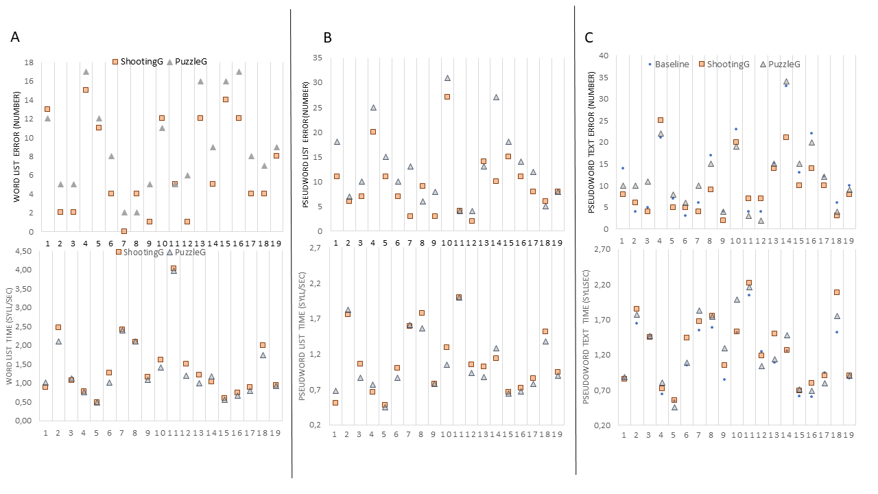
Figure A1. Individual data in reading time and errors of the 19 children with developmental coordination disorder and dyslexia (Experiment 1). Panel A: word list; Panel B: pseudoword list; Panel C: pseudoword text.
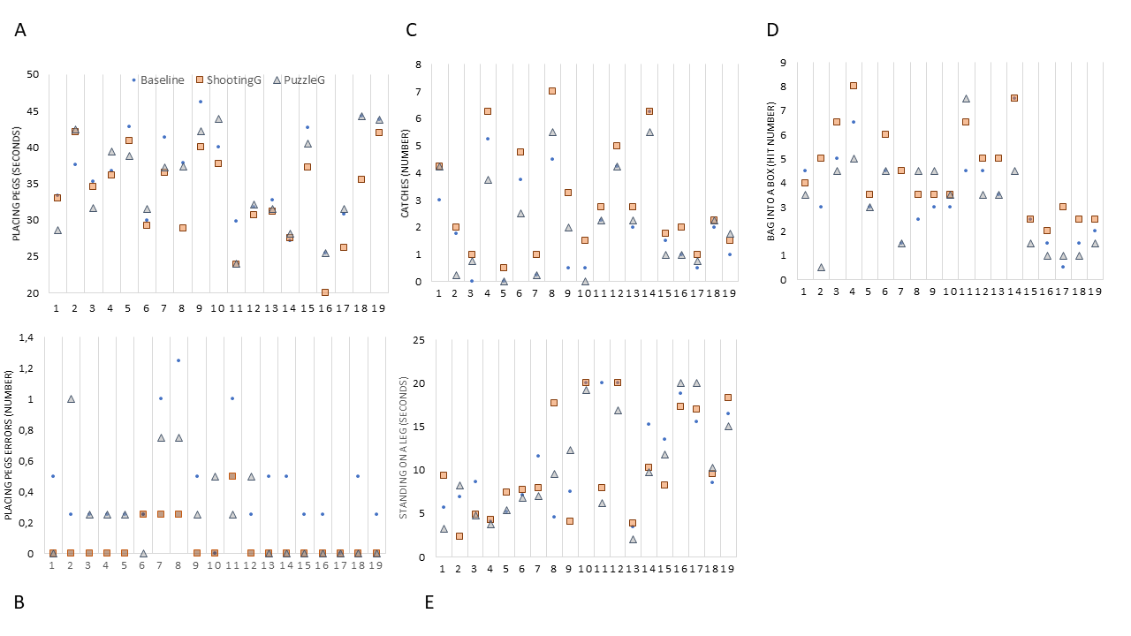
Figure A2. Individual data of the 19 children with developmental coordination disorder and dyslexia. Placing pegs (panel A and B), Catching with one hand (panel C), Throw a beans bag into a box (panel D) and Standing on a leg (panel E).

Supplementary information B
Experiment 2: Adult typical readers
Descriptive statistics of the sample | Speed Mean  (SD) | Accuracy  Mean (SD)
Word reading list (Z score) | -.19(1) | .21 (.88)
Pseudoword reading list (Z score) | .15 (1.07) | -.29(1.48)
Table B1. Standardized reading skills of 49 adult participants in Experiment 2.

 | AVG  Mean (SD) | NAVG  mean (SD) | t-value | p-value | Cohen’s d  (95%CI)
Difficult* | 6.14 (1.99) | 4.55 (1.97) | 5.757 | <.001 | .822 (.468/1.14)
Funny* | 5.25 (2.08) | 6.08 (1.84) | 2.096 | .041 | .299 (.015/.584)
Tense | 3.47 (2.02) | 3.63 (2.18) | .49 | .626 | .07 (-.211/.350)
Happy | 5.3 (1.91) | 5.5 (1.82) | .707 | .483 | .101(-.180/.381)
Vivacious* | 5.41 (2.3) | 6.31 (1.94) | 2.907 | .006 | .415 (.121/705)
Trait anxiety | 35.06 (7) | 36.12 (7.77) | 1.459 | .151 | .208 (-.076/.49)
Table B2. Video-games, emotional self-evaluation and anxiety questionnaires scores and statistics.

Salivary biomarkers
 | Pre AVG | Post AVG | Pre NAVG | Post NAVG
Cortisol | .73 (.26) | .68 (.26) | .78 (.23) | .72 (.24)
a-amylase | .60 (.3) | .70 (.26) | .67 (.28) | .75 (.28)
Table B3. Normalized levels of cortisol and a-amylase (mean and standard deviation) concentration pre and post each video-game session.

Supplementary information C

the game just played, indicate:
Difficulty
Almost nothing |  |  |  |  |  |  |  | A lot

Fun
Almost nothing |  |  |  |  |  |  |  | A lot

Now you feel
Tense
Almost nothing |  |  |  |  |  |  |  | A lot

happy
Almost nothing |  |  |  |  |  |  |  | A lot

vivacious
Almost nothing |  |  |  |  |  |  |  | A lot

