Associations between Skin Carotenoids, Sensory Processing, and Developmental Milestones in Midwestern Toddlers across 12 Months

Journal of Cognitive Enhancement

Laura M Rosok¹, Lexi M Fifield², Rhea Sarma², Shelby A Keye^{2,3}, Anne M Walk⁴, Kara D Federmeier^{1,2,5,6}, & Naiman A Khan^{1,2,6,7}

¹Neuroscience Program, University of Illinois Urbana-Champaign, Urbana, IL 61801
²Department of Health & Kinesiology, University of Illinois Urbana-Champaign, Urbana, IL 61801
³ Center for Social and Behavioral Science, University of Illinois Urbana-Champaign, Urbana, IL 61801
⁴Department of Psychology, Eastern Illinois University 61920
⁵Department of Psychology, University of Illinois Urbana-Champaign, Urbana, IL 61801
⁶Beckman Institute for the Advancement of Science and Technology, University of Illinois Urbana-Champaign, Urbana, IL 61801
⁷Division of Nutritional Sciences, University of Illinois Urbana-Champaign, Urbana, IL 61801

Corresponding Author: Naiman A. Khan, 317 Freer Hall, 906 S. Goodwin Ave., Urbana, IL 61801, nakhan2@illinois.edu, 217-300-2197

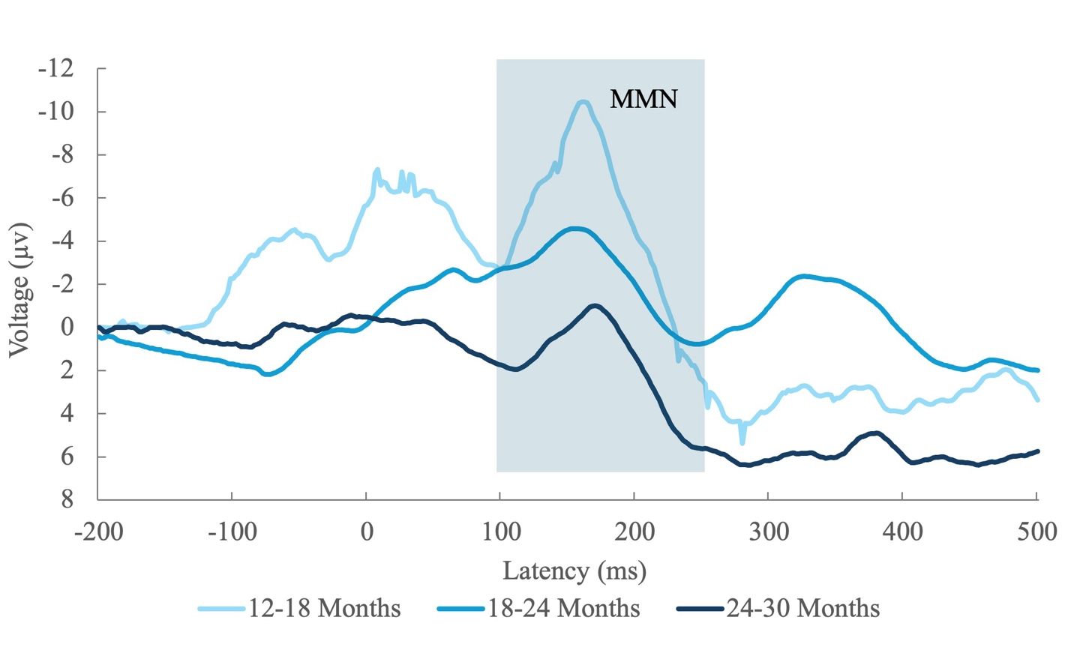
Supplemental Figure 1. Mismatch Negativity (MMN) Grand Averages at Fz Electrode (n=28).

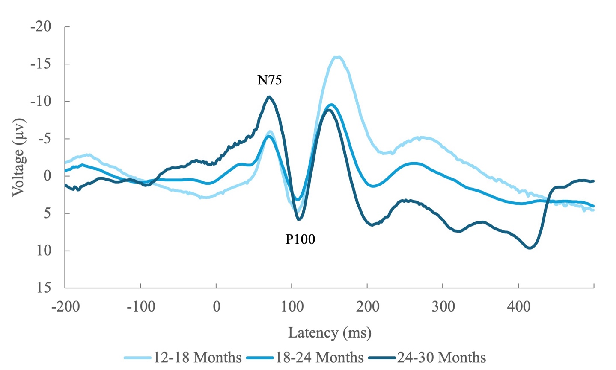
Supplemental Figure 2. Visual Evoked Potential (VEP) Grand Averages at Oz electrode (n=31).

