ONLINE APPENDIX FOR
ORGANIZATIONAL-PEFORMANCE PAY AND COMPENSATION DISPERSION

Appendix A. SUPPLEMENTARY Study: Esports Teams

Dota 2 Overview

History and popularity of the game. Dota 2, or Defense of the Ancients 2, is a MOBA (multiplayer online battle arena) game developed and published by Valve Corporation. Originally designed by IceFrog, the game is a sequel to Dota, which started as a modification for Blizzard Entertainment’s Warcraft III released in 2002. In July 2013, the Dota 2 title was officially published and has since become one of the most popular games played on Steam, a digital gaming content platform run by Valve, with over 11 million monthly active players worldwide as of 2019. Dota 2’s annual championship—dubbed The International or “TI”—ranks among “the most watched eSports tournaments worldwide,” attracting hundreds of competitors and millions of viewers each year. The prize pool of TI10 in 2021 alone topped over 40 million USD, with the champion team receiving 18.2 million. TI9 and TI8 in previous years also featured lucrative prize pool totals of 34.3 million and 25.5 million, respectively.

The objective of winning. In Dota 2, two teams of five athletes are matched against each other on a map with two different bases (see Figure A1 for an illustrative map of the Dota 2 environment). Before every match each athlete chooses to control one character—known as a “hero” (referred to as a “role” in the main manuscript)—from a roster of over one hundred different heroes, which have different abilities, strengths, and weaknesses (see Figure A2 for an example of a 5v5 team match with displayed hero characters). The main goal of each match is to destroy the enemy’s “Ancient” building, located in the middle of each team’s base. Games are always played in the same environment and typically last 30 to 60 minutes. Although the objective is straightforward, in order to be successful, players have to work as a team, coordinate tasks, and complete other objectives that lead to the destruction of the opposing team’s “Ancient” building.

How to win. Teamwork is essential for victory. The tasks in the game can be categorized into solo and group activities that can all potentially affect a team’s likelihood of winning. In solo activities, only one athlete completes the task and only that one athlete receives reward in the form of gold. Examples of solo activities in the game include activation of bounty runes (a type of special boosters that grant extra gold), execution of final damages in killing creeps (machine-generated units that spawn in waves at regular intervals and move towards the enemy base), destroying towers (which serve as defense for the “Ancient” building), and, more importantly, killing enemy heroes. Group activities, on the other hand, require more than one team member to contribute to the task, and all participating members receive a share of the gold rewards. The most common group activity is assisting other team members in their killing of enemy heroes. Notably, although there are many solo activities, group activity is crucial to a team’s victory in that killing enemies, a determining factor for winning, almost always involves multiple athletes’ participation (see Figure A3 for an example of match-level outcomes, including team-level hero kills, i.e., the number of group successes made by the team).

Incentives to win. The general incentive for an amateur athlete to win is to earn MMR points. Each winning team member earns additional matchmaking rating points (MMR), and each losing team member loses the same amount. MMR is a value that reflects the skill level of an athlete, and the game system matches players with similar MMRs in a game battle. The exact MMR value is not visible to the public but only to the athletes themselves. Individual athletes with the highest ratings are listed on the world leaderboard to allow players to be publicly recognized, opening the possibility for them to be hired by high-paying professional teams. Maintaining a high range of MMR points is thus important for professional athletes. A good Leaderboard position not only allows coaches and managers of organizations to notice the athletes and invite them to teams but also gives more bargaining power to the athletes for choosing from a range of high-growth and well-developed teams.
Moreover, professional athletes are much more incentivized to play in higher-tiered tournaments that typically feature large prize pools (the prize pool for Tier 2 tournaments in 2020 ranged from USD 50,000 to 200,000). For one thing, these tournament matches are exclusive to professional athletes and are either streamed or broadcast to a wider audience. For another, the entry tickets of TI (where the largest prize pool lies) are only granted to a small number of regional qualifiers where athletes compete in championship series—known as Dota Major Championships (Majors)—to win qualifying points. Before each regional league season starts, professional athletes need an invitation from organization managers who provide sponsorship, coaches, and other necessary resources for them to compete on the international stage. Because many of the professional athletes sustain their living on team salary and tournament prizes, “professional players are never just playing Dota 2—the-game” but are “playing Dota 2—the-esport.” Some athletes make their millions by winning tournament cash prizes while many still rely on team salary, digital streaming, and other fan engagement activities as major sources of gaming income. In our analyses, we focus on high-skilled professional athletes playing in professional matches because these athletes have strong incentives to win each match.

Details on Dota 2 Game Type under Study

Online tournaments for professional athletes. Dota 2 tournaments can be local, national, or international and are ranked in tiers. The highest tiers of all tournaments, including TI and the Majors, are exclusively offline and occur infrequently. However, the road to the Tier 1 tournaments runs through a series of online regional-league events either sponsored by Valve or third-party organizers (prior to 2020, they were known as Dota Minor Championships). These tournaments award qualifying points to winning teams for entry into Majors that lead to Dota 2’s annual championship TI and offer monetary awards. For 2020–2021, the TI qualification system featured six leagues in each season and three seasons in total with a prize pool of USD 840,000. More lower-tiered tournaments that lead to regional leagues constitute a wide range of professionally-skilled team competitions that could happen at weekly or monthly intervals, with or without tournament prizes. These less-prestigious tournaments serve the purpose of qualifying lower-tiered teams for higher-ranked events with more top-tiered teams, gaining traction and money prizes, and paving their path to TI. As such, rankings on regional leaderboards could vary match by match for the duration of each season. Consequently, matches in these online qualifier tournaments do not usually pit the same teams repeatedly against each together as in professional sports leagues like the NBA and MLB. Our analyses focus on these online tournaments in Dota 2 that are lower-tiered, more frequent, and played by teams that consist of different professional athletes across matches.

Captains mode. Two types of game mode exist in professional tournament matches: All Pick mode and Captains mode. In All Pick mode, each athlete can choose any hero, a random hero, or swap heroes with teammates. Captains mode, on the other hand, features a “captain” who chooses all five heroes for their team with individual teammates picking their individual heroes from their captains’ selection. Captains of each team can also ban heroes from the available options for both their own team and the opposing team. Each team has 30 seconds to decide on picks and bans; an additional 130 seconds total bonus time can be used. If time runs out for picks, a random hero will be selected; if time runs out for bans, no hero will be banned for either team. We restrict our attention to Captains mode, which does not allow teammates to swap heroes, because it is the most common and standard format for tournament matches.

Team formation and matching. A professional athlete usually progresses from public matchmaking games to leagues and tournaments. By maintaining a high MMR, showcasing quality teamwork and strategy in public matches, and networking with other professionals, high-skilled athletes build their reputation as serious competitors in the gaming community. Before they enter professional tournaments, they need to self-organize into or get invited by parities (informal groups of athletes) or teams (designated groups of five athletes with a fixed identity, e.g., logo, tag, etc.). To increase their chances of ranking the highest in tournaments, they usually team up with other similarly skilled professionals (see Figure A4 for the Dota 2 interface when joining a tournament). Once a full five-person team is ready, the system will match them to another random team at a similar skill level for completing a match. After the matching is done, each team is given a short amount of time (approximately five minutes) to discuss role allocations before the game starts.

Earning in matches. As discussed earlier, each professional athlete has a common incentive to win. Many of the critical activities that contribute to team victory come with either group- or individual-level “gold” gain—a type of in-game currency reward (or “compensation” in the main manuscript). Gold allows athletes to purchase items for strengthening heroes’ performance, but it cannot be shared with or transferred to teammates and is available only at the individual level. However, securing gold advantage is important to athletes for buying superior items and abilities due to their better “economy.”

Ways to earn. In order to achieve such advantage, athletes engage in either solo or group activities. Solo activities grant gold to one and only one individual with no other teammates involved; group activities grant gold to multiple athletes contributing to the success of a task. The simplest form of solo activities is staying in the game: each individual athlete receives a fixed amount of gold at the beginning of a match and a continuous but small stream of gold over the course of the match. Other ad hoc in-game solo activities include activating a bounty rune and executing last hits to buildings, lane creeps, and bounty creeps. Among all, the most common in-game solo activity is hero “kills” (or “solo activity contribution” in the main manuscript): each player’s first kill and subsequent kill streaks in a match earn extra amounts of bonus gold. Each time a hero kills an enemy hero, the killer is awarded with gold. One’s own deaths (or “individual frozen times” in the main manuscript), on the other hand, lead to losses of gold and restrict heroes from performing any activity. This negative gold reward concludes the last type of solo activity (see Figure A5 for an illustrative example of solo activity in the Dota 2 environment).
Group activities involve multiple teammates participating in a task with the reward shared among all participants conditional on the task’s success. We focus on this type of activity in our empirical study. The only group activity that fits in this definition is “assists” (or “individual contribution” in the main manuscript), which grants assist gold (or “AoE gold” in game terms) to all participants involved. To qualify for an assist, the allied hero must be within the given radius of the dying enemy hero to either execute damages to the victim or support the killing more directly. The amount of assist gold received by the killer and all assisting heroes is calculated using a pre-specified formula (see Figure A6 for an illustrative example of group activity in the Dota 2 environment).
In summary, each of the five athletes on a team can contribute to solo and/or group activities that lead to solo and/or group success. These successes increase the team’s likelihood of wining. Conditional on successes, athletes gain rewards in the form of gold. The key difference between group and solo activities lies in the fact that solo success results from only one individual’s efforts and only the individual performing the activity receives the gold, whereas group activities are performed by multiple individuals and the reward from group success is shared among all team members who play a role (see Figure A7 for a summary of the relationship between individual activities, reward gains, and team victory).

Individual Contribution in Games
At the end of each match, each individual athlete’s contribution to the team is shown on a scoreboard (see Figure A8 for an illustrative example). It shows basic summary statistics for the kills, deaths, and assist activities that each athlete accomplishes. It also details each hero’s net worth at the end of the match, calculated by the sum of the value of all their purchased items and their entire gold bank. Additional measures at the individual level include the number of times an individual successfully kills an enemy hero, which heroes are killed, and gold per minute, or “GPM.”

Game Updates and Unexpected Changes to Compensation Structures

Share dispersion in total rewards from group activities. Historically, there has been share dispersion in the shared rewards coming out of group successes. This variation in shares existed in-game because individuals occupy distinct roles from their teammates, determined prior to the start of each match. In Dota 2, athletes choose a specific hero, i.e., a game character, to play. Each hero is best-suited for certain bundles of tasks. The different bundles of tasks available to each player are stable enough across teams to have become institutionalized as recognizable roles with specific names. For example, a “carry” athlete is responsible for gathering resources for the team and leading collective fights against the opponent. A “support” athlete protects the carry and often moves around to strengthen the entire team or set up traps for carries to kill enemy heroes. Almost all teams feature carry and support roles, with the game convention of a maximum of two carries and three supports. A team typically decides its strategy before a match in terms of role assignment.
The distribution of “assists” rewards, or “AoE gold,” achieved upon group successes follows a formula that emulates share dispersion in an organizational-performance payment scheme based on the specific heroes athletes choose and, more specifically, whether an athlete chooses a hero that will fulfill a carry or support role. Up until March 2020, there was a “net worth ranking factor” that directly mandated the output share for each role in the game. The net worth ranking factor was a value ranging from 0.4 to 1.6 (as of patch 7.23, an update installed on November 26, 2019) based on the killer’s net worth rank within the team. The “carry” athletes would receive a low share of the AoE gold while the “support” athletes would receive a high share of the AoE gold. (This is common in MOBA game design, known as a “rubber band” mechanism.) Specifically, in all matches, one of the “carry” athletes would earn AoE gold based on a 1-to-4 ratio relative to one of the “support” athletes. In other words, within a task completed by the two athletes, the carry athlete would earn 20% of the total AoE gold earned while the support athlete would earn 80%.

Constant game updates. Valve Corporation, Dota 2’s developer, released game updates at irregular intervals during the observation period. These version updates, known as “patches,” often change the abilities of different heroes and/or the general rules of the game—a type of unexpected “shock” constantly introduced to the gaming community. Some of these patches affect how solo and group activities are rewarded with gold. There are five game updates in our observation period that affect gold earning in the game (see Table A1 for a timeline of patches). Three of these updates affect how gains of assists gold (“AoE gold”) associated with group activities are calculated specifically (patches 7.23, 7.25, and 7.27). One of these patches, patch 7.25, is our focal update, which shifted the share distribution of AoE gold (group rewards) from dispersion to compression. In our analyses, we also added 7.23 and 7.27 patch fixed effects because both patches made changes to group activity rewards by adjusting the AoE gold formula, but these changes were comparatively minor compared to the focal update. Because the other two patches, 7.24 and 7.26, did not change group activity reward structures, we did not include them in our regression design.

Focal game update and share compression in total rewards from group activities. The focal patch update of March 17, 2020 changed group rewards from share dispersion to compression. Following this update, matches happening after this patch do not have “net worth ranking factor” in the AoE formula and the payoff (conditional on success) is split evenly among all members involved (see Figure A9 for an illustration of pre- and post-update reward share distribution).

FIGURE A1 Map of the Dota 2 Environment.

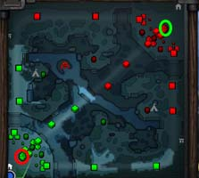
“Radiant” base: a team of five athletes starts here and has the objective to destroy the “dire” base.
“Dire” base: a team of five athletes starts here and has the objective to destroy the “radiant” base.

Note. Retrieved from Dota 2 guide, PurgeGamers, n.d., https://purgegamers.true.io/g/dota-2-guide/. Accessed on November 1, 2021.

FIGURE A2 Example of a 5v5 Team Match with Displayed Hero Characters.

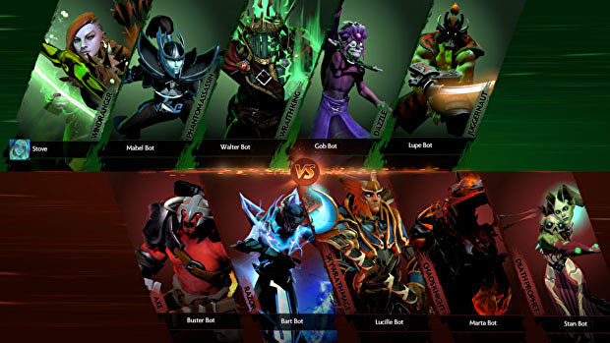

Note. Retrieved from James Archer, Dota 2: The new journey—why update 7.00 is such a massive game-changer, Rock Paper Shotgun, December 14, 2016, https://www.rockpapershotgun.com/dota-2-new-journey-details.

FIGURE A3 Example of End-of-Match Overview. The numbers on top show aggregated count of killing enemy heroes at the team level.

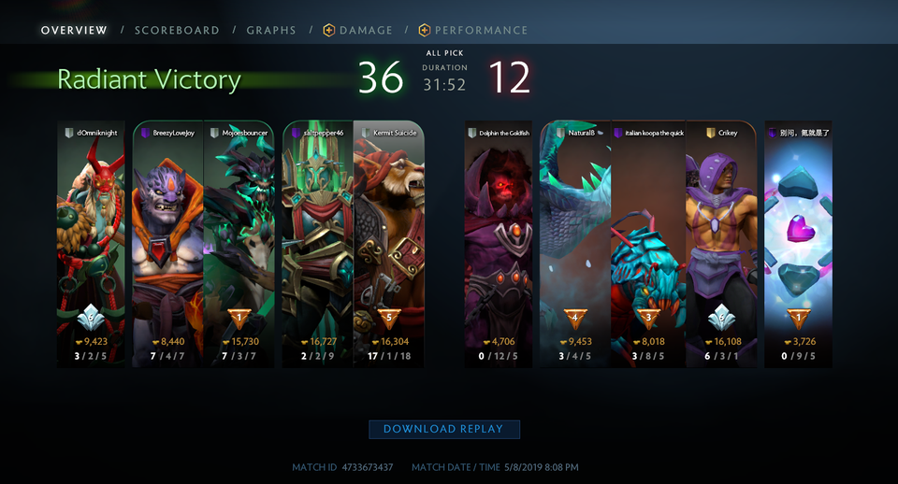
Note. Retrieved from u/Aljex13, Got 5+ MVP votes yet no MVP was chosen for the match. How are we supposed to get 25 for the achievement when the feature barely works, Reddit, May 8, 2019, May 8, https://www.reddit.com/r/DotA2/comments/bmd75o/got_5_mvp_votes_yet_no_mvp_was_chosen_for_the/.

FIGURE A4 Tournament Signup Interface.

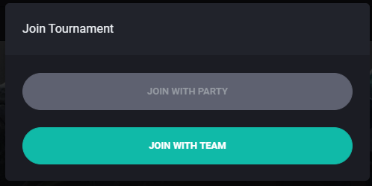

Note. Retrieved from M. Lidström, How to play a Dota 2 tournament, Challengermode, October 2021, https://help.challengermode.com/en/articles/3072643-how-to-play-a-dota-2-tournament.

FIGURE A5 Example of a Solo Activity.

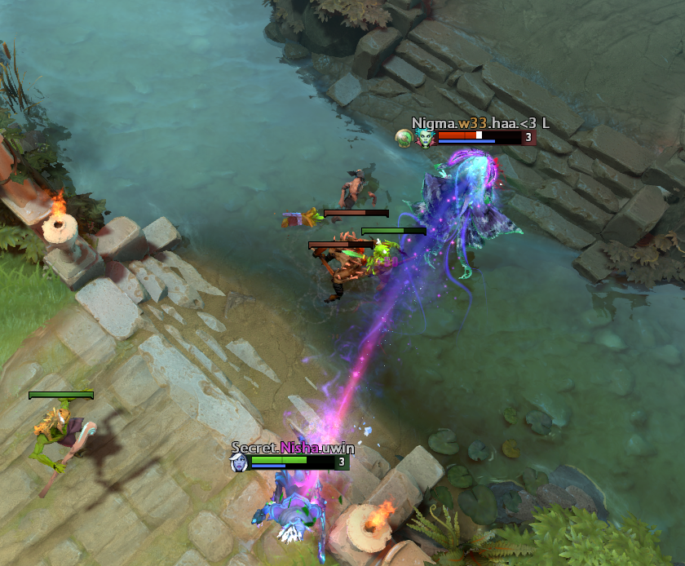

Note. Retrieved from Gopya, Are early rotations from mid heroes more beneficial in Dota 2 patch 7.27? VESports, July 3, 2020, https://www.vpesports.com/dota2/are-early-rotations-from-mid-heroes-more-beneficial-in-dota-2-patch-7-27/.

FIGURE A6 Example of a Group Activity.

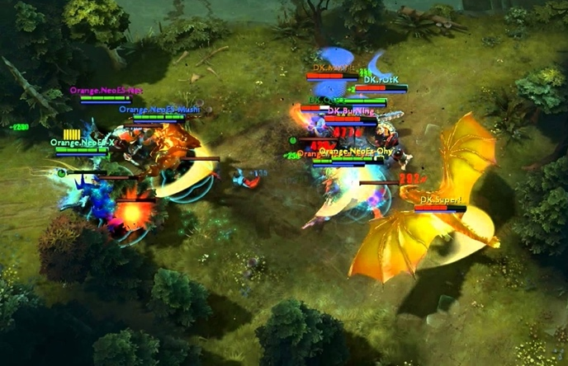

Note. Retrieved from I. Andita, Watch out, these 6 types of annoying Dota 2 player will ruin the fun, Dunia Games, May 26, 2021, https://duniagames.co.id/discover/article/6-jenis-pemain-dota-2-yang-menyebalkan/en.

FIGURE A7 Summary of Relationships between Individual Activities, Reward Gains, and Team Victory.

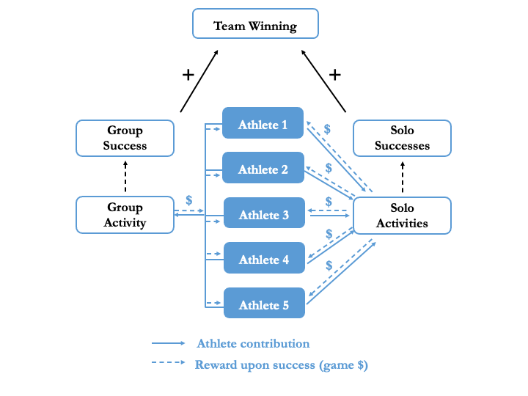

Note. Created by authors.

FIGURE A8 Example of End-of-Match Scoreboard.

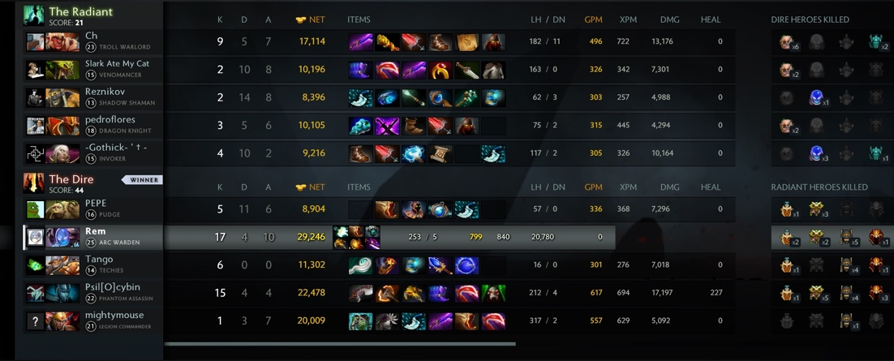

Note. Retrieved from u/trineroks, New scoreboard is buggy, Reddit, August 23, 2016, https://www.reddit.com/r/DotA2/comments/4z86up/new_scoreboard_is_buggy/.

FIGURE A9 Pre- and Post-Update Reward Share Distribution.

Group of two athletes who are at the high- or low-share positions in a team receive different shares of rewards.
Group of two athletes who were originally at the high- or low-share positions now receive the same share of group rewards.

Note. Created by authors.

FIGURE A10 Estimated Coefficients on High Share and Low Share for Different Time Periods. The figure shows the estimated coefficients for High Share and Low Share by repeating the model estimation in Table 7 with Individual Contribution as the dependent variable, using different pre-update and post-update time periods.

FIGURE A11 Estimated Coefficients on Post-Share Compression for Different Time Periods. The figure shows the estimated coefficients for Post-Share Compression by repeating the model estimation in Table 8 with Total Set Contribution as the dependent variable, using different pre-update and post-update time periods.
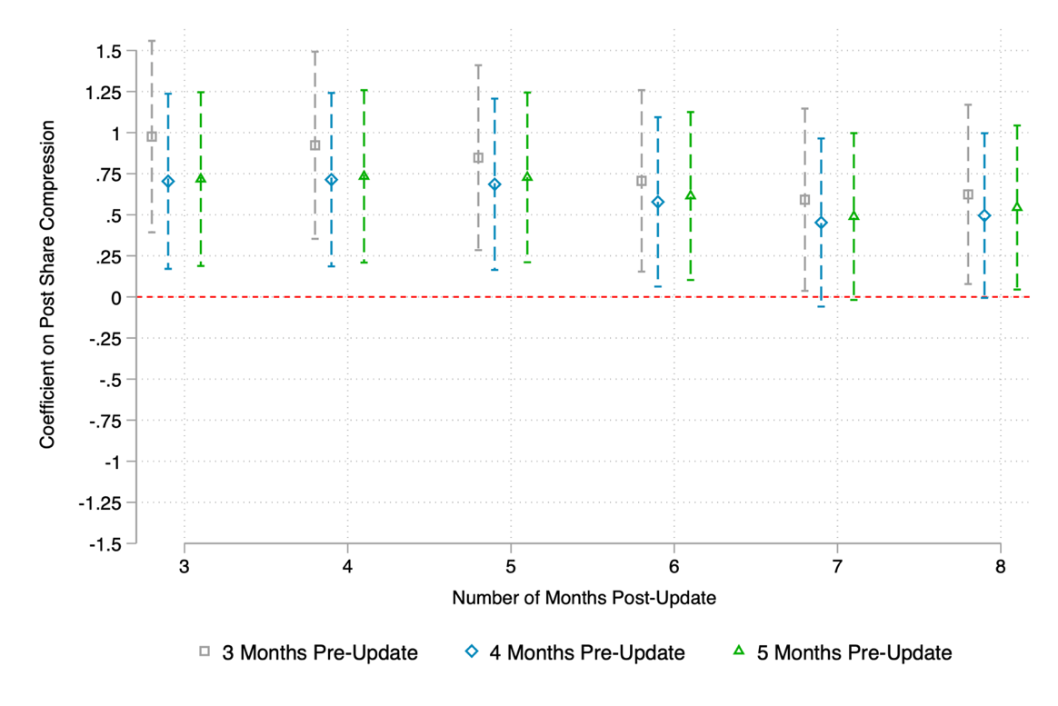

TABLE A1 Timeline of Patch Updates.
Date | Event | Description | Version
2019-08-06 | Data Sample Starts | The data collection period began on this date. | —
2019-11-26 | Minor Update | The passive gold income was reduced. The net worth ranking factor of AoE gold was modified from a range of 1.3 to 0.7, changing to a new range of 1.6 to 0.4, resulting in more dispersed distribution. | 7.23
2020-01-26 | Minor Update | The frozen time for dead heroes was increased. | 7.24
2020-03-17 | Focal Update | A new update was implemented to mandate equal allocation of AoE gold to all allied heroes, shifting from share dispersion to share compression. The solo activity kills reward was also increased during this update. | 7.25
2020-04-17 | Minor Update | The reward for solo activity kills was reduced. | 7.26
2020-06-28 | Minor Update | Several changes were implemented: the passive gold income was increased, the AoE base gold (fixed pay) was reduced, and the solo activity kills reward was increased. | 7.27
2020-10-27 | Data Sample Ends | The data collection period concluded on this date. | —

TABLE A2 Correlations.
Panel A: Individual-Match Level
 | Variables | 1 | 2 | 3 | 4 | 5 | 6 | 7 | 8 | 9 | 10 | 11 | 12 | 13
1 | Individual Contribution
2 | Low Share | –0.181
3 | High Share | 0.204 | –0.247
4 | Match Duration (Seconds) | 0.400 | 0.045 | 0.045
5 | Individual Frozen Times | 0.171 | –0.229 | 0.265 | 0.281
6 | Solo Activity Contribution | 0.056 | 0.308 | –0.293 | 0.224 | –0.334
7 | Individual Recent Matches | 0.005 | –0.216 | –0.208 | –0.014 | –0.039 | –0.000
8 | Individual Recent Win Rate | 0.047 | 0.023 | 0.012 | 0.032 | –0.061 | 0.034 | 0.103
9 | Partner Recent Matches | 0.009 | –0.031 | –0.032 | 0.017 | –0.001 | 0.007 | –0.021 | –0.009
10 | Partner Recent Win Rate | –0.002 | –0.014 | –0.017 | –0.011 | 0.008 | 0.001 | –0.019 | –0.004 | 0.087
11 | Average Opponent Team Recent Matches | –0.039 | –0.219 | –0.219 | –0.013 | –0.001 | –0.029 | 0.534 | 0.043 | –0.019 | –0.016
12 | Average Opponent Team Recent Win Rate | –0.056 | 0.015 | 0.015 | 0.032 | 0.032 | –0.049 | 0.045 | –0.030 | –0.006 | –0.016 | 0.130
13 | Average Other Team Members Recent Matches | 0.002 | –0.217 | –0.217 | –0.012 | –0.044 | 0.001 | 0.943 | 0.117 | –0.020 | –0.019 | 0.555 | 0.050
14 | Average Other Team Members Recent Win Rate | 0.051 | 0.014 | 0.014 | 0.030 | –0.059 | 0.028 | 0.120 | 0.890 | –0.007 | –0.007 | 0.045 | –0.034 | 0.125
Panel B: Comparison-Set-Match Level
 | Variables | 1 | 2 | 3 | 4 | 5 | 6 | 7 | 8 | 9 | 10 | 11
1 | Post-Share Compression
2 | Total Set Contribution | –0.022
3 | Total Set Successes | –0.019 | 0.682
4 | Winning Team | 0.000 | 0.556 | 0.519
5 | Match Duration (Seconds) | –0.073 | 0.468 | 0.360 | 0.000
6 | Set Frozen Times | –0.039 | –0.026 | –0.009 | –0.526 | 0.380
7 | Set Recent Matches | 0.252 | 0.018 | –0.016 | 0.042 | 0.054 | –0.050
8 | Set Recent Win Rate | –0.007 | 0.040 | 0.027 | 0.072 | 0.021 | –0.054 | 0.084
9 | Average Opponent Team Recent Matches | 0.357 | –0.046 | –0.047 | –0.042 | –0.013 | –0.001 | 0.353 | 0.026
10 | Average Opponent Team Recent Win Rate | –0.024 | –0.066 | –0.079 | –0.110 | 0.032 | 0.044 | 0.048 | –0.010 | 0.130
11 | Average Other Team Members Recent Matches | 0.354 | 0.003 | 0.001 | 0.044 | –0.012 | –0.060 | 0.638 | 0.082 | 0.555 | 0.050
12 | Average Other Team Members Recent Win Rate | –0.023 | 0.059 | 0.045 | 0.107 | 0.030 | –0.080 | 0.113 | 0.502 | 0.045 | –0.034 | 0.125

TABLE A3 Individual Responses to Changes in Share Level with Different Controls. This table shows the regression results for individual contribution when different controls are included. Robust standard errors are clustered at the individual level; p-values are reported in brackets.
 | Dependent Variable: Individual Contribution
 | Model 1 | Model 2 | Model 3 | Model 4 | Model 5 | Model 6
Low Share | –0.584 | –0.680 | –0.634 | –0.635 | –0.704 | –0.691
 | [0.000] | [0.000] | [0.000] | [0.000] | [0.000] | [0.000]
High Share | 0.193 | 0.296 | 0.341 | 0.341 | 0.260 | 0.276
 | [0.132] | [0.020] | [0.009] | [0.009] | [0.046] | [0.034]
Match Duration | 0.005 | 0.004 | 0.004 | 0.004 | 0.004 | 0.004
 | [0.000] | [0.000] | [0.000] | [0.000] | [0.000] | [0.000]
Individual Frozen Times | –0.503 | –0.379 | –0.379 | –0.379 | –0.373 | –0.373
 | [0.000] | [0.000] | [0.000] | [0.000] | [0.000] | [0.000]
Solo Activity Contribution |  | 0.330 | 0.330 | 0.330 | 0.323 | 0.323
 |  | [0.000] | [0.000] | [0.000] | [0.000] | [0.000]
Individual Recent Matches |  |  | 0.004 | 0.004 | 0.010 | –0.005
 |  |  | [0.156] | [0.159] | [0.001] | [0.409]
Individual Recent Win Rate |  |  | 0.091 | 0.091 | –0.011 | –0.316
 |  |  | [0.528] | [0.529] | [0.937] | [0.279]
Partner Recent Matches |  |  |  | –0.002 | –0.002 | –0.002
 |  |  |  | [0.521] | [0.470] | [0.478]
Partner Recent Win Rate |  |  |  | 0.006 | –0.008 | –0.007
 |  |  |  | [0.954] | [0.938] | [0.944]
Average Opponent Team Recent Matches |  |  |  |  | –0.012 | –0.013
 |  |  |  |  | [0.000] | [0.000]
Average Opponent Team Recent Win Rate |  |  |  |  | –1.567 | –1.565
 |  |  |  |  | [0.000] | [0.000]
Average Other Team Members Recent Matches |  |  |  |  |  | 0.017
 |  |  |  |  |  | [0.007]
Average Other Team Members Recent Win Rate |  |  |  |  |  | 0.335
 |  |  |  |  |  | [0.275]
Individual Fixed Effects | Yes | Yes | Yes | Yes | Yes | Yes
Role Fixed Effects | Yes | Yes | Yes | Yes | Yes | Yes
Patch Fixed Effects | Yes | Yes | Yes | Yes | Yes | Yes
Observations | 45,469 | 45,469 | 45,469 | 45,469 | 45,469 | 45,469
R² | 0.386 | 0.453 | 0.453 | 0.453 | 0.455 | 0.456
AIC | 277352.1 | 272097.2 | 272097.0 | 272100.7 | 271878.1 | 271872.3
Test: | Low Share Coefficient | = High Share Coefficient
F-test p-value | 0.0161 | 0.017 | 0.0952 | 0.0944 | 0.0129 | 0.0204

TABLE A4 Effect of Share Compression on Set Performance with Different Controls. This table shows the regression results for set performance when different controls are included. Robust standard errors are clustered at the comparison set level; p-values are reported in brackets.
Dependent Variable: | Total Set Successes
 | Model 1 | Model 2 | Model 3 | Model 4
Post-Share Compression | 0.262 | 0.278 | 0.427 | 0.403
 | [0.060] | [0.054] | [0.004] | [0.007]
Match Duration | 0.005 | 0.005 | 0.005 | 0.005
 | [0.000] | [0.000] | [0.000] | [0.000]
Set Frozen Times | –0.400 | –0.398 | –0.390 | –0.390
 | [0.000] | [0.000] | [0.000] | [0.000]
Set Recent Matches |  | –0.007 | 0.006 | –0.001
 |  | [0.386] | [0.463] | [0.938]
Set Recent Win Rate |  | –0.78 | –0.789 | –0.832
 |  | [0.000] | [0.000] | [0.000]
Average Opponent Team Recent Matches |  |  | –0.016 | –0.017
 |  |  | [0.000] | [0.000]
Average Opponent Team Recent Win Rate |  |  | –1.689 | –1.681
 |  |  | [0.000] | [0.000]
Average Other Team Members Recent Matches |  |  |  | 0.005
 |  |  |  | [0.438]
Average Other Team Members Recent Win Rate |  |  |  | 0.110
 |  |  |  | [0.711]
Set Fixed Effects | Yes | Yes | Yes | Yes
Dual-Role Fixed Effects | Yes | Yes | Yes | Yes
Patch Fixed Effects | Yes | Yes | Yes | Yes
Observations | 19,633 | 19,633 | 19,633 | 19,633
R-squared | 0.505 | 0.505 | 0.509 | 0.509
AIC | 111429.2 | 111402 | 111278.2 | 111281

Wikipedia, s.v. Dota 2, https://en.wikipedia.org/wiki/Dota_2. Accessed on November 1, 2021.
Number of monthly active users (MAU) of Dota 2 worldwide as of February 2021, Statista, March 2021, https://www.statista.com/statistics/607472/dota2-users-number/.
Defense of the Ancients 2—Statistics & facts, Statista, April 2021, https://www.statista.com/topics/4268/dota-2/.
Kurt Lozano, K, Dota 2’s The International 10 champions will win a whopping US$18 million. Yahoo! News, October 5, 2021, https://news.yahoo.com/dota-2-the-international-10-champions-teams-win-money-070452102.html.
Dota 2, eSportsGuide, n.d. https://www.esportsguide.com/game/dota-2.
Bounty rune, Dota 2 Wiki, n.d., https://dota2.fandom.com/wiki/Bounty_Rune. Accessed on November 1, 2021.
Creeps, Dota 2 Wiki, n.d., https://dota2.fandom.com/wiki/Creeps.
Buildings, Dota 2 Wiki, n.d., https://dota2.fandom.com/wiki/Buildings#Towers.
Matchmaking rating, Dota 2 Wiki, n.d., https://dota2.fandom.com/wiki/Matchmaking_Rating.
Tier 2 tournaments: 2021–2020, Liquipedia Dota 2, n.d.,, https://liquipedia.net/dota2/Tier_2_Tournaments/2021-2020.
League signup, Dota 2, n.d., https://www.dota2.com/league/0/list.
Dota Major Championships, Liquipedia Dota 2, n.d., https://liquipedia.net/dota2/Dota_Major_Championships.
Dota Pro Team Registration, Dota 2, https://www.dota2.com/majorsregistration/home/.
Will Partin, The International is bad for Dota 2, Kotaku, July 31, 2018, https://kotaku.com/the-international-is-bad-for-dota-2-1827996518.
Brian O’Connell, How much do eSports players make? TheStreet, February 12, 2020, https://www.thestreet.com/personal-finance/how-much-do-esports-players-make-15126931.
Tier 1 tournaments: 2021–2020, Liquipedia Dota 2, n.d., https://liquipedia.net/dota2/Tier_1_Tournaments. Accessed on November 1, 2021.
Dota Minor Championships, Liquipedia Dota 2, n.d., https://liquipedia.net/dota2/Dota_Minor_Championships. Accessed on November 1, 2021.
Dota Pro Circuit 2019–20, Liquipedia Dota 2, n.d., https://liquipedia.net/dota2/Dota_Pro_Circuit/2019-20; Dota Pro Circuit 2021, Liquipedia Dota 2, n.d., https://liquipedia.net/dota2/Dota_Pro_Circuit/2021. Accessed on November 1, 2021.
Dota Team, Introducing regional leagues, Dota 2, February 25, 2020, https://web.archive.org/web/20210212054111/http://blog.dota2.com/2020/02/introducing-regional-leagues/; Dota 2—The road to The International, Dota 2, n.d., http://www.dota2.com/procircuit. Accessed on November 1, 2021.
Tier 2 tournaments: 2021–2020, Liquipedia Dota 2, n.d., https://liquipedia.net/dota2/Tier_2_Tournaments/2021-2020; Tier 2 tournaments: 2019–2018 Liquipedia Dota 2, n.d., https://liquipedia.net/dota2/Tier_2_Tournaments/2019-2018. Accessed on November 1, 2021.
Game modes, Dota 2 Wiki, n.d., https://dota2.fandom.com/wiki/Game_modes. Accessed on November 1, 2021.
Is there a career in playing Dota 2? GamerZ Class, December 4, 2020, https://gamerzclass.com/news/dota-2/dota-2-guides/is-there-a-career-in-playing-dota-2/; Mkrtychian. A., How to become a pro in Dota 2? GOSU.AI, April 27, 2020, https://gosu.ai/blog/dota2/how-to-become-a-pro-in-dota-2/.
Party, Dota 2 Wiki, n.d., https://dota2.fandom.com/wiki/Party. Accessed on November 1, 2021.
Team, Dota 2 Wiki, n.d., https://dota2.fandom.com/wiki/Team. Accessed on November 1, 2021.
General rules for professional Dota 2 competitions, joinDOTA, June 24, 2016, https://www.joindota.com/statics/rules_pro.
Gold Dota 2 Wiki, n.d., https://dota2.fandom.com/wiki/Gold. Accessed on November 1, 2021.
Dota 2 guide, PurgeGamers, n.d., https://purgegamers.true.io/g/dota-2-guide/. Accessed on November 1, 2021.
Version 7.23, Dota 2 Wiki, n.d., https://dota2.fandom.com/wiki/Version_7.23. Accessed on November 1, 2021.
Gold/Changelogs, Dota 2 Wiki, n.d., https://dota2.fandom.com/wiki/Gold/Changelogs. Accessed on November 1, 2021.

