Supporting Information

A novel multiple-network analysis integrating metabolomics and pharmacology for mechanism study of medicine: a case study of CDD-2101 against constipation
Jingchun Shi ^{1,2,#}, Li Xiang ^{3,#}, Yan Y. Lam ^{1,2}, Ziwan Ning ^{1,2}, Jie Liu ^{1,2}, Yaqi Li ^{1,2}, Yujuan Zhou ^{1,2}, Lixiang Zhai ^{1,2} Chengyuan Lin ^{1,2}, Lin Zhu ^{1,2 *}, Zhaoxiang Bian ^{1,2 *}

¹ Centre for Chinese Herbal Medicine Drug Development, Hong Kong Baptist University, Hong Kong 999077, China
² School of Chinese Medicine, Hong Kong Baptist University, Hong Kong 999077, China
³ State Key Laboratory of Environmental and Biological Analysis, Department of Chemistry, Hong Kong Baptist University, Hong Kong 999077, China

* Corresponding authors:
Lin Zhu, Ph.D. Centre for Chinese Herbal Medicine Drug Development Limited, Hong Kong Baptist University, Hong Kong SAR, China; E-mail: zhulin@hkbu.edu.hk; Tel: (852)-34112857

ZhaoXiang Bian, MD, Ph.D. School of Chinese Medicine, Hong Kong Baptist University, Kowloon, Hong Kong SAR, China. E-mail: bzxiang@hkbu.edu.hk; Tel: (852)-34112905; Fax: (852)-34112929

#These authors contributed equally to the manuscript.

No. | RT (min) | Precursor MS | MS/MS | Metabolites | HMDB ID | FC1 | FC2
1 | 1.014 | 188.0558 | 55.0187/67.0187 | N-Acetylglutamic acid | HMDB0001138 | 2.65 | 2.07
2 | 1.575 | 350.109 | 87.0089/128.0350 | N-Acetyl-4-O-acetylneuraminic acid | HMDB0000796 | 0.36 | 0.29
3 | 1.640 | 130.05 | 41.0391/42.0344/68.050 | Pyrroline hydroxycarboxylic acid | HMDB0001369 | 1.82 | 1.99
4 | 2.880 | 288.1193 | 110.0718 | N-Ribosylhistidine | HMDB0002089 | 0.51 | 0.62
5 | 3.156 | 212.0915 | 94.0652/124.0757 | 3-Methoxytyrosine | HMDB0001434 | 2.61 | 3.39
6 | 4.098 | 191.0532 | 129.0552 | 3-Dehydroquinic acid | HMDB0012710 | 1.67 | 1.87
7 | 4.698 | 233.1536 | 41.0387/133.1016 | (Z)-8-Decene-4,6-diyn-1-yl 3-methylbutanoate | HMDB0031000 | 1.83 | 2.00
8 | 4.954 | 199.1334 | 43.0189/59.0138 | 3-Nonanon-1-yl acetate | HMDB0037179 | 0.76 | 0.77
9 | 5.106 | 426.2596 | 44.0496 | LysoPE(14:0/0:0) | HMDB0011500 | 0.42 | 0.50
10 | 5.296 | 167.107 | 77.0381/91.0543 | Pentyl 2-furyl ketone | HMDB0032462 | 0.61 | 0.41
11 | 5.319 | 191.0816 | 146.0606 | 6-Hydroxy-1H-indole-3-acetamide | HMDB0031173 | 1.64 | 2.96
12 | 6.217 | 363.2166 | 273.186 | 18-Hydroxycorticosterone | HMDB0000319 | 1.74 | 1.48
13 | 6.217 | 363.2166 | 273.186 | Cortisol | HMDB0000063 | 1.74 | 1.48
14 | 6.339 | 297.1119 | 55.0542/93.0701/ | DHAP(8:0) | HMDB0011685 | 2.09 | 3.03
15 | 6.774 | 268.1705 | 91.0543/130.0656 | N-(p-Hydroxyphenethyl)actinidine | HMDB0030347 | 0.01 | 0.21
16 | 7.137 | 351.216 | 351.2166 | Prostaglandin G2 | HMDB0003235 | 4.80 | 1.98
17 | 7.171 | 429.3006 | 55.0541 | 25-Hydroxyvitamin D3-26,23-lactone | HMDB0060126 | 0.22 | 0.45
18 | 7.512 | 391.285 | 337.2522/145.1009 | Nutriacholic acid | HMDB0000467 | 0.04 | 0.14
19 | 8.218 | 416.3158 | 81.0700/95.0860 | N-Stearoyl methionine | HMDB0241947 | 2.00 | 1.87
20 | 9.688 | 391.2843 | 337.2522/145.1009 | Chenodeoxycholic acid | HMDB0000518 | 5.18 | 3.42
21 | 9.978 | 502.2932 | 44.0495 | LysoPE(20:4(8Z,11Z,14Z,17Z)/0:0) | HMDB0011518 | 1.55 | 2.02
22 | 10.571 | 372.2906 | 107.0855/215.1805 | Docosahexaenoyl ethanolamide | HMDB0013658 | 1.97 | 1.64
23 | 10.866 | 516.306 | 86.0961/184.0724 | LysoPC(18:4(6Z,9Z,12Z,15Z)/0:0) | HMDB0010389 | 1.78 | 2.23
24 | 11.534 | 379.282 | 41.0386 | Nordeoxycholic acid | HMDB0304947 | 0.57 | 0.49
25 | 11.560 | 279.2326 | 261.2218/233.2269 | Gamma-linolenic acid | HMDB0003073 | 2.72 | 2.49
26 | 11.568 | 344.2799 | 55.0542/95.0855 | Dodecanoylcarnitine | HMDB0002250 | 1.53 | 2.35
27 | 11.815 | 439.2823 | 81.0699/109.1014 | LysoPA(18:0/0:0) | HMDB0007854 | 1.75 | 1.87
28 | 11.815 | 439.2823 | 81.0699/109.1014 | LysoPA(0:0/18:0) | HMDB0007850 | 1.75 | 1.87
29 | 11.842 | 307.263 | 289.2526/259.2426 | 8,11,14-Eicosatrienoic acid | HMDB0002925 | 1.64 | 2.34
30 | 11.893 | 546.3524 | 86.0964 | LysoPC(20:3(8Z,11Z,14Z)) | HMDB0010394 | 0.50 | 0.58
31 | 11.893 | 546.3524 | 86.0964 | LysoPC(20:3(5Z,8Z,11Z)) | HMDB0010393 | 0.50 | 0.58
32 | 13.181 | 376.3193 | 57.0699 | Adrenoyl ethanolamide | HMDB0013626 | 1.79 | 2.72
33 | 13.248 | 337.2722 | 107.0855/109.1012 | Pregnanetriol | HMDB0006070 | 1.62 | 2.93
Table S1 Details of differential metabolites in fecal samples (FC1: control vs. model, FC2: CDD-2101 vs. model).
PA: phosphatidic acid, PC: phosphocholine, PE: phatidylethanolamine

Table S2
The ingredients from CDD-2101 Senna as candidates for network pharmacology analysis.
RT (min) | Name | m/z | Formula | Herb
1.424 | Synephrine | 168.1019 | C₉H₁₃NO₂ | ZS
4.398 | Amygdalin | 456.1523 | C₂₀H₂₇NO₁₁ | KXR
4.779 | Albiflorin | 525.1614 | C₂₃H₂₈O₁₁ | BS
4.913 | Paeoniflorin | 525.1614 | C₂₃H₂₈O₁₁ | BS
4.924 | Sennoside B | 861.1884 | C₄₂H₃₈O₂₀ | Senna
5.26 | Sennoside A | 861.1884 | C₄₂H₃₈O₂₀ | Senna
5.368 | benzoic acid | 121.0295 | C₇H₆O₂ | BS
5.45 | Naringin | 579.1719 | C₂₇H₃₂O₁₄ | ZS
5.563 | Hesperidin | 609.1825 | C₂₈H₃₄O₁₅ | ZS
5.652 | Neohesperidin | 609.1825 | C₂₈H₃₄O₁₅ | ZS
5.794 | Benzaldehyde | 105.0346 | C₇H₆O | KXR
5.95 | Cannabisin A | 593.1929 | C₃₄H₃₀N₂O₈ | HMR
6.029 | Cannabisin B | 595.2086 | C₃₄H₃₂N₂O₈ | HMR
7.142 | Naringenin | 271.0617 | C₁₅H₁₂O₅ | ZS
7.368 | Hesperitin | 301.0718 | C₁₆H₁₄O₆ | ZS
8.239 | Aloe emodin | 269.0455 | C₁₅H₁₀O₅ | DH
8.339 | Rhein | 283.0248 | C₁₅H₈O₆ | DH, Senna
9.616 | Emodin | 269.0455 | C₁₅H₁₀O₅ | DH, Senna
9.728 | Honokiol | 265.1234 | C₁₈H₁₈O₂ | HP
10.288 | Magnolol | 265.1234 | C₁₈H₁₈O₂ | HP
10.904 | Chrysophanol | 253.0506 | C₁₅H₁₀O₄ | DH
11.329 | Physcion | 283.0612 | C₁₆H₁₂O₅ | DH
13.083 | Linoleic acid | 279.2328 | C₁₈H₃₂O₂ | HMR, HXR
The italics word indicates the metabolite of the prototype ingredient(s) of the corresponding herb
HMR: Fructus Cannabis (Huo Ma Ren), DH: Radix et Rhizoma Rhei (Da Huang), BS: Radix Paeoniae Alba (Bai Shao), KXR: Semen Armeniacae Amarum (Ku Xing Ren), ZS: Fructus Aurantii Immaturus (Zhi Shi), HP: Cortex Magnoliae Ofﬁcinalis (Hou Pu)

Table S3
The evaluation of hub genes by CytoHubba.

Name | MCC | MNC | Degree | EPC | Bottleneck | EcCentricity | Closeness | Radiality | Betweenness | Stress | Rank
CYP1A1 | 245922 | 26 | 52 | 14.588 | 1 | 0.31325 | 50.16667 | 4.05195 | 146.5545 | 12128 | 1
CYP1A2 | 250006 | 30 | 60 | 14.849 | 2 | 0.31325 | 52.5 | 4.12518 | 366.7513 | 19240 | 2
ESR1 | 49089 | 31 | 64 | 14.081 | 13 | 0.31325 | 53.5 | 4.14959 | 846.8168 | 37688 | 3
PTGS2 | 2126 | 28 | 56 | 14.403 | 5 | 0.31325 | 52.16667 | 4.14959 | 530.8391 | 26488 | 4
PLA2G4A | 1040 | 12 | 24 | 9.49 | 1 | 0.31325 | 42.83333 | 3.85667 | 41.69315 | 3552 | 5
ESR2 | 1036 | 13 | 26 | 9.616 | 6 | 0.23494 | 42.08333 | 3.77124 | 84.92436 | 5168 | 6
PPARG | 807 | 29 | 60 | 13.061 | 11 | 0.31325 | 53.16667 | 4.17399 | 784.1018 | 29512 | 7
PTGS1 | 220 | 10 | 20 | 7.642 | 1 | 0.23494 | 40.91667 | 3.75904 | 31.85226 | 2456 | 8
RXRA | 60 | 11 | 22 | 7.468 | 2 | 0.23494 | 40.5 | 3.69801 | 56.59551 | 2776 | 9
ACHE | 9 | 4 | 10 | 4.471 | 1 | 0.31325 | 36 | 3.52715 | 10.39204 | 576 | 10

Table S4
The Parameters of molecular docking.
Target | center_x | center_y | center_z
RXRA | 4.723 | 67.308 | 66.088
CYP1A1 | 9.698 | 0.508 | 27.347
PLA2G4A | 63.308 | 61.088 | 0.508
CYP1A2 | 1.345 | 8.598 | 33.208

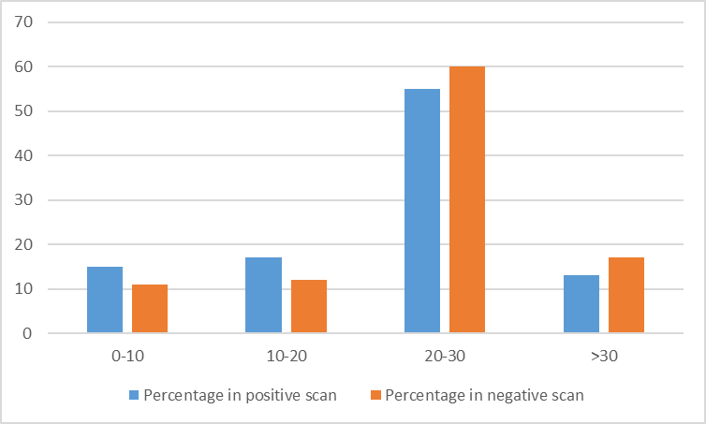

Fig. S1 RSD% distribution in samples metabolomics profiling of QC samples.

Fig. S2 The validation of PLS-DA of metabolomics.
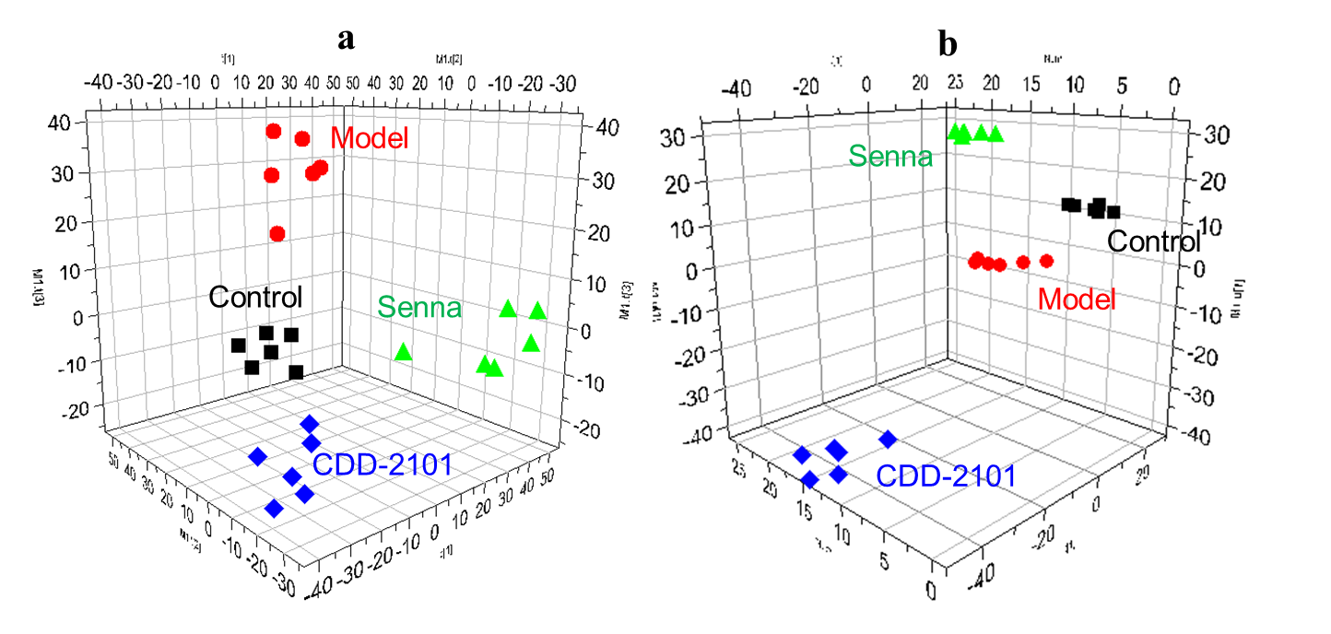
Fig. S3 PLS-DA score plots of the metabolic profiles in fecal samples from the four groups of mice in positive (a) and negative (b) mass spectrometry scan modes. The CDD-2101 at medium-dose (clinical equivalent dose) were selected and administered for metabolomic analysis.

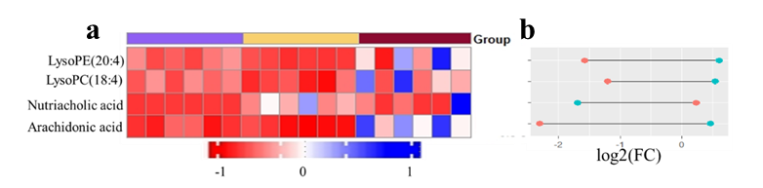
Fig. S4 (a) The heatmaps of differential metabolites identified from control vs. model vs. Senna; (b) the dumbbell charts correspond to the left heat maps, control vs. model (blue) and Senna vs. model (red).

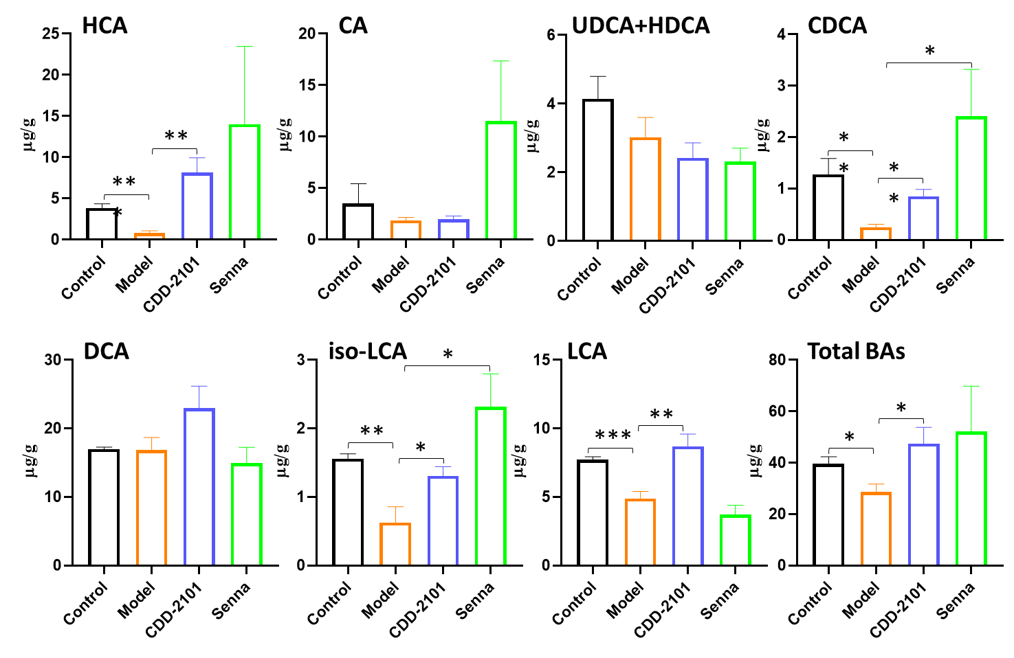
Fig. S5 The levels of BAs in feces from control, model, CDD-2101 and Senna groups (n = 6).

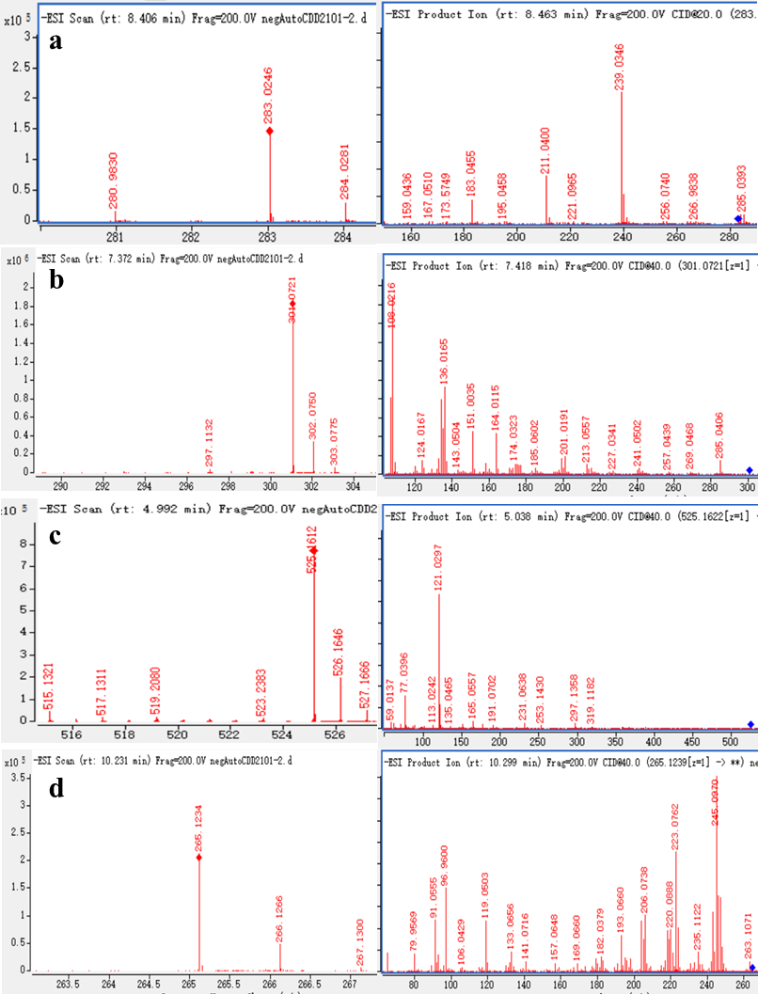
Fig. S6 MS1 (left) and MS2 (right) spectrum (m/z) of the key active ingredients: (a) rhein, (b) hesperetin, (c) albiflorin, (d) magnolol.

