Supplementary Information

Dual-mode Colorimetric and Fluorescent Detection of Tumor Cells Based on Gold Nanoparticles-Loaded Phosphine Covalent Organic Frameworks

Bilian Li¹ · Min Zhou¹ · Chun Zhao² · Lin Xiao¹ · Tianle Qi¹ · Hanbin Xu¹ · Linjiang Guo¹ · Guobao Ning¹ · Xiaokang Lu¹ · Keming Zhu³ · Hui Zhao⁴ · Can-Peng Li¹
¹School of Chemical Science and Technology, Yunnan University, 2 North Cuihu Road, Kunming 650091, People’s Republic of China
²Affiliated Hospital of Yunnan University, Yunnan University, 176 Qingnian Road, Kunming 650021, People’s Republic of China
³School of Life Science Yunnan University, 2 North Cuihu Road, Kunming 650091, People’s Republic of China
⁴Laboratory for Conservation and Utilization of Bioresource, Yunnan University, 2 North Cuihu Road, Kunming 650091, People’s Republic of China

Bilian Li, Min Zhou, and Chun Zhao contributed equally to this work.
Corresponding Authors：Keming Zhu · Hui Zhao · Can-Peng Li
E-mail: lcppp1974@sina.com (C.-P. Li); 1731226017@qq.com (K. Zhu); zhaohui@ynu.edu.cn (H. Zhao)

Supplementary Methods
Evaluation of the hydrogen peroxid
According to previous literatures [1-2], we verified the production of hydrogen peroxide by ultraviolet-visible spectrum. As depicted in Fig. S5, the production of H₂O₂ was confirmed using horseradish peroxidase (HRP) and 3,3', 5,5'-tetramethylbenzidine (TMB). In the presence of glucose, the characteristic absorption peak of oxidized TMB at 650 nm, Au@COFs catalyzed glucose to produce hydrogen peroxide, and hydrogen peroxide produced hydroxyl radicals catalyzed by horseradish peroxidase, which changed TMB from colorless to blue, indicating that H₂O₂ was produced by Au@COFs catalysis.

Supplementary Figures and Tables

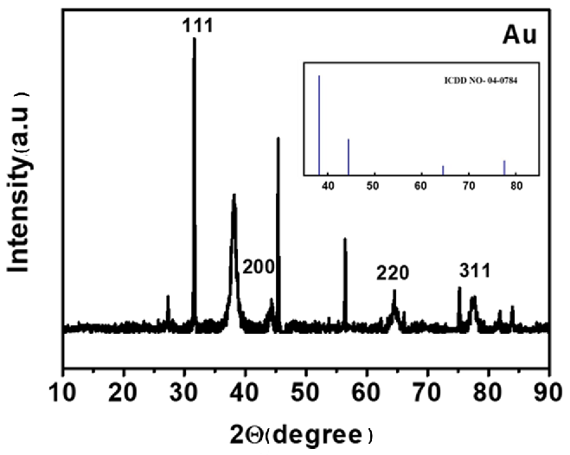

Fig. S1 XRD spectra of AuNPs.

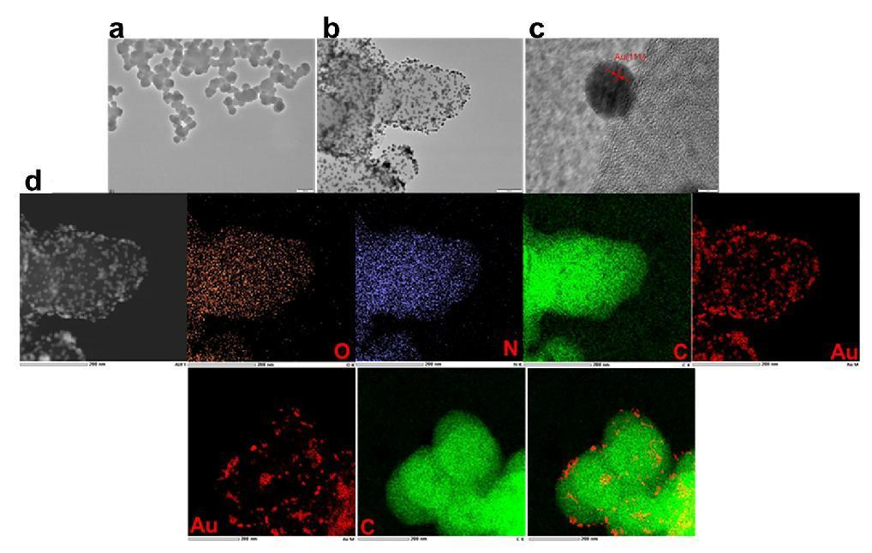

Fig. S2 HRTEM images of COFs (A), Au@COFs (B), AuNPs(C); EDS elemental mapping picture of Au@COFs (D).

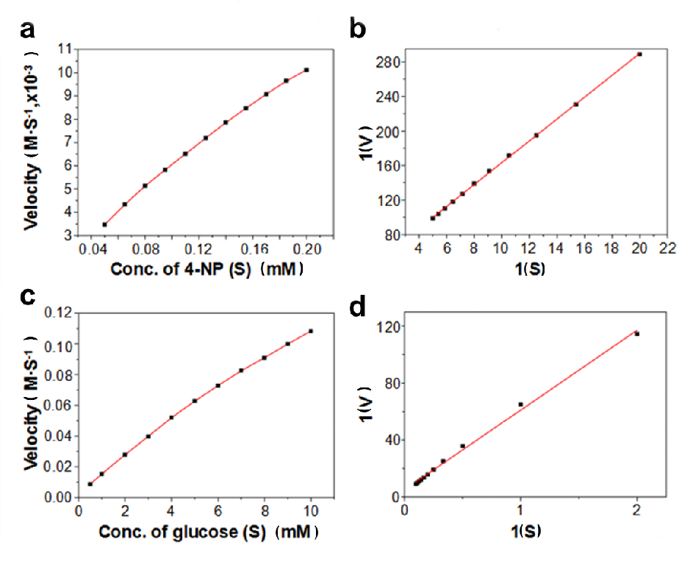

Fig. S3 Steady-state kinetics of COFs, 4-NP, glucose concentration rate relationship curve (A, C); Lineweaver Burk linear fitting (B, D).

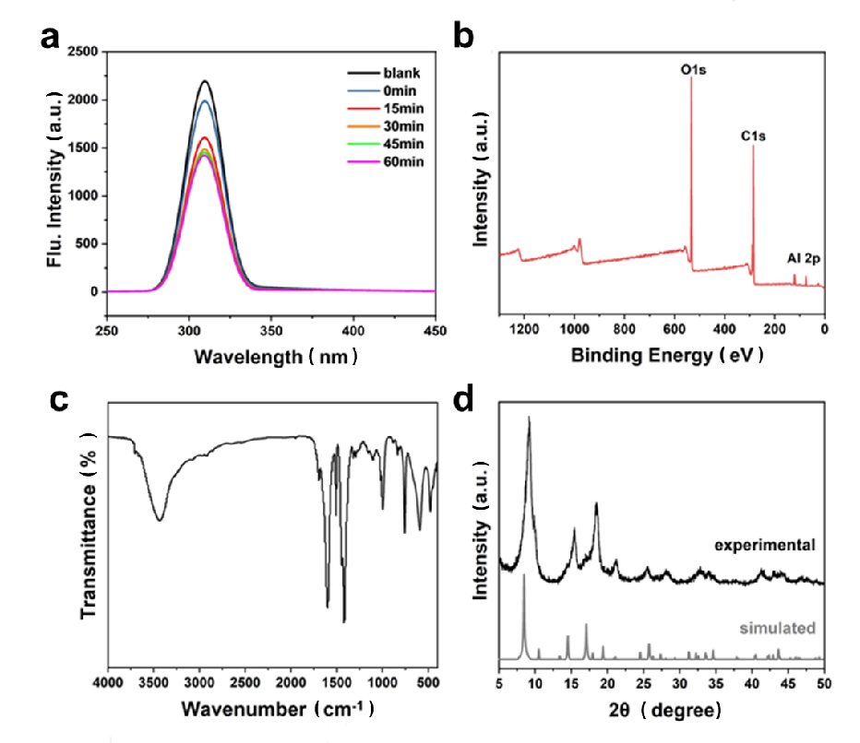

Fig. S4 Fluorescence spectrum of MIL-53(Al) (A); XPS of MIL-53(Al) (B); FTIR spectrum of MIL-53(Al) (C); XRD patterns of MIL-53(Al) (D).

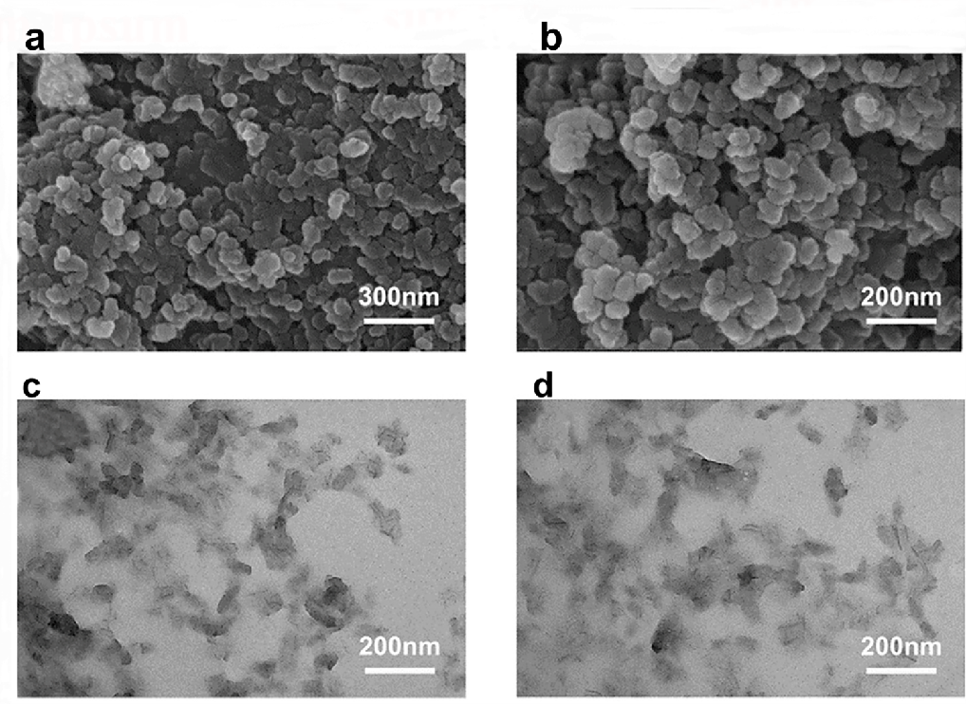

Fig. S5 TEM images of MIL-53(Al) (A-D).

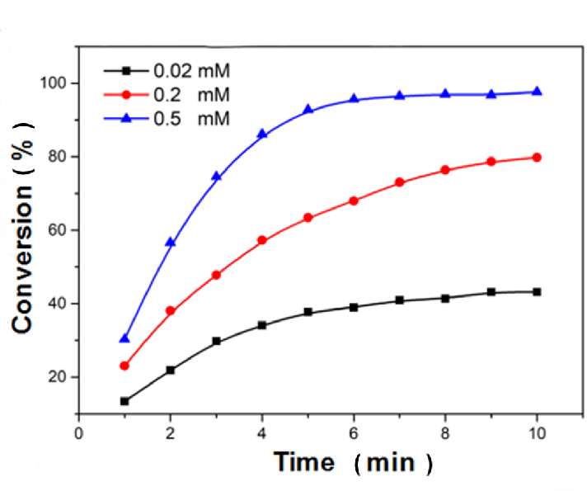
Fig. S6 The catalytic efficiency of different substrate concentrations over time.

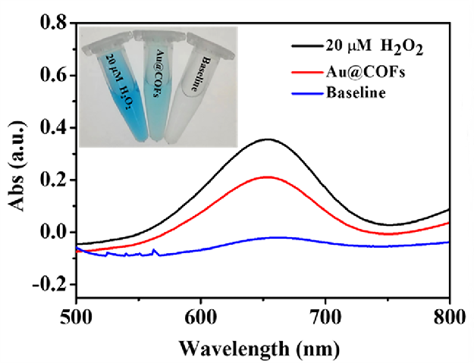

Fig. S7 UV-vis absorption spectra of Au@COFs incubated with glucose, TMB and HRP to prove the H₂O₂ production.

Table S1 Cancer cell determination using the proposed method.
Sample | Added (cells mL⁻¹) | Found (cells mL⁻¹) | RSD (%) | Recovery (%)
1 | 100 | 95±12 | 8.2 | 95.0
2 | 200 | 205±20 | 9.7 | 102.5
3 | 500 | 522±19 | 3.6 | 104.4
4 | 1000 | 981±30 | 3.1 | 98.1
5 | 5000 | 4978±321 | 6.4 | 99.6
6 | 10000 | 9950±528 | 5.3 | 99.5

References
1. Pezhhan H, Akhond M, Shamsipur M. Histidine capped-gold nanoclusters mediated fluorescence detection of glucose and hydrogen peroxide based on glucose oxidase-mimicking property of gold nanoparticles via an inner filter effect mechanism. J Lumin. 2020;228:117604.
2. Lu M, Su L, Luo Y, Ma X, Duan Z, Zhu D, Xiong Y. Gold nanoparticle etching induced by an enzymatic-like reaction for the colorimetric detection of hydrogen peroxide and glucose. Anal Methods. 2019:11(37):4829-34.

