SUPPLEMENTARY INFORMATION

Tellurium Speciation via Frontal Chromatography ICP-MS: An Innovative and Effective Approach for the Ultratrace Detection in Environmental Matrices

Davide Spanu^{a,}*, Chiara Omodeiª, Gilberto Binda^{b,a}, Tommaso Grandeª, Sandro Recchiaª

ª Department of Science and High Technology, University of Insubria, Via Valleggio 11, 22100 Como, Italy
^{b} Norwegian Institute for Water Research (NIVA), Økernveien 94, 0579 Oslo, Norway

* Corresponding Author
Mail: davide.spanu@uninsubria.it
Phone: +39 0312386428

Table S1. ICP-MS working parameters used under optimized conditions.
Parameter | Value
RF Power | 1550 W
Nebulizer gas flow | 1.06 L/min
Auxiliary gas flow | 0.80 L/min
Cooling gas flow | 13.99 L/min
Dwell time | 160 ms
Monitored channels (m/z) | ¹²⁶Te,⁷³Ge and ¹²⁹Xe^{(*)}
Sample flow rate | 1.39 mL/min
Methanol flow rate | 0.20 mL/min
^{(*)} Other monitored isotopes during optimization stage: ¹²⁵Te, ¹²⁸Te, ¹³⁰Te

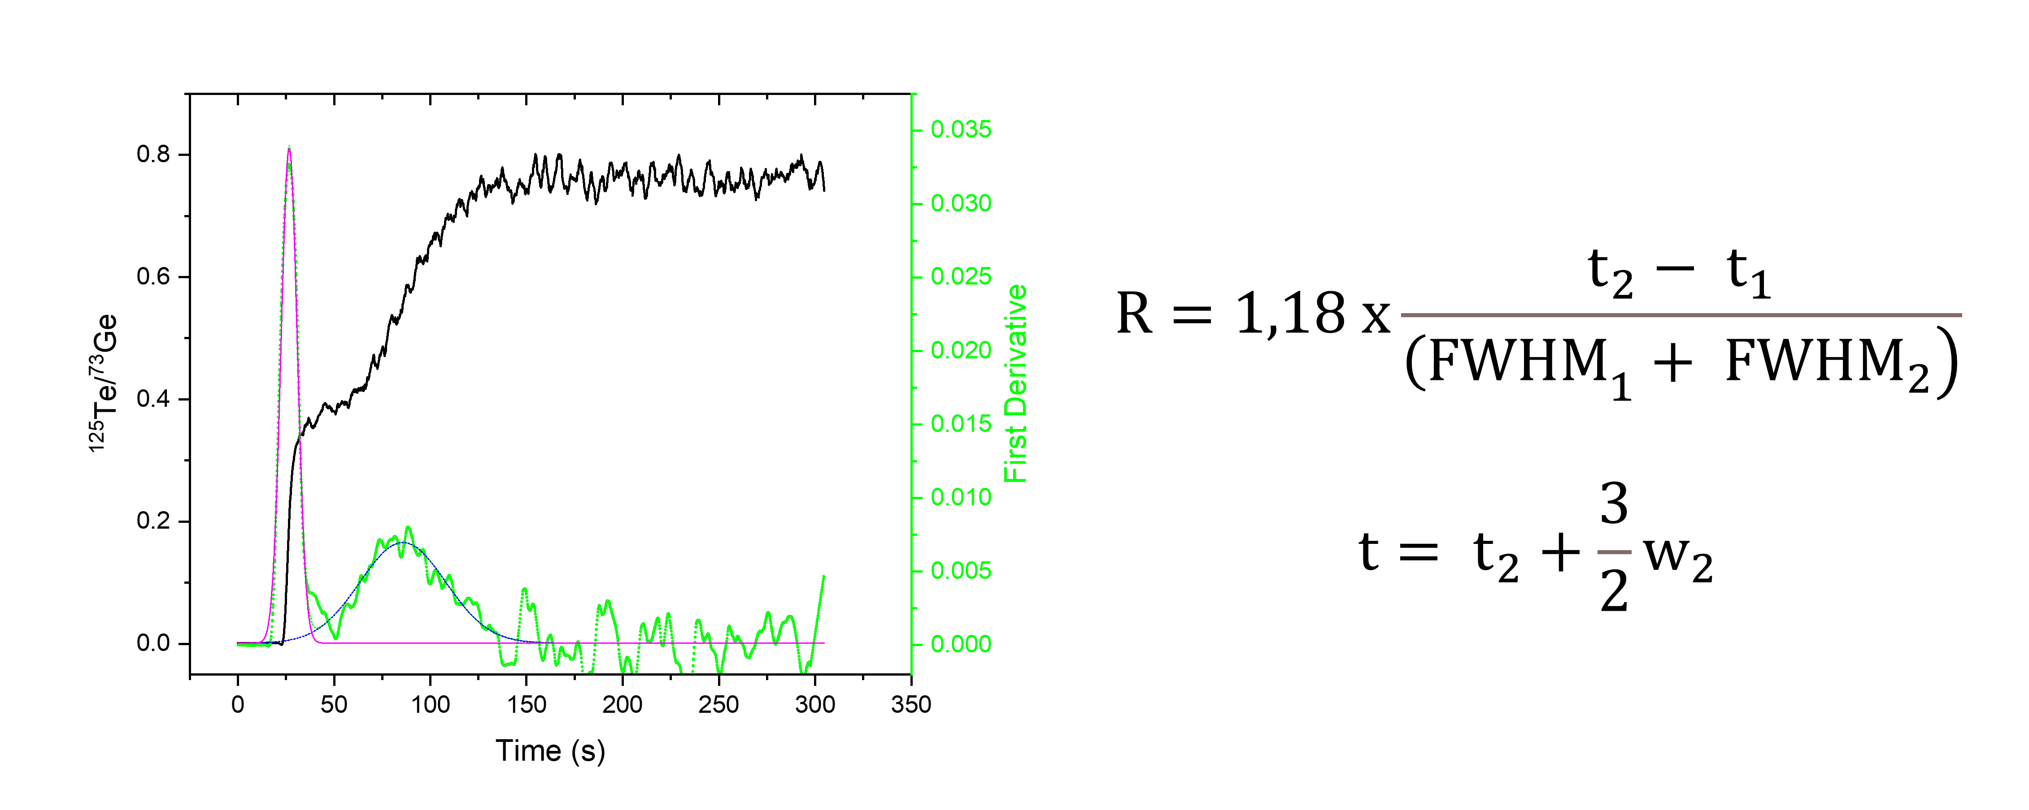
Figure S1. Illustration of analytical estimation for resolution and analysis time. Frontal chromatogram depicting a Te(IV)-Te(VI) mixture solution (black line), derivative function utilized for simulating an elution chromatogram (green line). Each peak is modeled with a Gaussian function. Resolution and analysis time are quantified based on the equations provided in the Figure, adhering to the standard definitions for these parameters in elution chromatography.

Figure S2. Frontal chromatogram of a 0.25 M HNO₃ solution containing 1 μg kg⁻¹ of both Te(VI) and Te(IV) species (red line, raw ¹²⁵Te signal). The signal of the internal standard ⁷³Ge is depicted in blue. Experimental conditions are detailed in Figure 3.

Table S2. Chemical composition and physiochemical parameters of mineral waters analyzed in this work.
Parameter | Wat-1 | Wat-2 | Wat-3 | Wat-4 | Wat-5 | Wat-6
Sodium (mg/l) | 0.58 | 0.85 | 4.31 | 3.5 | 4.9 | 50
Calcium (mg/l) | 10.8 | 33.4 | 56.82 | 96 | 120 | 400
Magnesium (mg/l) | 0.39 | 5.5 | 4 | 29 | 40 | 23
Potassium (mg/l) | 0.45 | 0.41 | 0.42 | 1.2 | 1.7 | 48
Silica (mg/l) | 3.5 | 4.8 | 5.8 | nd | nd | 87
Bicarbonate (mg/l) | 32.3 | 127 | 182 | 313 | 303 | 1500
Sulfate (mg/l) | 1.5 | 2.5 | 7.56 | 106 | 222 | 4.5
Nitrate (mg/l) | 1 | 0.96 | 1.34 | 2.9 | 5.6 | 4
Chloride (mg/l) | 0.55 | 0.95 | 8.09 | nd | 4.9 | 16.9
Fixed residue at 180°C (mg/l) | 34.9 | 112.1 | 178.4 | 422 | 566 | 1300
Conductivity at 20°C (μS/cm) | 52 | 171 | 303.9 | 582 | 767 | 1780
pH | 7 | 7.4 | 7.58 | 7.4 | 7.2 | 6.2

Table S3. Summary of the experimental conditions explored during DoE analysis and corresponding resolution and overall analysis time.
N° exp. | Column width (mm) | Column length (mm) | HNO₃ conc. (M) | Sample flow rate (mL min⁻¹) | Resolution | Analysis time (s)
1 | 2 | 50 | 0.5 | 1.39 | 0.73 | 95.8
2 | 2 | 50 | 0.5 | 1.14 | 0.53 | 112.9
3 | 2 | 50 | 0.25 | 1.39 | 0.78 | 181.0
4 | 2 | 50 | 0.25 | 1.14 | 0.99 | 198.8
5 | 2 | 25 | 0.5 | 1.39 | 0.38 | 59.1
6 | 2 | 25 | 0.5 | 1.14 | 0.37 | 70.3
7 | 2 | 25 | 0.25 | 1.39 | 0.52 | 82.6
8 | 2 | 25 | 0.25 | 1.14 | 0.51 | 97.2
9 | 3 | 50 | 0.5 | 1.39 | 1.05 | 147.9
10 | 3 | 50 | 0.5 | 1.14 | 1.00 | 172.6
11 | 3 | 50 | 0.25 | 1.39 | 1.77 | 238.5
12 | 3 | 50 | 0.25 | 1.14 | 1.71 | 289.8
13 | 3 | 25 | 0.5 | 1.39 | 0.52 | 91.3
14 | 3 | 25 | 0.5 | 1.14 | 0.54 | 107.4
15 | 3 | 25 | 0.25 | 1.39 | 0.89 | 143.0
16 | 3 | 25 | 0.25 | 1.14 | 0.87 | 171.6

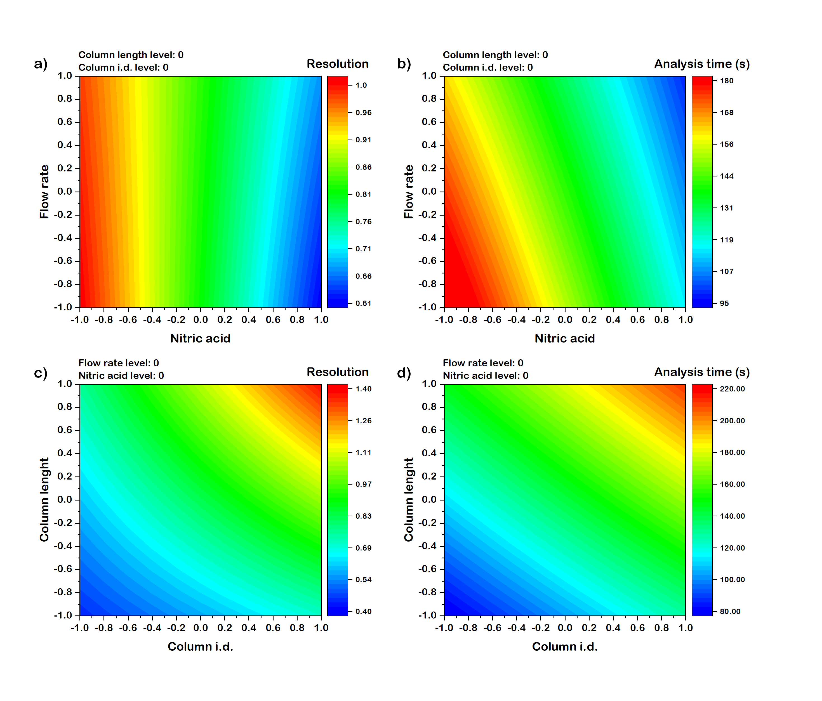
Figure S3. Surface responses depicting the effect of (a,b) sample flow rate and nitric acid concentration and (c,d) column geometry on the resolution and analysis time. Chromatographic conditions are detailed in their respective panels.

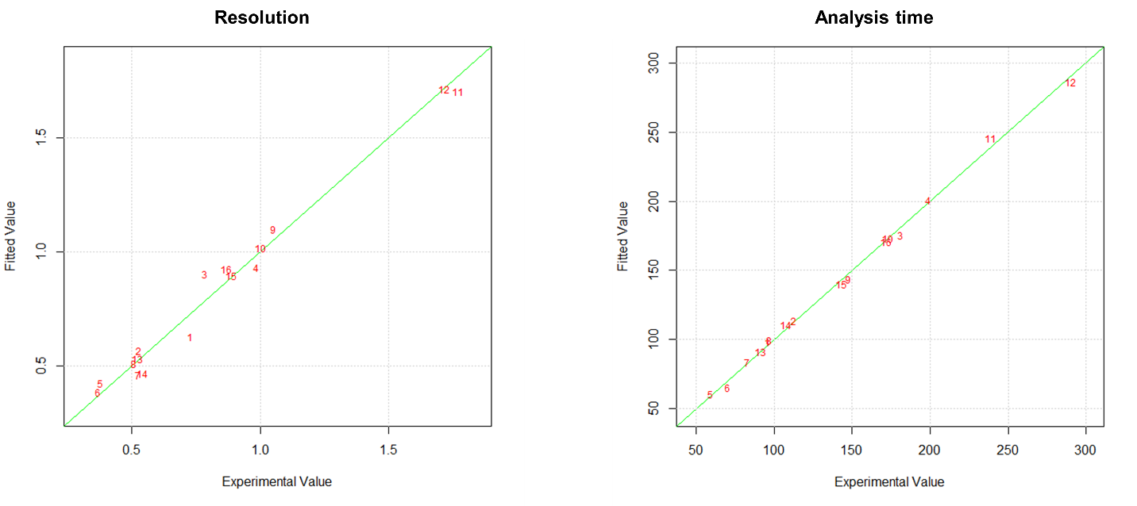
Figure S4. Scatter plots depicting Experimental versus Fitted resolution and analysis time data resulting from multivariate regression. Each data point is labeled with a number corresponding to the specific experimental condition (refer to Table S3 for details).

Figure S5. Frontal chromatogram obtained for a Te(IV)-Te(VI) mixture solution (both species at a concentration equal to 1 μg kg⁻¹) under the following conditions: column internal diameter = 3 mm, column length = 50 mm, HNO₃ concentration = 0.5 M, and sample flow rate = 1.39 mL min⁻¹.

Table S4. Formulas used to correct Xe interferences.
Isotope | Correction formula
¹²⁵Te | No corrections
¹²⁶Te | ¹²⁶Te - 0,00340909 × ¹²⁹Xe
¹²⁸Te | ¹²⁸Te - 0,0723485 × ¹²⁹Xe

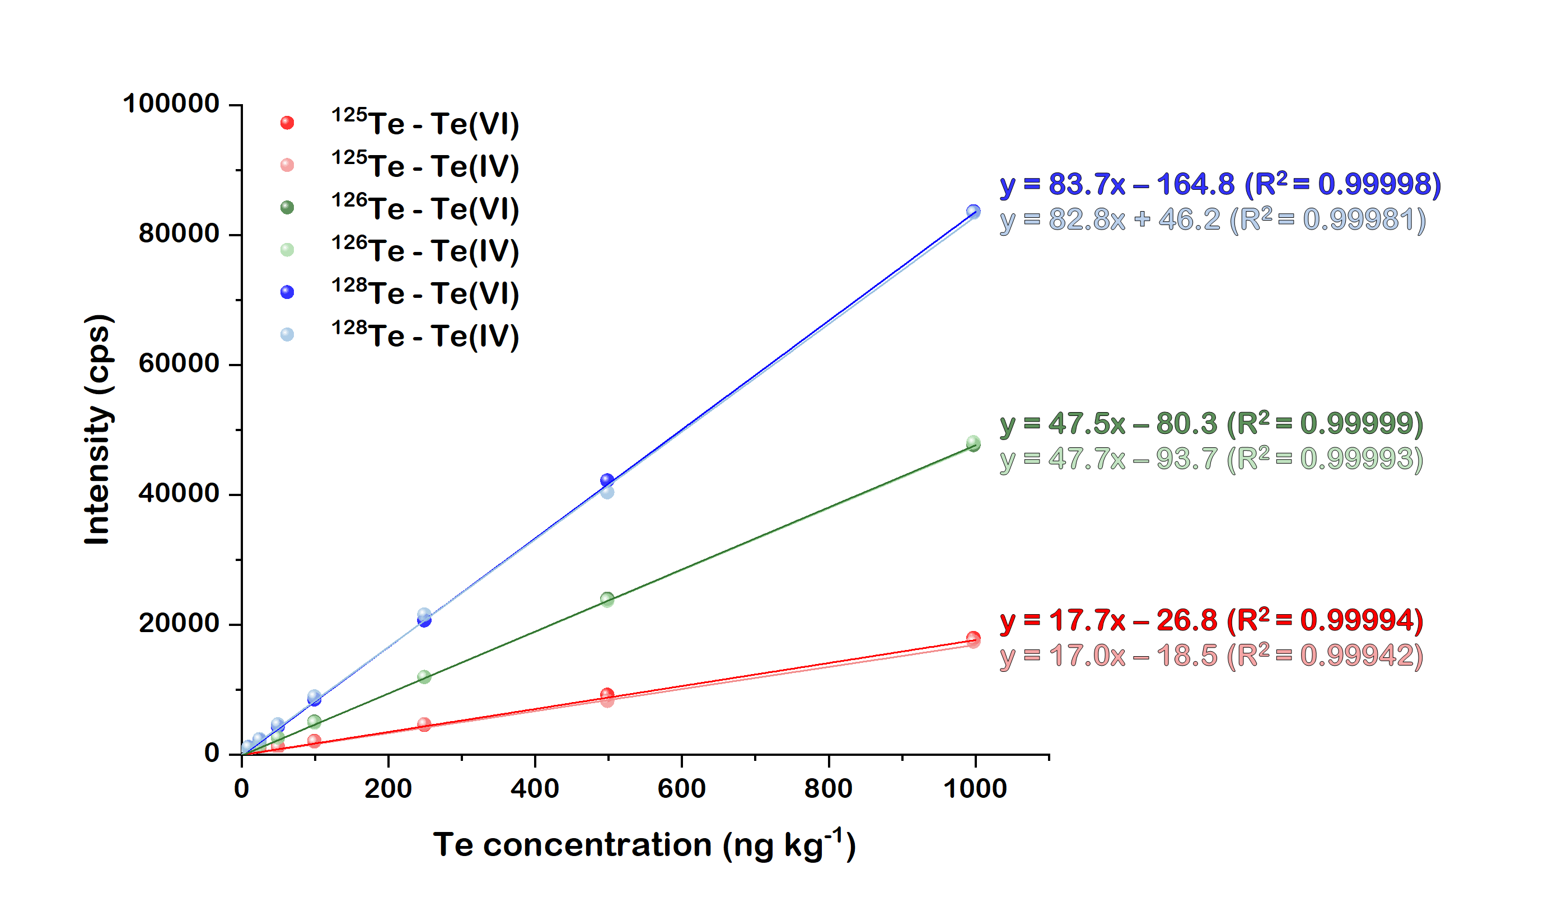
Figure S6. Calibrations curves obtained under optimized conditions for Te(IV) and Te(VI) using ¹²⁵Te (red), ¹²⁶Te (green) and ¹²⁸Te (blue) isotopes.

Figure S7. Frontal chromatograms of 5 ng kg⁻¹ Te(IV) and Te(VI) solutions analyzed for the estimation of LOD under optimized conditions (ten replicates).

