Supporting Information for
Peltier-Based Temperature Control Enables High-Bandwidth and Low-Noise Measurements with Solid-State Nanopores

Yunxuan Li, Gerardo Patino Guillen, Filip Boskovic, Thieme T. Schmidt,
Simon Brauburger, Raluca-Elena Alexii, Ulrich F. Keyser#

Supplementary Note
Principle of Peltier temperature control
In a Peltier module (Fig. 2f) composed of multiple p-type and n-type semiconductor junctions connected electrically in series and thermally in parallel, the direction of heat flow is determined by the direction of the applied current (Supplementary Fig. 1).[1] Reversal of the current direction results in an exchange of the hot and cold sides of the module, allowing a single device to perform both heating and cooling functions.[1] The magnitude of the heat flux is controlled by the applied current, enabling continuous and bidirectional temperature regulation.
The heat absorbed at the cold side of the Peltier module can be expressed as:[2, 3]
$$Q_{c}=αT_{c}I-\frac{1}{2}I^{2}R-κ(T_{h}-T_{c})$$
where $Q_{c}$ is the cooling power at the cold side, $α$ is the effective Seebeck coefficient,[4] $T_{c}$ and $T_{h}$ are the cold- and hot-side temperatures, $I$ is the drive current, $R$ is the electrical resistance of the module, and $κ$ represents parasitic thermal conduction between the two sides. This relationship highlights the trade-off between fast thermal response, Joule heating, and heat dissipation, emphasizing the importance of efficient thermal management at the hot side.
Accordingly, the heat released at the hot side of the thermoelectric module is given by:
$$Q_{c}=αT_{h}I+\frac{1}{2}I^{2}R-κ(T_{h}-T_{c})$$
This model highlights three key engineering constraints in the design of temperature control systems. First, achieving larger temperature differentials or faster thermal response requires higher drive currents, but the associated Joule heating term ($I^{2}R$) significantly increases the thermal load that must be dissipated at the hot side. Second, efficient heat removal at the hot side is essential to maintain effective cooling performance of the TEC, as an increase in $T_{h}$ directly reduces the net cooling power $Q_{c}$​. Third, minimizing parasitic heat backflow and interfacial thermal resistance is critical to ensure that the extracted heat $Q_{c}$​ is effectively used to regulate the sample temperature rather than being short-circuited within the device structure.

Supplementary Fig. 1 Principle of Peltier-based bidirectional temperature control for the nanopore platform. Reversal of the drive current through the n- and p-type semiconductor thermoelectric elements reverses the direction of charge-carrier transport, causing heat to be absorbed at one junction and released at the opposite junction. This inversion of heat pumping enables either heating or cooling of the nanopore chip depending on the current polarity. Heat exchange between the thermoelectric module and the nanopore chip is mediated by a Cu heat spreader to ensure uniform temperature distribution, while excess heat on the hot side is dissipated through a finned heat sink assisted by active cooling fans, stabilizing the thermal boundary conditions and enabling efficient, reversible temperature control

Supplementary Figures
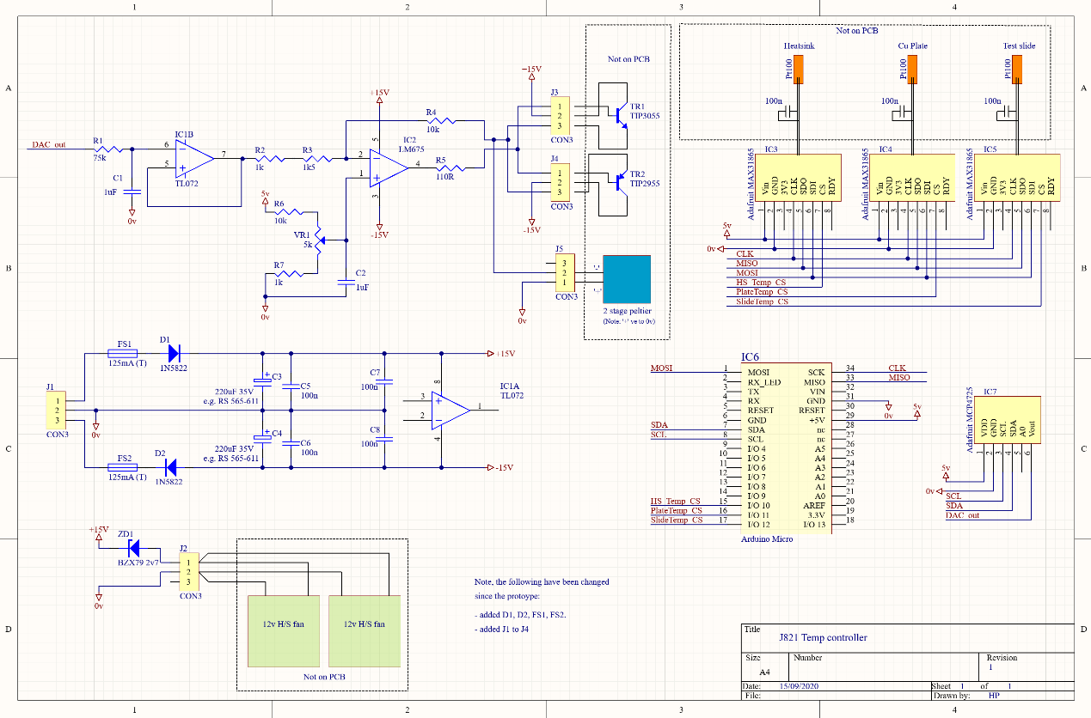
Supplementary Fig. 2 Schematic of the Peltier-based temperature control electronics for the glass nanopore sensing platform. The circuit implements a low-noise, bidirectional thermoelectric control system based on a linear driver architecture. A microcontroller-controlled DAC provides an analogue control voltage that is filtered and buffered before being amplified by a power operational amplifier and a complementary push-pull transistor stage, enabling reversible heating and cooling of a two-stage TEC. The TEC is powered from symmetric $±$15 V supply rails to allow bipolar operation. Multiple PT100 resistance temperature detectors located at the heat sink, Cu heat spreader, and test slide are digitized using MAX31865 RTD-to-digital converters and read out via an SPI interface for temperature monitoring and feedback control. The system is designed to minimize electrical noise coupling into the nanopore current measurement while providing stable, high-resolution temperature regulation

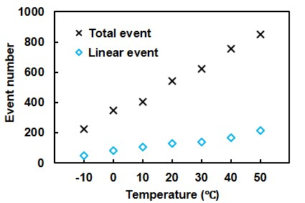
Supplementary Fig. 3 Total and linear translocation event numbers of M13mp18 DNA carriers through a glass nanopore of approximately 8.5 nm. Measurements were performed at a DNA concentration of 1.5 nM with a recording duration of 10 min at each temperature

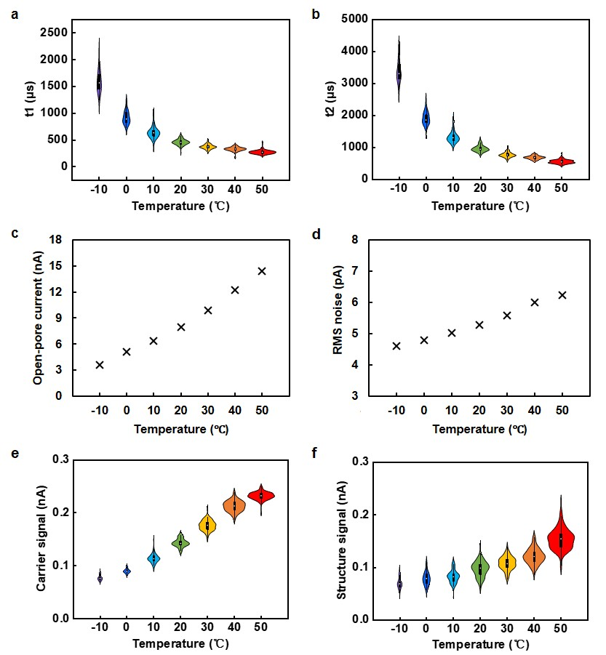
Supplementary Fig. 4 Temperature-dependent translocation characteristics of structured DNA carriers. Temperature-dependent translocation measurements were performed using structured DNA carriers with the same design as shown in Fig. 6, translocating through a glass nanopore with an effective diameter of approximately 8 nm. A total of 33, 58, 74, 92, 109, 125, and 160 translocation events were recorded at −10, 0, 10, 20, 30, 40, and 50 °C, respectively. Box plots indicate the interquartile range (25th-75th percentiles), the central markers denote the median, and the whiskers extend to values within 1.5× the interquartile range. a,b Dwell times t1 and t2​, c open-pore current, d RMS current noise, e carrier signal amplitude, and f structure signal amplitude as a function of temperature

Supplementary Table
Supplementary Table 1 Comparison of temperature-controlled solid-state nanopore platforms reported in the literature.
Platform | Nanopore type | Temp. range | Response time | Bandwidth | RMS noise | Temp. control method
Verschueren et al. (2015) [5] | SiN membrane | 0–40 °C | ~20 min equilibration | Not reported | Not reported | Peltier, bulk
Zhang et al. (2015) [6] | SiN membrane | 2–38 °C | Not reported | Not reported | Not reported | Fluidic heat exchange
Lomovtsev et al. (2025) [7] | SiN membrane | Ambient–95 °C | τ ≈ 53.2 s | 1 MHz | < 300 pA | Fluidic heat exchange
This work | Glass nanopore | -10–50 °C | τ ≈ 35-45 s | 50 kHz | 4.5−6.1 pA | Peltier, chip-level

References
1. Scherrer H, Rowe D, Kajikawa T, Matsubara K, Issi J-P, Goldsmid HJ, et al. Thermoelectrics Handbook: Macro to Nano. 2018.
2. Jugsujinda S, Vora-ud A, Seetawan T. Analyzing of thermoelectric refrigerator performance. Procedia Eng. 2011;8:154-9.
3. Goldsmid HJ. Theory of thermoelectric refrigeration and generation. Introduction to Thermoelectricity: Springer; 2016.
4. Blundell SJ, Blundell KM. Concepts in thermal physics: Oup Oxford; 2010.
5. Verschueren DV, Jonsson MP, Dekker C. Temperature dependence of DNA translocations through solid-state nanopores. Nanotechnology. 2015;26(23):234004.
6. Zhang Y, Wu G, Ma J, Yuan Z, Si W, Liu L, et al. Temperature effect on translocation speed and capture rate of nanoporebased DNA detection. Sci China Technol Sc. 2015;58(3):519-25.
7. Lomovtsev D, He L, Waugh M, St-Gelais R, Tabard-Cossa V. A platform for high-bandwidth nanopore sensing with thermal control and low electrical noise. Rev Sci Instrum. 2025;96(8).

