Appendix A: Causal loop diagrams notation [Source: Adapted from Sterman, J. (2000).
CLD symbols | Representation | Reading and interpretation
Positive links | 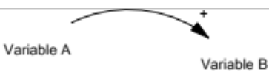 | Colloquial:
Positive links |  | - If ‘A’ goes up (down) then ‘B’ will go up (down);
Positive links |  | - If there is a change in ‘A’ then ‘B’ will change in the same direction.
Positive links |  | Formal:
Positive links |  | - All else equal, if ‘A’ increases then ‘B’ increases above what it would have been;
Positive links |  | - All else equal, if ‘A’ decreases then ‘B’ decreases below what it would have been;
Positive links |  | - In case of accumulations (i.e. stock-flow relationships) if ‘A’ increases it will add to ‘B’
Negative links | 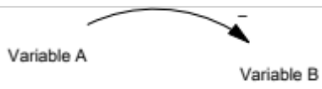 | Colloquial:
Negative links |  | - If ‘A’ goes up (down) then ‘B’ will go down (up);
Negative links |  | - If there is a change in ‘A’ then ‘B’ will change in the opposite direction.
Negative links |  | Formal:
Negative links |  | - All else equal, if ‘A’ increases then ‘B’ decreases above what it would have been  - In case of accumulations (i.e. stock-flow relationships) if ‘A’ subtracts from ‘B’.
Reinforcing (or positive) loops | 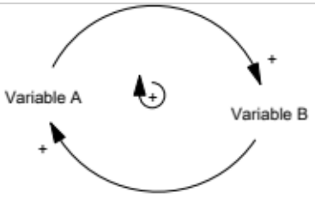 | Colloquial:
Reinforcing (or positive) loops |  | - A feedback loop is positive (+) if the number of negative (-) links is even, thus reinforcing (R) a given initial change.
Reinforcing (or positive) loops |  | Formal:
Reinforcing (or positive) loops |  | - Tracing the effect of a change in any of the variables around the loop reveals that the feedback effect opposes the initial change  - Positive feedback loops are sources of growth, erosion and collapse in systems.
Balancing (or negative) Loops | 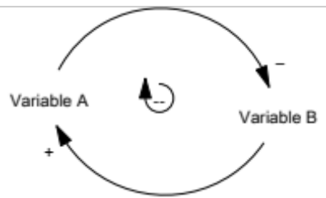 | Colloquial:
Balancing (or negative) Loops |  | - A feedback loop is negative if the number of negative links is odd, thus opposing disturbances and self-correcting/balancing a given initial change
Balancing (or negative) Loops |  | Formal:
Balancing (or negative) Loops |  | - Tracing the effect of a change in any of the variables around the loop reveals that the feedback effect opposes the initial change
Time delays | 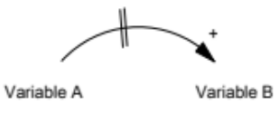 | - Time delays that are perceived relevant to the dynamics of the system may be represented explicitly in causal loop diagrams (e.g. using a mark crossing the causal link arrow). This convention denotes that the causal effect A has on B is significantly delayed in time, although the delay time is not usually specified in these diagrams

Appendix B: Focus Group Activity plan
Planned session activities (1 h 40 min.)
No. | Activity | Duration
1 | - Explain the dynamics of the two sessions (activities and objective of the focus group session, assignment of the person who will present the work in the next session).  - Ask permission to record the session | 10 minutes
2 | - Answer participants' questions and doubts | 10 minutes
3 | - Participants write the challenges on yellow post-it notes (sticky notes). | 10 minutes
4 | - The moderator collects the post-it notes and fixes them on the laminated wall/board.  - Participants are asked to discuss and prioritize the: 1) challenges, 2) identify causes and 3) consequences. | 60 minutes
5 | - Take photos of the models obtained from each group
Activity plan for the second session (65 minutes)
No. | Activity | Duration
1 | - Present a summary of the models obtained in the first parallel session | 10 minutes
2 | - Prioritize the challenges (focus on three key challenges); specify causes and consequences | 30 minutes
3 | - Link causal links (directional arrows) with marker pen. | 20 minutes
4 | - Take a photo of the models and the work done, thank the participants for their attendance and conclude the session. Ask them if we can send them a questionnaire by email and discuss the extent of this research with patient collaboration. | 5 minutes

