The Role of Real- World Evidence in UK Reimbursement: Case Study of Lenalidomide in Myelodysplastic Syndrome Deletion 5q
Journal: PharmacoEconomics Open
Dawn Lee¹*, Nic Brereton¹, Sujith Dhanasiri², Austin Kulasekararaj³
¹ BresMed, Sheffield, United Kingdom
² Celgene International, Boudry, Switzerland
³ King’s College Hospital National Health Service Foundation Trust, London, United Kingdom

* Corresponding author
Address: North Church House
84 Queen Street
Sheffield, S1 2DW
United Kingdom
Phone: +44 (0)114 309 4372
E-mail: dlee@bresmed.com (DL)

Supplementary model information

Treatments considered within the model
Lenalidomide (Revlimid®, a registered trademark of Celgene Corporation) is an oral therapy that modifies the natural course of myelodysplastic syndrome (MDS) through clonal suppression, which delays disease progression. Marketing authorisation was granted in Europe on 14 June 2007 for the treatment of patients with transfusion-dependent anaemia due to Low- or Intermediate-1-risk MDS associated with an isolated 5q deletion [MDS del(5q)] when other therapeutic options are insufficient or inadequate [1]. By maintaining patients independently of blood transfusions, lenalidomide could prevent the accelerating morbidity, mortality and quality of life impairment associated with MDS disease progression.
The mainstay of treatment for Low- and Intermediate-1-risk MDS del(5q) within the UK at the time of analysis was best supportive care (BSC; blood transfusions, growth factors and antibiotics) to control the symptoms of bone marrow failure, and most patients quickly become red blood cell transfusion dependent (RBC-TD) [2]. Erythropoiesis-stimulating agents (ESAs) and granulocyte colony-stimulating factor (G-CSF) were sometimes used successfully, but data show that the response to these treatments could be lower in MDS del(5q) than in other low-risk MDS patients [3]. In the model base case, it was assumed that 28% of patients would receive ESAs, and 72% would receive BSC, based upon prior ESA use in the MM-004 trial. Comparisons of all patients using ESAs and those receiving only transfusions as required are provided as sensitivity analysis results.

Source of effectiveness data
The model was parametrised using data from the intention-to-treat (ITT) population of the MDS-004 trial for lenalidomide at the licensed dose (10 mg) and placebo (BSC). This population included a small number of patients falling outside of the licensed population who either had unconfirmed MDS at randomisation, had additional cytogenetic abnormalities or had potentially not satisfied the criteria that other therapeutic options were insufficient or inadequate. However, the MDS-004 trial was not powered to show differences in the sub-group selected for marketing authorisation; the majority of patients enrolled in the trial had received previous treatment with ESAs or had a baseline EPO level >500 mlU/ml (77.6%), and most patients in the ITT population had isolated del(5q) (n=135 in the isolated del(5q) subgroup compared to n=205 for the ITT population). None of the factors used to define the licensed subgroup of patients were prognostically significant within the MDS-004 trial.
The major goal of treatment of patients with MDS is the achievement of transfusion independence (TI) [4, 5]. Within the MDS-004 trial, 60.9% of patients receiving lenalidomide 10 mg achieved TI (responded) for ≥8 weeks, and 55.1% achieved TI status for ≥26 weeks, compared to 7.5% and 6% of patients, respectively, in the placebo arm (p<0.001) [4].
The proportion of patients responding to treatment was taken directly from the MDS-004 trial for lenalidomide, and placebo response rates were used for patients receiving only transfusions [4]. Patients receiving ESAs with or without G-CSF have a greater chance of response than with transfusions alone [5-7]. As there was no ESA usage in the trial, available literature was used to estimate response rates in these patients. Published response rates to ESAs within the overall MDS population range from 10 to 49%, compared to approximately 50.6% with G-CSF. However, published literature shows that del(5q) patients have a significantly lower response rate and a significantly shorter duration of response to ESAs [5-7].
Therefore, to estimate ESA response for the MDS-004 trial population, patients in the trial were categorised into three predictive groups based on criteria from Hellstrom-Lindberg et al. [8]. Response rates to ESAs in combination with G-CSF for these groups were reported by Jädersten et al.: 6% in the low-probability response group, 18% in the intermediate-probability group and 60% in the high-probability group [9]. Patients in the ‘low’ predictive group are unlikely to be treated by ESAs or G-CSF. As such, in the model, the response rates for the high- and intermediate-probability groups were weighted with the proportion of trial patients in those groups (in the MDS-004 trial, 36.4% of patients were in the intermediate-probability group, and 3.5% were in the high-probability group). This methodology provides an estimated response rate to ESAs in combination with G-CSF of 21.7%.
However, this rate is unlikely to be applicable to the UK because combination therapy is started upon the failure of ESAs alone. The response rate to monotherapy with either ESAs or G-CSF is assumed by Balleari et al. to be half that of combination therapy [10]. This assumption gives a response rate of 10.8% for ESAs alone and a response rate of 10.8% for G-CSF.
Duration of response, time to acute myeloid leukaemia (AML) progression and survival time for patients who do not progress to AML is modelled based upon patient-level data from the MDS-004 trial. Exponential, Weibull, extreme-value, log-normal and log-logistic parametric survival curves were fitted to patient-level data from MDS-004 (Fig. S2). Progression to AML and survival were modelled based upon response (as opposed to trial arm). Goodness of fit for all curves was evaluated using the Integrated Brier Score (IBS) [Fig. S3], Akaike Information Criterion (AIC) [Fig. S3], visual fit to the Kaplan–Meier curve and long-term plausibility of the estimates based upon expert opinion.
Log-rank tests were used to determine if there was a significant difference in response duration depending on whether a treatment was received as the first or second treatment within the trial, i.e. whether crossover within the trial may have impacted upon results. The results showed that the order patients received treatment (and therefore crossover) did not have a significant impact on duration of response.
In order to determine the time that patients continued to respond to treatment, response curves were calculated for ITT patients initially receiving the lenalidomide 10 mg dose. Response curves could not be calculated for patients on the placebo arm as there were insufficient responses to provide data for a reasonable curve fit (only five patients responded and four of these were censored). Therefore, the lenalidomide 5 mg dose efficacy was used as a proxy to determine the response curves for the BSC arm in the model. This most likely overestimates the treatment effect in the comparator arm. A lognormal model was selected in the model base case due to its low AIC value and low IBS.
For AML progression, the base case model used the Weibull distribution as this had as a relatively low IBS and low AIC and offered a more clinically realistic fit than the extreme value distribution which, despite having the lowest IBS, predicted 100% AML progression relatively quickly. The Weibull distribution was also selected to model overall survival (OS) as it had a relatively low IBS, a low AIC and long-term was considered plausible by clinical experts.
The cross-over of patients in the MDS-004 trial at Week 16 precludes any long-term assessment of the impact of lenalidomide on survival compared to an untreated cohort. Reliance on MDS-004 trial data alone to extrapolate mean survival is therefore likely to result in an overestimate for BSC. The median survival within the model for BSC was therefore adjusted to match the reported combined median survival for the MDS-003 and MDS-004 trials of 3.8 years (2.9, 4.8) [11]. The adjustment has been applied to the scale parameter for the OS curve for transfusion dependent patients, keeping the hazard ratio for the difference in survival between transfusion independent and dependent patients fixed as per the MDS-004 trial.
More information on the survival curve fitting and adjustments made for crossover can be found in the documentation used within the National Institute for Health and Care Excellence (NICE) submission [12].
AML mortality could not be estimated from the MDS-004 study because the number of deaths from AML was too low. Instead, the study by Wahlin et al. [13] (2001) of older people with AML, including 113 people with MDS caused by 5q deletion, was used to provide data. The log-normal function provided the best statistical fit to the data but this resulted in a ‘long tail’. This meant that some people remained alive for an unrealistically long time. Therefore, a Weibull distribution was chosen to estimate the survival time and avoid this discrepancy.
A full list of model parameters is provided in Table 1 [8-10, 14-27].

Safety
Adverse event rates for patients receiving lenalidomide and the proportion of patients experiencing adverse events that required treatment were estimated using data from the MDS-004 trial [4]. Neutropenia and thrombocytopenia were the only events that were both serious enough to warrant inclusion in the model and showed a difference between rates in the lenalidomide and placebo arms in the trial [4].
It is unlikely that all instances of neutropenia and thrombocytopenia can be attributed to lenalidomide because MDS is characterised by these peripheral cytopenias. Therefore, the number of patients experiencing these cytopenias due to lenalidomide was calculated as the difference between the lenalidomide and placebo groups. It is assumed that any lenalidomide adverse events have a constant hazard over four cycles because the majority of events occurred within this time frame in the trial. After four cycles, there is no longer a risk of adverse events.

Costs
The primary cost drivers are the duration and intensity of treatment and requirements for transfusions. Patients continue treatment for two cycles before response is evaluated with only responding patients continuing treatment. Patients remaining on treatment after 26 cycles receive lenalidomide free in the UK as per the PAS agreed with the Department of Health. Patients in the trial were allowed up to two treatment interruptions, usually due to adverse events. Because no lenalidomide is given during these interruptions, no treatment costs are incurred for these patients over these periods. Clinical outcomes were not adjusted because the efficacy data for the ITT population used within the model already accounted for these interruptions.
Monitoring costs were taken from UK sources, with UK clinicians estimating that monitoring would be required by a haematologist weekly for the first 8 weeks of treatment with lenalidomide and monthly thereafter, with BSC and ESA monitoring being monthly throughout treatment.
The average number of RBC/platelet units transfused per cycle was estimated from UK patient-level data during the weeks recorded prior to randomisation in the MDS-004 trial data [4] and applied to all patients, in every cycle, in the transfusion states. No difference was assumed in the RBC/platelet transfusion rates between the different iron chelation health states. Other key outcome dependent costs were taken from the published literature, and costs were taken from standard UK published sources (Table S1).
The model results incorporate a delayed cost of 16 days of lenalidomide at Cycle 27 to allow for treatment interruptions.

Quality of life
Quality of life in MDS is highly dependent upon transfusion status, with decrements of between 0.17 and 0.3 observed in the published literature for transfusion dependence versus independence [23,28,29].
Functional Assessment of Cancer Therapy-Anemia (FACT-An) score was measured throughout the MDS-004 trial, and EuroQol five-dimensions (EQ-5D) score was only measured at baseline. Mapping was attempted by the School of Health and Related Research (ScHARR) in order to establish a relationship between FACT-An and EQ-5D and to utilise the EQ-5D to fit in line with NICE guidelines. Within the FACT-An questionnaire, several items had scores that differed depending on transfusion status; for example, items that focused on the impact of fatigue on patient quality of life. Items such as these are not explicitly considered in the EQ-5D questionnaire. Not all items were included in the mapping, and for the items excluded from the mapping, the relative reduction in transfusion dependency scores compared to transfusion independence scores was substantially greater than for the items included. Therefore, these were not used in the model. Instead the model used more sensitive utility scores, found via a systematic literature review.
The systematic literature review, conducted to identify relevant health-related quality of life data for people with MDS found four potentially relevant studies: Buckstein et al. (2009) [30], Buckstein et al. (2011) [28], Goss et al. (2006) [29] and Szende et al. (2009) [23]. Data from Szende et al. were used in the base case model. Szende et al. did not conform to the NICE reference case as it did not use a general UK population sample. However, patient experts thought that the study was a reasonable reflection of the negative impact that transfusion dependence has on health-related quality of life. Alternative estimates are used in sensitivity analysis. Utility decrements for complications were taken from published literature (Table S1).

Uncertainty
The uncertainty around all model parameters was tested via probabilistic (5,000 iterations) and one-way sensitivity analysis, taking distributional information from the original source material where possible (Table S2). Parameter uncertainty for individual parameters was explored via one-way sensitivity analysis (Fig. S4). Scenario analysis was conducted to test the impact of key structural assumptions within the model (Table S2).

References
1. Celgene Ltd. Revlimid®. Summary of product characteristics. 2014. https://www.medicines.org.uk/emc/medicine/19841/SPC/Revlimid. Accessed 13 January 2015.
2. National Institute for Health and Care Excellence. TA322: Lenalidomide for the treatment of myelodysplastic syndromes associated with deletion 5q cytogenetic abnormality Final Scope. 2012. https://www.nice.org.uk/guidance/ta322/documents/myelodysplastic-syndrome-deletion-5q-lenalidomide-final-scope2. Accessed 13 January 2015.
3. Kelaidi C, Eclache V, Fenaux P. The role of lenalidomide in the management of myelodysplasia with del 5q. Br J Haematol. 2008;140(3):267–78.
4. Fenaux P, Giagounidis A, Selleslag D, Beyne-Rauzy O, Mufti G, Mittelman M, et al. A randomized phase 3 study of lenalidomide versus placebo in RBC transfusion-dependent patients with Low-/Intermediate-1-risk myelodysplastic syndromes with del5q. Blood. 2011;118(14):3765–-76.
5. Santini V. Clinical use of erythropoietic stimulating agents in myelodysplastic syndromes. Oncologist. 2011;16(suppl 3):35–42.
6. Hellstrom-Lindberg E, Ahlgren T, Beguin Y, Carlsson M, Carneskog J, Dahl IM, et al. Treatment of anemia in myelodysplastic syndromes with granulocyte colony-stimulating factor plus erythropoietin: results from a randomized phase II study and long-term follow-up of 71 patients. Blood. 1998;92(1):68–75.
7. Mundle S, Lefebvre P, Vekeman F, Duh MS, Rastogi R, Moyo V. An assessment of erythroid response to epoetin alpha as a single agent versus in combination with granulocyte- or granulocyte-macrophage-colony-stimulating factor in myelodysplastic syndromes using a meta-analysis approach. Cancer. 2009;115(4):706–15.
8. Hellstrom-Lindberg E, Gulbrandsen N, Lindberg G, Ahlgren T, Dahl IM, Dybedal I, et al. A validated decision model for treating the anaemia of myelodysplastic syndromes with erythropoietin + granulocyte colony-stimulating factor: significant effects on quality of life. Brit J Haematol. 2003;120(6):1037–46.
9. Jadersten M, Montgomery SM, Dybedal I, Porwit-MacDonald A, Hellstrom-Lindberg E. Long-term outcome of treatment of anemia in MDS with erythropoietin and G-CSF. Blood. 2005;106(3):803–11.
10. Balleari E, Rossi E, Clavio M, Congiu A, Gobbi M, Grosso M, et al. Erythropoietin plus granulocyte colony-stimulating factor is better than erythropoietin alone to treat anemia in low-risk myelodysplastic syndromes: results from a randomized single-centre study. Ann Hematol. 2006;85(3):174–80.
11. Kuendgen A, Strupp C, Aivado M, Hildebrandt B, Haas R, Gattermann N, et al. Myelodysplastic syndromes in patients younger than age 50. J Clin Oncol. 2006;24(34):5358–65.
12. National Institute for Health and Clinical Excellence. TA322: Lenalidomide for treating myelodysplastic syndromes associated with an isolated deletion 5q cytogenetic abnormality. 2014. https://www.nice.org.uk/guidance/ta322. Accessed 22 December 2015.
13. Wahlin A, Markevarn B, Golovleva I, Nilsson M. Prognostic significance of risk group stratification in elderly patients with acute myeloid leukaemia. Brit J Haematol. 2001;115(1):25–33.
14. Joint Formulary Committee. British National Formulary (online) version 64. 2013. Accessed 13 January 2015.
15. Department of Health. NHS reference costs financial year 2011 to 2012. 2012. https://www.gov.uk/government/publications/nhs-reference-costs-financial-year-2011-to-2012. Accessed 13 January 2015.
16. Guest JF, Munro V, Cookson RF. The annual cost of blood transfusions in the United Kingdom. Clin Lab Haematol. 1998;20(2):111–8.
17. Davies L, Brown TJ, Haynes S, Payne K, Elliott RA, McCollum C. Cost-effectiveness of cell salvage and alternative methods of minimising perioperative allogeneic blood transfusion: a systematic review and economic model. Health Technol Assess. 2006;10(44):iii-iv, ix-x, 1–210.
18. Luengo-Fernandez R, Leal J, Gray A, Petersen S, Rayner M. Cost of cardiovascular diseases in the United Kingdom. Heart. 2006;92(10):1384–9.
19. Wright M, Grieve R, Roberts J, Main J, Thomas HC, Investigators UKMHCT. Health benefits of antiviral therapy for mild chronic hepatitis C: randomised controlled trial and economic evaluation. Health Technol Assess. 2006;10(21):1–113, iii.
20. Curtis L. Personal Social Services Research Unit. Unit Costs of Health and Social Care 2011. https://www.pssru.ac.uk/project-pages/unit-costs/unit-costs-2016/ Accessed 13 January 2015.
21. Kanavos P, van den Aardweg S, Schurer W. Diabetes expenditure, burden of disease and management in 5 EU countries. London: LSE Health, London School of Economics; 2012.
22. McLeod C, Fleeman N, Kirkham J, Bagust A, Boland A, Chu P, et al. Deferasirox for the treatment of iron overload associated with regular blood transfusions (transfusional haemosiderosis) in patients suffering with chronic anaemia: a systematic review and economic evaluation. Health Technol Assess. 2009;13(1):iii-iv, ix-xi, 1–121.
23. Szende A, Schaefer C, Goss TF, Heptinstall K, Knight R, Lubbert M, et al. Valuation of transfusion-free living in MDS: results of health utility interviews with patients. Health Qual Life Outcomes. 2009;7:81.
24. Fryback DG, Dasbach EJ, Klein R, Klein BE, Dorn N, Peterson K, et al. The Beaver Dam Health Outcomes Study: initial catalog of health-state quality factors. Medl Decis Making. 1993;13(2):89–102.
25. Wong JB, Koff RS, Tine F, Pauker SG. Cost-effectiveness of interferon-alpha2b treatment for hepatitis B e antigen-positive chronic hepatitis B. Ann Int Med. 1995;122(9):664–75.
26. Jabbour E, Kantarjian HM, Koller C, Taher A. Red blood cell transfusions and iron overload in the treatment of patients with myelodysplastic syndromes. Cancer. 2008;112(5):1089–95.
27. Kontoghiorghes GJ, Pattichi K, Hadjigavriel M, Kolnagou A. Transfusional iron overload and chelation therapy with deferoxamine and deferiprone (L1). Transfus Sci. 2000;23(3):211–23.
28. Buckstein R, Alibhai SM, Lam A, Mamedov A. The health-related quality of life of MDS patients is impaired and most predicted by transfusion dependence, hemoglobin and age. Leuk Res. 2011;35(Suppl 1 ):S55–S6.
29. Goss TF, Szende A, Schaefer C, Totten PJ, Knight R, Jadersten M, et al. Cost effectiveness of lenalidomide in the treatment of transfusion-dependent myelodysplastic syndromes in the United States. Cancer Control. 2006;13 Suppl:17–25.
30. Buckstein R, Jang K, Friedlich J, Zhang L, Reis M, Chesney A, et al. Estimating the prevalence of myelodysplastic syndromes in patients with unexplained cytopenias: a retrospective study of 322 bone marrows. Leuk Res. 2009;33(10):1313–8.

Tables
Table S1 Key model parameters
 | Value | Source
Costs
Lenalidomide | £170 per 5 mg tablet  £15,000 per 200 mg vial | BNF 64 [14]
ESAs | £110.62 per 20,000 unit vial | BNF 64 [14], Epoetin alpha – Eprex
G-CSF | £52.71 | BNF 64 [14], Neupogen
DFO | £22.35 | BNF 64 [14]
Exjade  Deferiprone | £46.37  £152.39, 100 × 500 mg tabs | BNF 64 [14]  MIMS 2015
Haematologist visit | £159.56, per visit | NHS reference costs 2012/13 [15] - clinical haematology
Full blood count | £3.09, per test | NHS 2011/12 reference costs [15] – haematology
Serum ferritin | £1.23, per test | NHS 2011/12 reference costs [15] – biochemistry
Platelet transfusion | £312.49 | Guest et al. [16], inflated using PSSRU to 2011
Blood administration | £234.88 | Davies et al. (all costs aside from the unit of blood; cross matching, equipment, procedure etc.) [17]
Cost of unit of blood | £133.10 | Davies et al. inflated to 2011 using PSSRU [17]
Carriage (each way) | £12.27 | NHS reference costs 2011/12 [15]
Thrombocytopenia | £1,768.01, per episode | NHS reference costs 2011/12 [15] – SA12F inpatient
Neutropenia | £1,044.73, per episode | NHS reference costs 2011/12 [15] – SA08F inpatient
Cardiac disease | £3,792.30, annual cost | Luengo-Fernandez et al. 2006 inflated to 2011 using PSSRU [18]
Hepatic complications | £1,445.80, annual cost | Wright et al. 2006 inflated to 2011 using PSSRU [19,20]
Diabetes mellitus | £3,644.40, annual cost | Kanavos et al. 2012 [21]
AML | £51.84, daily | McLeod et al. 2009 (STA Azactadine) [22]
Dosing
Proportion of patients experiencing dose interruption with lenalidomide (first interruption, second interruption given first interruption) | 68.7%, 73.8% | MDS-004 trial
Mean duration of dose interruptions (first, second) | 17.5 days, 13.9 days | MDS-004 trial
Mean time to interruption (first, second) | 54.2 days, 17.5 days | MDS-004 trial
Dose of ESA | 2 × 20,000 IU vials per week | MDS-004 trial
Dose of G-CSF | 3 × 200 mg vials per week | Product SPCs
Utilities
TI | 0.85 | Szende et al. 2009 [23]
Transfusion dependant | 0.65 | Szende et al. 2009 [23]
AML | 0.65 | Assumed same as TD
% decrease in utility due to –
DFO use | 21.0 | McLeod et al. 2009 (STA Azactadine) [22]
Oral chelator use | 0.0 | McLeod et al. 2009 (STA Azactadine) [22]
Cardiac disease | 17.9 | Fryback et al. 1993 [24]
Diabetes | 12.3 | Fryback et al. 1993 [24]
Hepatic complication | 8.0 | Wong et al. 1995 [25]
Neutropenia and thrombocytopenia | 0 | Not expected to impact patients quality of life due to their transient nature
Curve fit parameters
Mortality – TD | Weibull curve: beta = 1.172, alpha = 0.0003 | MM-004 trial – patient-level data analysis
Mortality – TI | Weibull curve: beta = 1.172, alpha = 0.0002 | MM-004 trial – patient-level data analysis
Median survival from MDS-003 and MDS-004 | 3.80 | Kuendegen et al. [11]
Response duration – lenalidomide | Log-normal curve beta = 1.187, alpha = 7.07 | MM-004 trial – patient-level data analysis
Response duration – best supportive care | Log-normal curve beta = 1.187, alpha = 6.542 | MM-004 trial – patient-level data analysis
AML progression – TD | Weibull curve: beta = 1.388, alpha = 0.0002 | MM-004 trial – patient-level data analysis
AML progression – TI | Weibull curve: beta = 1.388, alpha = 0.0001 | MM-004 trial – patient-level data analysis
Response rates
Timeframe required to assess response | 84 days | Pragmatic stopping rule consistent with UK assessment patterns
% of people achieving TI – lenalidomide | 60.9 | Fenaux et al. 2011 [4]
% of people achieving TI – transfusions only | 7.5 | Fenaux et al. 2011 [4]
% of people achieving TI – ESAs | 10.8 | Hellstrom-Lindberg et al. 2003; Jadersten et al. 2005; Balleari et al. 2006 [8-10]
% of people achieving TI – G-CSF | 10.8 | Hellstrom-Lindberg et al. 2003; Jadersten et al. 2005; Balleari et al. 2006 [8-10]
Chelation response and threshold
Chelation threshold | 25 RBC units | Jabbour et al. 2008 [26]
% of people responding to chelation | 66 | Kontoghiorghes et al. 2000 [27]
% of patients previously chelated | 8 | MDS-004 trial data
Complications and adverse event rates
Risk of thrombocytopenia per cycle – lenalidomide | 0.127 | MDS-004 trial data
Thrombocytopenia – % of patients treated | 0.060 | MDS-004 trial data
Risk of neutropenia per cycle – lenalidomide | 0.193 | MDS-004 trial data
Neutropenia – % of patients treated | 0.277 | MDS-004 trial data
Risk per cycle of diabetes during iron chelation | 0.002 | Fryback et al. 1993 [24]
Risk per cycle of hepatic complications during iron chelation | 0.007 | Fryback et al. 1993 [24]
Risk per cycle of cardiac disease when TD | Gompertz: beta 4.935, gamma 0.006 | Wong et al. 1995 [25]
Transfusion rates
Average number of RBC transfusions per month cycle | 4.574 | MDS-004 trial data
Average RBC units per transfusion | 2.426 | MDS-004 trial data
Average number of platelet transfusions per month cycle | 0.060 | MDS-004 trial data
Average platelet units per transfusion | 3.000 | MDS-004 trial data
AML acute myeloid leukaemia, BNF British National Formulary, DFO desferrioxamine,
ESA erythropoiesis-stimulating agent, G-CSF granulocyte colony-stimulating factor, MIMS Monthly Index of Medical Specialities, NHS National Health Service, PSSRU Personal Social Services Research Unit,
RBC red blood cell, SPC summary of product characteristics, STA single technology assessment,
TI transfusion independent, TD transfusion dependent

Table S2 Scenario analysis
 | Total |  |  | Incremental |  |  | ICER
 | Costs | LYG | QALYs | Costs | LYG | QALYs | ICER
Treatment pathway
Comparing to all patients using ESAs
Best supportive care | £131,509 | 5.34 | 3.04 | £9,961 | 0.71 | 0.63 | £15,911
Lenalidomide | £141,470 | 6.06 | 3.67
Comparing to all patients only receiving transfusions as required
Best supportive care | £124,802 | 5.65 | 3.45 | £23,399 | 1.07 | 0.82 | £28,646
Lenalidomide | £101,403 | 4.58 | 2.63
Structural uncertainty
Selecting alternative curve fits for mortality
Best supportive care | (£120,419–£133,596) | (5.02–5.76) | (2.89-3.17) | (£15,769–£20,989) | (0.73–1.08) | (0.64–0.82) | (£22,647–£25,831)
Lenalidomide | (£136,187–£151,713) | (5.75–6.65) | (3.53– 3.94)
Selecting alternative curve fits for AML
Best supportive care | (£121,208–£127,893) | (5.07–5.28) | (2.91–3.05) | (£16,961–£25,918) | (0.79 –0.98) | (0.68–0.79) | (£24,784– £25,918)
Lenalidomide | (£138,169–£148,384) | (5.86–6.46) | (3.59–3.84)
Selecting alternative curve fits for response duration
Best supportive care | (£123,235–£123,349) | 5.17 | (2.95) | (£18,229–£21,328) | 0.88 | (0.69-0.72) | (£25,310–30,827)
Lenalidomide | (£141,470–£144,677) | 6.06 | (3.64–3.67)
Stopping rule - response assessment at 56 days (rather than 84 days)
Best supportive care | £123,273 | 5.15 | 2.94 | £17,512 | 0.58 | 0.49 | £35,539
Lenalidomide | £140,785 | 5.73 | 3.43
Stopping rule - response assessment at 182 days (rather than 84 days)
Best supportive care | £122,321 | 5.19 | 2.97 | £19,683 | 0.90 | 0.72 | £27,232
Lenalidomide | £142,004 | 6.09 | 3.69
Parameter uncertainty
Use of alternative utility sources - Buckstein
Best supportive care | £123,241 | 5.17 | 2.99 | £18,229 | 0.88 | 0.68 | £26,668
Lenalidomide | £141,470 | 6.06 | 3.67
Use of alternative utility sources - Goss
Best supportive care | £123,241 | 5.17 | 2.31 | £18,229 | 0.88 | 0.92 | £19,732
Lenalidomide | £141,470 | 6.06 | 3.23
Utility of AML = 0
Best supportive care | £123,241 | 5.17 | 2.82 | £18,229 | 0.88 | 0.70 | £26,139
Lenalidomide | £141,470 | 6.06 | 3.52
Note: Costs and QALYs discounted at 3.5% per year
ESA erythropoiesis-stimulating agents, ICER incremental cost effectiveness ratio, LYG life year gained, QALY quality-adjusted life year

Figures
Fig. S1 Cost-effectiveness acceptability plane
- 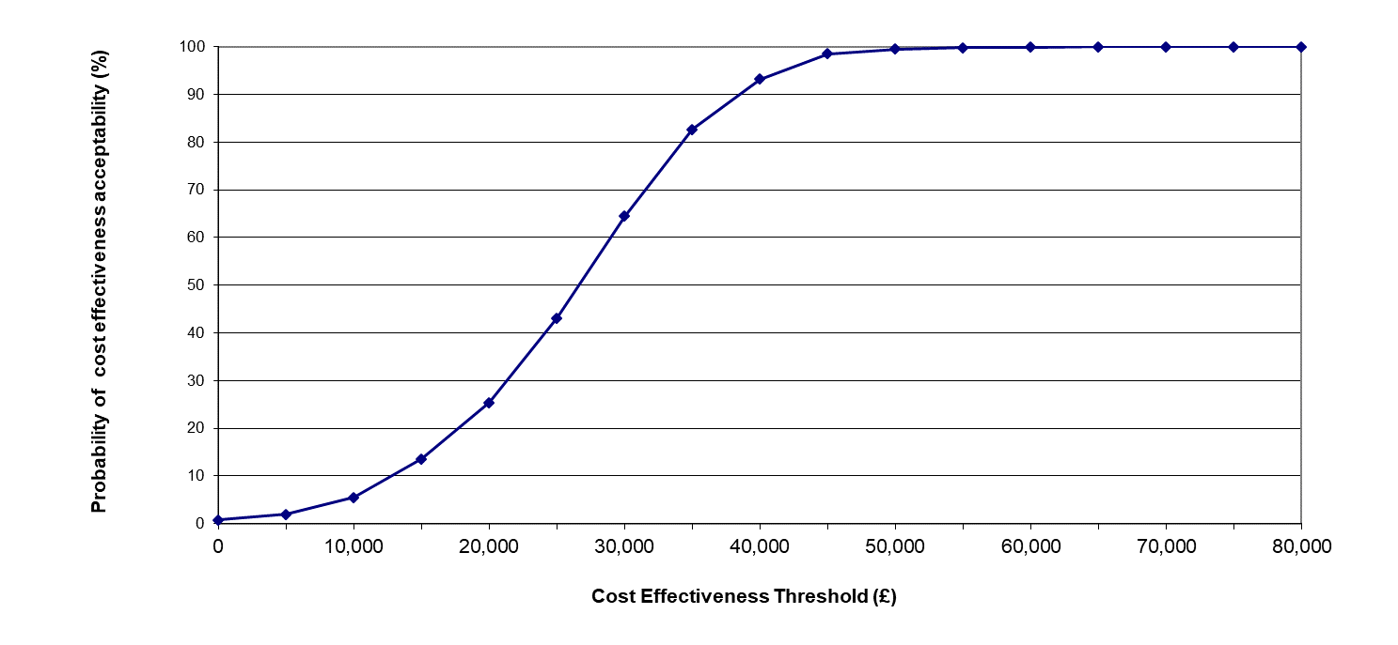
- BSC best supportive care, EUMDS European Leukemianet myelodysplastic syndrome registry

Fig. S2 Extrapolation of treatment duration, survival and AML progression
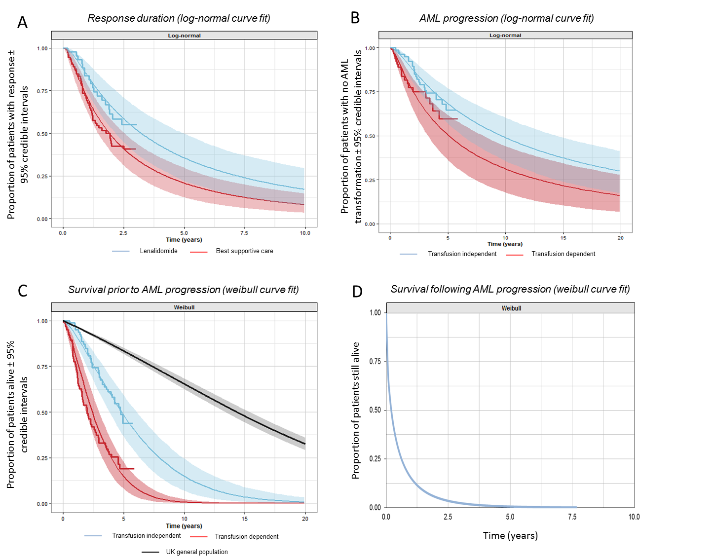
AML acute myeloid leukaemia

Fig. S3 Goodness of fit for extrapolated curves
Response duration
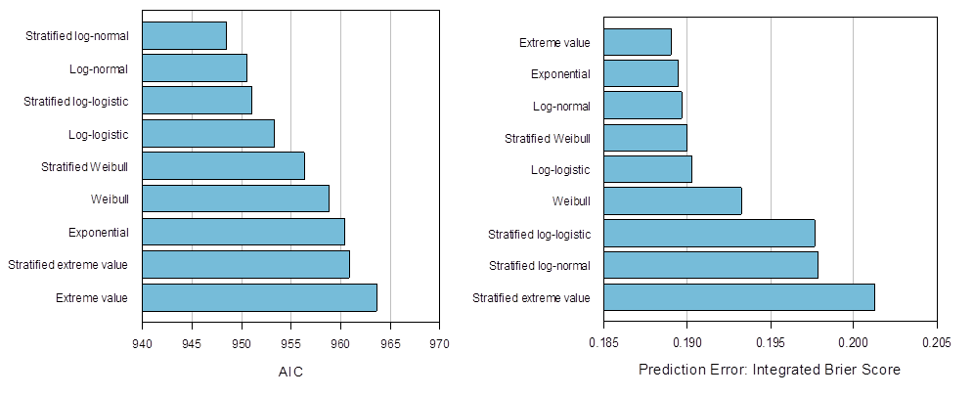
Progression to AML
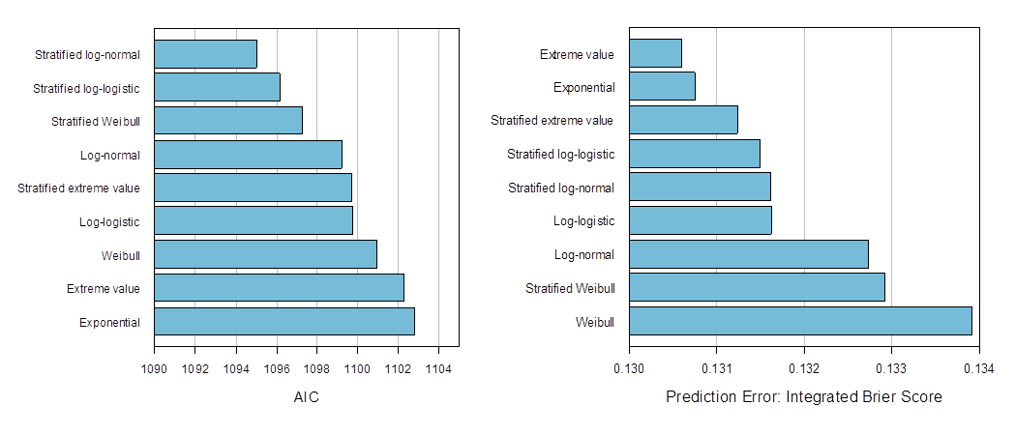
Survival
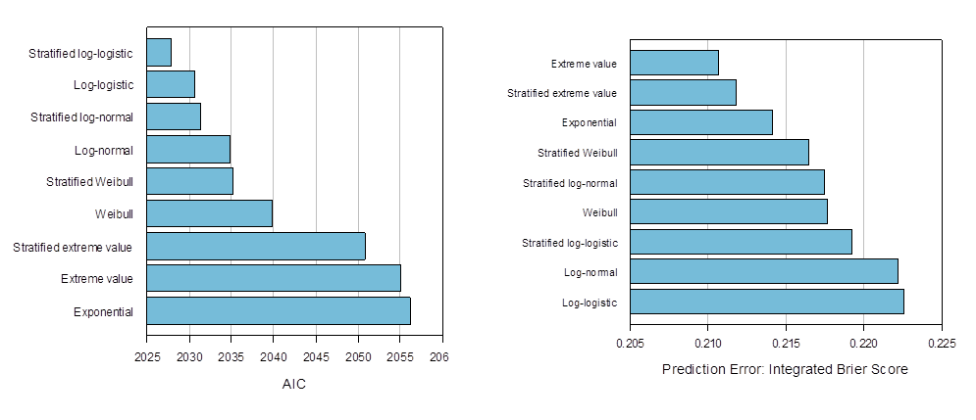
AIC Akaike Information Criterion, AML acute myeloid leukaemia
Fig. S4 One-way sensitivity analysis
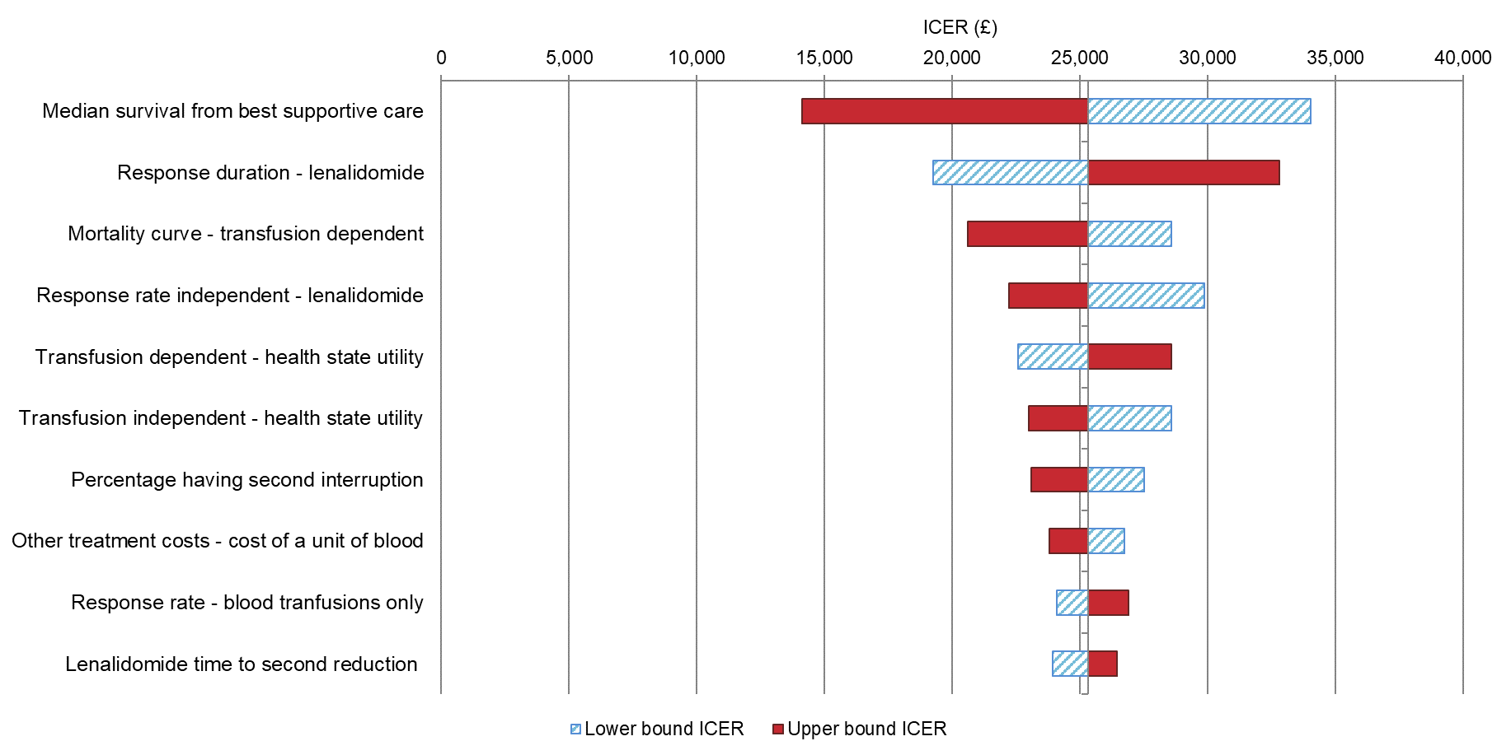
ICER incremental cost-effectiveness ratio

Fig. S5 Survival of low and intermediate-1 risk MDS patients in EUMDS and Greenberg et al. versus cost-effectiveness model projected survival
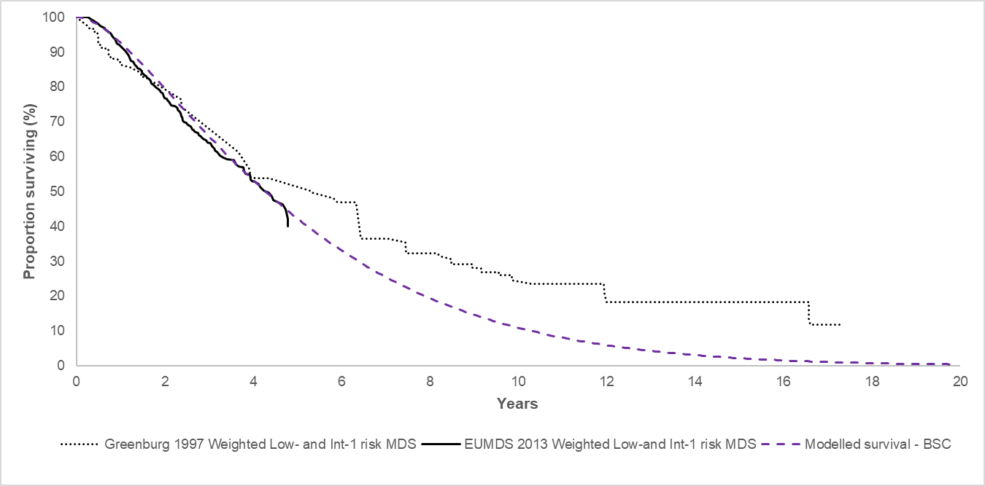
BSC best supportive care, EUMDS European Leukemianet myelodysplastic syndrome registry, Int Intermediate, MDS myelodysplastic syndrome

