Out-of-pocket cancer care costs and value frameworks:
A case study in a community oncology practice with a financial navigator program

Journal: PharmacoEconomics - Open

Christine Leopold¹, Carina Araujo-Lane¹, Carol Rosenberg³, Melissa Gilkey², Anita K. Wagner¹

Corresponding author:
Christine Leopold, PhD, MS;
Division of Health Policy and Insurance Research, Harvard Medical School and Harvard Pilgrim Health Care Institute,
Landmark Center, 401 Park Drive Suite 401, Boston, MA 02215, phone: (617)-867-44813, fax: (617)-867-44276, christleopold@gmx.net

Supplementary material: Semi-structured interview guide
Treatment decision process and acceptability of discussing value
- There are a lot of effective treatment options for patients with chronic lymphocytic leukemia (CLL). When you decide to treat a patient, what is the treatment decision process? Which decisions tend to be the most difficult?
- Over the last few years, there has been a lot of discussion about the value of various cancer treatments. When you discuss treatment options with patients who have CLL, how do you think about the value of different treatment options?
- How do you think about effectiveness?
- How do you think about the safety of the treatments?
- Do you think about the cost of the treatment for the patient? [Do you know the cost to patients?]
Awareness of value tools
This study focuses on value-focused decision-making tools for shared decision-making of patients and providers. The leading concepts are from the National Comprehensive Cancer Network (NCCN), the Evidence Block, and the American Society of Clinical Oncology (ASCO), the ASCO value framework.
- What is your experience, if any, with value frameworks like these?
- What have you heard about them?
- How have you used them?
Usability of value tools
Great. Let me summarize some key points: Tools like the Evidence Block and ASCO value framework propose to assess the value of new therapies based on efficacy, safety, quality of evidence and costs. Let’s look at an example of the NCCN Evidence Block and the ASCO value framework for CLL.
Prompt: In Appendix A, you’ll see a snapshot of the NCCN Evidence Block. The overall structure is similar to the NCCN guidelines, but in addition it includes a ranking of different treatment options based on efficacy, safety, quality of evidence, consistency of evidence and affordability (costs). I picked an example of the ranking of different treatment options for a frail patient with co-morbidities. The box includes on the left the different drug therapies and on the right for each therapy a graphical representation of its ranking based on efficacy, safety, quality of evidence, consistency of evidence and affordability (costs). While a score of 5 means that the therapy if highly effective, not toxic or inexpensive and a score of 1 means that it is not effective, very toxic and very expensive.
- From your perspective, how useful is the NCCN evidence block for assessing the value of treatment options for CLL?
- How easy is it to understand?
- In this particular example, which treatment options appear to you to be of highest value? Lowest? Does this match your clinical experience of these treatments?
- How would you imagine using the tool, if at all?
- Why would you not use it?
- Would you use something else?
- How would you imagine your patients using the tool, if at all?
- What, if anything, is missing from the framework?
Prompt: In Appendix B, you’ll see a snapshot of the ASCO value framework. ASCO proposes to measure value by looking at clinical benefit, toxicity other bonus points (such as palliation, quality of life etc.) and costs. In this scenario, ASCO compares ibrutinib versus chlorambucil as initial treatment for patients with CLL. They include the clinical benefit score, the toxicity score as well as different bonus points (such as palliation) and finally the drug acquisition costs.
- From your perspective, how useful is the ASCO value framework for assessing the value of treatment options for CLL?
  - How easy is it to understand?
  - In this particular example, which treatment options appear to you to be of highest value? Lowest? Does this match your clinical experience of these treatments?
  - How would you imagine using the tool, if at all?
- Why would you not use it?
- Would you use something else?
  - How would you imagine your patients using the tool, if at all?
  - What, if anything, is missing from the framework?
  - Which of the tools is more appealing to you?
- What kind of information would you find helpful in a value tool (e.g. comparative effectiveness data, cost data (overall costs of drug, out-of-pocket spending for patients)?
- You have now answered my primary questions. Before we move on to a few last questions on your practice characteristics, are there other thoughts on measuring the value of cancer treatments you would like to share with us?
Close:
Thank you so much for your time. Your insights will be very helpful to us. I am stopping the recording now.

Appendix A: NCCN Evidence Block for CLL
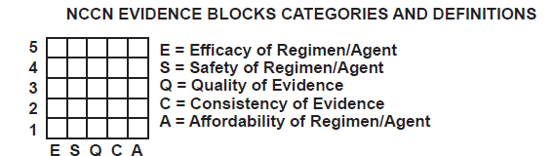
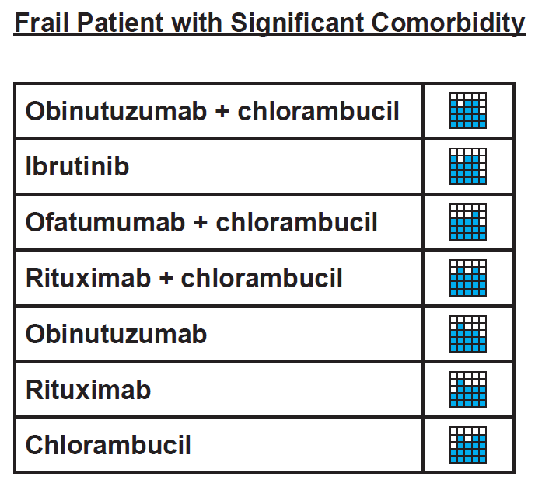

Appendix B: ASCO value framework for CLL
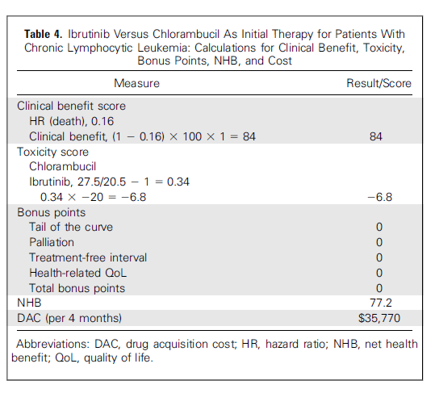

Specific questions for focus group – are costs considered during treatment decision
- Do you currently consider costs in treatment discussions with patients?
  - If yes, at what point in the treatment decision flowchart are costs considered?
  - If no, would they be willing to consider and discuss costs with patients during treatment discussions and at what point in the flowchart would that discussion occur?
- Looking at the NCCN Evidence Block and the ASCO value framework, are the proposed variables and the structure of the tool helpful to guide treatment discussions?
- Which additional information or tool structure would be needed to include costs in treatment decisions?

