Supplementary Tables and Figures
Journal name: Pharmacoeconomics Open
- Article title: Is protocolised weaning that includes early extubation onto non-invasive ventilation more cost-effective than protocolised weaning without non-invasive ventilation? Findings from the Breathe Study
- Author names: Iftekhar Khan, PhD^{1,2}; Mandy Maredza, PhD¹; Melina Dritsaki, PhD²; Dipesh Mistry, PhD¹; Ranjit Lall, PhD¹; Sarah E Lamb, DPhil^{1,3}; Keith Couper, PhD¹; Simon Gates, PhD¹; Gavin D Perkins, M.D. ¹; Stavros Petrou, PhD¹
corresponding author: Iftekhar Khan, University of Oxford, Oxford, OX3 9DU, UK; email: iftekhar.khan@ndorms.ox.ac.uk

Web Appendix Table 1: Resource Use by Trial Allocation, Resource Category and Study Period for Complete Cases
Randomization to Hospital Discharge | Non-invasive weaning arm  (N=182) | Invasive weaning arm  (N=182)
Number of Days in ICU | Mean (SE) | Mean (SE)
 | 14.0 (1.078) | 15.0 (1.12)
Maximum Number of Organs Supported | n(%) | n(%)
0 | 1(<1%) | 0
1 | 5(3%) | 6(3%)
2 | 131(72%) | 139(76%)
3 | 43(24%) | 34(19%)
4 | 2(1%) | 3(2%)
 | Mean (SE) | Mean (SE)
Days in ICU for supporting | n(%) | n(%)
0 organs | 7.0(n/c)ª | 0
1 organ | 12.8 (3.07) | 8.0 (2.2)
2 organs | 9.7 (0.64) | 12.9 (0.7)
3 organs | 18.1 (1.50) | 13.1 (1.6)
4 organs | 10.5 (3.50) | 16.0 (7.4)
Highest Level of Care | n(%) | n(%)
0/1 | 0 | 0
2 | 18(10%) | 2(1%)
3 | 164(90%) | 180(99%)
Days in ICU with highest level of care as:
 | Mean (SE) | Mean (SE)
0/1 | 10.2(0.78) | 13.4(1.06)
2 | 10.4(0.83) | 10.7(0.74)
3 | 19.7(2.15) | 17.1(1.78)
 | n(%) | n(%)
Tracheostomy | 43(24%) | 55(30%)
Anti-fungal use | 10(5%) | 21(12%)
Anti-viral use | 2(1%) | 0
Emergency Transport | 37(20%) | 39(21%)
Post Discharge to 3 Months (post randomization) [ 3months] | n=95 | n=91
Inpatient Care (Hospital Readmission) | Mean (SE) n(%) | Mean (SE) n(%)
Length of Stay (days) | 2.8(1.01) 19(20%) | 6.0(1.61) 22(24%)
Outpatient Care (hospitals /Clinics) | Mean (SE) n(%) | Mean (SE) n(%)
Outpatient clinic (# visits) | 1.3(0.20) 51(54%) | 1.6(0.30) 54(59%)
Radiology: MRI scan (# visits) | 0.1(0.03) 4(4%) | 0.0(0.02) 4(4%)
Radiology: CT scan (# visits) | 0.1(0.05) 7(7%) | 0.1(0.04) 10(11%)
Radiology: x-ray (# visits) | 0.3(0.09) 16(17%) | 0.2(0.05) 15(17%)
Radiology: ultrasound (# visits) | 0.0(0.02) 4(4%) | 0.1(0.03) 6(7%)
Hospital A and E (# visits) | 0.2(0.05) 9(10%) | 0.2(0.06) 8(9%)
Other service: (# visits) | 1.1(0.49) 24(25%) | 0.8(0.19) 26(29%)
Residential Care Services | Mean (SE) n(%) | Mean (SE) n(%)
Residential care home (# days) | 0.1(0.08) 1(1%) | 0.4(0.24) 3(3%)
Rehabilitation centre (# days) | 0.7(0.33) 5(5%) | 1.6(0.69) 6(7%)
Warden controlled residence (# days) | 0.0(0.00) 0(0%) | 0.0(0.00) 0(0%)
Day centre run by your local authority (# days) | 0.0(0.00) 0(0%) | 0.0(0.00) 0(0%)
Other service (# days) | 0.5(0.35) 4(4%) | 0.2(0.15) 2(2%)
Community health and social care | Mean (SE) n(%) | Mean (SE) n(%)
GP surgery visit (# visits) | 2.1(0.26) 59(62%) | 1.9(0.29) 58(64%)
GP home visit (# visits) | 0.3(0.07) 19(20%) | 0.5(0.15) 20(22%)
GP telephone consultation(# visits) | 0.5(0.12) 18(19%) | 0.5(0.13) 19(21%)
District Nurse (# visits) | 3.5(0.96) 33(35%) | 3.7(1.15) 29(32%)
Health Visitor (# visits) | 0.0(0.00) 0(0%) | 0.0(0.03) 2(2%)
Social Worker (# visits) | 0.2(0.11) 3(3%) | 0.2(0.05) 9(10%)
Physiotherapist (# visits) | 1.3(0.41) 23(24%) | 1.2(0.29) 22(24%)
Occupational therapist (# visits) | 0.8(0.29) 13(14%) | 0.4(0.10) 15(16%)
Counsellor (# visits) | 0.2(0.14) 4(4%) | 0.0(0.04) 1(1%)
Psychologist (# visits) | 0.0(0.02) 2(2%) | 0.1(0.07) 4(4%)
Home help/care worker(# visits) | 6.8(2.40) 12(13%) | 3.9(2.10) 9(10%)
Other (# visits) | 2.2(1.06) 18(19%) | 2.2(1.05) 19(21%)
Medication (on prescription) | Mean (SE) n(%) | Mean (SE) n(%)
Number of Medications | 5.1(0.46) 73(77%) | 4.0(0.39) 68(75%)
 | n(%) | n(%)
0 Medication | 17(18%) | 22(24%)
1 Medication | 8(8%) | 11(12%)
2 Medications | 9(9%) | 4(4%)
3 Medications | 5(5%) | 8(9%)
> 3 Medications | 51(54%) | 45(50%)
Medication (over the counter) | Mean (SE) n(%) | Mean (SE) n(%)
Number of medications | 4.7(1.11) 13(14%) | 5.9(1.36) 12(13%)
 | n(%) | n(%)
0 Medication | 78(82%) | 81(89%)
1 Medication | 6(6%) | 2(2%)
2 Medications | 0 | 0
3 Medications | 0 | 0
> 3 Medications | 7(7%) | 8(9%)
Equipment and aids | n(%) | n(%)
Patients who required equipment and aids | 53(56%) | 59(65%)
Provided by:
Health Service / NHS | 44(46%) | 46(51%)
Patient | 8(8%) | 16(18%)
Charity | 1(1%) | 4(4%)
Social Services | 7(7%) | 4(4%)
Other/not stated | 1(1%) | 2(2%)
Additional Resource use by patient or partner/relative | n(%) | n(%)
Patients/partner/relative that used an additional resource | 30(32%) | 32(35%)
Travel cost incurred | 19(20%) | 25(27%)
Child care | 1(1%) | 1(1%)
Income lost | 7(7%) | 9(10%)
Housework | 8(8%) | 3(3%)
Laundry | 4(4%) | 3(3%)
Other | 1(1%) | 2(2%)
Post Discharge 3 months to 6 Months (post randomization) [ 3 to 6 months] | Non-invasive weaning arm  n=93 | Invasive weaning arm  n=84
Inpatient Care (Hospital Readmission) | Mean (SE) n(%) | Mean (SE) n(%)
Length of Stay (days) /# hospital visits | 3.1(1.26) 16(17%) | 4.3(2.19) 23(27.4%)
Outpatient Care (hospitals /Clinics) | Mean (SE) n(%) | Mean (SE) n(%)
Outpatient clinic (# visits) | 1.9(0.35) 49(53%) | 1.5(0.16) 61(73%)
Radiology: MRI scan (# visits) | 0.1(0.05) 7(8%) | 0.1(0.04) 9(11%)
Radiology: CT scan (# visits) | 0.2(0.06) 15(16%) | 0.2(0.04) 14(17%)
Radiology: x-ray (# visits) | 0.2(0.05) 12(13%) | 0.2(0.06) 12(14%)
Radiology: ultrasound (# visits) | 0.1(0.03) 6(7%) | 0.1(0.04) 11(13%)
Hospital A and E (# visits) | 0.1(0.05) 7(8%) | 0.2(0.06) 10(12%)
Other service: (# visits) | 0.8(0.30) 16(17%) | 1.1(0.45) 28(33%)
Residential Care Services | Mean (SE) n(%) | Mean (SE) n(%)
Residential care home (# days) | 0.0(0.00) 0(0%) | 1.3(1.02) 2(2%)
Rehabilitation centre (# days) | 0.0(0.00) 0(0%) | 1.8(1.23) 3(4%)
Warden controlled residence (# days) | 0.0(0.00) 0(0%) | 0.0(0.00) 0(0%)
Day centre run by your local authority (# days) | 0.0(0.00) 0(0%) | 0.0(0.01) 1(1%)
Other service (# days) | 0.0(0.00) 0(0%) | 0.0(0.00) 0(0%)
Community health and social care | Mean (SE) n(%) | Mean (SE) n(%)
GP surgery visit (# visits) | 1.9(0.34) 48(52%) | 2.0(0.23) 61(73%)
GP home visit (# visits) | 0.2(0.06) 9(10%) | 0.4(0.14) 12(14%)
GP telephone consultation(# visits) | 0.4(0.09) 20(22%) | 0.2(0.07) 13(16%)
District Nurse (# visits) | 3.9(1.66) 18(19%) | 5.4(2.16) 28(33%)
Health Visitor (# visits) | 0.1(0.05) 3(3%) | 1.0(0.98) 4(5%)
Social Worker (# visits) | 0.0(0.04) 2(2%) | 0.2(0.15) 4(5%)
Physiotherapist (# visits) | 0.7(0.24) 14(15%) | 0.9(0.37) 14(17%)
Occupational therapist (# visits) | 0.2(0.15) 5(5%) | 0.3(0.14) 9(11%)
Counsellor (# visits) | 0.2(0.16) 4(4%) | 0.1(0.04) 2(2%)
Psychologist (# visits) | 0.1(0.04) 2(2%) | 0.1(0.04) 5(6.0%)
Home help/care worker(# visits) | 2.5(1.43) 4(4%) | 3.8(2.35) 5(6%)
Other (# visits) | 1.1(0.35) 13(14%) | 1.5(0.80) 16(19%)
Medication (on prescription) | Mean (SE) n(%) | Mean (SE) n(%)
Number of Medications | 4.8(0.46) 67(72%) | 4.9(0.50) 67(80%)
 | n(%) | n(%)
0 Medication | 15(16%) | 25(30%)
1 Medication | 13(14%) | 12(14%)
2 Medications | 5(5%) | 2(2%)
3 Medications | 5(5%) | 4(5%)
> 3 Medications | 44(47%) | 49(58%)
Medication (over the counter) | Mean (SE) n(%) | Mean (SE) n(%)
Number of medications | 4.7(1.11) 13(14 %) | 5.9(1.36) 12(14%)
 | n(%) | n(%)
0 Medication | 74(80%) | 80(95%)
1 Medication | 3(3%) | 3(4%)
2 Medications | 0 | 1(1%)
3 Medications | 2(2%) | 1(1%)
> 3 Medications | 3(3%) | 7(8%)
Equipment and aids | n(%) | n(%)
Patients who required equipment and aids | 27(29%) | 42(50%)
Provided by:
Health Service / NHS | 24(26%) | 25(30%)
Patient | 4(4%) | 12(14%)
Charity | 0(0%) | 4(5%)
Social Services | 2(2%) | 7(8%)
Other/not stated | 2(2%) | 4(5%)
Additional Resource use by patient or partner/relative | n(%) | n(%)
Patients/partner/relative that used an additional resource | 23(25%) | 35(42%)
Travel cost incurred | 19(20%) | 23(27%)
Child care | 0(0%) | 0(0%)
Income lost | 7(8%) | 8(10%)
Housework | 5(5%) | 6(7%)
Laundry | 4(4%) | 4(5%)
Other | 0(0%) | 1(1%)
 | Non-invasive weaning arm  n=93 | Invasive weaning arm  n=84
Post Discharge to 6 Months (post randomization) [ 6 months] | Mean (SE) n(%) | Mean (SE) n(%)
Inpatient Care (Hospital Readmission) | Mean (SE) n(%) | Mean (SE) n(%)
Length of Stay (days) /# hospital visits | 9.5(2.45) 35(38%) | 5.2(1.52) 28(33%)
Outpatient Care (hospitals /Clinics) | Mean (SE) n(%) | Mean (SE) n(%)
Outpatient clinic (# visits) | 2.9(0.35) 77(83%) | 2.8(0.37) 71(85%)
Radiology: MRI scan (# visits) | 0.1(0.04) 13(14%) | 0.1(0.05) 10(12%)
Radiology: CT scan (# visits) | 0.3(0.06) 20(22%) | 0.3(0.08) 18(21%)
Radiology: x-ray (# visits) | 0.3(0.07) 25(27%) | 0.4(0.10) 23(27%)
Radiology: ultrasound (# visits) | 0.2(0.05) 15(16%) | 0.1(0.03) 10(12%)
Hospital A and E (# visits) | 0.3(0.09) 15(16%) | 0.2(0.08) 14(17%)
Other service: (# visits) | 1.7(0.44) 48(52%) | 1.7(0.52) 35(42%)
Residential Care Services | Mean (SE) n(%) | Mean (SE) n(%)
Residential care home (# days) | 1.5(0.99) 4(4%) | 0.1(0.07) 1(1%)
Rehabilitation centre (# days) | 3.1(1.27) 9(10%) | 0.6(0.31) 5(6%)
Warden controlled residence (# days) | 0.0(0.00) 0(0%) | 0.0(0.00) 0(0%)
Day centre run by your local authority (# days) | 0.0(0.01) 1(1%) | 0.0(0.00) 0(0%)
Other service (# days) | 0.2(0.14) 2(2%) | 0.5(0.32) 4(5%)
Community health and social care | Mean (SE) n(%) | Mean (SE) n(%)
GP surgery visit (# visits) | 3.5(0.41) 76(82%) | 3.5(0.44) 77(92%)
GP home visit (# visits) | 0.8(0.24) 23(25%) | 0.4(0.10) 24(29%)
GP telephone consultation(# visits) | 0.6(0.15) 27(29%) | 0.8(0.14) 29(35%)
District Nurse (# visits) | 8.4(2.75) 46(49%) | 6.6(2.00) 42(50%)
Health Visitor (# visits) | 1.0(0.89) 6(6%) | 0.1(0.04) 3(4%)
Social Worker (# visits) | 0.3(0.16) 11(12%) | 0.2(0.12) 3(4%)
Physiotherapist (# visits) | 1.9(0.44) 30(32%) | 1.8(0.46) 31(37%)
Occupational therapist (# visits) | 0.6(0.16) 21(23%) | 0.9(0.34) 17(20%)
Counsellor (# visits) | 0.1(0.06) 3(3%) | 0.4(0.25) 5(6%)
Psychologist (# visits) | 0.2(0.09) 8(9%) | 0.1(0.06) 2(2%)
Home help/care worker(# visits) | 7.1(2.98) 13(14%) | 8.3(2.95) 13(15%)
Other (# visits) | 3.4(1.21) 28(30%) | 2.9(1.09) 24(29%)
Medication (on prescription) | Mean (SE) n(%) | Mean (SE) n(%)
Number of Medications | 4.6(0.849) 21(23%) | 5.8(0.953) 24(29%)
0 Medication | 61(66%) | 68(81%)
1 Medication | 9(10%) | 5(6%)
2 Medications | 0 | 3(4%)
3 Medications | 2(2%) | 1(1%)
> 3 Medications | 10(11%) | 15(18%)
Medication (over the counter) | Mean (SE) n(%) | Mean (SE) n(%)
Number of medications | 4.6(0.849) 21(23%) | 5.8(0.953) 24(29%)
 | n(%) | n(%)
0 Medication | 61(66%) | 68(81%)
1 Medication | 9(10%) | 5(6%)
2 Medications | 0 | 3(4%)
3 Medications | 2(2%) | 1(1%)
> 3 Medications | 10(11%) | 15(18%)
Equipment and aids | n(%) | n(%)
Patients who required equipment and aids | 70(75%) | 61(73%)
Provided by:
Health Service / NHS | 54(58%) | 54(64%)
Patient | 24(26%) | 10(12%)
Charity | 6(6%) | 1(1%)
Social Services | 10(11%) | 7(8%)
Other/not stated | 6(6%) | 3(4%)
Additional Resource use by patient or partner/relative | n(%) | n(%)
Patients/partner/relative that used an additional resource | 46(49%) | 41(49%)
Travel cost incurred | 35(38%) | 32(38%)
Child care | 1(1%) | 1(1%)
Income lost | 11(12%) | 10(12%)
Housework | 7(8%) | 10(12%)
Laundry | 6(6%) | 6(7%)
Other | 3(3%) | 1(1%)
Notes: N=Number of participants who used a health resource at least once at a given assessment; Patients with missing data at 3 months present with data at 6 months and patients with missing data at 6 months present with data at 3 months; ICU: Intensive Care unit; SE: standard error of the mean; Hospital A and E: Hospital Accident And Emergency; CT: Computed Tomography; MRI: Magnetic Resonance Imaging; GP: General Practitioner; NHS: National Health Service;
ªn/c: standard error was not calculable because only 1 patient had a stay of 7 days in ICU.

Web Appendix Table 2: Unit costs for resource items (£, 2015 - 2016 prices)
Cost Category | Resource Item | Unit Cost (£)ª | Unit of Analysis | Source
Intervention-related | #organs supported in the ICU (includes antimicrobial and sedative costs)
 | 0 organs | 759 | per day | National Reference of Schedule Costs 2016, Critical Care
 | 1 organ | 1031 | per day | National Reference of Schedule Costs 2016, Critical Care
 | 2 organs | 1399 | per day | National Reference of Schedule Costs 2016, Critical Care
 | 3 | 1619 | per day | National Reference of Schedule Costs 2016, Critical Care
 | 4 | 1794 | per day | National Reference of Schedule Costs 2016, Critical Care
 | 5 | 1977 | per day | National Reference of Schedule Costs 2016, Critical Care
 | 6 or more | 2274 | per day | National Reference of Schedule Costs 2016, Critical Care
 | Highest Level of care:
 | Level 3 Care | 1641.92 |  | NICE – Critical illness rehabilitation (CG83) 2009
 | Level 2 Care | 1641.92 |  | NICE – Critical illness rehabilitation (CG83) 2009
 | Level 1 Care | 303.65 |  | NHS Reference Costs 2013-2014
 | Tracheostomy | 4151.51 | Per procedure | NHS Reference Costs 2014-15
 | High Cost Drugs
 | Antibiotics
 | Linezolid | 0.074 | Per mg | Prescription Cost Analysis, England – 2016
 | Meropenem | 0.016 | Per mg | Prescription Cost Analysis, England – 2016
 | Metronidazole | 0.002 | Per mg | Prescription Cost Analysis, England – 2016
 | Anti-Fungals
 | Amphotericin Liposomal | 1.644 | Per mg | Prescription Cost Analysis, England – 2016
 | Caspofungin | 6.553 | Per mg | Prescription Cost Analysis, England – 2016
 | Voriconazole | 0.197 | Per mg | Prescription Cost Analysis, England – 2016
 | Anidulafungin | 3.000 | Per mg | Prescription Cost Analysis, England – 2016
 | Micafungin | 3.41 | Per mg | Prescription Cost Analysis, England – 2016
 | Anti-Viral
 | Abacavir | 0.010 | Per mg | Prescription Cost Analysis, England – 2016
 | Atazanavir | 0.034 | Per mg | Prescription Cost Analysis, England – 2016
 | Didanosine | 0.013 | Per mg | Prescription Cost Analysis, England – 2016
 | Efavirenz | 0.011 | Per mg | Prescription Cost Analysis, England – 2016
 | Emtricitabine | 0.023 | Per mg | Prescription Cost Analysis, England – 2016
 | Enfuvirtide | 10.02 | Per mg | Prescription Cost Analysis, England – 2016
 | Fesamprenavir | 0.005 | Per mg | Prescription Cost Analysis, England – 2016
 | Idinavir | 0.003 | Per mg | Prescription Cost Analysis, England – 2016
 | Lopinavir with Ritonavir | 0.013 | Per mg | Prescription Cost Analysis, England – 2016
 | Navirapine | 0.010 | Per mg | Prescription Cost Analysis, England – 2016
 | Ritonavir | 0.006 | Per mg | Prescription Cost Analysis, England – 2016
 | Saquinavir | 0.004 | Per mg | Prescription Cost Analysis, England – 2016
 | Stavudine | 0.125 | Per mg | Prescription Cost Analysis, England – 2016
 | Tenofovir disoproxil | 0.028 | Per mg | Prescription Cost Analysis, England – 2016
 | Zidovudine with lamivudine and Abacavir | 0.024 | Per mg | Prescription Cost Analysis, England – 2016
 | Darunavir | 0.012 | Per mg | Prescription Cost Analysis, England – 2016
Health Resource Use
Inpatient Care | Cost per in patient stay | 173.56 | Per bed day | PSSRU – Unit Costs of Health and Social Care 2010 pg. 31
 | General Medical Ward | 400.0 | day | DOH Communication (2015) https://data.gov.uk/data-request/nhs-hospital-stay
Outpatient Care | Outpatient Clinic | 115.52 | Visit | NHS Reference Costs 2014-2015
 | MRI Scan | 170.74 | Per test | NHS Reference Costs 2013-2014
 | CT Scan | 94.06 | Per test | NHS Reference Costs 2013-2014
 | X Ray | 27.60 | Per test | http://www.portsmouthccg.nhs.uk/AGM%20Presentation%2002.10.13.pdf, 2013
 | Ultrasound | 48.05 | Per test | NHS Reference Costs 2013-2014
 | Emergency Department | 133.76 | Per session | NHS Reference Costs 2014-2015
 | Emergency Transport | £261.35 | Per transfer | PSSRU – Unit Costs of Health and Social Care 2011 www.pssru.ac.uk/archive/pdf/uc/uc2011/uc2011.pdf
Residential Care | Residential Care Home | 151.63 | Per day | PSSRU – Unit Costs of Health and Social Care 2013
 | Rehabilitation Centre | 101.08 | Per day | PSSRU – Unit Costs of Health and Social Care 2013
 | Warden Controlled Residence | 63.06 | Per day | PSSRU – Unit Costs of Health and Social Care 2013
 | Local Authority Day Centre | 39.87 | Per day | PSSRU – Unit Costs of Health and Social Care 2013
Community Health and Social care
 | GP Surgery | 44.59 | Per contact | PSSRU – Unit Costs of Health and Social Care 2015 pg. 177 (186 of 284)
 | GP Home visit | 138.35 | Per home visit | PSSRU – Unit Costs of Health and Social Care 2010 pg. 167 (169 of 257)
 | GP Phone Call | 27.36 | Per call | PSSRU – Unit Costs of Health and Social Care 2015 pg. 177 (186 of 284)
 | District Nurse | 38.51 | Per contact | PSSRU – Unit Costs of Health and Social Care 2015 pg. 169 (178 of 284)
 | Health Visitor | 54.72 | Per Hour | PSSRU – Unit Costs of Health and Social Care 2015 pg. 169 (205 of 284)
 | Social Worker | 57.76 | Per contact (average) | PSSRU – Unit Costs of Health and Social Care 2015 pg. 188 (197 of 284)
 | Community Physiotherapist | 49.02 | Per contact | PSSRU – Unit Costs of Health and Social Care 2013
 | Occupational therapist | 74.63 | Per contact (average) | PSSRU – Unit Costs of Health and Social Care 2013 pg. 176 (183/289 pdf)
 | Counsellor | 49.07 | Per Hour | PSSRU – Unit Costs of Health and Social Care 2013 pg. 54 (61/289 pdf)
 | Community Psychologist | 60.32 | Per Hour | PSSRU – Unit Costs of Health and Social Care 2013
 | Home Help/ Care Worker | 24.32 | Per Hour | PSSRU – Unit Costs of Health and Social Care 2015 pg. 201 (192 of 284)
Medication | Various medications | Range £0.01 - £271.88 | Per dose | Prescription Cost Analysis, England – 2016
Equipment and Adaptations~ | Various aids^{b} | Range: 4.8 – 930.0 | per item | NHS Catalogue (2014-2015)
^{b}Equipment aids include support rails, bathroom aids and accessories, ramps, beds, wheelchairs and bed supports; ICU: Intensive Care unit; SE: standard error of the mean; Hospital A and E: Hospital Accident And Emergency; CT: Computed Tomography; MRI: Magnetic Resonance Imaging; GP: General Practitioner; NHS: National Health Service; PSSRU: Personal And Social Services Research Unit

Web Appendix Table 3: Summary of data completeness of economic measures
Resource use Item |  | Non-invasive weaning arm (N=182) |  |  | Invasive weaning arm (N=182)
 | Time Point | Number (%)  completed¹ | Number (%)  unavailable² | Number (%)  missing³ | Number (%)  completed¹ | Number (%)  unavailable² | Number (%)  missing³
ICU Admission Length of Stay by Organ Support and Level of Care | Initial Hospitalization | 182 (100%) | 0 | 0 | 182 (100%) | 0 | 0
Post-ICU Admission Length of Stay and Procedures | Initial Hospitalization | 182 (100%) | 0 | 0 | 182 (100%) | 0 | 0
Inpatient Care (Re-admissions) | 3 Months | 95(52%) | 87(48%) | 0 | 91(50%) | 89(49%) | 2(1%)
 | 6 Months | 93(51%) | 88(48%) | 1(1%) | 84(46%) | 97(53%) | 1(1%)
Outpatient Care (hospitals / clinics) | 3 Months | 95(52%) | 87(48%) | 0 | 91(50%) | 89(49%) | 2(1%)
 | 6 Months | 93(51%) | 88(48%) | 1(1%) | 84(46%) | 97(53%) | 1(1%)
Residential Care Services | 3 Months | 95(52%) | 87(48%) | 0 | 91(50%) | 89(49%) | 2(1%)
 | 6 Months | 93(51%) | 88(48%) | 1(1%) | 84(46%) | 97(53%) | 1(1%)
Community Health and Social Care | 3 Months | 95(52%) | 87(48%) | 0 | 91(50%) | 89(49%) | 2(1%)
 | 6 Months | 93(51%) | 88(48%) | 1(1%) | 84(46%) | 97(53%) | 1(1%)
Medications | 3 Months | 95(52%) | 87(48%) | 0 | 91(50%) | 89(49%) | 2(1%)
 | 6 Months | 93(51%) | 88(48%) | 1(1%) | 84(46%) | 97(53%) | 1(1%)
Equipment or Aids | 3 Months | 95(52%) | 87(48%) | 0 | 91(50%) | 89(49%) | 2(1%)
 | 6 Months | 93(51%) | 88(48%) | 1(1%) | 84(46%) | 97(53%) | 1(1%)
Broader Societal Resource Use | 3 Months | 95(52%) | 87(48%) | 0 | 91(50%) | 89(49%) | 2(1%)
 | 6 Months | 93(51%) | 88(48%) | 1(1%) | 84(46%) | 97(53%) | 1(1%)
EQ-5D-3L Index | Prior to Hospital Admission⁺⁺ | 121(66%) | 58(32%) | 3(2%) | 120(66%) | 62(34%) | 0
 | 3 Months | 91(50%) | 87(48%) | 4(2%) | 88(48%) | 91(50%) | 3(2%)
 | 6 Months | 90(49%) | 89(49%) | 3(2%) | 80(44%) | 99(54%) | 3(2%)
EQ-5D-3L -VAS | Prior to Hospital Admission | 121(66%) | 58(32%) | 3(2%) | 120(66%) | 62(34%) | 0
 | 3 Months | 91(50%) | 87(48%) | 4(2%) | 88(48%) | 91(50%) | 3(2%)
 | 6 Months | 91(50%) | 90(49%) | 3(2%) | 82(45%) | 101(55%) | 3(2%)
SF-12 | Prior to Hospital Admission’ | 120(66%) | 59(32%) | 3(2%) | 120(66%) | 62(34%) | 0
 | 3 Months | 91(50%) | 87(48%) | 4(2%) | 88(48%) | 91(50%) | 3(2%)
 | 6 Months | 91(50%) | 90(49%) | 3(2%) | 82(45%) | 101(55%) | 3(2%)
¹Assessments were made, data available;
²Assessments not made, data collection forms missing (due to either deaths, withdrawals from study or losses to follow up);
³Assessments made, but data collection forms returned with incomplete data
; ICU: Intensive Care unit; SF-12: Short Form 12 questionnaire;

Web Appendix Table 4: Patient Reported EQ-5D-3L by trial allocation, study period and dimension

 | EQ-5D-3L dimension, n(%)
Time Point | Mobility |  |  | Self Care |  |  | Usual Activities |  |  | Pain/ Discomfort |  |  | Anxiety/Depression |  |  | EQ VAS | Utility
 | Level  1 | Level  2 | Level  3 | Level  1 | Level  2 | Level  3 | Level  1 | Level  2 | Level  3 | Level  1 | Level  2 | Level  3 | Level  1 | Level  2 | Level  3 | Mean  (SE) | Mean  (SE)
Prior to Hospital admission
NIV (n= 122) n(%) | 63(52) | 56(46) | 3(2) | 93(76) | 27(22) | 2(2) | 69(57) | 39(32) | 14(11) | 63(52) | 43(35) | 16(13) | 74(61) | 37(30) | 10(8) | 58.7(1.98) | 0.66(0.031)
IMV (n= 120) n(%) | 65(54) | 49(41) | 6(5) | 88(73) | 25(21) | 7(6) | 76(63) | 35(29) | 9(8) | 66(55) | 39(33) | 15(13) | 78(65) | 34(28) | 8(7) | 60.7(2.01) | 0.67(0.033)
p-value |  |  |  |  |  |  |  |  |  |  |  |  |  |  |  | 0.491 | 0.733
3 Months Post ICU discharge
NIV (N= 91) n(%) | 25(27) | 66(71) | 2(2) | 53(58) | 36(40) | 3(3) | 21(23) | 52(57) | 19(21) | 26(29) | 56(62) | 11(12) | 39(43) | 45(49) | 8(9) | 60.9(2.03) | 0.53(0.035)
IMV (N= 88) n(%) | 24(27) | 64(71) | 2(2) | 52(59) | 35(40) | 4(5) | 21(24) | 54(61) | 15(17) | 26(30) | 55(63) | 9(10) | 49(56) | 36(41) | 5(6) | 62.5(2.11) | 0.56(0.035)
p-value ^{b} |  |  |  |  |  |  |  |  |  |  |  |  |  |  |  | 0.593 | 0.543
6 Months Post ICU Discharge
NIV (N= 91) n(%) | 28(31) | 59(65) | 4(4) | 54(59) | 32(35) | 5(5) | 27(30) | 46(51) | 19(21) | 30(33) | 47(52) | 15(16) | 45(49) | 40(44) | 6(7) | 61.7(2.35) | 0.53(0.032)
IMV (N= 82) n(%) | 31(38) | 50(61) | 1(1) | 53(65) | 26(32) | 2(2) | 25(30) | 48(59) | 7(9) | 33(40) | 45(55) | 3(4) | 50(61) | 26(32) | 4(5) | 65.0(2.34) | 0.66(0.039)
p-value ^{b} |  |  |  |  |  |  |  |  |  |  |  |  |  |  |  | 0.377 | 0.0147
NIV = Non-invasive ventilation; IMV = Invasive mechanical ventilation

Web Appendix Table 5: Patient reported EQ-5D-3L QALYs (Complete Cases, baseline fixed)
Intervention | QALY (EQ-5D-3L Participant)a
 | n | Mean (SE)
Non-Invasive | 120 | 0.0928 (0.0616)
Invasive | 118 | 0.0747 (0.0179)
Mean Differenceb |  | 0.0181
p-value  95% CI |  | 0.4522  (-0.0293, 0.0656)
a estimated QALYs are determined using fixed baseline and also setting utilities to zero for patients that died from the date of death; b Comparisons of EQ-5D-3L QALYs using Student’s t-test for unequal variances assuming a fixed baseline of -0.402; QALY: Quality Adjusted Life Years; SE: standard error of the mean; CI: confidence interval

Web Appendix Table 6: Long-term survival model estimates
Model | Parameter | Estimate (SE) | 95% CI | p-value | Akaikes Information  Criteria (AIC)
Exponential
 | Treatment | -0.0526 (0.119) | -0.287,0.182 | 0.668 | 777.39
 |  | HR=0.948
Weibull
 | Treatment | -0.021 (0.0667) | -0.15,0.11 | 0.757 | 672.63
 |  | HR=0.9979
Flexible: RP(4)
3 Knota
 | Treatment | -0.0533 (0.1713) | -0.3902,0.2835 | 0.755 | 411.2
 |  | HR=0.948
a 4 degrees of freedom (the intercept, treatment and 4 further parameters that are used to build a regression function to predict survival rates. Only the treatment parameter has been reported to allow for comparability between models). All hazard ratios show that no difference in terms of survival is observed using the observed data from the trial; HR: Hazard Ratio; RP: Royston Parmar; CI: confidence interval;

Web Appendix Table 7: Longer-term costs and effects (base case)
Parameter | Parameter | NIV | IMV | Difference*
Survival | Time Horizon | 60 months | 60 months
 | Mean OS (KM) [observed] | 4.12 months | 4.07 months | 0.05
 | RP(3)¹ (mean) | 41.9 months | 33.3 months | 8.6
Utilities | Constant (mean)² | 0.444 | 0.361 | 0.083 (more effective)
QALYs | QALY (discounted)³ | 2.247 | 1.824 | 0.427 (more effective)
Costs | NHS/PSS during trial⁴ | £31,711 | £32,476 | £765 (less costly)
 | >6 months to 5 years⁵ | £12,048 | £9,311 | £2,737 (more costly)
 | Total over 5 years including ICU⁶ | £43,759 | £41,787 | £1,972 (more costly)
ICER |  |  |  | £4,618
INMB | CE Threshold £20,000 |  |  | £6,568
 | CE Threshold £30,000 |  |  | £10,838

¹Royston Parmar 3 Knot Model, extrapolated survival; * NIV versus IMV
²Mean utilities calculated as means across all observed and predicted estimates between randomization and 5 years; assumes utilities remain constant after 6 months post-randomization (i.e. carried forward); ³From baseline to 5 years as the area under the curve, where utilities are carried forward ; ⁴Observed costs during the trial, including ICU costs; ⁵Extrapolated using predicted survival rates assuming equal future health resource use; ⁶the total costs between randomization and 5 years post randomization; OS: Overall Survival; KM: Kaplan Meier; RP: Royston Parmar; QALY: Quality Adjusted Life Year; ICER: Incremental cost-effectiveness ratio; NHS: National Health Service; PSS: Personal and Social Services; CE: Cost-Effectiveness; INMB: Incremental Net Monetary Benefit; ICU: intensive care unit;

Web Appendix Table 8: Longer-term cost-effectiveness sensitivity analyses
Subgroup/sensitivity Analysis | Incremental  Cost | Incremental QALY | ICER | INMBª | INMB^{b} | INMB^{c} | PCEd | PCEe | PCEf
Base case (Trial) | (£302) | 0.01589 | NIV dominant | £779 | £620 | £541 | 0.59 | 0.58 | 0.57
1. Assuming costs and utilities are equal between arms after 6 months, extrapolated survival ratesg | £1972 | 0.427 | £4618 | £10838 | £6568 | £4433 | 1.0 | 1.0 | 0.99
Sensitivity Analyses
2. Assuming survival rates and utilities between 6 months and 5 years are equal (IMV=NIV) between arms, costs carried forward | £6453 | -0.092 | NIV dominated | (£7833) | (£8293) | (£9213) | <0.01 | <0.01 | <0.01
3.Decrease in extrapolated survival rates in NIV arm by 10%, equal costs and utilities carried forwardh | £237 | 0.028 | £8,393 | £603 | £323 | £183 | 0.79 | 0.68 | 0.58
4. Assuming costs and utilities are unequal between arms, costs and utilities carried forwardi | £6631 | 0.019 | £349000 | (£6061) | (£6251) | (£6346) | 0.01 | 0.01 | <0.01
5. Assumes costs are equal between arms, but utilities carried forwardj | £2737 | 0.019 | £144052 | (£2167) | (£2357) | (£2452) | 0.02 | <0.02 | <0.02
6. Utility declines linearly (costs are equal between arms after 6 months)k | £2737 | 0.301 | £9093 | £6293 | £3283 | £1778 | 0.99 | 0.91 | 0.83
7. Utility declines exponentially (costs are equal between arms after 6 months)l | £2737 | 0.093 | £29430 | £53 | (£877) | (1342) | 0.69 | 0.48 | 0.26
8. Assuming costs and utilities are equal between arms after 6 months (societal costs)m | £2951 | 0.424 | £6960 | £9769 | £5529 | £3409 | 0.99 | 0.95 | 0.91
9. Utility declines linearly (costs are equal between arms after 6 months) – societal costsn | £2951 | 0.301 | £9804 | £6079 | £3069 | £1564 | 0.99 | 0.95 | 0.88
10. Utility declines exponentially (costs are equal between arms after 6 months) –societal costso | £2951 | 0.093 | £31731 | (£161) | (£1091) | (£1556) | 0.14 | 0.10 | 0.06

a INMB, incremental net monetary benefit if cost-effectiveness threshold is £30,000/QALY
b INMB, incremental net monetary benefit if cost-effectiveness threshold is £20,000/QALY
c INMB, incremental net monetary benefit if cost-effectiveness threshold is £15,000/QALY
d Cost-effectiveness threshold of £30,000; PCE: Probability of Cost-Effectiveness; QALY: Quality Adjusted Life Year,
e Cost-effectiveness threshold of £20,00/QALY
f Cost-effectiveness threshold of £15,000/QALY

g No further future differential benefits or costs assumed between treatments, extrapolated survival rates used
h Survival rates on NIV are lower by 10%; costs assumed equal between arms, but utilities carried forward
i Future costs (after 6 months) assumed unequal between arms; utility and costs observed at 6 months in trial carried forward
j Assumes no differential costs, but utilities carried forward differ between arms (due to projected survival patterns)
k Utilities decline linearly over 5 years assuming an equal slope (for interventions) between 6 months and 5 years; costs after 6 months are carried forward.
l Utilities decline exponentially over 5 years between 6 months and 5 years; costs after 6 months are carried forward

m Assumes no differential costs, but utilities carried forward differ between arms (due to projected survival patterns) – includes societal costs
n Utilities decline linearly over 5 years assuming an equal slope (for interventions) between 6 months and 5 years; costs after 6 months are carried forward – includes societal costs.
o Utilities decline exponentially over 5 years between 6 months and 5 years; costs after 6 months are carried forward – includes societal costs
QALY: Quality Adjusted Life Year; ICER: Incremental cost-effectiveness ratio; NHS: National Health Service; CE: Cost-Effectiveness; INMB: Incremental Net Monetary Benefit;

Web Appendix Table 9: Economic costs for complete cases for entire follow-up period, by trial allocation and cost category (£; 2015-16 prices)

Evaluation Period by Cost Type | Non Invasive Mean (SE) | Invasive Mean (SE) | Mean  Difference | p-value | Bootstrap 95% CI
Randomization to Hospital Discharge | n=182 | n=182
Intensive Care Support@ | 20509.7( 1762.56) | 22018.9( 1685.17) | -1509.2 | 0.5515 | (-5533.9, 2586.3)
Tracheostomy | 980.9( 131.08) | 1254.6( 141.7) | -273.7 | 0.1570 | ( -584.1, 57.2)
Anti-virals/Anti-fungals | 455.7( 194.91) | 758.2( 219.66) | -302.5 | 0.3036 | ( -768.1, 215.8)
Hospital care between ICU and Hospital Discharge | 7694.5( 695.69) | 7967.0( 1038.27) | -272.5 | 0.8275 | (-2511.2, 1682.5)
Transfer by Ambulance/NHS transport | 56.0( 7.97) | 53.1( 7.82) | 2.87 | 0.7971 | ( -16.1, 20.7)
Total NHS and PSS costs | 29696.8 (2069.8) | 32051.8( 2204.56) | -2355.0 | 0.4472 | (-7291.5, 2750.0)
Hospital Discharge to 3 Months post randomization | Non Invasive Mean (SE) | Invasive Mean (SE) | Mean  Difference | p-value | Bootstrap 95% CI
 | n=130 | n=131
Health and Social Care Resource Use
Hospital Inpatient Care | 686.8( 163.83) | 381.8( 123.63) | 305.0 | 0.1387 | ( --30.0, 642.2)
Hospital Outpatient Care | 130.7( 25.95) | 86.7( 17.41) | -4.0 | 0.1602 | ( -5.2, 97.3)
Residential Care | 158.6( 55.55) | 43.2( 22.64) | 115.4 | 0.0560 | ( 20.1, 219.7)
Community Health & Social Care | 280.7( 46.03) | 301.3( 75.31) | -20.6 | 0.8157 | ( -171.3, 114.3)
Medications | 67.8( 21.23) | 139.5( 36.84) | -71.7 | 0.0935 | ( -141.4, -4.7)
Equipment and Aids | 32.2( 8.79) | 13.9( 4.71) | 18.3 | 0.0679 | ( 2.8, 35.5)
Total NHS and PSS costs | 1356.8 (196.32) | 966.4 (151.99) | 390.4 | 0.0836 | ( -47.1, 775.7)
Broader Societal Costs
Additional# | 108.6( 33.02) | 297.7( 129.15) | -189.1 | 0.0926 | ( -324.6, -4.2)
Equipment and Aids (private and charity) | 29.3(10.53) | 158.3 (120.1) | -129 | 0.2854 | (-259.3,131.4)
Total Broader Societal costs | 137.9 (22.47) | 456.0 (93.68) | -318.1 | 0.0012 | (-434.1, -158.4)
Total Societal Costs | 1104.3 (179.61) | 1812.8(202.29) | -708.5 | 0.0004 | (-1108.2, -308.4)
3 months post Randomization to 6 Months post randomization | Non Invasive Mean (SE) | Invasive Mean (SE) | Mean  Difference | p-value | Bootstrap 95% CI
 | n=129 | n=127
Health and Social Care Resource Use
Hospital Inpatient Care | 788.4( 203.12) | 403.0( 144.18) | 385.4 | 0.1233 | ( -7.0, 1101.3)
Hospital Outpatient Care | 131.5( 20.23) | 123.0( 24.85) | 28.50 | 0.7913 | ( -56.8, 105.0)
Residential Care | 264.4( 140.96) | 0.0( 0.00) | 264.0 | 0.0630 | ( 57.6, 515.2)
Community Health & Social Care | 373.2( 102.74) | 214.5( 66.54) | 158.7 | 0.1963 | ( -33.2,362.5)
Medications | 176.2( 45.39) | 206.0( 46.65) | -29.8 | 0.6480 | ( -135.9,78.5)
Equipment and Aids | 30.9( 6.30) | 17.4( 5.25) | -13.5 | 0.1010 | ( -0.27,26.9)
Total NHS and PSS costs | 1764.6( 258.47) | 963.9 (157.71) | 798.6 | 0.0031 | ( 308.9,1294.7)
Broader Societal Costs
Additional# | 171.8( 70.17) | 245.9( 110.38) | -74.1 | 0.3864 | ( -207.6, 52.9)
Equipment and Aids (private and charity) | 25.9(9.67) | 14.7(12.5) | 11.2 | 0.4788 | (-10.8, 33.2)
Total Broader Societal costs | 197.7(45.3) | 260.6(66.3) | -62.9 | 0.4336 | (-173.9, 48.1)
Total Societal Costs | 1962.3(265.94) | 1224.5(178.96) | 737.8 | 0.2262 | (-432.6,1928.3)
From Randomization to 6 months post randomization | Non Invasive Mean (SE) | Invasive Mean (SE) | Mean  Difference | p-value | Bootstrap 95% CI
Initial Hospitalization Costs | n=129 | n=127
Intensive Care Support@ | 20815.7 (2134027) | 21659.9(2059.30) | -844.2 | 0.7761 | (-5699,4114)
Tracheostomy | 922.6(149.01) | 1129.5(159.01) | -206.9 | 0.3435 | ( -570.1,151.2)
Anti-virals/Anti-fungals | 448.2(234.98) | 968.8(288.76) | -520.6 | 0.1635 | ( -1131.2, 89.9)
Hospital care between ICU and Hospital Discharge | 6613.3(707.09) | 6914.7(896.01) | -301.4 | 0.7921 | (-2229,1519)
Transfer by Ambulance/NHS transport | 42.6(8.33) | 46.1(8.57) | -3.5 | 0.7681 | ( -23.3,16.1)
Total NHS and PSS Costs | 28842.4 (2462.57) | 30719.0(2501.67) | -1876.6 | 0.5934 | (-7612, 3989)
Health and Social Care Resource Use
Hospital Inpatient Care | 1323.6( 294.88) | 698.2( 221.55) | 625.4 | 0.0913 | ( 28.3,1236.9)
Hospital Outpatient Care | 240.7( 39.10) | 188.8( 34.85) | 51.9 | 0.3222 | ( -33.4,139.6)
Residential Care | 405.4( 150.44) | 41.6( 21.81) | 363.8 | 0.0180 | ( 132.7,632.6)
Community Health & Social Care | 613.8( 129.40) | 475.5( 124.74) | 138.3 | 0.4426 | ( -153.7,424.5)
Medications | 226.3( 59.99) | 315.8( 68.56) | -89.5 | 0.3268 | ( -237.9,60.7)
Equipment and Aids | 59.1( 10.89) | 28.6( 8.45) | 30.5 | 0.0276 | ( 7.3,53.4)
Total NHS and PSS Costs | 2868.9 (392.94) | 1748.5(276.45) | 1120.4 | 0.0494 | ( 176.5, 1542.9)
Broader Societal Costs
Additional~ | 171.7 (67.65) | 374.6 (164.09) | -202.9 | 0.2542 | ( -441.1, -23.3)
Equipment and Aids (private and charity) | 51.2 (24.45) | 157.0 (98.87) | -105.8 | 0.2498 | (-179.3, 16.0)
Total Broader Societal costs | 222.9 (97.44) | 531.6 (120.33) | -309.7 | 0.0142 | (-489.5, 272.6)
Total Societal Costs | 3091.8 (392.94) | 2280.1(276.45) | 811.7 | 0.3163 | (-128.3, 1371.6)
Total NHS/PSS including ICU | 31711.3 (2498.47) | 32467.5 (2550.99) | -756.2 | 0.8321 | (-6642.1,5245.7)
Total Societal including ICU | 31934.2 (2498.58) | 32999.1 (2547.95) | -1064.9 | 0.7981 | (-6804.2,5055.9)
#including travel, child care, income lost, housework help and laundry services costs
@Includes Organ Monitoring Support, level of care and anti-biotics; SE: Standard error of the mean; CI: confidence interval; NHS: National Health Service; PSS: Personal and Social Services; CE: Cost-Effectiveness; INMB: Incremental Net Monetary Benefit; ICU: intensive care unit;

Web Appendix Figures

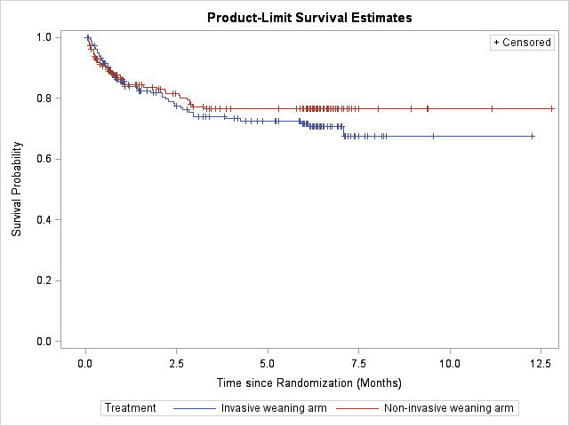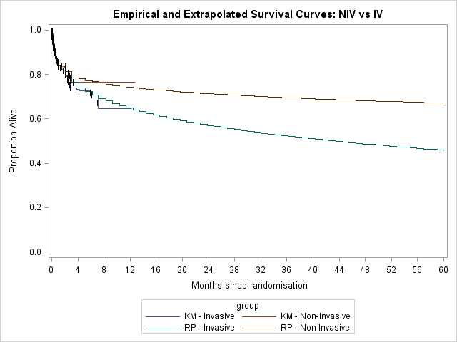RP: Royston Parmar 3 Knot; KM- Kaplan Meier; KM: Kaplan Meier; NIV: Non –invasive; IMV: invasive mechanical ventilation
NIV vs IMV
(a)
(b)
Log-rank p-value =0.366
Web Appendix - Figure 1: (a) Observed Kaplan Meir Survival; (b) Extrapolated and observed survival over 5 years

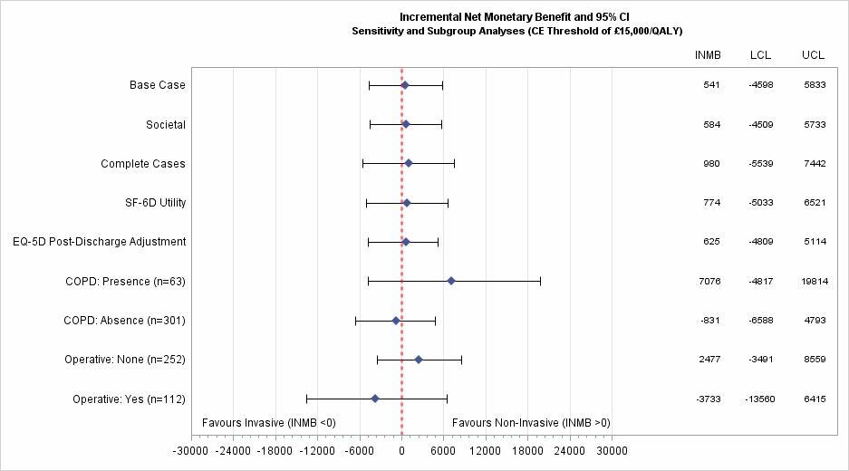
OPD: Chronic obstructive pulmonary disease; LCL: Lower 95% Confidence limit for the mean difference; UCL: Upper 95% Confidence limit for the mean difference; SF-6D: Short Form 6D instrument. Note: See also Table 2
Web Appendix Figure 2: Sensitivity Analyses and Subgroup Results (cost effectiveness of threshold of £15,000/QALY)

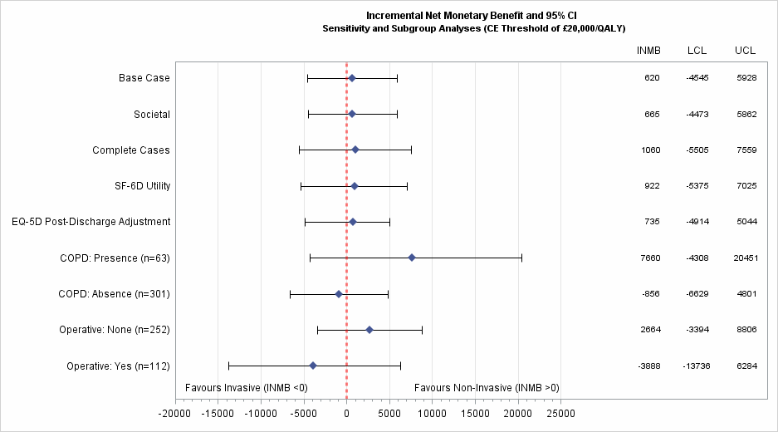
COPD: Chronic obstructive pulmonary disease; LCL: Lower 95% Confidence limit for the mean difference; UCL: Upper 95% Confidence limit for the mean difference; SF-6D: Short Form 6D instrument. Note: See also Table 2
Web Appendix Figure 3: Sensitivity Analyses and Subgroup Results (cost effectiveness of threshold of £20,000/QALY)
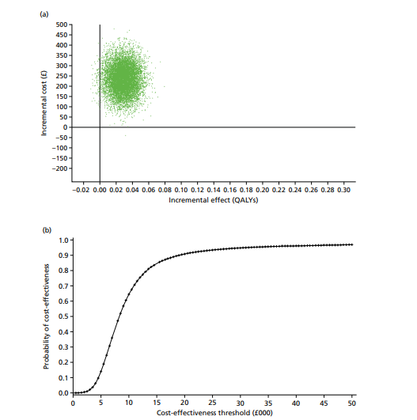
QALY: Quality Adjusted Life Years

Web Appendix Figure 4: CEAC and CE plane for long term effectiveness (base case assuming equal future costs and effects

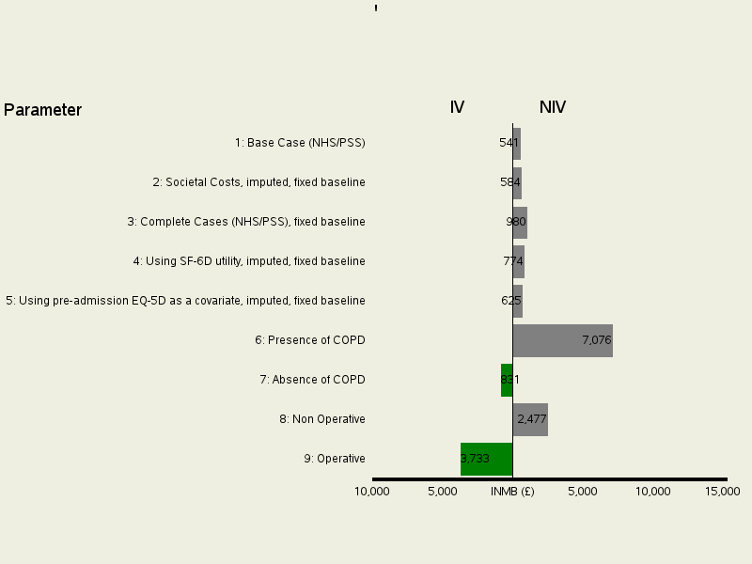
Cost-Effectiveness Threshold (£30,000)

(Change in INMB)
IMV NIV

¹Base Case - imputed attributable costs and QALYs (fixed baseline), adjusted for covariates (See Table 3)
²Imputed societal attributable costs and QALYs (fixed baseline), adjusted for covariates
³Complete cases (NHS/PSS) attributable costs and QALYs (fixed baseline), adjusted for covariates
⁴Imputed attributable costs and QALYs (fixed baseline using SF-6D utility score), covariates adjusted
⁵Imputed attributable costs and QALYs (fixed baseline), adjusted for covariates and pre-admission EQ-5D covariate
⁶Presence of COPD: Imputed attributable costs and QALYs (fixed baseline), covariates adjusted EQ-5D utility score
⁷COPD: Absence of COPD: Imputed attributable costs and QALYs (fixed baseline), covariates adjusted EQ-5D utility score
⁸Operative Status: Non-operative: Imputed attributable costs and QALYs (fixed baseline), covariates adjusted EQ-5D utility score
⁹Operative Status: Operative: Imputed attributable costs and QALYs (fixed baseline), covariates adjusted EQ-5D utility score
NIV: Non-Invasive Protocol Weaning; IMV: Invasive Mechanical Ventilation; INMB: Incremental Net Monetary Benefit; COPD: Chronic Obstructive Pulmonary Disease; NHS: National Health Service; PSS: Personal and Social Services; SF-6D: Short Form 6 health related quality of life instrument;

Web Appendix Figure 5: Tornado Plot of key parameters that impact INMB between baseline and 6 months post randomization (short-term cost-effectiveness)

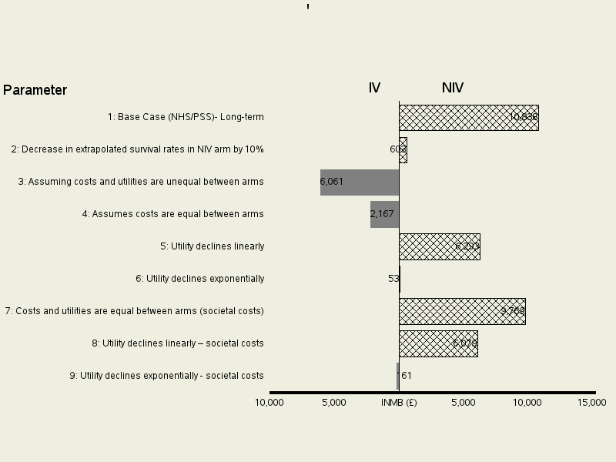
Cost-Effectiveness Threshold (£30,000)

(Change in INMB)
IMV NIV

¹No further future differential benefits or costs assumed between treatments (base case long-term cost-effectiveness)
²Survival rates on NIV are lower by 10%; costs assumed equal between arms, but utilities carried forward
³Future costs (after 6 months) assumed unequal between arms; utility and costs observed at 6 months in trial carried forward
⁴Assumes no differential costs, but utilities carried forward differ between arms (due to projected survival patterns)
⁵Utilities decline linearly over 5 years assuming an equal slope (for interventions) between 6 months and 5 years; costs after 6 months are carried forward.
⁶Utilities decline exponentially over 5 years between 6 months and 5 years; costs after 6 months are carried forward.
⁷No further future differential benefits or costs assumed between treatments – based on societal costs
⁸Utilities decline linearly over 5 years assuming an equal slope (for interventions) between 6 months and 5 years; costs after 6 months are carried forward – based on societal costs
⁹Utilities decline exponentially over 5 years between 6 months and 5 years; costs after 6 months are carried forward – based on societal costs
NIV: Non-Invasive Protocol Weaning; IMV: Invasive Mechanical Ventilation; INMB: Incremental Net Monetary Benefit; COPD: Chronic Obstructive Pulmonary Disease; NHS: National Health Service; PSS: Personal and Social Services; SF-6D: Short Form 6 health related quality of life instrument;

Web Appendix Figure 6 Tornado Plot of key parameters that impact long-term cost-effectiveness (INMB)

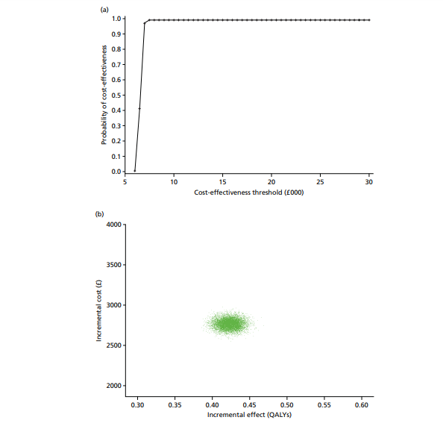
Web Appendix Figure 7: CEAC and CE plane for long term effectiveness (base case assuming equal future costs and effects)

Web Appendix Figure 8: Cost-effectiveness acceptability curves and cost-effectiveness plane for long-term effectiveness (sensitivity analyses assuming survival on NIV group is lower by 10%)
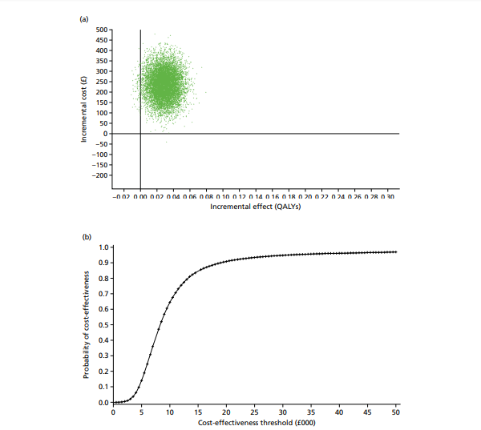
QALY: Quality Adjusted Life Years

a Inflated to 2015-16 prices using the NHS Hospital and Community Health Services Pay and Prices Index
These data were recollected using questionnaires administered at the point of discharge following initial hospitalisation.
Comparisons of EQ_5D-3L VAS and Utility score using Student’s t-test for unequal variances based on complete cases.
Note: some categories have missing values (not included in percentage computation); for VAS, n=92 and 91 for NIV and IMV respectively at 3 months; NIV: Non invasive protocol weaning; IMV: Invasive mechanical ventilation; ICU: Intensive care unit; SE: standard error of the mean; EQ-VAS: Visual Analogue Score from the EQ-5D

