Online Resource 1

eFigure 1. Overall Population Survival Extrapolations
a. Relapse-Free Survival
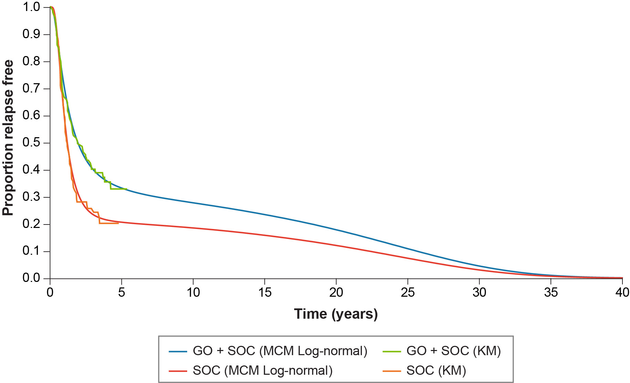
b. Overall Survival (Complete Remission or Incomplete Platelet Recovery)
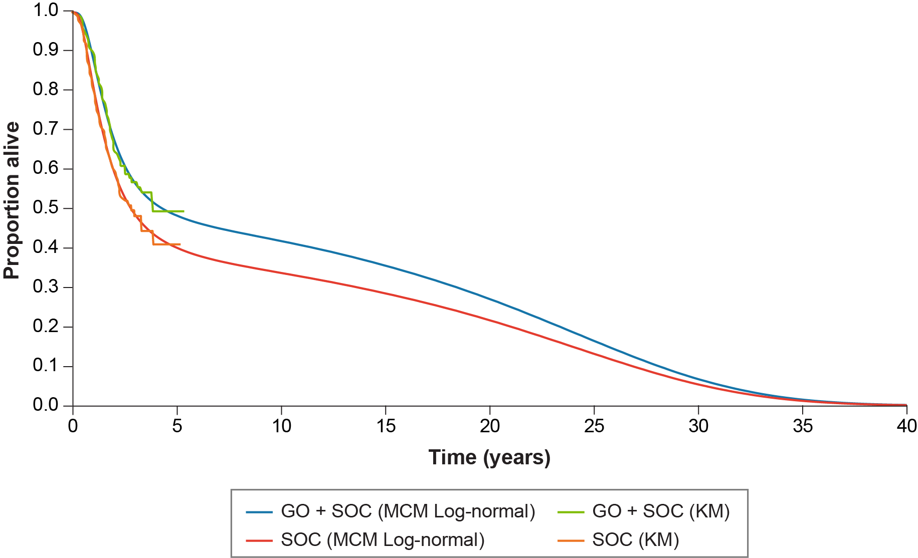
c. Overall Survival (Refractory)
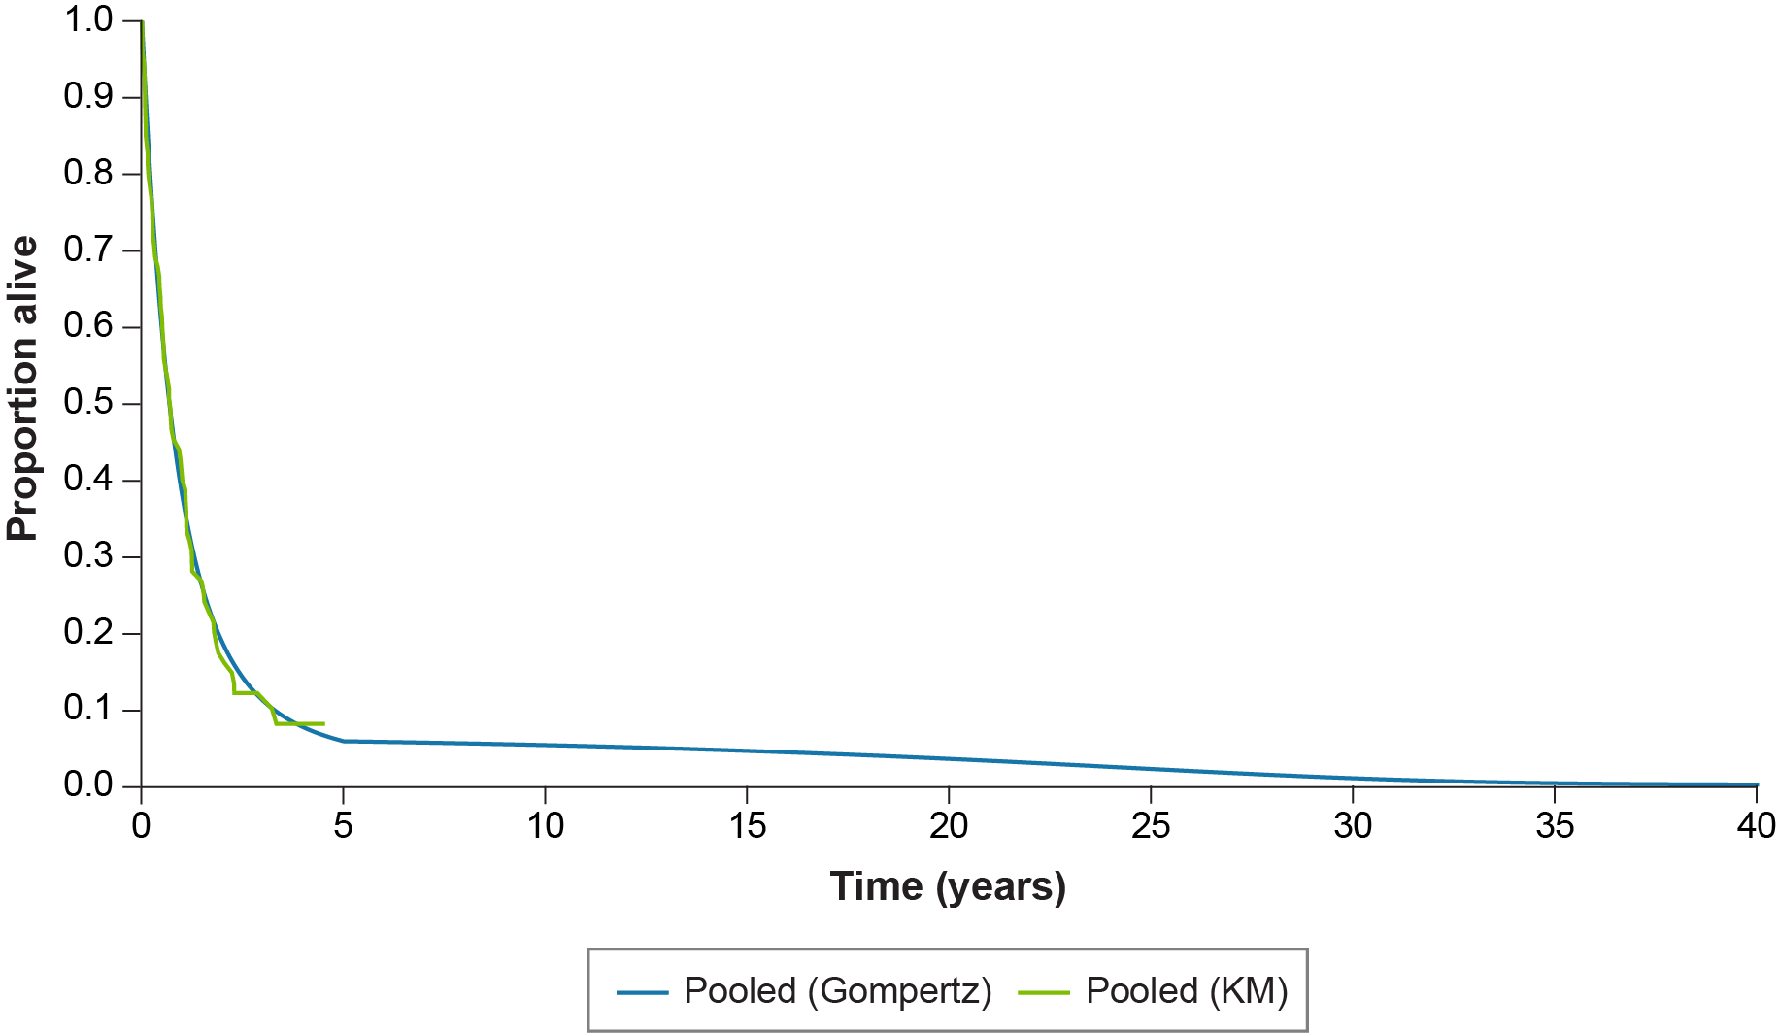
GO, gemtuzumab ozogamicin; KM, Kaplan-Meier; MCM, mixture cure models; OS, overall survival; RFS, relapse-free survival; SOC, standard of care.

eFigure 2. Tornado Diagram (ICER [£ per QALY])
a. Base-Case Population
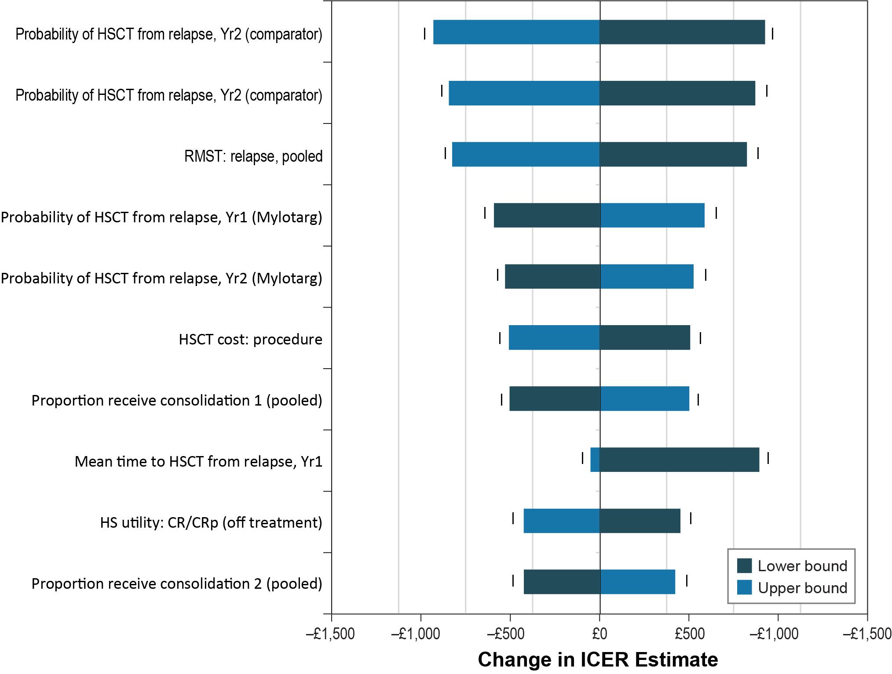
b. Overall Population

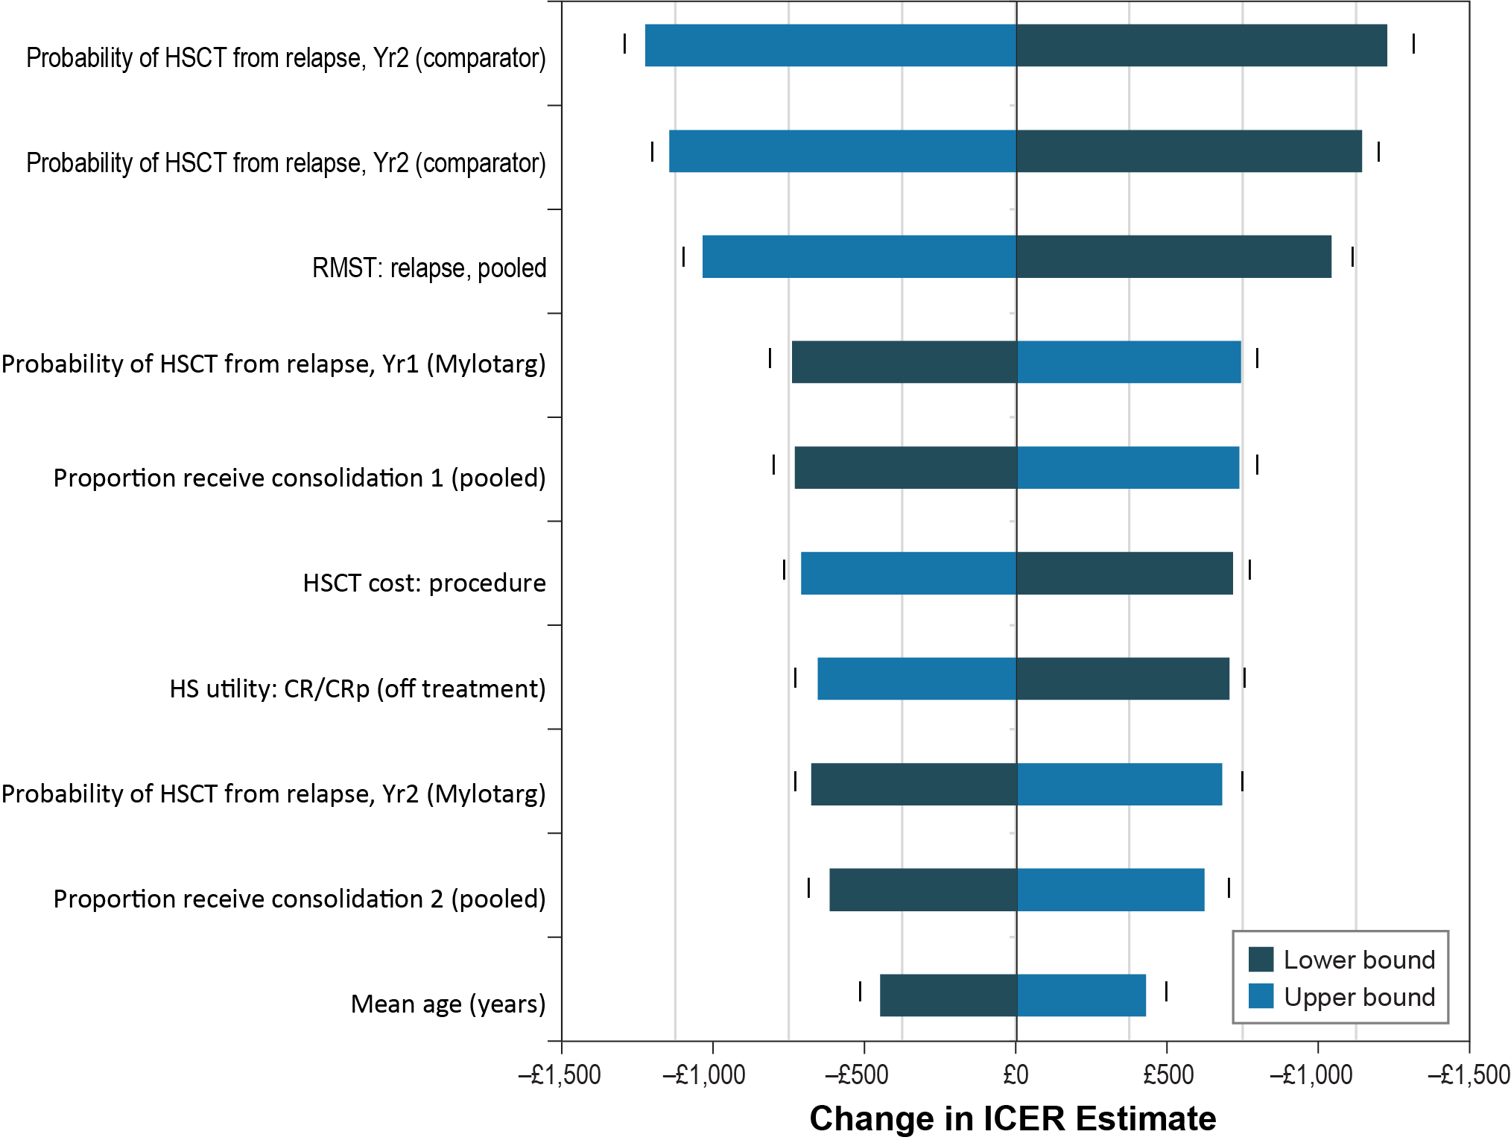

AE = adverse event; BSA = body surface area; CR = complete remission; CRp = CR with incomplete platelet recovery; GO = gemtuzumab ozogamicin; HS = health state; HSCT = haematopoietic stem-cell transplant; ICER = incremental cost-effectiveness ratio; QALY = quality-adjusted life-year; RMST = restricted mean survival time; RU = resource use; SOC = standard of care; Yr = year.
Note: The quadrant where the ICER falls is shown in the graph at the ends of each bar: I = quadrant 1 (GO + SOC is more expensive and more effective than the comparator); II = quadrant 2 (GO + SOC is more expensive and less effective than the comparator; GO + SOC is dominated); III = quadrant 3 (GO + SOC is less expensive and less effective than the comparator); IV = quadrant 4 (GO + SOC is less expensive and more effective than the comparator; GO + SOC is dominant)

eTable 1. Monthly Resource Use and Costs, by Health State
Resource Item | Frequency (Per Cycle)^{c} | Measurement of Uncertainty (Distribution)^{d} | Unit Costs | Source
Induction therapy: first induction
Inpatient attendances |  |  | Total: £18,528
Elective inpatient (days) | 28 | SE = 2.8 (normal) | £661.72 | DoH [1]; SA25G-Me
Outpatient attendances |  |  | Total: £233
Consultant haematologist, first | 1 | SE = 0.1 (normal) | £196.64 | DoH [1]; WF01B
Specialist nurse (20 minutes) | 1 | SE = 0.1 (normal) | £36.00 | PSSRU [2]; band 6
Disease monitoring |  |  | Total: £1,225
Bone marrow cytogenetics profile | 1 | SE = 5.3 (normal) | £16.88 | DoH [1]; DAPS01
Bone marrow aspirate & extraction | 2 | SE = 0.2 (normal) | £493.90 + £1.18 | DoH [1]; SA33Z & DAPS04
Full blood count & phlebotomy | 28 | SE = 2.8 (normal) | £3.37 + £3.10 | DoH [1]; DAPS08 & DAPS05
Biochemistry profile & phlebotomy | 8 | SE = 0.8 (normal) | £3.37 + £1.18 | DoH [1]; DAPS08 & DAPS04
Supportive therapies |  |  | Total: £1,971
Antifungals (days) | 21 | SE = 2.8 (normal) | £491.20 | BNF [3]
Antibiotics (days) | 21 | SE = 2.8 (normal) | £1.62-£4.61 | BNF [3]
Induction therapy: second induction
Inpatient attendances |  |  | Total: £12,573
Elective inpatient (days) | 19 | SE = 1.9 (normal) | £661.72 | DoH [1]; SA25G-Me
Outpatient attendances |  |  | Total: £199
Consultant haematologist, follow-up | 1 | SE = 0.1 (normal) | £162.84 | DoH [1]; WF01A
Specialist nurse (20 minutes) | 1 | SE = 0.1 (normal) | £36.00 | PSSRU [2]; band 6
Disease monitoring |  |  | Total: £1,208
Bone marrow aspirate & extraction | 2 | SE = 0.2 (normal) | £493.90 + £1.18 | DoH [1]; SA33Z & DAPS04
Full blood count & phlebotomy | 28 | SE = 2.8 (normal) | £3.37 + £3.10 | DoH [1]; DAPS08 & DAPS05
Biochemistry profile & phlebotomy | 8 | SE = 0.8 (normal) | £3.37 + £1.18 | DoH [2]; DAPS08 & DAPS04
Supportive therapies |  |  | Total: £1,971
Antifungals (days) | 21 | SE = 2.8 (normal) | £491.20 | BNF [3]
Antibiotics (days) | 21 | SE = 2.8 (normal) | £1.62-£4.61 | BNF [3]
CR or CRp: first consolidation
Inpatient attendances |  |  | Total: £3,573
Elective inpatient (days) | 5.4 | SE = 0.54 (normal) | £661.72 | DoH [1]; SA25G-Me
Outpatient attendances |  |  | Total: £199
Consultant haematologist, follow-up | 1 | SE = 0.1 (normal) | £162.84 | DoH [1]; WF01A
Specialist nurse (20 minutes) | 1 | SE = 0.1 (normal) | £36.00 | PSSRU [3]; band 6
Disease monitoring |  |  | Total: £495
Bone marrow aspirate & extraction | 1 | SE = 0.1 (normal) | £493.90 + £1.18 | DoH [1]; SA33Z & DAPS04
Biochemistry profile & phlebotomy | 1 | SE = 0.1 (normal) | £3.37 + £1.18 | DoH [1]; DAPS08 & DAPS04
Supportive therapies |  |  | Total: £1,971
Antifungals (days) | 21 | SE = 2.8 (normal) | £491.20 | BNF [3]
Antibiotics (days) | 21 | SE = 2.8 (normal) | £1.62-£4.61 | BNF [3]
CR or CRp: second consolidation
Inpatient attendances |  |  | Total: £3,573
Elective inpatient (days) | 5.4 | SE = 0.54 (normal) | £661.72 | DoH [1]; SA25G-Me
Outpatient attendances |  |  | Total: £199
Consultant haematologist, follow-up | 1 | SE = 0.1 (normal) | £162.84 | DoH [1]; WF01A
Specialist nurse (20 minutes) | 1 | SE = 0.1 (normal) | £36.00 | PSSRU [2]; band 6
Disease monitoring |  |  | Total: £500
Bone marrow aspirate & extraction | 1 | SE = 0.1 (normal) | £493.90 + £1.18 | DoH [1]; SA33Z & DAPS04
Biochemistry profile & phlebotomy | 1 | SE = 0.1 (normal) | £3.37 + £1.18 | DoH [1]; DAPS08 & DAPS04
Supportive therapies |  |  | Total: £1,971
Antifungals (days) | 21 | SE = 2.8 (normal) | £491.20 | BNF [3]
Antibiotics (days) | 21 | SE = 2.8 (normal) | £1.62-£4.61 | BNF [3]
CR or CRp: off treatment
Outpatient attendances |  |  | Total: £99
Consultant haematologist, follow-up | 0.5 | SE = 0.05 (normal) | £162.84 | DoH [1]; WF01A
Specialist nurse (20 minutes) | 0.5 | SE = 0.05 (normal) | £36.00 | PSSRU [2]; band 6
Relapse or refractory: salvage therapy
Inpatient attendances |  |  | Total: £16,543
Elective inpatient (days) | 25 | SE = 2.5 (normal) | £661.72 | DoH [1]; SA25G-Me
Outpatient attendances |  |  | Total: £199
Consultant haematologist, follow-up | 1 | SE = 0.1 (normal) | £162.84 | DoH [1]; WF01A
Specialist nurse (20 minutes) | 1 | SE = 0.1 (normal) | £36.00 | PSSRU [2]; band 6
Disease monitoring |  |  | Total: £1,185
Bone marrow aspirate & extraction | 2 | SE = 0.2 (normal) | £493.90 + £1.18 | DoH [1]; SA33Z & DAPS04
Full blood count & phlebotomy | 28 | SE = 2.8 (normal) | £3.37 + £3.10 | DoH [1]; DAPS08 & DAPS05
Biochemistry profile & phlebotomy | 3 | SE = 0.3 (normal) | £3.37 + £1.18 | DoH [1]; DAPS08 & DAPS04
Supportive therapies |  |  | Total: £1,971
Antifungals (days) | 21 | SE = 2.8 (normal) | £491.20 | BNF [3]
Antibiotics (days) | 21 | SE = 2.8 (normal) | £1.62-£4.61 | BNF [3]
Relapse or refractory: non-curative therapy
Drug administrationª |  |  | Total: £1,484
Subsequent infusion (outpatient) | 7 | Fixed | £211.99 | DoH [1]; SB15Z
Inpatient attendances |  |  | Total: £9,264
Elective inpatient (days) | 14^{b} | SE = 1.0 (normal) | £661.72 | DoH [1]; SA25G-Me
Outpatient attendances |  |  | Total: £597
Consultant haematologist, follow-up | 3 | SE = 0.3 (normal) | £162.84 | DoH [1]; WF01A
Specialist nurse (20 minutes) | 3 | SE = 0.3 (normal) | £36.00 | PSSRU [2]; band 6
Disease monitoring |  |  | Total: £1,051
Bone marrow aspirate & extraction | 2 | SE = 0.2 (normal) | £493.90 + £1.18 | DoH [1]; SA33Z & DAPS04
Full blood count & phlebotomy | 8 | SE = 0.8 (normal) | £3.37 + £3.10 | DoH [1]; DAPS08 & DAPS05
Biochemistry profile & phlebotomy | 2 | SE = 0.2 (normal) | £3.37 + £1.18 | DoH [1]; DAPS08 & DAPS04
Supportive therapies |  |  | Total: £1,971
Antifungals (days) | 21 | SE = 2.8 (normal) | £491.20 | BNF [3]
Antibiotics (days) | 21 | SE = 2.8 (normal) | £1.62-£4.61 | BNF [3]
BNF = British National Formulary; CR = complete remission; CRp = CR with incomplete platelet recovery; DoH = Department of Health; PSSRU = Personal Social Services Research; SE = standard error.
ª Administration cost applied for azacitidine only.
^{b} This estimate is based on clinical opinion that for these patients it is reasonable to expect two significant week-long inpatient admissions due to severe infection for the remainder of the patients’ lifespan.
^{c} Based on clinical opinion.
^{d} Uncertainty information was not available; SE was estimated as 10% of the mean value.
^{e} Weighted-average cost calculated.

References
- Department of Health (DoH). NHS reference costs 2015 to 2016. December 2016. https://www.gov.uk/government/publications/nhs-reference-costs-2015-to-2016. Accessed 20 July 2017.
- Curtis L, Burns A. Personal Social Services Research Unit (PSSRU). Unit Costs of Health and Social Care 2016. http://www.pssru.ac.uk/project-pages/unit-costs/2016/. Accessed 20 July 2017.
- British National Formulary (BNF) Online. February, 2017. Available at: https://www.medicinescomplete.com/mc/bnf/current/. Accessed 2 March, 2017.

