Supplementary material file
Journal: Pharmacoeconomics-Open
Title: Cost analysis of adjuvant whole brain radiotherapy treatment versus no whole brain radiotherapy after stereotactic radiosurgery and/or surgery among adults with one to three melanoma brain metastases: results from a randomized trial
Authors:
Anh D Tran, PhD^{1,2} orcid: 0000-0001-8677-4637; Angela M Hong MBBS, MMed, PhD, FRANZCR^{3,4} orcid: 0000-0003-3668-243X; Mai T H Nguyen, MSc²; Gerald Fogarty, BSc, MBBS, PhD, FRANZCR⁵; Victoria Steel, BSc⁶, Elizabeth Paton⁶; Rachael L Morton, MSc(Clin Epi)(Hons), PhD^{2,3} orcid: 0000-0001-7834-0572
Affiliations:
¹National Drug and Alcohol Research Centre, UNSW, Sydney, Australia
²NHMRC Clinical Trials Centre, Faculty of Medicine and Health, The University of Sydney, Australia
³Melanoma Institute of Australia, The University of Sydney, Australia
⁴Sydney Medical School, The University of Sydney, Sydney, New South Wales, Australia
⁵Genesis Cancer Care, St Vincent’s Clinic, Darlinghurst, Australia
⁶Melanoma and Skin Cancer Trials, Monash University, Australia
Corresponding author:
Dr Anh Dam Tran
National Drug and Alcohol Research Centre
Email: anh.tran@unsw.edu.au
Funding: This work was funded by a Cancer Australia, Priority-driven Collaborative Cancer Research Scheme, Project #1046923; and an NHMRC Centre of Research Excellence in Melanoma #1135285; Rachael L. Morton is supported by an NHMRC Investigator grant #1194703 and University of Sydney, Robinson Fellowship.
Conflicts of interest statements: Nothing to declare
Table S1. Comparison of characteristics between costing sub-study and whole trial
 | Adjuvant WBRT sub-study(n=43) | Adjuvant WBRT whole trial | p value |  | SRS/surgery sub-study (n=46) | SRS/Surgery whole trial | p value
Characteristics | n (%) | n (%) |  |  | n (%) | n (%)
Sex |  |  | 0.53 |  |  |  | 0.80
Males | 26 (60) | 66 (66) |  |  | 30 (65) | 72 (67)
Females | 17 (40) | 34 (34) |  |  | 16 (35) | 35 (33)
Age, years |  |  | 0.52 |  |  |  | 0.43
Mean (SD) | 62 (13) | 63 (12) |  |  | 62 (11) | 64 (12)
ECOG Performance Status |  |  | 0.05 |  |  |  | 0.51
0 | 30 (73) | 53 (53) |  |  | 28 (68) | 62 (58)
1 | 11 (27) | 41 (41) |  |  | 12 (29) | 42 (39)
2 | 0 (0) | 6 (6) |  |  | 1 (2) | 3 (3)
Breslow thickness of the primary lesion (mm) |  |  | 0.13 |  |  |  | 0.002
<1 | 19 (45) | 15 (23) |  |  | 22 (51) | 15 (19)
1.01-2 | 8 (19) | 18 (28) |  |  | 9 (21) | 26 (33)
2.01-4 | 8 (19) | 16 (25) |  |  | 5 (12) | 21 (26)
>4 | 7 (17) | 15 (23) |  |  | 7 (16) | 18 (23)
Number of brain metastases |  |  | 0.78 |  |  |  | 0.31
1 | 22 (56) | 59 (59) |  |  | 31 (70) | 66 (62)
2-3 | 17 (44) | 41 (41) |  |  | 13 (30) | 41 (38)
Presence of extracranial disease at baseline |  |  | 0.50 |  |  |  | 0.92
Yes | 25 (61) | 67 (67) |  |  | 30 (68) | 72 (67)
No | 16 (39) | 33 (33) |  |  | 14 (32) | 35 (33)

Table S2. Mean 2 monthly unadjusted treatment costs over 12-month follow-up
WBRT and SRS/Surgery group (AU$ 2018)

 | WBRT |  |  | SRS/Surgery
Month visits | n | Mean* | SD | n | Mean | SD
Month 02 | 43 | 22,679 | 12,359 | 46 | 19,384 | 8,692
Month 04 | 34 | 17,754 | 10,007 | 38 | 17,898 | 10,949
Month 06 | 27 | 18,611 | 11,005 | 30 | 20,733 | 12,367
Month 08 | 22 | 19,176 | 8,958 | 22 | 16,163 | 8,081
Month 10 | 17 | 18,559 | 12,256 | 19 | 17,960 | 11,980
Month 12 | 12 | 20,019 | 13,009 | 17 | 18,964 | 12,020
Average 2- monthly cost |  | $19,466 | 10,033 |  | $18,517 | 11,258

*Mean costs rounded to nearest dollar. Abbreviation: SD: Standard deviation

Figure S1: Two monthly costs in WBRT and SRS/Surgery groups

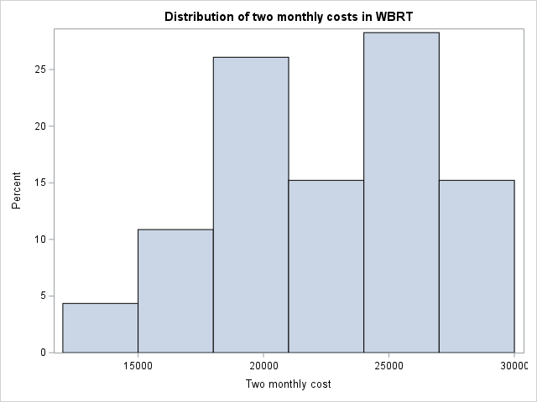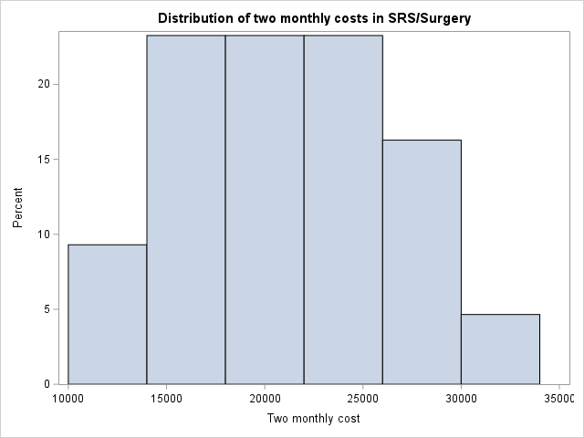
Table S3: Two monthly cost comparison between WBRT and SRS/Surgery groups 12 months follow up- GLM method

Parameter | Coefficient | SE | 95% CL |  | Pr > |Z|
Intercept | 9.927 | 0.272 | 8.221 | 10.123 | <.0001
Month 02 | 0.158 | 0.267 | -0.284 | 0.334 | 0.744
Month 04 | -0.277 | 0.154 | -0.856 | 0.124 | 0.229
Month 06 | -0.324 | 0.289 | -0.722 | 0.321 | 0.511
Month 08 | -0.354 | 0.212 | -1.231 | 0.112 | 0.282
Month 10 | -0.844 | 0.117 | -1.228 | -0.211 | 0.388
Month 12 | 0 | 0 | 0 | 0
WBRT | -0.282 | 0.175 | -0.411 | 0.309 | 0.788
SRS/Surgery | 0 | 0 | 0 | 0

Abbreviation: GLM, Generalised linear model; SE, Standard error; CL, confidence limits

Table S4: Difference in 2 monthly costs between WBRT and SRS/Surgery –
Modified Park test

 | Coefficient | SE | P>z | 95% CL
Total cost | 2.189 | 0.128 | 0 | 2.045 | 2.309
Constant | -0.622 | 0.238 | 0 | -1.221 | -0.750

Coefficient is 2, so gamma distribution was chosen

Total cost | Coefficient | SE | P>z | 95% CL
WBRT | -0.100 | 0.130 | 0.337 | -0.348 | 0.147
Constant | 7.680 | 0.279 | 0 | 6.428 | 8.524

Abbreviation: SE, Standard error; CL, Confidence Limit
Table S5: Difference in 2 monthly costs between WBRT and SRS/Surgery –
Ordinary least squares model

Total cost | Coefficient | SE | P>z | 95% CL
Total cost | 1.57E-04 | 4.97E-06 | 0.000 | 1.47E-04 | 1.67E-04
WBRT | 0.022 | 0.058 | 0.574 | -0.091 | 0.135
Constant | 6.787 | 0.097 | 0.000 | 6.597 | 6.978

Abbreviation: OLS, Ordinary least squares; SE, Standard error; CL, Confidence Limits

Table S6: Difference in 2 monthly costs between WBRT and SRS/Surgery
- Non parametric bootstrapping method

Mean difference | -$1,174.03
Standard error | $1,237.27
Lower 95% limit | -$3,236.21
Upper 95% limit | $4,452.11
t value | -0.219
p value | 0.655

Table S7. Healthcare resource use every two months for adjuvant WBRT and SRS/surgery alone
 | Outpatient visits |  |  | Procedure |  | Medicine |  | Hospitalization
 | WBRT | SRS/Surgery | WBRT |  | SRS/Surgery | WBRT | SRS/Surgery | WBRT | SRS/Surgery
Month 2 | 3.75 (1.13) | 4.73 (1.2) | 2.93 (0.54) |  | 2.2 (0.43) | 5.64 (2.15) | 6.23 (2.6) | 2.22 (1.54) | 3.67 (1.78)
Month 4 | 1.42 (0.98) | 2.27 (0.76) | 3.11 (1.22) |  | 1.05 (0.69) | 3.12 (1.67) | 3.69 (1.49) | 2.25 (1.04) | 3.23 (1.67)
Month 6 | 5.51 (1.34) | 3.8 (1.34) | 2.02 (0.56) |  | 2.55 (0.14) | 5.46 (2.78) | 5.26 (2.05) | 3.1 (1.59) | 2.37 (0.79)
Month 8 | 3.6 (0.96) | 6.93 (2.11) | 2.88 (0.32) |  | 3.8 (1.4) | 3.57 (1.73) | 3.88 (1.6) | 2.06 (0.97) | 2.88 (0.69)
Month 10 | 4.14 (1.34) | 1.69 (0.43) | 1.35 (0.41) |  | 2.76 (0.56) | 2.56 (1.77) | 2.28 (1.53) | 2.12 (0.56) | 2.5 (0.72)
Month 12 | 5.97 (1.22) | 4.37 (1.44) | 3.77 (1.34) |  | 3.22 (1.66) | 6.74 (2.7) | 6.03 (2.95) | 2.11 (0.42) | 3.71 (1.56)
Outpatient visits included: Medical and radiation oncologist, General practitioner, Physiotherapist, Dietician, Social worker , and Psychologist . Procedures included: Surgery, Day surgery, Stereotactic radiosurgery, Histopathology, Radiotherapy, MRI, CT, PET, Ultrasound and X-ray imaging, and blood tests. Medicines included prescribed and over counter medicines. Abbreviations: SD, standard deviation; MRI, magnetic resonance imaging; PET, positron-emission tomography; CT, Computed tomography; SRS, Stereotactic radiosurgery

Appendix S8. Follow – up cost questionnaire used in the trial