Cost-effectiveness of nintedanib for patients with progressive fibrosing interstitial lung disease (PF-ILD)
Journal: Pharmacoeconomics Open
Authors: Lotte Westerink, Jelmer LJ Nicolai, Maarten J Postma, Job FM van Boven, Cornelis Boersma
Corresponding author: Lotte Westerink^{1,2}, lotte.westerink@ascacademics.com
ORCID: 0000-0001-9515-1044
- Department of Health Sciences, University of Groningen, University
Medical Center Groningen, Groningen, The Netherlands
- Asc Academics Inc., New York, United States of America.

Funding: This study was funded by Boehringer Ingelheim.
Conflicts of interest: CB received grants and honoraria from various pharmaceutical companies, including other companies interested in the subject of this paper.
JB received consultancy fees, honorarium and research funding from AstraZeneca, Boehringer Ingelheim, Chiesi, GSK, Menarini, Novartis, Pfizer, Teva and Trudell Medical to consult, give lectures, provide advice and conduct independent research, all paid to his institution.
MJP received grants and honoraria from various pharmaceutical companies, including other companies interested in the subject of this paper. LW is an employee of Asc Academics. JLJN is an employee of Boehringer Ingelheim.

- Supplementary Material -

Appendix A
Consolidated Health Economic Evaluation Reporting Standards (CHEERS) Checklist
Section/item | Item No | Recommendation | Reported on  page No/ line No
Title and abstract
Title | 1 | Identify the study as an economic evaluation or use more specific terms such as “cost-effectiveness analysis”, and describe the interventions compared. | Page 1, lines 1&2
Abstract | 2 | Provide a structured summary of objectives, perspective, setting, methods (including study design and inputs), results (including base case and uncertainty analyses), and conclusions. | Page 3, lines 1-22
Introduction
Background and objectives | 3 | Provide an explicit statement of the broader context for the study. | Page 5, lines 1-30
Background and objectives | 3 | Present the study question and its relevance for health policy or practice decisions. | Page 5, 19-30
Methods
Target population and subgroups | 4 | Describe characteristics of the base case population and subgroups analysed, including why they were chosen. | Page 6, lines 10-12
Setting and location | 5 | State relevant aspects of the system(s) in which the decision(s) need(s) to be made. | Page 7, lines 21-30  Page 8, Lines 1,2
Study perspective | 6 | Describe the perspective of the study and relate this to the costs being evaluated. | Page 7, lines 21-30  Page 8, Lines 1,2
Comparators | 7 | Describe the interventions or strategies being compared and state why they were chosen. | Page 6, line 5-7  Page 7, line 27,28
Time horizon | 8 | State the time horizon(s) over which costs and consequences are being evaluated and say why appropriate. | Page 6. Line 7  Page 7, lines 29-30  Page 12, lines 1-5
Discount rate | 9 | Report the choice of discount rate(s) used for costs and outcomes and say why appropriate. | Page 7, lines 28-30
Choice of health outcomes | 10 | Describe what outcomes were used as the measure(s) of benefit in the evaluation and their relevance for the type of analysis performed. | Page 7, lines 20-30  Page 8, lines 1-2
Measurement of effectiveness | 11a | Single study-based estimates: Describe fully the design features of the single effectiveness study and why the single study was a sufficient source of clinical effectiveness data. | Not applicable
Measurement of effectiveness | 11b | Synthesis-based estimates: Describe fully the methods used for identification of included studies and synthesis of clinical effectiveness data. | Not applicable
Measurement and valuation of preference based outcomes | 12 | If applicable, describe the population and methods used to elicit preferences for outcomes. | Not applicable
Estimating resources and costs | 13a | Single study-based economic evaluation: Describe approaches used to estimate resource use associated with the alternative interventions. Describe primary or secondary research methods for valuing each resource item in terms of its unit cost. Describe any adjustments made to approximate to opportunity costs. | Not applicable
Estimating resources and costs | 13b | Model-based economic evaluation: Describe approaches and data sources used to estimate resource use associated with model health states. Describe primary or secondary research methods for valuing each resource item in terms of its unit cost. Describe any adjustments made to approximate to opportunity costs. | Page 7, lines 7-18  Page 8, lines 14-30  Page 9, lines 1-2
Currency, price date, and conversion | 14 | Report the dates of the estimated resource quantities and unit costs. Describe methods for adjusting estimated unit costs to the year of reported costs if necessary. Describe methods for converting costs into a common currency base and the exchange rate. | Page 8, line 14-30
Choice of model | 15 | Describe and give reasons for the specific type of decision-analytical model used. Providing a figure to show model structure is strongly recommended. | Page 6, lines 9-22
Assumptions | 16 | Describe all structural or other assumptions underpinning the decision-analytical model. | Appendix C, Tables C1&C2
Analytical methods | 17 | Describe all analytical methods supporting the evaluation. This could include methods for dealing with skewed, missing, or censored data; extrapolation methods; methods for pooling data; approaches to validate or make adjustments (such as half cycle corrections) to a model; and methods for handling population heterogeneity and uncertainty. | Page 6, 24-29  Page 7, lines 1-18  Page 8, lines 5-12
Results
Study parameters | 18 | Report the values, ranges, references, and, if used, probability distributions for all parameters. Report reasons or sources for distributions used to represent uncertainty where appropriate. Providing a table to show the input values is strongly recommended. | Page 10, lines 5-13  Appendix B
Incremental costs and outcomes | 19 | For each intervention, report mean values for the main categories of estimated costs and outcomes of interest, as well as mean differences between the comparator groups. If applicable, report incremental cost-effectiveness ratios. | Page 10, lines 5-29
Characterising uncertainty | 20a | Single study-based economic evaluation: Describe the effects of sampling uncertainty for the estimated incremental cost and incremental effectiveness parameters, together with the impact of methodological assumptions (such as discount rate, study perspective). | Not applicable
Characterising uncertainty | 20b | Model-based economic evaluation: Describe the effects on the results of uncertainty for all input parameters, and uncertainty related to the structure of the model and assumptions. | Page 11, lines 1-28
Characterising heterogeneity | 21 | If applicable, report differences in costs, outcomes, or cost-effectiveness that can be explained by variations between subgroups of patients with different baseline characteristics or other observed variability in effects that are not reducible by more information. | Not applicable
Discussion
Study findings, limitations, generalisability, and current knowledge | 22 | Summarise key study findings and describe how they support the conclusions reached. Discuss limitations and the generalisability of the findings and how the findings fit with current knowledge. | Page 12, lines 1-30  Page 13, lines 1-30  Page 14, lines 1-30  Page 15, lines 1-2
Other
Source of funding | 23 | Describe how the study was funded and the role of the funder in the identification, design, conduct, and reporting of the analysis. Describe other non-monetary sources of support. | Titlepage
Conflicts of interest | 24 | Describe any potential for conflict of interest of study contributors in accordance with journal policy. In the absence of a journal policy, we recommend authors comply with International Committee of Medical Journal Editors recommendations. | Titlepage

Appendix B – Regression analysis
An individual simulation model with discrete time intervals was analysed to describe decline in lung function and incidence of first acute exacerbations over a lifetime horizon. In table B1 an overview is presented of the input for the model transitions Disease progression, Acute Exacerbation, Lung transplant, and Mortality.
Parametric modelling was performed to determine the transition probabilities for the cost-effectiveness model for overall survival, acute exacerbations, and treatment discontinuation. Goodness of fit was assessed for all model transitions and for the safety and tolerability of nintedanib, with six regression models: exponential, Gompertz, generalised gamma, log-normal, log-logistic, and Weibull. These standard parametric models were fit using the “flexsurv” package in R (data analysis and statistics software).
The curve selection process was based on visual inspection, the statistical goodness of fit and the clinical plausibility. The goodness of fit was assessed using the Akaike information criterion (AIC) and Bayesian information criterion (BIC) values as the statistical criteria. In general, the smallest AIC/BIC values represent the best-fit parametric model when comparing across parametric models. The magnitude of the absolute AIC/BIC values are not meaningful in themselves as they depend on the set of data. However, relative differences are meaningful; parametric models are seen as suitable candidates for inclusion in the economic model if they are within three points of the parametric model with the lowest AIC or BIC.
The results of the parametric modelling were compared with evidence from the literature for idiopathic pulmonary fibrosis (IPF) (visual inspection) when possible. A combined IPF trial dataset including INPULSIS-ON, the long-term follow-up to the INPULSIS IPF trials, provided just over eight years of data for patients on nintedanib.
Ultimately, the next three criteria supported choosing the parametric model for the economic analysis:
- The AIC/BIC values (smallest value preferred)
- Consistency with the IPF literature, especially when considering validity of long-term extrapolations (for OS only)
- Ease of understanding and computational efficiency.

The exponential model was chosen based on the best fit with the smallest AIC and BIC values for both the TTFAE and the TTD. See Tables B2 and B3 the TTFAE and Figure B1 shows the comparison of the fit of the exponential parametric models for exacerbations to the Kaplan-Meier curves from the clinical trial for TTFAE. See Table B4 for the TTD and Figure B2 presents the comparison of the fit of the exponential parametric model for discontinuation to the Kaplan Meyer curve from the clinical trial for time to treatment discontinuation.

Regression equation to predict patient FVC%pred
A regression equation to predict patient FVC%pred was derived based on post-hoc analysis of INBUILD trial data. The parameters included in the lung function decline model were selected using backwards stepwise regression. The final model included treatment, risk factors (HRCT pattern, baseline FVC%pred, age, sex, race, criteria for progressive ILD, time since diagnosis, underlying ILD diagnosis) and a time- dependent predictor (ongoing acute ILD exacerbation) as fixed effects (FE). Ongoing acute ILD exacerbations were not found to be significant in the backwards stepwise regression, likely due to the small number of events that occurred in the INBUILD trial. However, acute exacerbations were thought to be strongly linked to lung function decline and so this variable was included in the model. The model also included interaction effects between time and fixed factors if they were found to be significant in the backwards stepwise regression. An unstructured correlation matrix was used, and all statistical analyses included a random intercept and slope; however, the random effects (RE) were only included in the utility regression analysis in the cost-effectiveness model.
Progression was defined as the date when ≥10% of absolute decline in FVC%pred compared to baseline occurred for the first time. In the model, this was represented by a binary variable that indicated whether a patient has progressed in a certain cycle. If a patient was marked as progressed in a cycle, they would be marked as such in subsequent cycles as well.
Coefficients from the linear mixed-effects model obtained after backwards stepwise selection are shown for placebo and nintedanib in Table B2 and Table B3 respectively.

Overall Survival
Due to unclear best-fitting model outcomes in terms of AIC and BIC values for the standard parametric models of mean overall survival (see Table 4 in the Appendix), a Bayesian survival analysis was conducted in OpenBUGS 3.2.3 (using a chain length of 100,000-150,000 iterations and a burn-in of 30,000-50,000, dependant on chain convergence and memory capacity). The Bayesian survival analysis was conducted to address the uncertainty in long-term PF-ILD extrapolations based on the long-term IPF data. The IPF data used in the Bayesian analysis consisted of the following trials: TOMORROW (NCT00514683), an open-label extension (NCT01170065), INPULSIS (NCT01335464 and NCT01335477), INPULSIS-ON (NCT01619085), a phase IIIb trial (NCT01979952), collectively defined as the “Lancaster 2019” dataset. A Weibull survival model was fit to the IPF data using a vague prior (i.e. a prior that does not impart any understanding of the data). The results of this analysis were then used to inform the shape parameter of the subsequent Bayesian survival model fit to the PF-ILD data. The final output of the PF-ILD Bayesian analysis is influenced by both the IPF prior and the evidence from the INBUILD trial.
The Bayesian Weibull model was considered the best parametric distribution for overall survival based on comparability with clinical trials and observational studies with IPF. Figures B3 and B4 present an overview of the parametric extrapolation results for the placebo arm and the nintedanib arm for the overall survival, respectively. Tables B6–B9 summarise the coefficients and variance-covariance matrices for overall survival for both arms. (1–5)

Table B1: Overview of model transitions and inputs
Transition | Input | Source
Disease progression by loss of lung function | Regression analysis of time to progression of FVC%pred (progression defined as a 10%-point decline from baseline) | [6]
Acute exacerbation | Survival analysis of time-to-first acute ILD exacerbation | [6]
Treatment discontinuation | Survival analysis of time-to-discontinuation | [6]
Lung transplant | Patients are allowed to undergo lung transplant if they progressed and were under the age of 65 years old. | [7]
Mortality | Survival analysis of time to death  Conditional to progression to FVC%pred ≤ 40% | [6]

Table B2: Independent placebo model - Linear mixed-effects estimates (FVC%pred – first 52 weeks)
Term | Estimate | SE | Statistic  (t-test) | DF | P-value
(Intercept) | 1.979 | 1.654 | 1.196 | 321.761 | 0.232
fvc_base | 0.976 | 0.014 | 68.700 | 324.781 | 0.000
AGE | -0.015 | 0.021 | -0.698 | 323.888 | 0.486
PGGR1_marginal | 0.333 | 0.507 | 0.656 | 330.044 | 0.513
PGGR1_worsening | -0.032 | 0.595 | -0.053 | 325.752 | 0.958
acute_ild_exacerbation1 | -6.946 | 1.424 | -4.878 | 1779.340 | 0.000
AGE:analysis_year | -0.102 | 0.008 | -12.401 | 264.101 | 0.000
PGGR1_marginal:analysis_year | 2.148 | 0.922 | 2.329 | 265.155 | 0.021
PGGR1_worsening:analysis_year | 2.421 | 1.063 | 2.277 | 256.464 | 0.024
Abbreviations: BL: Baseline; DF: degrees of freedom; FVC%pred: forced vital capacity percent predicted; ILD: interstitial lung disease; PGGR1: grouped criteria for progressive interstitial lung disease; SE: Standard error

Table B3: Independent nintedanib model - Linear mixed-effects estimates (FVC%pred – first 52 weeks)
Term | Estimate | SE | Statistic  (t-test) | DF | P-value
(Intercept) | -0.179 | 1.574 | -0.114 | 323.889 | 0.909
fvc_base | 0.993 | 0.013 | 75.147 | 324.217 | 0.000
AGE | 0.007 | 0.022 | 0.340 | 325.216 | 0.734
acute_ild_exacerbation1 | -4.028 | 1.535 | -2.625 | 1822.064 | 0.009
AGE:analysis_year | -0.038 | 0.007 | -5.338 | 285.131 | 0.000
Abbreviations: BL: Baseline; DF: degrees of freedom; FVC%pred: forced vital capacity percent predicted; ILD: interstitial lung disease; SE: Standard error
Table B4: Overview of coefficients for the parametric models – time to first acute ILD exacerbation for the placebo arm
Model | Variable | Coefficient | Standard deviation | 95% Confidence Interval
Exponential | Rate | -8.541 | 3.216 | -8.887 | -8.194
Generalised Gamma | mu | 9.136 | 13.915 | 7.637 | 10.635
Generalised Gamma | sigma | 0.772 | 16.618 | -1.019 | 2.562
Generalised Gamma | q | 0.053 | 26.715 | -2.825 | 2.931
Gompertz | Shape | 0.000 | 0.019 | -0.002 | 0.002
Gompertz | Rate | -8.567 | 6.021 | -9.215 | -7.918
Log-logistic | Shape | 0.002 | 3.075 | -0.329 | 0.334
Log-logistic | Scale | 8.484 | 7.729 | 7.651 | 9.317
Log-normal | Meanlog | 9.155 | 9.541 | 8.128 | 10.183
Log-normal | sdlog | 0.804 | 2.750 | 0.507 | 1.100
Weibull | Scale | -0.021 | 3.110 | -0.356 | 0.314
Weibull | Shape | 8.590 | 7.972 | 7.731 | 9.449

Table B5: Independent placebo model - Linear mixed-effects estimates (FVC%pred – first 52 weeks)
Term | Estimate | SE | Statistic  (t-test) | DF | P-value
(Intercept) | 1.979 | 1.654 | 1.196 | 321.761 | 0.232
fvc_base | 0.976 | 0.014 | 68.700 | 324.781 | 0.000
AGE | -0.015 | 0.021 | -0.698 | 323.888 | 0.486
PGGR1_marginal | 0.333 | 0.507 | 0.656 | 330.044 | 0.513
PGGR1_worsening | -0.032 | 0.595 | -0.053 | 325.752 | 0.958
acute_ild_exacerbation1 | -6.946 | 1.424 | -4.878 | 1779.340 | 0.000
AGE:analysis_year | -0.102 | 0.008 | -12.401 | 264.101 | 0.000
PGGR1_marginal:analysis_year | 2.148 | 0.922 | 2.329 | 265.155 | 0.021
PGGR1_worsening:analysis_year | 2.421 | 1.063 | 2.277 | 256.464 | 0.024
Abbreviations: BL: Baseline; DF: degrees of freedom; FVC%pred: forced vital capacity percent predicted; ILD: interstitial lung disease; PGGR1: grouped criteria for progressive interstitial lung disease; SE: Standard error

Table B6: Independent nintedanib model - Linear mixed-effects estimates (FVC%pred – first 52 weeks)
Term | Estimate | SE | Statistic  (t-test) | DF | P-value
(Intercept) | -0.179 | 1.574 | -0.114 | 323.889 | 0.909
fvc_base | 0.993 | 0.013 | 75.147 | 324.217 | 0.000
AGE | 0.007 | 0.022 | 0.340 | 325.216 | 0.734
acute_ild_exacerbation1 | -4.028 | 1.535 | -2.625 | 1822.064 | 0.009
AGE:analysis_year | -0.038 | 0.007 | -5.338 | 285.131 | 0.000
Abbreviations: BL: Baseline; DF: degrees of freedom; FVC%pred: forced vital capacity percent predicted; ILD: interstitial lung disease; SE: Standard error

Table B7: Overview of coefficients for the parametric models – time to first acute ILD exacerbation for the nintedanib arm
Model | Variable | Coefficient | Standard deviation | 95% Confidence Interval
Exponential | Rate | -8.891 | 3.799 | -9.299 | -8.482
Generalised Gamma | mu | 5.597 | 29.470 | 2.426 | 8.767
Generalised Gamma | sigma | 1.015 | 10.235 | -0.086 | 2.116
Generalised Gamma | q | -9.108 | 138.533 | -24.010 | 5.794
Gompertz | Shape | 0.000 | 0.022 | -0.002 | 0.003
Gompertz | Rate | -8.965 | 7.219 | -9.742 | -8.189
Log-logistic | Shape | 0.153 | 3.632 | -0.237 | 0.544
Log-logistic | Scale | 8.484 | 8.787 | 7.539 | 9.429
Log-normal | Meanlog | 9.112 | 10.749 | 7.956 | 10.269
Log-normal | sdlog | 0.660 | 3.307 | 0.304 | 1.016
Weibull | Scale | 0.134 | 3.664 | -0.260 | 0.528
Weibull | Shape | 8.562 | 9.022 | 7.591 | 9.532

Table B8: Overview of coefficients for the parametric models – time to treatment discontinuation for the nintedanib arm
Model | Variable | Coefficient | Standard deviation | 95% Confidence Interval
Exponential | Rate | -7.336 | 1.831 | -7.533 | -7.139
Generalised Gamma | mu | 7.740 | 6.068 | 7.087 | 8.393
Generalised Gamma | sigma | 0.940 | 4.604 | 0.445 | 1.436
Generalised Gamma | q | 0.047 | 10.538 | -1.087 | 1.180
Gompertz | Shape | -0.003 | 0.011 | -0.004 | -0.001
Gompertz | Rate | -6.735 | 2.979 | -7.056 | -6.415
Log-logistic | Shape | -0.321 | 1.686 | -0.502 | -0.140
Log-logistic | Scale | 7.504 | 3.866 | 7.088 | 7.920
Log-normal | Meanlog | 7.722 | 4.550 | 7.232 | 8.211
Log-normal | sdlog | 0.959 | 1.499 | 0.798 | 1.121
Weibull | Scale | -0.407 | 1.742 | -0.594 | -0.220
Weibull | Shape | 7.887 | 4.018 | 7.455 | 8.320

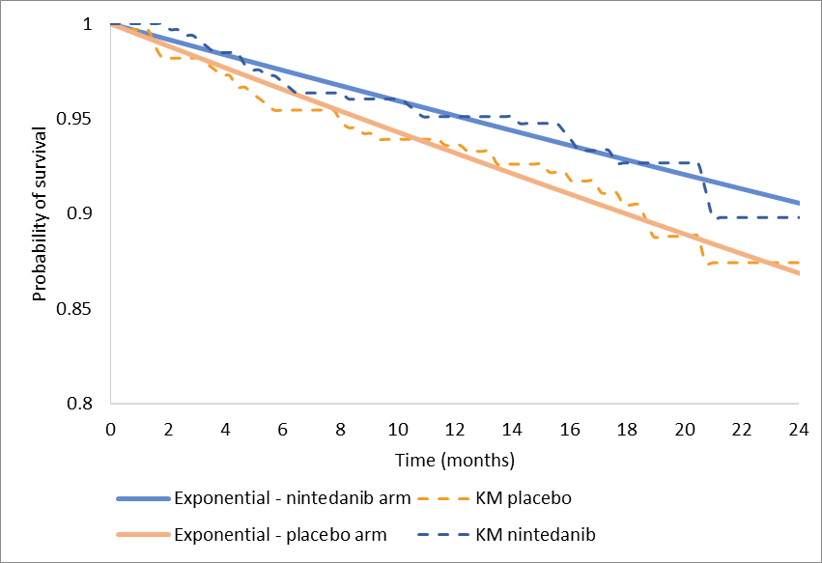
Figure 1: Comparison of the fit of the exponential parametric models for exacerbations to the Kaplan-Meier curves from the clinical trial for time to first acute ILD exacerbation
Abbreviations: KM: Kaplan-Meier.

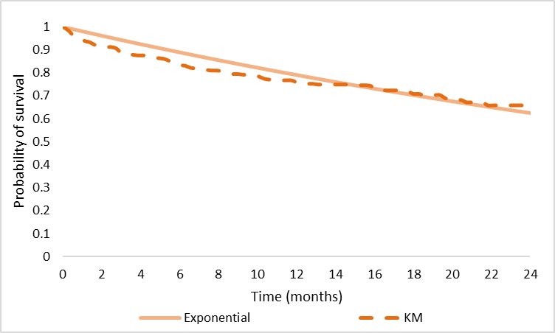
Figure 2: Comparison of the fit of the exponential parametric model for discontinuation to the Kaplan Meyer curve from the clinical trial for time to treatment discontinuation.
Abbreviations: KM: Kaplan-Meier.
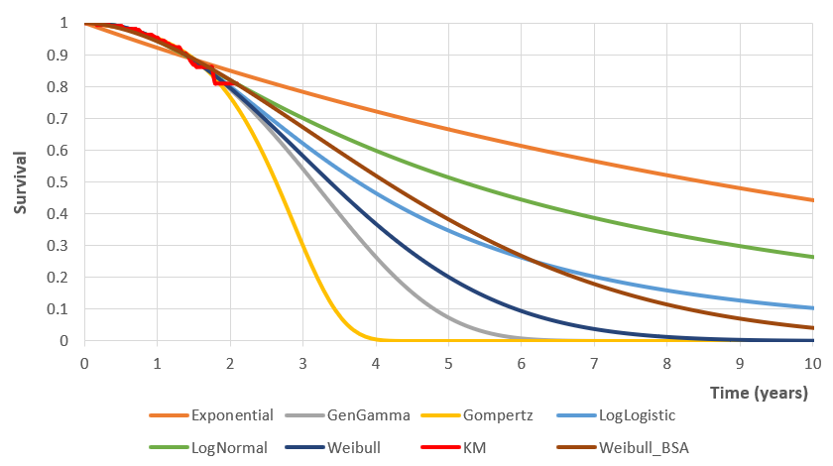

Figure 3: Overall survival placebo extrapolation.
*Curves are overlapping and may not be entirely distinguishable.
Abbreviations: BSA: Bayesian survival analysis; KM: Kaplan-Meier. Abbreviations: BSA: Bayesian survival analysis; KM: Kaplan-Meier.
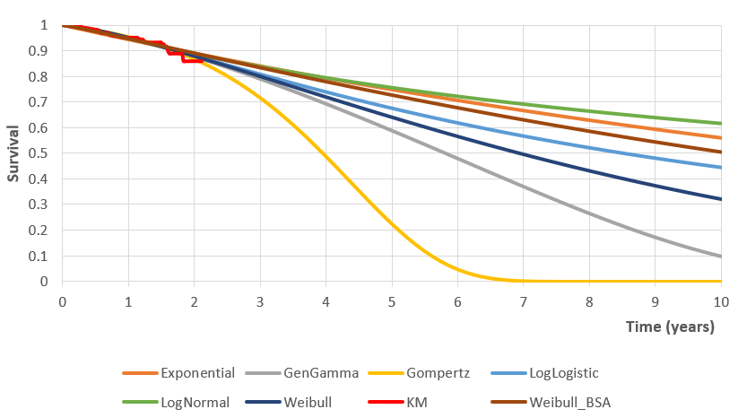

Figure 4: Overall survival nintedanib extrapolation
*Curves are overlapping and may not be entirely distinguishable.
Abbreviations: BSA: Bayesian survival analysis; KM: Kaplan-Meier.

Table B8: Overview of goodness of fit analysis – overall survival standard parametric models
Abbreviations: AIC: Akaike information criterion; BIC: Bayesian information criterion.
Model | Exponential | Gompertz | Generalised Gamma | Log-logistic | Log-normal | Weibull
AIC | 528.479 | 527.562 | 701.710 | 528.248 | 529.641 | 528.108
BIC | 532.285 | 535.173 | 713.116 | 535.858 | 537.251 | 535.718

Table B9: Coefficients for overall survival parametric models – placebo arm
Model | Variable | Coefficient | Standard Deviation | 95% Confidence Interval
Exponential | Rate | -8.405 | 2.951 | -8.723 | -8.087
Generalised Gamma | mu | 7.241 | 3.603 | 6.852 | 7.629
Generalised Gamma | sigma | -1.098 | 35.116 | -4.881 | 2.685
Generalised Gamma | q | 1.462 | 52.729 | -4.219 | 7.142
Gompertz | Shape | 0.004 | 0.017 | 0.002 | 0.006
Gompertz | Rate | -9.732 | 7.276 | -10.515 | -8.948
Log-logistic | Shape | 0.791 | 2.716 | 0.498 | 1.083
Log-logistic | Scale | 7.223 | 2.906 | 6.910 | 7.536
Log-normal | Meanlog | 7.547 | 3.770 | 7.141 | 7.953
Log-normal | sdlog | 0.040 | 2.424 | -0.221 | 0.302
Standard Weibull | Scale | 0.754 | 2.729 | 0.460 | 1.048
Standard Weibull | Shape | 7.288 | 2.989 | 6.966 | 7.610
Bayesian Weibull | Scale | 0.546 | 0.068 | 0.399 | 0.667
Bayesian Weibull | Shape | 7.372 | 0.441 | 6.627 | 8.359

Table B10: Coefficients for overall survival parametric models – nintedanib arm
Model | Variable | Coefficient | Standard Deviation | 95% Confidence Interval
Exponential | Rate | -8.750 | 3.507 | -9.127 | -8.372
Generalised Gamma | mu | 7.989 | 7.879 | 7.142 | 8.837
Generalised Gamma | sigma | -0.964 | 84.697 | -10.075 | 8.146
Generalised Gamma | q | 1.982 | 167.769 | -16.065 | 20.029
Gompertz | Shape | 0.002 | 0.020 | 0.000 | 0.004
Gompertz | Rate | -9.320 | 7.418 | -10.118 | -8.522
Log-logistic | Shape | 0.322 | 3.351 | -0.039 | 0.682
Log-logistic | Scale | 8.040 | 6.506 | 7.341 | 8.740
Log-normal | Meanlog | 8.716 | 8.418 | 7.810 | 9.621
Log-normal | sdlog | 0.555 | 2.975 | 0.235 | 0.874
Standard Weibull | Scale | 0.301 | 3.375 | -0.062 | 0.664
Standard Weibull | Shape | 8.107 | 6.667 | 7.390 | 8.825
Bayesian Weibull | Scale | 0.097 | 0.046 | 0.004 | 0.188
Bayesian Weibull | Shape | 8.484 | 0.345 | 7.901 | 9.255

Table B11: Variance-covariance matrix for overall survival – placebo arm
Model | Variable | Rate | Shape | Scale | meanlog | sdlog | mu | sigma | q
Exponential | Rate | 0.026 | NA | NA | NA | NA | NA | NA | NA
Weibull | Shape | NA | 0.022 | -0.022 | NA | NA | NA | NA | NA
Weibull | Scale | NA | -0.022 | 0.027 | NA | NA | NA | NA | NA
Log-normal | meanlog | NA | NA | NA | 0.043 | 0.025 | NA | NA | NA
Log-normal | sdlog | NA | NA | NA | 0.025 | 0.018 | NA | NA | NA
Log-logistic | Shape | NA | 0.022 | -0.021 | NA | NA | NA | NA | NA
Log-logistic | Scale | NA | -0.021 | 0.026 | NA | NA | NA | NA | NA
Gompertz | Shape | 0.000 | 0.000 | NA | NA | NA | NA | NA | NA
Gompertz | Rate | 0.160 | 0.000 | NA | NA | NA | NA | NA | NA
Generalised gamma | mu | NA | NA | NA | NA | NA | 0.039 | 0.259 | -0.359
Generalised gamma | sigma | NA | NA | NA | NA | NA | 0.259 | 3.726 | -5.577
Generalised gamma | q | NA | NA | NA | NA | NA | -0.359 | -5.577 | 8.400

Table B12:1 Variance-covariance matrix for overall survival – nintedanib arm
Model | Variable | Rate | Shape | Scale | meanlog | sdlog | mu | sigma | q
Exponential | Rate | 0.037 | NA | NA | NA | NA | NA | NA | NA
Weibull | Shape | NA | 0.034 | -0.062 | NA | NA | NA | NA | NA
Weibull | Scale | NA | -0.062 | 0.134 | NA | NA | NA | NA | NA
Log-normal | meanlog | NA | NA | NA | 0.213 | 0.070 | NA | NA | NA
Log-normal | sdlog | NA | NA | NA | 0.070 | 0.027 | NA | NA | NA
Log-logistic | Shape | NA | 0.034 | -0.060 | NA | NA | NA | NA | NA
Log-logistic | Scale | NA | -0.060 | 0.127 | NA | NA | NA | NA | NA
Gompertz | Shape | 0.000 | 0.000 | NA | NA | NA | NA | NA | NA
Gompertz | Rate | 0.166 | 0.000 | NA | NA | NA | NA | NA | NA
Generalised gamma | mu | NA | NA | NA | NA | NA | 0.187 | -1.162 | 2.419
Generalised gamma | sigma | NA | NA | NA | NA | NA | -1.162 | 21.608 | -42.767
Generalised gamma | q | NA | NA | NA | NA | NA | 2.419 | -42.767 | 84.781

Appendix C
Utility values
The economic analysis used a regression equation based on EQ-5D-3L data collected in the INBUILD clinical trial to determine patient-specific health state utility values. A linear mixed-effects model with a random intercept was fit to assess utility as a function of baseline utility, baseline characteristics (age, sex, race, HRCT pattern, criteria for progressive ILD, methotrexate use at baseline, time since diagnosis, underlying ILD diagnosis) and time-dependent predictors (FVC%pred, progression status and ongoing acute ILD exacerbation). Covariates were selected via backwards stepwise regression with a p-value cut-off of 0.05. Treatment was not included as a covariate because it was not significant in initial testing, suggesting that there is no evidence of a difference between INBUILD patients on nintedanib and placebo in terms of utility. The results of the mixed-effects regression model to model utility over time are shown in Table C2.

Table C1 provides an overview of the variance-covariance matrix for the UK utility regression model.
Table C2 provides an overview of model parameters included in the cost-effectiveness model for treatment with nintedanib in PF-ILD patients.

Table C1: Acute exacerbations and discontinuation’s model coefficients - UK fixed effects covariance matrix.
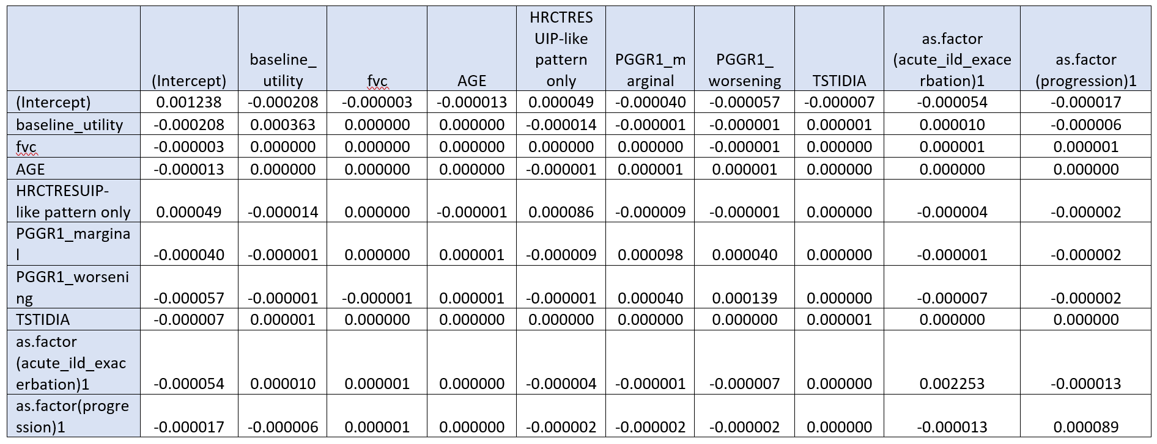
Abbreviations: BL: Baseline; DF: Degrees of freedom; FVC: forced vital capacity; HRCTRES: HRCT pattern; ILD: interstitial lung disease; NA: Not applicable; PGGR1: grouped criteria for progressive interstitial lung disease; SE: standard error; TSTDIA: time since diagnosis; UIP: usual interstitial pneumonia

Table C2: Overview of model parameters included in the cost-effectiveness model for treatment with nintedanib in PF-ILD patients.
Abbreviations: ALT: alanine aminotransferase; FVC: forced vital capacity; FVC%pred: forced vital capacity percent predicted; GP: general practitioner; HRCTRES: High Resolution Computed Tomography pattern; HCRU: healthcare resource use; ILD: interstitial lung disease; NA: not applicable; PGGR1: grouped criteria for progressive interstitial lung disease; SE: standard error; UIP: usual interstitial pneumonia.
1-Month probabilities of hospitalisations, ER visits, oxygen use, and outpatient visits
FVC%pred group | Hospi-  talisation | ER visit | Oxygen use | GP | Specialist | Nurse | Physio-  therapist | Occu-pational  therapy | Other | Source
>110 | 0.04 | 0.034 | 0.050 | 0.042 | 0.025 | 0.009 | 0.004 | 0.009 | 0.009 | (8)
100–110 | 0.04 | 0.017 | 0.058 | 0.033 | 0.054 | 0.002 | 0.002 | 0.002 | 0.002 | (8)
90–100 | 0.04 | 0.008 | 0.056 | 0.052 | 0.088 | 0.011 | 0.002 | 0.006 | 0.006 | (8)
80–90 | 0.01 | 0.012 | 0.048 | 0.058 | 0.063 | 0.008 | 0.005 | 0.015 | 0.015 | (8)
70–80 | 0.02 | 0.012 | 0.085 | 0.095 | 0.072 | 0.011 | 0.002 | 0.002 | 0.002 | (8)
60–70 | 0.03 | 0.019 | 0.113 | 0.063 | 0.082 | 0.009 | 0.001 | 0.004 | 0.004 | (8)
50–60 | 0.03 | 0.020 | 0.154 | 0.057 | 0.060 | 0.008 | 0.001 | 0.006 | 0.006 | (8)
< 50 | 0.04 | 0.018 | 0.191 | 0.051 | 0.054 | 0.006 | 0.000 | 0.007 | 0.007 | (8)
Overview of utility values
Effect | Group | Term |  |  | Estimate | SE | Statistic | P-Value |  | Source
Fixed | NA | (Intercept) |  |  | 0.147 | 0.035 | 4.165 | 0.000 |  | (9)
Fixed | NA | baseline_utility |  |  | 0.704 | 0.019 | 36.999 | 0.000 |  | (9)
Fixed | NA | FVC |  |  | 0.002 | 0.000 | 6.234 | 0.000 |  | (9)
Fixed | NA | AGE |  |  | -0.001 | 0.000 | -2.743 | 0.006 |  | (9)
Fixed | NA | HRCTRES UIP-like pattern only |  |  | 0.019 | 0.009 | 2.063 | 0.039 |  | (9)
Fixed | NA | PGGR1_marginal |  |  | 0.026 | 0.010 | 2.579 | 0.010 |  | (9)
Fixed | NA | PGGR1_worsening |  |  | 0.015 | 0.012 | 1.283 | 0.200 |  | (9)
Fixed | NA | Time since diagnosis |  |  | 0.002 | 0.001 | 2.076 | 0.038 |  | (9)
Fixed | NA | as.factor(acute_ild_exacerbation)1 |  |  | -0.178 | 0.047 | -3.759 | 0.000 |  | (9)
Fixed | NA | as.factor(progression)1 |  |  | -0.077 | 0.009 | -8.216 | 0.000 |  | (9)
Random | USUBJID | sd_Intercept |  |  | 0.09 | NA | NA | NA |  | (9)
Random | Residual | sd_Observation |  |  | 0.14 | NA | NA | NA |  | (9)
Treatment related Adverse events disutilities
Adverse event |  |  |  |  | Utility | Source
Diarrhoea |  |  |  |  | -0.0340 | [3]
Nausea |  |  |  |  | -0.0340 | [3]
Vomiting |  |  |  |  | -0.0340 | [3]
Alanine aminotransferase increased |  |  |  |  | 0.000 | Assumption, event is assumed to be asymptomatic
Decreased appetite |  |  |  |  | 0.000 | Assumption, event is assumed to be asymptomatic
Utility values following lung transplant
Time after Transplant |  |  |  |  | Utility | Source
0-6 months |  |  |  |  | 0.7100 | [10,11]
7-18 months |  |  |  |  | 0.7200 | [10,11]
19-36 months |  |  |  |  | 0.7000 | [10,11]
>36 months |  |  |  |  | 0.6800 | [10,11]
Overview of Dutch unit costs (€) for resources used

Resources | Parameter description | Description of measurement |  |  | Unit Cost |  |  | Source
HCRU  Cost | Hospitalisation | Nursing day, university hospital |  |  | € 671.79 |  |  | [12]
HCRU  Cost | ICU stay | Nursing day, intensive care (excl. diagnostics and medication) |  |  | € 1,241.03 |  |  | [12]
HCRU  Cost | Mechanical ventilation | Assistance with home ventilation for chronic home ventilation Code:990011013. Year 2019 |  |  | € 646.43 |  |  | [13]
HCRU  Cost | ER overnight stay | Exacerbation Emergency Department. Cost in 2013. |  |  | € 752.79 |  |  | [14]
HCRU  Cost | ER visit | Reference price emergency room |  |  | € 271.02 |  |  | [12]
HCRU  Cost | Exacerbation cost | Exacerbation cost for acute event |  |  | € 5,463.02 |  |  | [14]
HCRU  Cost | Lung transplan-tation | Cost for lung transplantation |  |  | € 38,213.53 |  |  | [15]
HCRU  Cost | Ambulance use | Ambulance, weighted average |  |  | € 538.90 |  |  | [12]
HCRU  Cost | End-of-life cost | End-of-life care |  |  | € 2,124.39 |  |  | [16]
HCRU  Cost | Liver function test | Liver function test |  |  | € 2.19 |  |  | [12]
HCRU  Cost | GP | GP, standard consultation |  |  | € 34.53 |  |  | [12]
HCRU  Cost | Specialist | Outpatient visit, weighted average |  |  | € 95.22 |  |  | [12]
HCRU  Cost | Nurse | Nurse visit of 15 minutes:  € 32 39/4 = € 8.10 |  |  | € 8.48 |  |  | [12]
HCRU  Cost | Physio-therapist | Physiotherapy per session |  |  | € 34.53 |  |  | [12]
HCRU  Cost | Occupational therapy | Single occupational therapy per 15 minutes |  |  | € 16.84 |  |  | [17]
HCRU  Cost | Other visits | Outpatient visit, weighted average |  |  | € 95.22 |  |  | [12]
HCRU  Cost | Oxygen use (annual cost) | LAN portable oxygen pump |  |  | € 1,500.00 |  |  | [18]
Societal costs | Round trip to hospital | Car, cost per kilometer € 0.19 |  |  | € 5.78 |  |  | [12]
Societal costs | Round trip to GP and specialist | Car, parking costs per visit € 3.00 |  |  | € 3.44 |  |  | [12]
Societal costs | Healthcare worker | Healthcare worker – domestic support at home |  |  | € 24.07 |  |  | [12]
Societal costs | Hourly wage | Productivity costs per hour per paid employee |  |  | € 36.36 |  |  | [12]
Societal costs | Hours spent at work | Assumption number of hours work per day for a full-time employee, working 35 hours or more per week |  |  | 7.20 hours |  |  | [19]
Adverse event costs | Diarrhoea | Assumption proportion of patients experiencing an AE within 1 cycle; incur the cost of 1 GP visit |  |  | €34.53 |  |  | [12]
Adverse event costs | Nausea | Assumption proportion of patients experiencing an AE within 1 cycle; incur the cost of 1 GP visit |  |  | €34.53 |  |  | [12]
Adverse event costs | Vomiting | Assumption proportion of patients experiencing an AE within 1 cycle; incur the cost of 1 GP visit |  |  | €34.53 |  |  | [12]
Adverse event costs | Alanine amino-transferase increased |  |  |  | € 2.19 |  |  | [12]
Adverse event costs | Decreased appetite | Assumption proportion of patients experiencing an AE within 1 cycle; incur the cost of 1 GP visit |  |  | €34.53 |  |  | [12]
Drug cost per month
 |  | Costs |  |  | Percentage use |  |  | Source
Nintedanib  100 mg 60 capsules |  | €1,683.00 |  |  | 30% |  |  | [20]
Nintedanib  150 mg 60 capsules |  | €2,258.04 |  |  | 70% |  |  | [20]
Resource use per patient
 |  | Average frequency per patient |  |  | SE |  |  | Source
Average nr. of hospitalisations per patient with ≥1 hospitalisation |  | 1.35 |  |  | 0.25 |  |  | [21]
Average duration of hospitalisation |  | 10.54 days |  |  | 0.67 |  |  | [21]
Proportion of hospitalisations associated with ICU stay |  | 5.8% |  |  | 1.3% |  |  | [21]
Proportion of hospitalisation associated with mechanical ventilation use |  | 1.6% |  |  | 0.7% |  |  | [21]
Proportion of hospitalisation associated with ER overnight stay |  | 7.4% |  |  | 1.5% |  |  | [21]
Proportion of hospitalisation associated with ambulance use |  | 20.3% |  |  | 2.2% |  |  | [21]
ER visit |  | 1.17 |  |  | 0.092 |  |  | [21]
Ambulance use (%) |  | 20.3% |  |  | 3.0% |  |  | [21]
GP |  | 1.374 |  |  | 0.424 |  |  | [21]
Specialist |  | 1.456 |  |  | 0.303 |  |  | [21]
Nurse |  | 0.181 |  |  | 0.048 |  |  | [21]
Physiotherapist |  | 0.0310 |  |  | 0.029 |  |  | [21]
Occupational therapy |  | 0.115 |  |  | 0.088 |  |  | [21]
Other visits |  | 0.115 |  |  | 0.088 |  |  | [21]

Table C3: Overview of input parameters used in the univariate sensitivity analysis and the probabilistic sensitivity analysis.
Abbreviations: AE: adverse events; ER: emergency room; GI: gastrointestinal; GP: general practitioner; FVC%pred: forced vital capacity percent predicted; ICU: intensive care unit; N: number; PSA: probabilistic sensitivity analysis.
Parameter limits used in the univariate sensitivity analyses
Parameter |  | Base case analysis | Lower limit |  |  |  | Upper limit |  | Source
Liver panel test costs |  | €2.19 | €1.64 |  |  |  | €2.73 |  | Assume 25% variation around mean value.  [12]
Acute exacerbation resource use |  | €5,463.02 | €4,097.26 |  |  |  | €6,828.77 |  | Assume 25% variation around mean value.  [14]
End-of-life costs |  | €2,124.39 | €1,593.29 |  |  |  | €2,655.49 |  | Assume 25% variation around mean value.  [16]
Adverse events disutilities |  | -0.034 | -0.0255 |  |  |  | -0.0425 |  | Assume 25% variation around mean value.  Assume half of a serious GI event disutility, based on [3]
Adverse events costs |  | €34.53 | €25.90 |  |  |  | €43.16 |  | Assume 25% variation around mean value.  [12]
Distribution and parameter limits used in the probabilistic sensitivity analysis
Parameter | Distribution |  |  | Base case | Lower limit | Upper limit |  | Assumption/sources
Probabilities
Overall survival | Multivariate normal |  |  | - | - | - |  | Cholesky decomposition based on variance-covariance matrix
Time to treatment discontinuation | Multivariate normal |  |  | - | - | - |  | Cholesky decomposition based on variance-covariance matrix
Loss of lung function (regression coefficients) | Multivariate normal |  |  | - | - | - |  | Cholesky decomposition based on variance-covariance matrix
Utility values (regression coefficients) | Multivariate normal |  |  | - | - | - |  | Cholesky decomposition based on variance-covariance matrix
Adverse events risks
Diarrhoea (nintedanib arm) | Beta  (α = 196, β = 136) |  |  | 0.0709 | 0.0638 | 0.0702 |  | Total N = 332, N (diarrhoea) = 196  Ref:[8]
Nausea (nintedanib arm) | Beta  (α = 79, β = 253) |  |  | 0.0221 | 0.0199 | 0.0219 |  | Total N = 332, N (nausea) = 79  Ref: [9]
Vomiting (nintedanib arm) | Beta  (α = 41, β = 291) |  |  | 0.0108 | 0.0097 | 0.0107 |  | Total N = 332, N (vomiting) = 41  Ref: [9]
Alanine aminotransferase increased (nintedanib arm) | Beta  (α = 36, β = 296) |  |  | 0.0094 | 0.0085 | 0.0093 |  | Total N = 332, N (alanine aminotransferase increased) = 36  Ref.:[9]
Decreased appetite (nintedanib arm) | Beta  (α = 37, β = 295) |  |  | 0.0097 | 0.0087 | 0.0096 |  | Total N = 332, N (decreased appetite) = 37  Ref: [9]
Diarrhoea (placebo arm) | Beta  (α = 59, β = 272) |  |  | 0.0161 | 0.0144 | 0.0159 |  | Total N = 331, N (diarrhoea) = 59  Ref: [9]
Nausea (placebo arm) | Beta  (α = 19, β = 312) |  |  | 0.0049 | 0.0044 | 0.0048 |  | Total N = 331, N (nausea) = 19  Ref: [9]
Vomiting (placebo arm) | Beta  (α = 7, β = 324) |  |  | 0.0018 | 0.0016 | 0.0017 |  | Total N = 331, N (vomiting) = 7  Ref: [9]
Alanine aminotransferase increased (placebo arm) | Beta  (α = 8, β = 323) |  |  | 0.0020 | 0.0018 | 0.0020 |  | Total N = 331, N (alanine aminotransferase increased) = 63  Ref: [9]
Decreased appetite (placebo arm) | Beta  (α = 10, β = 321) |  |  | 0.0025 | 0.0023 | 0.0025 |  | Total N = 331, N (decreased appetite) = 37  Ref: [9]
Liver function test cost
Frequency of liver function test (per cycle) | Gamma  (α = 5.53, β = 0.045) |  |  | 0.25 | 0.188 | 0.31 |  | Assumption every 3 months
Liver function test cost | Log-normal (mean = 0.92, SE = 0.133) |  |  | €2.19 | €1.64 | €2.73 |  | [12]
Treatment-related AE costs
GI events cost (per event) | Gamma  (α = 200.38, β = 0.16) |  |  | €34.53 | €25.90 | €43.16 |  | [12]
Decreased appetite (per event)
Resource use
Number of hospitalisations | Log-normal (mean = 0.30, SE = 0.193) |  |  | 1.35 | 1.013 | 1.69 |  | [8]
Average duration of each hospitalisation (days) | Log-normal (mean = 2.36, SE = 0.064) |  |  | 10.54 | 10.54 | 13.18 |  | [8]
Proportion in ICU | Beta  (α = 17.94, β = 292.05) |  |  | 0.06 | 0.043 | 0.07 |  | [8]
Proportion with mechanical ventilation | Beta  (α = 4.98, β = 305.02) |  |  | 0.02 | 0.01 | 0.02 |  | [8]
Proportion associated with ER overnight | Beta  (α = 22.93, β = 287.07) |  |  | 0.07 | 0.055 | 0.09 |  | [6]
Proportion associated with ambulance use (hospital) | Beta  (α = 62.80, β = 247.20) |  |  | 0.20 | 0.15 | 0.25 |  | [8]
Average number of ER visits | Log-normal (mean = 0.16, SE = 0.079) |  |  | 1.17 | 0.88 | 1.47 |  | [8]
Proportion associated with ambulance use (ER) | Beta  (α = 36.80, β = 144.20) |  |  | 0.20 | 0.152 | 0.25 |  | [8]
Number of GP visits | Log-normal (mean = 0.32, SE = 0.358) |  |  | 1.37 | 1.03 | 1.72 |  | [8]
Number of specialist visits | Log-normal (mean = 0.38, SE = 0.221) |  |  | 1.46 | 1.092 | 1.82 |  | [8]
Number of nurse visits | Log-normal  (mean = -1.71, SE = 0.297) |  |  | 0.18 | 0.14 | 0.23 |  | [8]
Mean days of oxygen use | Log-normal (mean = 4.00, SE = 0.208) |  |  | 54.51 | 40.88 | 68.13 |  | [8]
Mean average hours of oxygen use per day | Log-normal (mean = 2.56, SE = 0.102) |  |  | 12.87 | 9.65 | 16.08 |  | [8]
Exacerbation cost (per event) | Gamma  (α = 42.68, β = 115.50) |  |  | €5463.02 | €4097.23 | €6828.77 |  | [14]
End-of-life cost  (annual cost) | Gamma  (α = 42.68, β = 254.45) |  |  | €2124.39 | €1593.29 | €2655.49 |  | [16]
Treatment-related adverse events disutility
GI events (diarrhoea, nausea, vomiting) | Beta  (α = 59.34, β = 1686.004) |  |  | -0.034 | -0.0255 | -0.0425 |  | Assumed half of serious GI 95% CI: (-0.0225, -0.0425)  Ref: [3]

Figure 1: Cost-effectiveness acceptability curve of nintedanib versus placebo, both on top of usual care.

Table C4: Overview of PSA outcomes with 200, 500 and 1000 iterations.
 | QALYs |  | LYs |  | Total costs |  | Incremental
 | BSC - disc | NDB - disc | BSC - disc | NDB - disc | BSC - disc | NDB - disc | QALYs | Costs
200 iterations
Probabilistic average | 1.966649848 | 2.964273313 | 3.033657131 | 4.539384961 | 31312.49899 | 93579.75836 | 0.997623466 | 62267.25937
SD | 0.028584708 | 0.034835522 | 0.04194541 | 0.051741569 | 3055.812006 | 4410.398956 | 0.043616041 | 4568.849405
Base-case | 2.000911557 | 2.873274398 | 3.10001896 | 4.409934671 | € 38,357.57 | € 91,301.16 | 0.872362841 | € 52,943.59
Min | 1.895740628 | 2.864998341 | 2.924459457 | 4.387527943 | 25685.35156 | 83913.40625 | 0.858388424 | 50348.91016
Max | 2.059064865 | 3.042659283 | 3.15881443 | 4.689800262 | 42527.39063 | 109019.1797 | 1.113200784 | 77825.27539
Lower limit (95% CI) | 1.909388191 | 2.889458025 | 2.947794181 | 4.441252875 | 26908.73828 | 85426.50273 | 0.910210761 | 54296.51074
Upper limit (95% CI) | 2.020990694 | 3.035229695 | 3.110869592 | 4.628809571 | 38470.41592 | 102595.5154 | 1.0843281 | 71350.97886
Check | 0.98288 | 1.03167 | 0.97859 | 1.02935 | € 0.82 | € 1.02 | 1.14359 | € 1.18
500 iterations
Probabilistic average | 1.967155732 | 2.967383652 | 3.034691405 | 4.546332916 | 31030.99688 | 94212.78905 | 1.00022792 | 63181.79217
SD | 0.028239493 | 0.039778896 | 0.0416848 | 0.059459786 | 3050.751918 | 4778.457882 | 0.046089747 | 5126.824576
Base-case | 2.000911557 | 2.873274398 | 3.10001896 | 4.409934671 | € 38,357.57 | € 91,301.16 | 0.872362841 | € 52,943.59
Min | 1.887951374 | 2.839096308 | 2.931126833 | 4.372844219 | 25492.30469 | 81506.8125 | 0.870662212 | 48633.64063
Max | 2.053117514 | 3.085829258 | 3.15615344 | 4.711200714 | 42641.13672 | 119030.3047 | 1.126681447 | 78690.77148
Lower limit (95% CI) | 1.913516325 | 2.891523194 | 2.952357936 | 4.42278558 | 26221.65674 | 86058.47715 | 0.91049937 | 52696.90225
Upper limit (95% CI) | 2.026862979 | 3.041829967 | 3.121378767 | 4.671994352 | 38124.27217 | 103695.9889 | 1.08745513 | 73468.74673
Check | 0.98313 | 1.03275 | 0.97893 | 1.03093 | € 0.81 | € 1.03 | 1.14657 | € 1.19
1000 iterations
Probabilistic average | 1.967016284 | 2.964721118 | 3.03464808 | 4.543365003 | 30923.82346 | 94032.4753 | 0.997704834 | 63108.65184
SD | 0.027740063 | 0.03891014 | 0.040213939 | 0.056676517 | 2916.541855 | 4393.108953 | 0.045776251 | 4573.554036
Base-case | 2.000911557 | 2.873274398 | 3.10001896 | 4.409934671 | € 38,357.57 | € 91,301.16 | 0.872362841 | € 52,943.59
Min | 1.875605226 | 2.772083282 | 2.910951614 | 4.276036739 | 24731.44922 | 81457.10938 | 0.773999095 | 46849.40625
Max | 2.061721563 | 3.086795568 | 3.154693127 | 4.707053185 | 46432.96875 | 109221.8125 | 1.143805981 | 78633.47656
Lower limit (95% CI) | 1.914017442 | 2.890248275 | 2.954464102 | 4.436220539 | 26379.1417 | 86581.68398 | 0.913517353 | 54157.0584
Upper limit (95% CI) | 2.019256032 | 3.044227588 | 3.11192686 | 4.655775368 | 37507.23926 | 103382.4906 | 1.087249672 | 72452.71118
Check | 0.98306 | 1.03183 | 0.97891 | 1.03026 | € 0.81 | € 1.03 | 1.14368 | € 1.19

Table C5: Overview outcomes of the scenario analyses
Subject | ICER (€/LYG) | ICER (€/QALY)
Base case | 40,418 | 60,690
Time horizon: 1 year | 2,236,518 | 2,294,659
Time horizon: 5 years | 72,946 | 105,280
Time horizon: 25 years | 36,903 | 55,509
Healthcare perspective | 39,825 | 59,801
Utilities – random effect excluded | 40,418 | 61,076
Variation drug costs: 80% | 31,222 | 46,882
Variation drug costs: 120% | 49,613 | 74,497
Variation relative dose intensity:  50% both 100mg & 150mg | 37,882 | 56,883
Variation relative dose intensity:  0% 100mg and 100% 150mg | 44,221 | 66,401
Variation relative dose intensity:  100% 100mg and 0% 150mg | 31,544 | 47,365
No end-of-life costs included | 40,512 | 60,832
No lung transplant included | 56,606 | 84,926
Nr. of acute exacerbations: 3 | 40,489 | 60,711
Gompertz distribution – Parametric function for OS - both nintedanib and placebo arms | 49,959 | 74,254
LogLogistic distribution – Parametric function for OS - both nintedanib and placebo arms | 43,843 | 65,025
Standard Weibull distribution – Parametric function for OS - both nintedanib and placebo arms | 37,973 | 57,479

References
1. Richeldi L, Costabel U, Selman M et al. Efficacy of a Tyrosine Kinase Inhibitor in Idiopathic Pulmonary Fibrosis. New England Journal of Medicine. 2011;365(12).
DOI: 10.1056/NEJMoa1402584
2. Richeldi L, Kreuter M, Selman M et al. Long-term treatment of patients with idiopathic pulmonary fibrosis with nintedanib: results from the TOMORROW trial and its open-label extension. Thorax. 2018;73(6). DOI: 10.1136/thoraxjnl-2016-209701
3. Richeldi L, du Bois RM, Raghu G et al. Efficacy and Safety of Nintedanib in Idiopathic Pulmonary Fibrosis. New England Journal of Medicine. 2014 May 29;370(22):2071–82.
DOI: 10.1056/NEJMoa1402584
4. Crestani B, Huggins JT, Kaye M et al. Long-term safety and tolerability of nintedanib in patients with idiopathic pulmonary fibrosis: results from the open-label extension study, INPULSIS-ON. The Lancet Respiratory Medicine. 2019;7(1).
DOI: 10.1016/S2213-2600(18)30339-4
5. Kondoh Y., Taniguchi H., Katsuta T et al. Risk factors of acute exacerbation of idiopathic pulmonary fibrosis. Sarcoidosis Vasculitis and Diffuse Lung Diseases. 2010.
6. Flaherty KR, Wells AU, Cottin V et al. Nintedanib in Progressive Fibrosing Interstitial Lung Diseases. New England Journal of Medicine. 2019 Oct 31;381(18):1718–27.
DOI: 10.1056/NEJMoa1908681
7. Dutch Patient Society; Report Lung fibrosis - Lung Transplantation; 2015 [Internet]. [cited 2021 Aug 20]. Available from: https://www.longfibrose.nl/patient-naasten/behandelingen/longtransplantatie/
8. Boehringer Ingelheim, INBUILD phase III trial (no. 1199.247) post-hoc analysis. Data on file. 2019.
9. Boehringer Ingelheim, INBUILD phase III trial - Clinical Trial Report. Data on file - Utilities. 2019.
10. Anyanwu AC, McGuire A, Rogers CA et al. Assessment of quality of life in lung transplantation using a simple generic tool. Thorax. 2001;56(3). DOI: 10.1136/thorax.56.3.218
11. Loveman E, Copley VR, Colquitt J et al. The clinical effectiveness and cost-effectiveness of treatments for idiopathic pulmonary fibrosis: A systematic review and economic evaluation. Health Technology Assessment. 2015;19(20). DOI: 10.3310/hta19200
12. Hakkaart-van Roijen L, van der Linden N, Bouwmans C et al. Cost Manual: Methodology of research for costs and reference prices for economic evaluations in health care. Zorginstituut Nederland [Internet]. 2016;1–73. Available from: www.zorginstituutnederland.nl/publicaties/publicatie/2016/02/29/richtlijn-voor-het-uitvoeren-van-economische-evaluaties-in-de-gezondheidszorg
13. Dutch Healthcare Authority; report Tariffs Medical Specialist care. 2019.
14. van Boven JFM, Tommelein E, Boussery K et al. Improving inhaler adherence in patients with Chronic Obstructive Pulmonary Disease: A cost-effectiveness analysis. Respiratory Research. 2014 Jun 14;15(1). DOI: 10.1186/1465-9921-15-66
15. Dutch Healthcare Authority; Cost for Lung transplantation [Internet]. [cited 2021 Aug 20]. Available from: https://zorgproducten.nza.nl/ZoekZorgproduct.aspx?psId=12&pId=65720
16. Wuyts WA, Papiris S, Manali E. et al. The Burden of Progressive Fibrosing Interstitial Lung Disease: A DELPHI Approach. Adv Ther. 2020 Jul;37(7):3246-3264. doi: 10.1007/s12325-020-01384-0. Epub 2020 May 22. PMID: 32445186; PMCID: PMC7467418.
17. Dutch Healthcare Authority; Report Advice Regulating occupational therapy. 2015.
18. Dutch Lung fund brochure [Internet]. 2020 [cited 2021 May 20]. Available from: https://www.longfonds.nl/sites/default/files/commerse/ webshop_pdfs/Brochure%20zuurstof%20DEF%20PDF.pdf
19. Statistics Netherlands’ database, Inflation calculation. [Internet]. [cited 2021 Mar 15]. Available from: https://opendata.cbs.nl/statline/#/CBS/nl/dataset/83131NED/table?fromstatweb
20. G-Standard, Dutch treatment database (Z-index), Prices for a 30-day prescription of nintedanib 150mg and 100mg. March 2021.
21. Boehringer Ingelheim, INBUILD phase III trial - Post-hoc analysis (per patient values, all-cause (not just PF-ILD-related). 2020.

